What to do before an Interview and during!

So you have finally got the chance for a job interview but don’t know what to do, right?
Here are some tips for that interview and what to do before it.

Step 1: Do as much research as you can, you need to find out what the job enquires from you and then you need to know what they do. Another tip is to find out who the interviewer is and find out what their interests are and then you can try to match them.

Step 2: Make sure that you are confident with the way that you are going to tell people about yourselves. You can run through your interview with a friend or family member, this can help you if they have different questions that could pop-up in the interview.

Step 3: Make sure you have got things ready the night before the interview. Make sure that your suit is ready, make sure that you are going to bed early so that you are fully rested before. MAKE SURE TO SET YOUR ALARM! So you’re not going to be late.

Step 4: It is the day of your interview, make sure that your feeling confident, you need to have some breakfast and some coffee to waken yourself up. You need to have a good suit and make sure especially you men have a shave and so that you look smooth and not bad.

Step 5: Take deep breaths before and make sure to be their 10 to 15 minutes early, this shows that you are a time keeper.
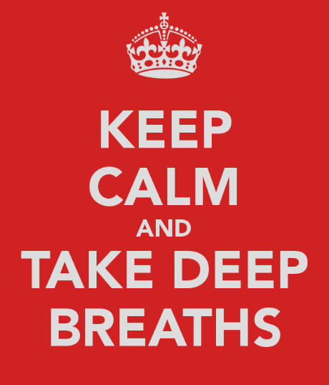
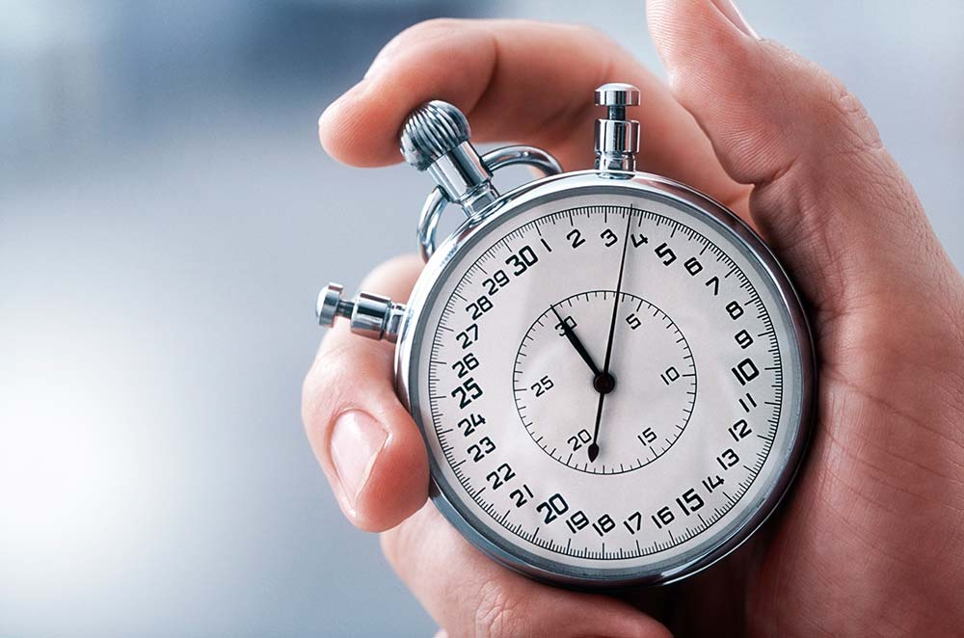

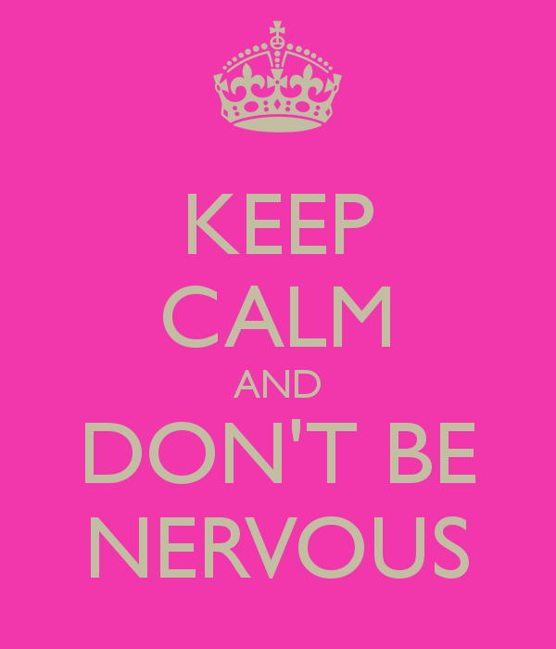
Step 6: In the interview make sure that you DO keep eye contact with the employer, be smiley and happy, make sure that you talk about your research and just be relaxed. DON’T be nervous.

Step 7: After the interview treat yourself to something and don’t worry about it too much. You will have done great!

