Unit 59 Assignment 2 Task 2 Analysis of websites

Name of company | Timely
Web site address (full url) | https://www.timelyapp.com
What types of goods / services does the website cater for? | This website will help you to keep time tracking and will help you schedule things, like meetings, when to get the bus. It will also tell you how long you have done something for. This is also a app for phones.
Which target audience is the site for? | The target audience could be for anyone, but it would mainly be for people who work in an office, where they struggle to get work done before deadlines.
What type of navigation does the site have? | There are seven pages in the navigation tab; Pricings, company, jobs, contact, help, blog, sign in. As it uses bootstrap, you can resize the page and the text will change to a 3 lined icon in the corner.
Is it easy to navigate, why?  (for example use of a drop down submenu) | The navigation was easy to navigate around, the buttons when you want to select them, the text will go white. The drop down menu when in a smaller view is still easy to use.
Where on the pages is the navigation?  Is it in the same place on each page? | The navigation doesn’t change on any webpage, the only time it does is when you resize the browser.
Does the main navigation remain visible all of the time or does it scroll with the page? | The main navigation will only be seen at the top of the webpage. When you scroll down you only see the text on the screen and not the navigation.
Can you get back to the home page from any other page? | Yes, you just click on the logo.
Is it easy to find what you are looking for? | Yes, it is. With the nice text and all the different colours.
What type of font is used in the site? Is this on all of the pages? | The font looks the same, but when you look at the different quotes it has changed to italics
Is the body text the same size throughout the site? | The main body text is the same, but the headings of either questions or telling us about a specific section, the size is a few sizes bigger.
Are all of the heading the same size throughout the site? | The headings are all the same size, but the position moves from place to place.
Is the body text on the website easy to read? For example, does it contrast with any background colour? | The colours all work well with each other, the text is a good size and therefore easy to read.
Is any of the text coloured? If so what colour? | The text is a dark navy blue; this is easy to see on the white background.
Do all of the pages in the site have a similar look? | Yes they do, there is a big blue banner at the top, there is a blue border at the bottom of each page, there are pictures throughout.
Is there a background colour or image on each page? If so is it the same colour/image? | 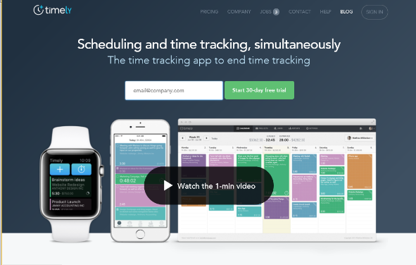  The main colour of the page is white, but the top and bottom are blue. This is consistent throughout, there either a video, image, maps. They usually look the same.
What is the approximate size of the images used through the site? | The size of the images are fairly big on the website, they are about 600 X 150 ish, but the map box is about 900X 300.
Are any animations used on this site? For example, a slideshow of images used in the banner | There is a bit of a rollover on the 1 min video, this goes from small rounded corner box with white text, to a bigger rounded corner box with a blue text.

Unit 59 Assignment 2 Task 2 Analysis of websites

Name of company | Apple Inc
Web site address (full url) | www.apple.com/uk
What types of goods / services does the website cater for? | The website creates and sells phones and computer products. They are widely known around the globe.
Which target audience is the site for? | The target audience is for people who have a lot of cash, this is because they sell their products at a big price. But everybody
What type of navigation does the site have? | There is a navigation bar at the top which goes through its products; Logo, Mac, iPad, iPhone, Watch, Tv, Music, support, search, basket
Is it easy to navigate, why?  (for example use of a drop down submenu) | There isn’t a drop down menu, but the navigation is still easy. When going over the tech that you want to visit, the colours change
Where on the pages is the navigation?  Is it in the same place on each page? | The navigation is at the top of the page, this stay’s the same and in the same position.
Does the main navigation remain visible all of the time or does it scroll with the page? | No, it only appears when you have scrolled all the way to the top.
Can you get back to the home page from any other page? | Yes, but when you click on the Apple logo.
Is it easy to find what you are looking for? | Yes, but if you can’t find something, then you can use the search bar in the top right corner.
What type of font is used in the site? Is this on all of the pages? | The font that is used is Times New Roman, this is easy to read and see, this is also is in a black colour.
Is the body text the same size throughout the site? | The body text is the same size throughout.
Are all of the heading the same size throughout the site? | No, there are different sized headings depending on what bit they are talking about.
Is the body text on the website easy to read? For example, does it contrast with any background colour? | The text is easy to read; it also goes well with white background. As the text colour is black.
Is any of the text coloured? If so what colour? | Yes the text is coloured and it is black.
Do all of the pages in the site have a similar look? | Yes the page looks good and is very similar looking.
Is there a background colour or image on each page? If so is it the same colour/image? | The background colour is white and the images are different depending on what product it is.
What is the approximate size of the images used through the site? | The pictures are around 600 X 200
Are any animations used on this site? For example, a slideshow of images used in the banner | There are lots of slideshows and lots of banners throughout.

Unit 59 Assignment 2 Task 2 Analysis of websites

Name of company | Kingdom Rush
Web site address (full url) | www.kingdomrush.com/home.html
What types of goods / services does the website cater for? | It is promoting a app on a mobile or tablet device.
Which target audience is the site for? | Anyone
What type of navigation does the site have? | There isn’t a lot of navigation, but the website has a lot of social media sites that people can visit.
Is it easy to navigate, why?  (for example use of a drop down submenu) | The site is easy to navigate around, the navigation has got some rollovers on, this means that you know what you are looking for.
Where on the pages is the navigation?  Is it in the same place on each page? | The navigation stays in the top throughout, even when you scroll it stays in the same place.
Does the main navigation remain visible all of the time or does it scroll with the page? | The logo in the right changes, but the navigation Is the same still throughout.
Can you get back to the home page from any other page? | The home page is easy to get to, you just need to click on the golden home button.
Is it easy to find what you are looking for? | The site is easy to find what you want, you can see it all with all the bubble writing.
What type of font is used in the site? Is this on all of the pages? | The font stays the same and it is a version of Montserrat.
Is the body text the same size throughout the site? | The writing is the same size and it is easy to read.
Are all of the heading the same size throughout the site? | They look like they are the same size throughout.
Is the body text on the website easy to read? For example, does it contrast with any background colour? | Everything looks good, colourful and vibrant. This means you can see the words and the main info, easily.
Is any of the text coloured? If so what colour? | The headlines are a black and the main body text is a brown/ bronze colour.
Do all of the pages in the site have a similar look? | They all have a similar look.
Is there a background colour or image on each page? If so is it the same colour/image? | There is a big image at the back, this has a nice appearance throughout the website.
What is the approximate size of the images used through the site? | They are quite big so around 600X 800
Are any animations used on this site? For example, a slideshow of images used in the banner | There are lots of rollovers, videos, images as well.

