Unit 6, Critical approaches to Creative Media Products - Assignment 3

Audience theory
Hypodermic needle model
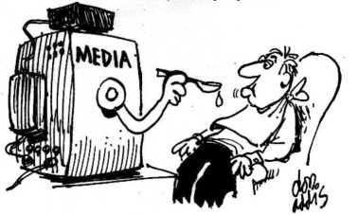
Hypodermic needle model is an audience that have become passive consumers. These passive consumers are then going to consume and use the media products themselves and therefore are going to be accepting a dominant ideology, with no questions asked. If a new console or game in a popular sequel were to be released to the customers, the consumers would automatically buy the product without thinking too much into it, this is because they have got used to having the latest and greatest thing on the market. No research would be done, it is typically a straight up purchase. One of the examples would be Apple, as when the new iPhones come out these types of people just go and jump onto it and instantly go and buy one without thinking about any other different models from companies like Samsung as it is just a very big brand that is recognisable and people just like to pay for it. Hypodermic Needle Theory is a good way to force the gamers and the customers into making the company have more profit as they just want to make them experience the game to the extent that when buying the next bit to the storyline, they will just go out and buy more. The game Final Fantasy is a big item to do with HNM, as there have been about 10 different games and they presumably just go and get the new one, as the game brings something different to the table.
As the game from Unit 78, which is called Wanted- Kill me if you can. This game would probably be a prequel to a sequel so then therefore people would jump right on in and buy this as they have a custom to Hypodermic needle model (HNM). However, if the game that were to be created turned out were a one of game then people would not be affected by HNM.

Uses and gratification theory
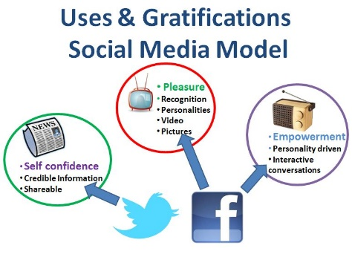
This theory sees consumers and customers more active. As this theory has a big effect on the mass media, consumers are not helpless; rather they are able to use the media to gain certain gratifications, such as laughter, interaction, information and so on. In other words, the audience questions and analyses media texts rather than just confusing them. I feel as if this is a good way to target its audience as people get a say into what could be happening. The theory of this means that people have more of a say into whatever happens to the game. This theory is positive in its approach, based on that the fact is that it focuses on communication but on a mass media scale. The audience has power over their media consumption and assumes an active role in interpreting and integrating media into their own lives.
The game Wanted – Kill me if you can (from Unit 78) would use this theory as I can improve the game from this as people can give me some feedback into what I can do and change for the next version or update. Otherwise, it is just a one-way conversation, that does not take in any other comments then it can be a problem, as they probably will not get any gratification from it.

Reception study
Reception study is when the producers or directors of a film or game will construct a text that has been encoded and implemented within a hidden message or meaning that the producers or directors want the gamers and watchers to get at some point as if it is a meaning to the whole of it. If this has been done correctly, the audience will be able to pick up the meaning or message straight away or after an introduction or a video of what has happened previously. However, the audience will need to be reminded of the message throughout as if not then they will not have a clue about what to do. Even if the introduction was to be skipped at the start by the gamer, then this story can be seen or told throughout that game.
The game Wanted – Kill me if you can game (from Unit 78) would use some sort of a reception but it wouldn’t be a big and important in the game as I don’t think that it would be necessary.

Effects debate
Effects of exposure to explicit sexual or violent content
Explicit content whether it is sexual or violent is going to be shown more through games that have an age rating of 16 to 18, rather than a nonviolent or nonsexual game produced for people aged 7. Many parents though with a child of the ages of 16-18 do not agree with the materials and think that they should be protected by this. As exposure of this content, it can be a big problem for children that could also be in the room. If a child was to be in the room then the causes that this has can be extraordinary as they would more likely to become violent and sexual very early on.
The age rating is warned on the front and the back of the game box or in a booklet and the ages that have been selected are by the PEGI and they will be in a number of categories such as; Language, Drugs, Fear, Sex, Violence, Gambling and Discrimination.
PEGI 3+ games will not have a violence apart from cartoon slapstick violence.
PEGI 7+ games may include “non-realistic violence or implied violence”.
PEGI 12+ will have the “violence towards human like characters” but this must mean the entities will be removed so you can’t see things like a dead corpse.
PEGI 16+ games are “violence towards human characters” who react to being shot as they would in real life.
PEGI 18+ games are flagged for including violence towards humans that are not very nice and quite horrific.
The game Wanted – Kill me if you can game (from Unit 78) would be a PEGI 18+ game as their will be blood and gore as you would have thought so with being in a western kind of setting. The game won’t be over the top like Grand Theft Auto as this is very bad. This would cause some problems for their parents but at the end of the day it would be a 18+.

Effects of advertising
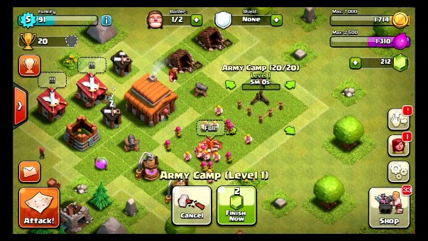
The use of advertising to gain more visitors and customers in the gaming community is a very powerful tool. Advertising a game is a very powerful tool to persuade them to purchase certain products or their game. In addition, if there is advertisement for people to get the next expansion pack like in Sims then they will gain profit from advertising it. There are many different ways for a company to advertise their game through video clips on TV or Internet using a website called YouTube. They can also advertise through social media with little hints and tricks into what the new items are going to be like. I do also feel though that if a parent where to see the advert as well then they are most likely to consider buying the game for them as to just a child convincing them to do so. However, this could lead them into not getting it for them. The power of the advertisement is to convince someone to buy their product and to excite and to hype them up so that once they have the game it would be more of an excitement as you have seen the adverts but when you get the game it is so much better.
My game would need to use advertising to gain more profit and more support to the fact that there would be probably more people getting the game and making the game more successful, plus I could advertise more updates. So that people then know that there is going to be another extension to the game and this would be good.
Health concerns
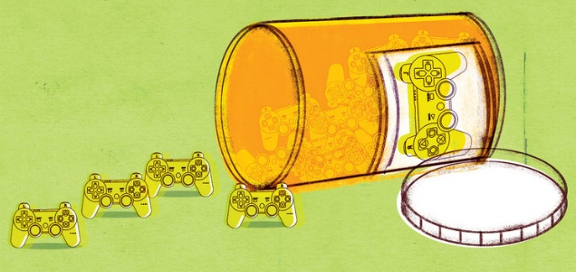
There is a massive amount of health concerns when gaming, but there can be good health concerns as well. The bad health concerns are injuries induce repetitive strain injuries, skin disorders or other health issues. Other problems include video game-provoked seizures in patients with epilepsy. In rare and extreme cases, deaths have resulted from excessive video game playing. These health concerns are bad but there can be good things that come out of it, as your typing speed can be increased your interests and hobbies can be down to the games that you play. Video game play has been constantly associated with obesity; this is because you are not really doing very much exercise if you are just at home in a chair all day. Therefore, if people want to get rid of this problem then they can just go out and get some fresh air and something like a walk can be good.
Video game playing may be associated with vision problems. Extensive viewing of the screen can cause eyestrain, as the cornea, pupil, and iris are not intended for mass viewing sessions of electronic devices. Using video games for too long may also cause headaches, dizziness, and chances of vomiting from focusing on a screen. However, if you game you can have a chance to gain some quick reactions from moving around all the time. Although it has not be proven its said to believe that there are strong correlations between gaming and psychological issues like increased aggression in males, and increased depression in females. Whilst another study claims that girls who gamed were less likely to experience depression but were more likely to get into fights.
With the game that I would create there are obviously are going to have a lot of problems with health as every game will have their concerns but it’s just something that we just have to deal with. I could say on the box or in the terms and conditions, that there could be health related problems with the game but this is just something that would be on the parents hand to keep an eye on. The player could alter the game risks so that it does not cause them too many big and possibly long-term health concerns.
Censorship debates
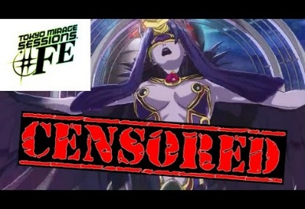
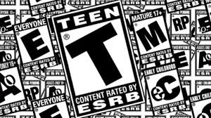
Censorship is when someone puts censors over it or have some age restrictions on that piece of media. This is so that people know when to buy something as it predicts what the game content could be about. People that place games and watch films that are censored are all going to be aware of why they are rated the age they are and this is an important guideline. Some parents will allow their children to play games such as grand theft auto at 12 and that choice is theirs. However, some will stick to the guidelines, or close to them. For me personally I was not allowed to play games like grand theft auto until I was 16, even though that this game is an 18. That choice was my parents, I think it is a perfectly acceptable decision, seeming, as this decision is a game that I cannot get involved in to much. To add censoring games is important, some stick to the ratings where as some do not, and that is expected. I do not believe there is any way of changing that. For people aged 16- 18 there is a big controversy as if we can buy the games themselves as they are starting to earn trust and they are starting to grow up, plus these are the days that they will have time to play games as they will go on to do different things. Some parents still believe their 17-year-old children should be protected from certain things and that the best way to do it is to censor the material in the first place.
Here are a couple of researched censorship debates:
For Censorship 1:
Censorship is a good thing, it keeps children from hearing and seeing inappropriate things. I for one like the censorship because children do not need to hear a slur of cuss words, or see body parts of others. I also do not want to hear or see it either, so I appreciate it.
For censorship 2:
The purpose of censorship is good. It is there to help protect people and keep them safe from things that are bad. If used correctly censorship is very good. However if you use it the wrong way or excessively then you are only going to be doing harm to society as a whole.
Not for Censorship 1:

It should not be the government's choice, Censorship is not always bad, such as blocking cuss words or sex scenes. When censorship extends to, entire books, movies, and TV shows, is when it should be stopped. The government does not have the right to decide what is acceptable for people to see and hear, even kids.

Not for censorship 2:
Censorship is really a violation of free speech. I can understand censorship in some places, like on local TV channels, but I don't think it should go any further than that. I don't think books or music should be censored at all. If a person doesn't like what is said, then don't read the book or listen to the music.
With the game that I would create there are obviously are going to have a lot of problems with censorship as every game will have their concerns but it’s just something that we just have to deal with. Everyone will have their concerns and want to express their own views about the game, but I will have a censorship, as it is part of the law. If I could avoid it though, I would have the game made for people aged 15 upwards as this seems to be the right age to do so.

