Unit 65 Assignment 1 theory – Web Animation

Uses of web animation
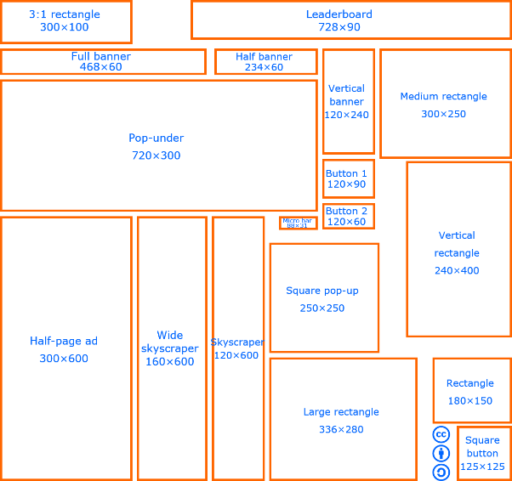
Banner ads
Banner ads are the extremely annoying adverts that are on lots of websites. They will usually appear across the top of the page on the internet. These advertisements will use either cookies or some pop-up ad features. Banners can be any orientation like horizontal or vertical, some sites even have a section where they are bound to and they are set to a certain size. If you don’t like the banners, then you can add some web banner blockers on the web browser extensions. Animated web banner. Button is present but if you click anywhere the ad will re-direct you to that page.

Animated interface elements
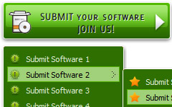
Animated interface elements are on websites and they will provide the user with some more other user feedback. These can be either rollover adverts, that will change colour when you hover over it. Or interactive buttons which also change when the cursor is over it and it has been changed to another page. In terms of animation there is a lot of software available which allows a user to create an animation by drawing a shape and manipulating it using tools such as Adobe Flash or Photoshop. However, there are few programmes available which allow a user to manipulate a pre-existing object using HTML inputs to animate.
Linear and interactive animations
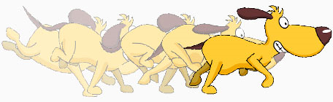
When the animation can be interactive it will need some type of purpose, this type of animation will usually have the exact information that is needed by users and are often suited to their needs. These are then done by using some links, this is done by embedding in the data within the animations. Interactive animation is applied to any game based media. The player interacts with the on screen character through the use of a control pad/screen. It is classes and interactive animation because as the player is inputting controls the on screen character will be moving, for example if the player presses either left or right, the character sprite will move accordingly. An example of this is the game boy on the right, when the player presses right and the A button the character runs across the screen and jumps.

Promotion
A web banner or a web animation will most likely to be promoting something. There are a lot of web banners out online that will do this, mostly for a new product in their range. This will have images or assets of that product, if not you will just be selling a different product and this doesn’t look good on your sites reputation. An advert is the best way to promote something, when there is a gimmick in the video even if it is of no relation. You can use the voices of famous people to make the video get more views. A game advert called mobile strike, has the voice of Arnold Schwarzenegger is in it.
Instruction
Web Animations will have instructions these will be very different to normal instructions from a book, they won’t show a step by step but these instructions tell you the things that you need to know. Web Instructions are usually small sentences which will say things such as ‘click here’, ‘Sign-up’ and ‘view’ these will normally be hyperlinks which will re-direct the user once clicked on. This will either open up a new window or it will activate a pop-up. They will be short and snappy to get the point across quickly.
Information
Web animation can be used for information, they can be informative and use various pieces of data and statistics. Most of web animations are used as their purpose to inform customers or users about a new product that has been up for sale, this may offer and inform people about a new promotion.
Entertainment
Web banners or web animation needs to contain some kind of entertainment otherwise people will get incredibly bored and very quickly. They need to drag your attention and to do this they entertain you into focusing your eyes on the animation or a banner. There can be many different ways to entertain people through these. Like including some sound, or a film clip. Entertainment adverts are quite popular on YouTube, they were originally played on a window on the right of a video page, but they are now played before you can watch a video, you can skip the ads that popup after about five seconds.
History of animation
Hand drawn (cell)
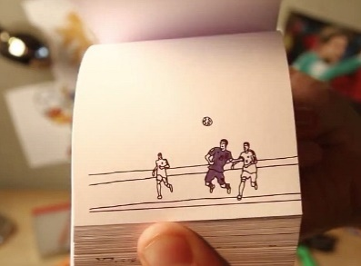
Traditional animation (hand-drawn animation) is an animation technique where each frame is drawn by hand. The technique was the dominant form of animation in cinema until the advent of computer animation. The person who creates the animation will take months of hard work and labor just to create one scene at a time. They will then make the animation over a few weeks maybe months depending on what it is. Then the person will then take the animation through a camera. Then they will get some criticism or what they need to change, they will then take some more pictures of it. Eventually you will have an animation that lasts about 5 to 10 minutes for about 6 weeks’ worth of work.
Flick books
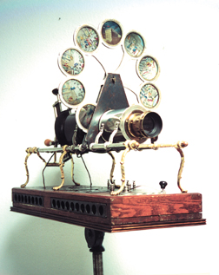
A flip book (flick book) is a book with a lot of pictures that gradually change from one page to the next, so when the pages are turned rapidly, the pictures appear to move and with some other changes. A Flick book can be on a book in any corner on the same side of page, these pictures can be in different colours. These flick books can be anything that you can think of.
Animated cartoon
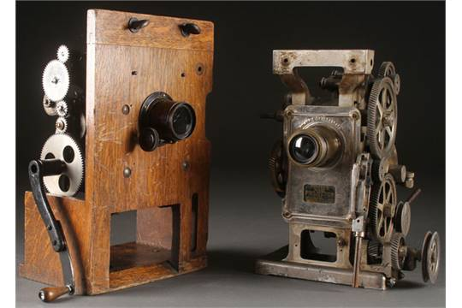
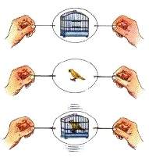
The first type of animated cartoon was in 1640 and it was called ‘The Magic Lantern’. This was made by using different layers of glass, in the end you would get some movement. In the 1826 Mr Ayrton created “The Taumatrope”. This consisted of having one side as a bird and the other a cage. Then he attached a stick to the bottom, he then twisted the stick at high speed. With this movement it made the bird seem as if it was in the cage, when they were on the opposite sides of the paper. Then in 1867 a man called George Horner created the “The Zoetrope”, This was a device that projected images that when turned inside a drum it would create some animated movement, this is seen through one of the slits in the drum. This is like the Taumatrope, but inside a drum/ box. In 1891 some people invented “The Kinetoscope”, this was a machine that had an input of reals then they produced the animated cartoons. This was the first type of projector and from this there have been animated cartoons since, they have developed since then.
Animation process
The animation process takes a very long time and to create a whole movie it takes them about 4 to 5 years to complete. The company will first think of a story idea. Once this has happened they will then start looking at making text and then a script. Then they make a basic storyboard outlining a lot of the story and developing the emotional features of the characters. They will then create a lot of temporary “scratch voices” these are basic sounds and words that the actor will change throughout. They then create some basic reels with colour to see what they are looking for. After this they start the hard work, which is the basic 3D version of the characters, this makes the characters come to life. Meanwhile another group will be creating all the different sets for the animation. They will then combine these two to create the different shots. And they can then start to animate it. once they have animated it, they will shade and light it so it looks good on the finished product. They will then render the move and they will add the voices, music and the final touches.
https://www.youtube.com/watch?v=Z_V752_-8F0
Graphic Information File Format (GIF)
Graphics information format (GIF), was introduced by CompuServe in 1987. File format was the ideal for performing image transfers. The format also allowed for colour, replacing the black-and-white run-length encoding format. There is a website for just GIF’s this is called giphy.com, you can spend hours looking at the different gifs
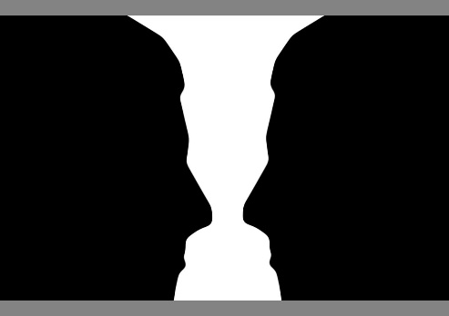
Animation
Optical illusions of motion (persistence of vision)
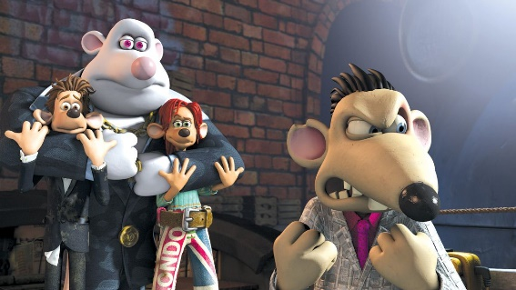
Optical illusion is also known as Persistence vision, this is a theory which that involves the human eye and you can see an illusion after a you have looked at it. This is when the eye has an ability to persist for a 1/16 of a second after the image has been removed. For every 24 frames which is about a second the optical effect will feel like you have seen 12 pictures in that one section. Then this gives the effect of the illusion and you can still see the after image. In terms of animation this is very important and have been used for the Praxinoscope, Zoetrope and Taumatrope. The image to the right is an optical effect, this is because at times you will see the black coloured people and at other times you will see a vase/glass in white. By presenting a sequence of still images in quick enough, the viewer will see them as a continuous moving image.
Claymation
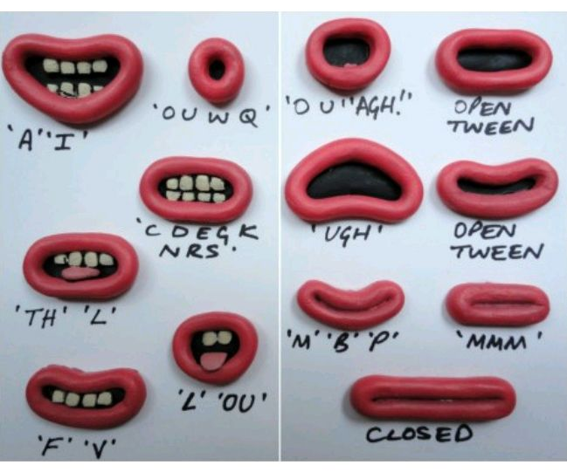
Claymation is the animation clay, they will start by making storyboards digitalized, then they will make a digitalized version of the overall scene made in different drawings. Meanwhile the actors have created all the sound in a sound studio so they are ready for the end result. When they have done designing they use casts so they can put a metal body inside so they can get the correct movement, they then and the different layers of paint for the colours. They make lots of puppets and their faces for the change all the time. For parts like arms and legs they make the final version out of silicon so they can get the movement correct. They make all these parts ready for the shootings. The animator will use a rig so the characters can bounce, jump and skip easier. When shooting the cameraman will use the camera in different positions each time. When there are new scenes the set dressers will change them so they can be changed. Finally, the editor will remove the rigging or anything else. Then the last thing they do is publish it and then show it to the audience at home.
https://www.youtube.com/watch?v=irOecGxh36g
Stop Motion
Stop motion animation (stop frame animation) is an animation that is captured one frame at time, with objects moving between the frames. When you play back the sequence of images rapidly, it creates the illusion of movement and this makes everything seem like normal but with non-real characters. It is a bit like the early age of Disney and like the way they did the 2D animations. Stop motion is nearly the same, but they use physical objects instead of 2D drawings. The basic process of animation involves taking a photo of your objects or characters, moving them slightly, and taking another photograph. When you play back the images at the same time but made a bit faster, the objects or characters appear to move on their own at an average speed.

Computer generation
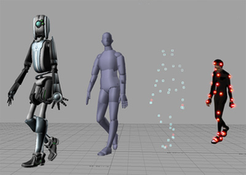
Computer animation, or CGI animation, is a process used for generating animated images. This type can create both static scenes and dynamic images. Modern computer animation usually uses 3D computer graphics, although 2D computer graphics are still used for storyboards and the animation logs. Computer animation is essentially a digital successor to the stop motion techniques used in traditional animation with 3D models and frame-by-frame animation of 2D illustrations. Computer animations are made in some specialist software’s that will help you create the animation. The software allows the creator to use motion capture to get the human like features of actions.
Frame rates
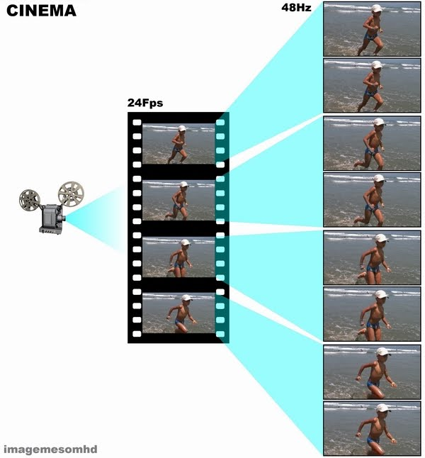
Frame rates are the amount of frames in a second, in animation they are about 24 frames per second. But if the animation was set up with a low frame rate then the movement would appear to be faster when projected, you need to get the right amount of frames per second so it runs smoothly. Most cartoons are often shown as a drawing per two frames, this means that you will be producing 12 images in every second. In European films they are 25 frames per second instead of 24 which is the rest of the world. When you see a sports program they are set out to be 300 frames per seconds, this is so they can get the slow motion replays.
Frames
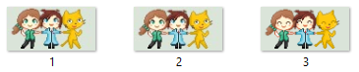
A frame in an animation refers to the image played per second. Each time the puppet is manipulated a photograph is taken they will move it around before and after to get it to look like it should. There are hundreds of photos which will be taken in order to get a flowing sequence of images which make up a different scene, these photos will be uploaded to a computer and then they will be played in a consecutive order to create the animation, they will edit it and remove bits that they want. Each individual photo once assembled on a timeline is called an animation frame. If the person shoots the image or messes it up they will have to do that whole scene again from the beginning, so they need to be very careful.
Key frames
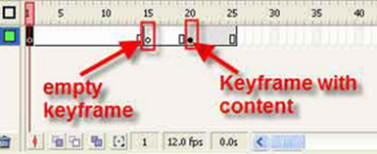
Key frames are what contains the image frame. In a timeline for an animation sequence are many key frames, these key frames are like small inserts to which a user can place a frame. They can either be blank or non-blank key frames. Key frames can be used to edit the footage or they can produce a flowing consistency throughout, they can be used to extend a frame and in doing so slow down the animation they can edited it in slow motion, or they can be reduced in order to increase the speed of the animation this can be useful if you want to make the character or asset run or fly faster.
Onion skinning
This is a graphics term which will apply to 2D animated cartoons, and is a way of editing stop motion movies to allow editors to view several frames at once. Originally hand-drawn animations were drawn on onionskin-paper over a light tablet, this paper was a bit see through when it was viewed normally you couldn’t make the image out but it became like tracing paper when pressed against a source of light, usually a light box. This is still a technique used digitally, like layers in Photoshop the previous frames will decrease in opacity if they wished. This method is used then the animation looks to be not right or jumpy the issue is fixed after it is used.
Tweening
Tweening is a process which is used in order to generate a frame between two images in order to create a smoother animation transition between to two frames, this will be done when in the editing process, this can make the animation run smoothly without any or many problems. Tweening an animation becomes easier and more difficult depending on the age of the software in question. More modern animation software make tweening transitions easier to apply through tools, but older programmes are more manual and as a result time consuming. This all depends on the computer specs and if it can handle the newer versions.

Digital animation
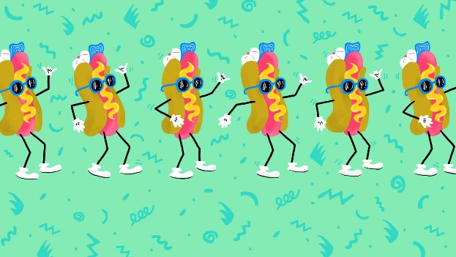
Vector animation
In computer generated graphics which appear in Cell-animation (hand drawn). A raster image is a data structure that has a lot of pixels in a grid. Raster images are shown by the bits of an image displayed on a screen, like when you store an images as the videos memory. A bitmap is normally shown by the width and height of the image in pixels and by the number of bits of the image in per pixel. Most images on a computer screen are raster images. a 640 x 480 image requires information to be stored for 307,200 pixels, while a 3072 x 2048 image needs to store information for 6,291,456 pixels.
Raster animation
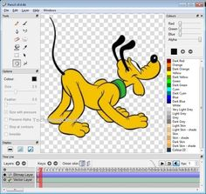
Vector animations are smooth due to the use of geometrical primitives; points, lines, curves, shapes, and polygons, these are all based on mathematical expressions representing images/animation in computer designs. Vector animations are based on vectors rather than pixels and are led by points (or paths). Each of these points has a position on the x and y axes. Each point, as well, is a variety of database, includes the location of the point in the work space and the direction of the vector. Each track can be assigned a colour, a shape, a thickness and also a fill. Unlike GIFs, JPEGs, and BMP images, vector animations are not made up of a grid of pixels. Instead, vector images are comprised of paths which were made using anchor points, these results in smooth crisp outlines. Rasterised are commonly used to create pixel animations and sprites which make it look pixelated.

Compression – file size
Lossy file compression results in lost data and quality from the original version. Lossy compression is associated with image files, such as JPEGs, but can also be used for audio files, like MP3s. The "lossyness" of an image files shows up as jagged edges or pixelated areas. Because lossy compression removes data from the original file, the resulting file often takes up much less disk space than the original. For example, a JPEG image may reduce an image's file size by more than 80%, with little noticeable effect.
Compression – download speeds
The download speed of an item is highly based on the computers capability, internet connection, and web browser. If a person plans on creating a file for downloading one of the things they should bear in mind is the download speed. A computer with a smaller processor will struggle with files, this may need upgrading. The computer is an essential part in the download of assets or videos.
Scalability
Scalability is when you make a file smaller, this can be effected by whether the image or animation is a Raster file or a Bitmap file. Raster images can be scaled down or expanded, however if done so the effect makes the smoothness, sharpness, and overall quality of the graphic will end up being pixelating and blurred, therefore rendering a graphic is useless for the web. Bitmap images however are based by maths in size rather than the pixels. This results in enabling a Bitmap graphic/animation being capable of re-sizing without any problems. This can be good for logos as you can resize them on the multimedia product.

File formats – .Fla
FLA formats are the formats of work created in Flash. The convention is to add the .FLA file extension to such a file. By saving an animation in a flash format the animation had editing enabled, it is also playable from documents, if it were to be saved under a different file format for example JPEG, the animation would become an image based of its first frame, once this has been done the whole animation is lost and cannot be edited.
File formats –. Swf
A SWF is a file format which is used alongside Flash files. It is currently the most dominant file format for viewing online vector animations and vector video files on the internet as well as action script games.

Web animation software
Authoring: Flash, Director
Adobe Flash is a multimedia product which enables the user to create animations, games, vector graphics, and rich internet applications. Flash is often used to serve streaming Medias, such as online advertising. Recently Flash usage has been declining online. Due to the quick and easy interface you can use the tools and the scripts, timelines that are used without any problems.
Director is used to create an animated interactive multimedia product; an easy example would be a DVD menu. Director uses a script language names which is what makes it a good choice for creating CD-ROMS. The programme also reads HTML code. Lingo works with the 2D image manipulation tools in Director. Intermediate users can utilise Director in order to create games and high quality products.

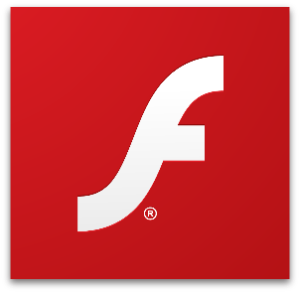
Players: Flash Players, QuickTime
Adobe Flash Player is a free piece of software that was created on the Adobe Flash platform, this was made for viewing multimedia, using Internet applications, and streaming video and audio. Flash Players can run from a web browser as a browser plug-in or on supported mobile devices. Flash Player was created by Macromedia but was bought by adobe and then changed and updated it. Macromedia published and released it in 1996. Flash Player has been developed for games, animations, and web pages. Adobe has made sure that their new software stays up to date with everything new. Flash Player can be downloaded for free and its plug-in version is available for every major web browser.
QuickTime is a framework developed by Apple, capable of handling various formats of digital video, picture, sound, panoramic images, and with lots of interactive features. QuickTime is available for Windows Vista and upwards, as well as Mac OS X Leopard and upwards. QuickTime X, is currently available on Mac OS X Snow Leopard and is newer features. It is a multimedia container file that contains one or more tracks, each of which stores a particular type of data. Each track either contains a digitally encoded media stream or a data reference to the media stream located in another file. The separation of the track means that QuickTime is particularly suited for editing, as it is capable of importing and editing in place.

