Unit 2- Assignment 1, LOG
I started the lesson by creating this word document and then selecting the correct folder to save it in.
I then went on google and searched for www.pixnlovepublishing.com
From this I got this page on the right.

I then went into the left hand navigation bar and clicked on “The history of Nintendo vol 2”. Then the next page came up like this.

From this I clicked on the preview section.

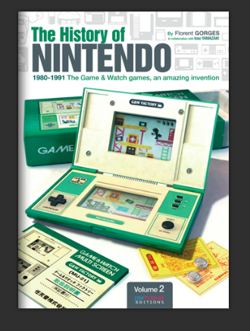
This is the cover for the E-Book:

Chapters
I then went to the chapter’s page to get this information,
There are 4 chapters, the first one is going to be talking about the history of the games this will also talk about a person called Gunpei Yoko, this starts on page 16 through to page 47. The second chapter will be talking about what you need to know about the world of LCD games, this is pages 48 to 141 pages. The third chapter is going to talk about how games are rare and how they can become rare, this is going to talk about some collections and this will also tell you about where to get them, this pages 142 to 181. The final chapter is going to be talking about when they stopped in 1991 they can be found along with the characters, and how you can still find them in the most recent films today, this is pages 182 onwards.

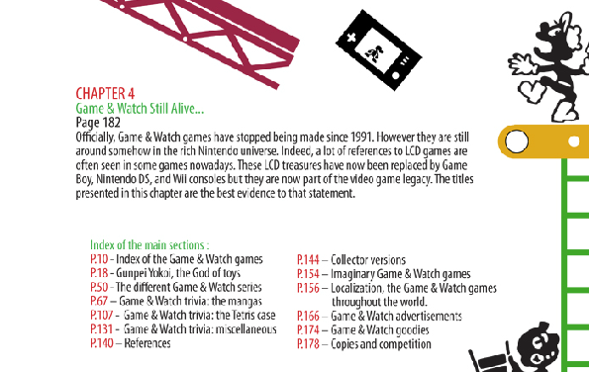
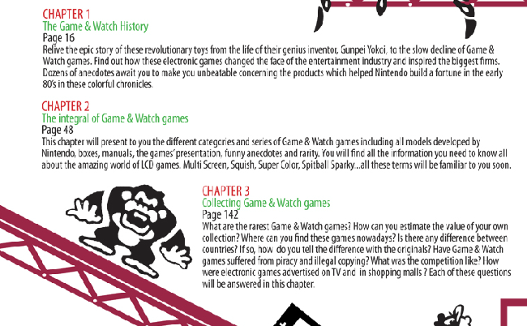

Name of the developer:
The name of the developer is called Gunpei Yokoi. He is also referred “to the god of toys”

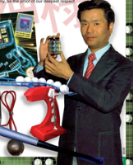
The details of his career:

Gunpei Yokoi, started his career by going to some of the interviews, after failing a lot they decided to take him on he started by working in the technical maintenance, this was fixing bits and bobs, he then in his spare time creating things from spare bits, then one day the C.E.O came in and saw him doing the crafting and immediately wanted him in the office and with the gadget, the C.E.O talked to him about the gadget he had created and used it to sell 1.2 million of them. From this the C.E.O thought about his status in the company and then became well known in the company. He is now known for selling lots of different products and then he is now known as “The God of Toys”.

Donkey Kong Overview:

The overview of Donkey Kong is that you are trying to save Mario’s fiancé by dodging barrels that are thrown from DK and they will work their way to the top of the ladder. They will unlock different levels to get to save the bride to be. They took this concept of the arcade game and then eventually added it to the Nintendo DS and this is still considered to be the best game by a lot.

Additional material:
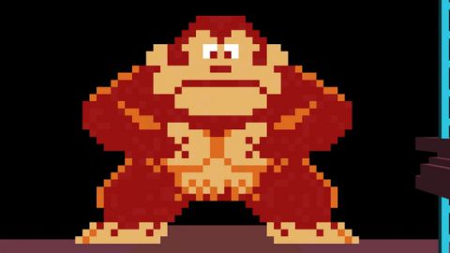
History of Donkey Kong.
In 1981, Nintendo had barely gone into the Japanese gaming market, but was ready to beat America’s. The publisher repurposed some unpopular arcades into a house, the game created by Shigeru Miyamoto who was overseen by the man that would eventually build the Game Boy, Gumpei Yokoi. This was based on a mainac throwing things around. Nintendo introduced the plot to the game, the silly but simple tale followed a carpenter's pet gorilla stealing the workman's girlfriend. Thus Donkey Kong was born, they then introduced Mario who was the work man.
The game became a massive hit around the world, getting millions of buyers. The game basically invented the platform (Game Boy), but back then arcade titles were inventing genres left and right. The real reason it's forever lodged in the minds of the players worldwide is the compelling narrative hook, memorable music, and colorful, cartoony graphics that have aged gracefully. But even though his name was on the marquee, it was Jumpman (soon to be renamed Mario) that became the real star, pushing DK into the background.
BIBLIOGRAPHY

http://www.pixnlovepublishing.com/The-History-Of-Nintendo-Vol.2.html
http://www.gamesradar.com/history-donkey-kong/

