Theory report
Opportunities
Creation of corporate identity
A corporate identity is the way in which a corporation, firm or business presents themselves to the public they will make use of its customers and investors as well as employees, to make them stand out from the others in the herd. The main task of the corporate communications department is to maintain and build the identity to accord with and facilitate business objectives. It is typically visually manifested by way of branding and the use of trademarks, logos, catch lines and a jingle.
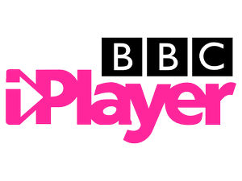
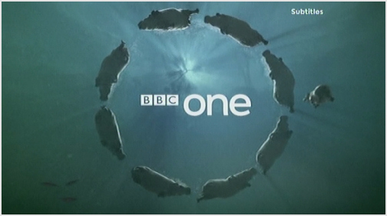
At the beginning there were only a couple of TV stations because there were only a few people who owned or could afford a TV. This resulted in the few existing channels being well known this is BBC 1 as the main one. Now there are thousands of TV channels with their own identities that lots of different people will now about and they have their own preferences. Channels which belong to other countries may also be viewed in the UK sometimes as an extra cost, but this is great for when the Olympics and Paralympics are on. As well as international TV viewing increasing that audience, certain channels have gone online or digital such as Channel 4 and BBC iplayer which allows a person to watch episodes of a series online. Lots of these channels are going to post more shows online as there will be more viewers and then their identity can be boosted. When the Tv started the channel idents were made to appear during times where no programme or advertisement slots were taken. But the new modern idents have characters/actors from programmes on the channel are also included. This makes the new channels more appealing and this is what is a good thing.
Branding of content
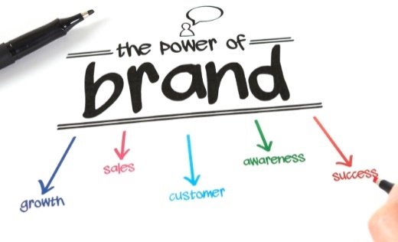
Branded content is a form of advertising that uses the new way of generating content as a way to promote the particular brand which funds the content's production and this is a very clever idea of how to do this. It is often utilized in native marketing, and somewhat similar in appearance to content marketing. Branded content is typically presented by itself as something other than a marketing ploy first. Branded property has been often labeled as being "sponsored." An ident is also used to present a programmes style that would be suitable for the audience and how it fits in with the channels brand. An ident helps to endorse the brand of a particular channel by allowing the audience to become familiar with the logo and also the style of the channel. This is also important as it encourages the audience to stick with them and to stay familiar and loyal to that particular channel, this means that if they want to change something to do with the brand and whether this is to do with the logo they need to do it in a specialist way so it doesn’t break the people’s views and ideas of the channel. Lots of channels that have been around for some time are now re- branding its channel so they can fit in with the new interests of the demographics.
Appeal to target audience
An ident needs to appeal to its intended audience because that is who they were made for, and they want the channels and shows to suite their audience and for it not to put them off. The main purpose of a Tv ident is to establish a company and aim to portray a company via on-screen graphics such as idents, logos and snappy catch-line. If this is not done well or if the audience is unable to understand it then the ident is destroying their chances of creating brand loyalty and are then unable to uphold the audience and views will fall rapidly. It is vital and necessary that the designers will design idents with careful consideration of the following; speed, colour, space, purpose and tone. Without this being good then the viewers and the channel will fall and then others will rise above. So the attention to detail will result in a successful ident that will attract the audience and this also represents the brand identity. The target audience is a specialist thing as you need to get the right amount of difference between yours and another one, this means that you have your own amount of audience than another ident and channel, you can target the audience that you want so that the best amount of views is going to be coming your way.
Encouragement of brand loyalty
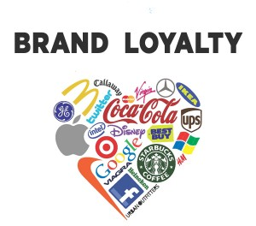
“Brand loyalty is defined as positive feelings towards a brand and dedication to purchase the same product or service repeatedly now and in the future from the same brand, regardless of a competitor’s actions or changes in the environment. It can also be demonstrated with other behaviors such as positive word of mouth advocacy”- Wikipedia definition. This is what makes the audience keep on coming back to watch shows on your channel, you might need to fight off the prey and this means that the audience will stay with your brand and only your brand. If you are a frequent viewer you will know that at some point a certain angle will begin to reveal, this is what people will know if you have been following them for a long time and this is brand loyalty. To encourage this, they will place shows and characters that are famous and this means that it will attract more viewers and this is what they do. The designers will also keep updating and making their logo better to go with the brand loyalty and this will be good. Some channels will approach to viewers with interactivity, it captures the attention by using different characters from some shows on the channel together in different patterns and colours to make some logos. This encourages the viewers to want to focus on the patterns, searching for their favourite characters, or trying to see if they can recognise all of the characters who do appear, this is how they make the audience and viewer interested in the brand and this therefore encourages them.

Conclusion
So to conclude when thinking about and creating the Tv ident, you need to consider the creation of corporate identity, the branding of content, whether it appeals to the target audience, and then the encouragement of brand loyalty. These are all needed in a Tv Ident to make the audience and the viewer and the advertisers to choose that channel over other channels. A way that you can make this happen is through the use of competition as when the Tv started the channel idents were made to appear during times where no programme or advertisement slots were taken. But the new modern idents have characters/actors from programmes on the channel are also included. They want there’s to stand out from anyone else. An ident helps to endorse the brand of a particular channel by allowing the audience to become familiar with the logo and also the style of the channel. This is also important as it encourages the audience to stick with them and to stay familiar and loyal to that particular channel, this is to do with the use of the branding and this is helpful. One of the most important things to consider is the target audience and whether that you can use it and whether that can be achievable to connect with. So without these you can’t create a successful Tv Ident.
Creative Communication
Enhancing ideas
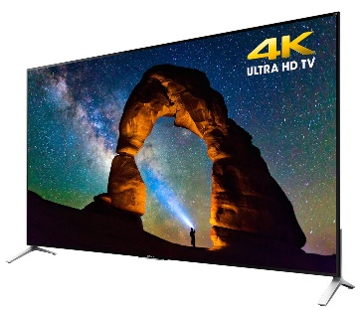
Once you have an idea or a design of a logo for example, you can’t keep on using the same logo throughout the idents life, so you will have to keep on updating it and then enhancing the ideas. The ident producer will only have between 10 and 20 seconds to get a point across and persuade the viewers to stay with the channel. Designers can use various elements such as specific colours, fonts, sounds, images, etc. This is to communicate to the audience and enhance the channels ideas and what it represents. For example, the BBC use a circle in every ident they produce, this is well known but then it doesn’t have the same animation on the outside and this is enhancing and improving as it goes on throughout. If a channel used impressive animation or CGI, or special effects, it would look attractive and make the viewer notice it more. This means that this would also gain more popularity for people who enjoy animation and special effects will be drawn to them as well as the fact that it shows the channel is up to date with technology. You would assume that their up to date ideas would carry through to their programs. Lambie Nairn created the floating puzzle ident for Channel 4. It uses our natural minds as humans to watch the pieces form the puzzle together and make the ‘4’. Once it is over, viewers will sit there thinking how clever and cool it was and by the time they’ve realized it, the ident is over and the program next up on the channel has already started, meaning that it is highly likely the viewer stays and watches it, they will then wait then for it to come around again. This ident is very clever in that respect and the initial idea of it has been enhanced through the use of technology.
Pushing the technology
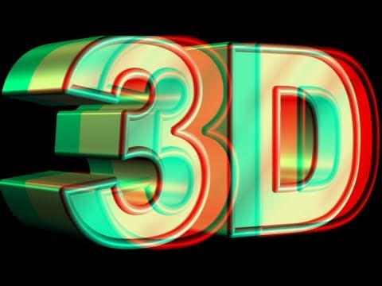
If the channel wants to communicate to its viewers then they are going to use more cutting edge effects than the other channels, and effective method is by pushing their available technology, this includes the use of CGI and special effect quality as well as believable footage, high quality animation, professionalism and high definition without it looking bad and horrible. A great way to communicate creatively is by pushing the technology to make and display an ident. This can be done by creating idents in a HD or 4k format making this as detailed as possible with the best resolution possible. You can also create an ident in a 3D format if it is presented on a 3D channel or on a 3D Tv. But both of these options will be costly and therefore need a high budget to make the experience and creation possible, then a lot of time and also access to the correct technology is needed to make this happen. The use of technology doesn’t have to be that; it can be done as an advert saying to download their new application or go to their website. A channel might also push the current technology to creatively communicate with their audience. for example, if there was a channel that just used simple filming to produce their ident, it wouldn’t stick in your head as much as a highly animated, special effects and CGI packed ident especially if the channels target audience is younger because younger people tend to look out for technology pushes more. This also shows that the channel is very up to date because they are on top of the new technology.
Creating under pressure of time and budget
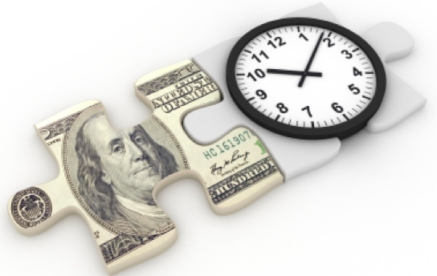
Creating any piece of work, weather it is a Tv ident or something to do with media, under the pressure of a deadline can be stressful. But this stress is eased when time management documents are set up in order to help manage the project, such as a diary, ILP, timeline and a Gantt Chart. These are all used to keep to the time scale and this is what a lot of people will use. This is a pressure of time on the production process. If designers lose track of time and don’t meet the deadline or rush any of the pre-production processes, it does not only affect them but the whole corporation. Time is money and if they don’t keep to schedule, money losses will result in designers having to pay for the time and money lost. A budget also pressurises designers because they are limited to how far they can go with the high quality resources (which are more expensive) or whether they only have enough money for low/middle quality resources. Bigger budgets are ideal because designers do not have to be cautious about using particular (better) resources. The amount of money put into an ident is usually clear but this does not mean it is a better ident. If it does not create a corporate identity, convey the organisations’ aims and mission, then it is unlikely to be successful in promoting the channel, making it a waste of time and money. The budget is one of the biggest problems that you could face in the process as if the work cost more than you has allowed then you’re going to have to make some cut backs and this can be bad, but before then you should make a budget report on how much things are going to cost.
Appealing to the target audience
An ident needs to appeal to its intended audience because that is who they were made for, and they want the channels and shows to suite their audience and for it not to put them off. The main purpose of a Tv ident is to establish a company and aim to portray a company via on-screen graphics such as idents, logos and snappy catch-line. If this is not done well or if the audience is unable to understand it then the ident is destroying their chances of creating brand loyalty and are then unable to uphold the audience and views will fall rapidly. It is vital and necessary that the designers will design idents with careful consideration of the following; speed, colour, space, purpose and tone. Without this being good then the viewers and the channel will fall and then others will rise above. So the attention to detail will result in a successful ident that will attract the audience and this also represents the brand identity. The target audience is a specialist thing as you need to get the right amount of difference between yours and another one, this means that you have your own amount of audience than another ident and channel, you can target the audience that you want so that the best amount of views is going to be coming your way.
Conclusion
Communication is one of the hardest of things in life and then you need to but to do this in a creative way is harder so that’s why you need help to enhance those small ideas from something small into a bigger idea this has to appeal to the audience as well as using the latest technology to the best kind of use. One other thing to take into consideration is the budget and how that budget can be incorporated into the time scale and how long you have to create it. Bigger budgets are ideal because designers do not have to be cautious about using particular (better) resources. The amount of money put into an ident is usually clear but this does not mean it is a better ident. A channel might also push the current technology to creatively communicate with their audience. for example, if there was a channel that just used simple filming to produce their ident, it wouldn’t stick in your head as much as a highly animated, special effects and CGI packed ident especially if the channels target audience is younger because younger people tend to look out for the technology push more. So in a way all these different departments and segments need to come together to form the ident in a way that is cost and time effective, it has expanded on the original idea and it suites the audiences viewing pleasure.

