Theory diary Unit 62 assignment 1

3/2/16 – Started ass1, I copied the ILP to my account, I then created this dairy, and I started my sources document. I need to do a checklist/ table on board.
I stared of by doing short films, I used Wikipedia and the shared example to get all the information.
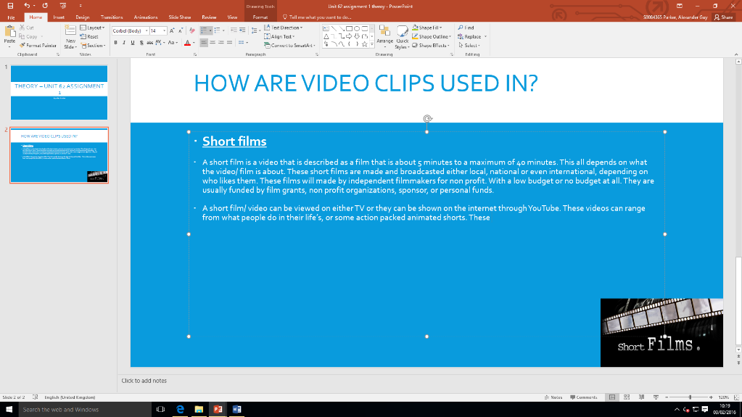
Learnt: Today I learnt that there are such things as a short film, I didn’t know a lot about a short film, I now know that people can create these and then upload them to YouTube.

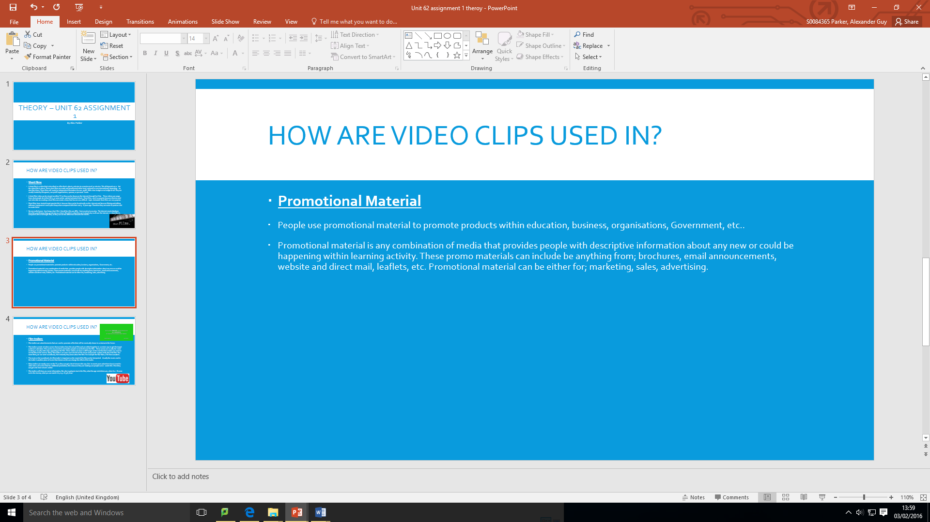

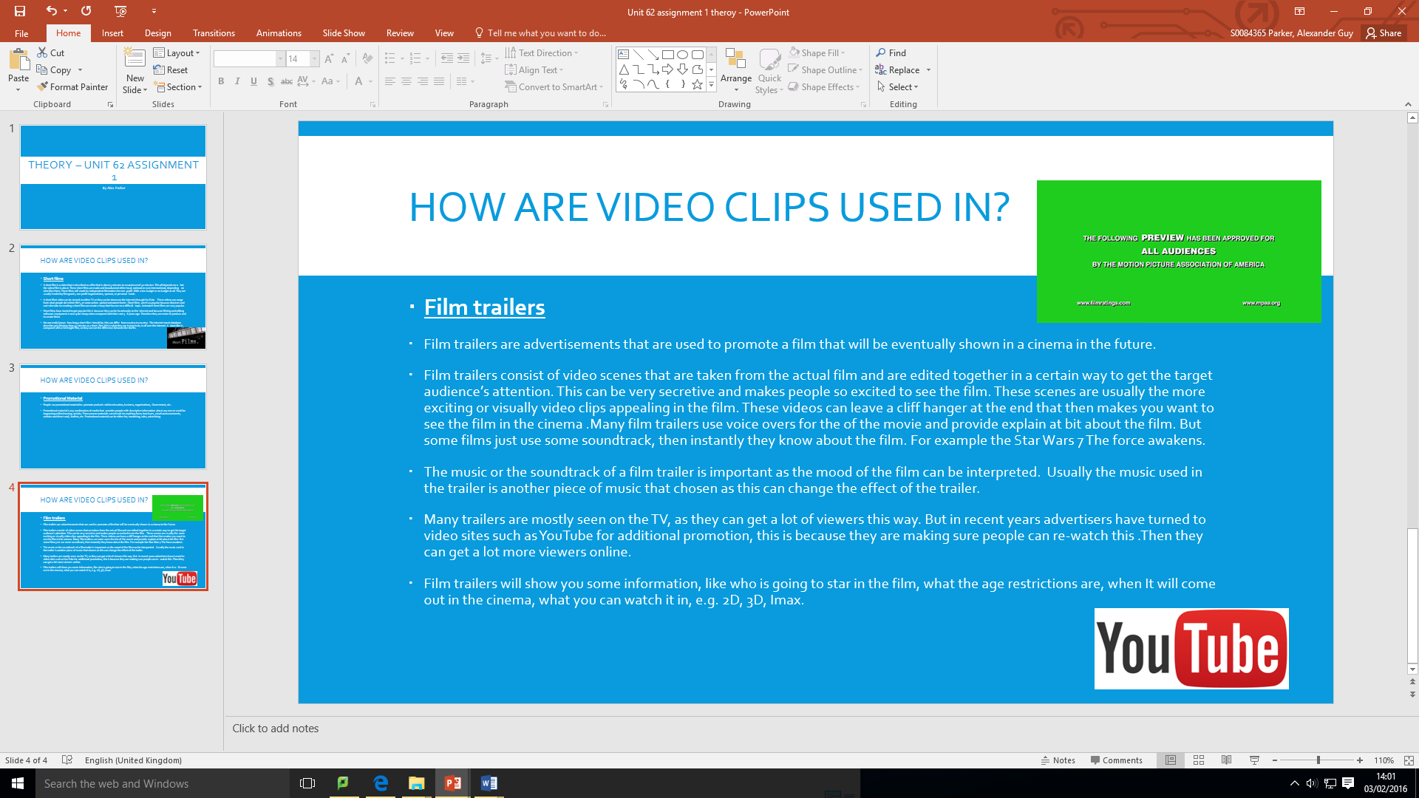
I did some extra work in another free lesson, I did a bit about promotional material, but I will add some more information in this later on. I then did some work about film trailers, I added some images which I included in my sources document.

3/2/16
I got through the technology 1 range up to FLV and then I did the technology 2.
Learnt- I need to do some extra work outside the lesson.
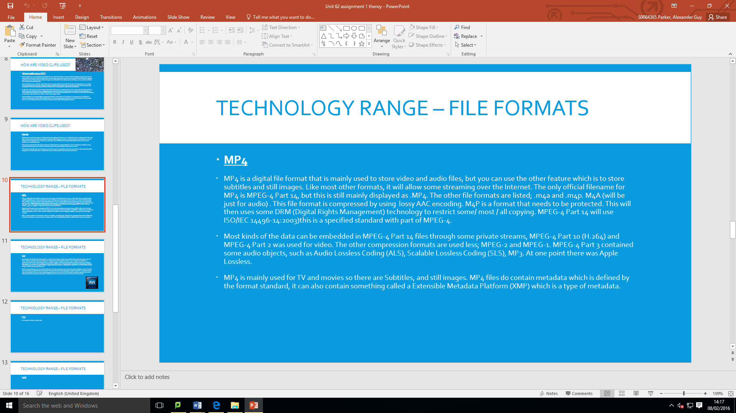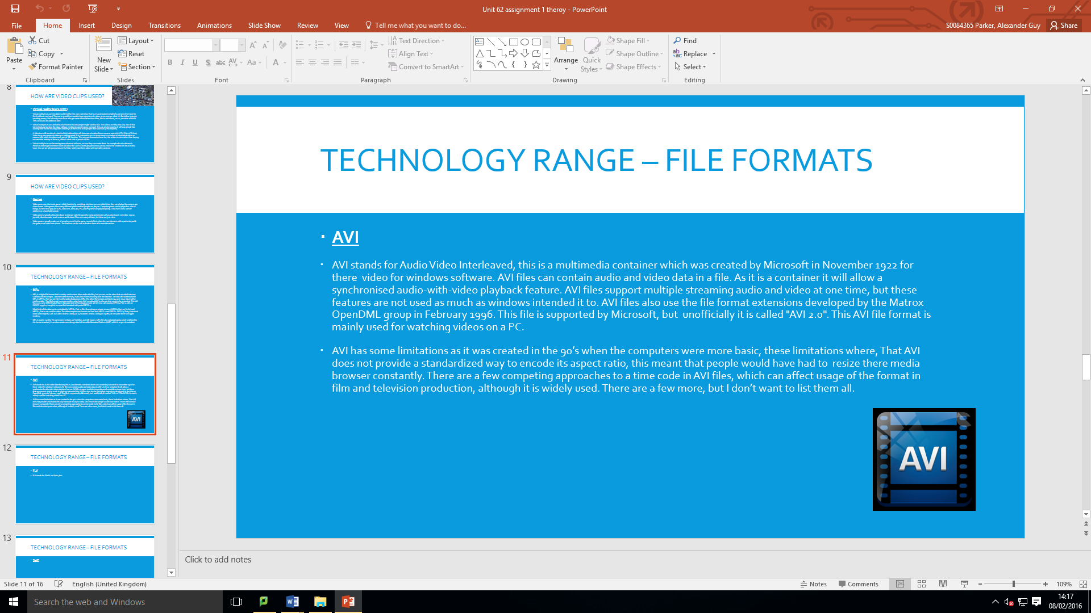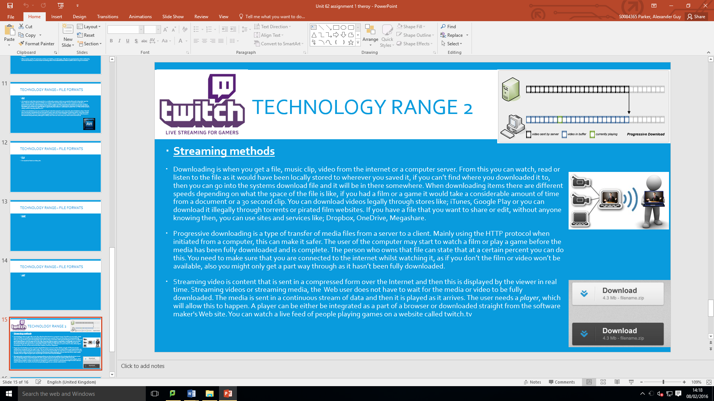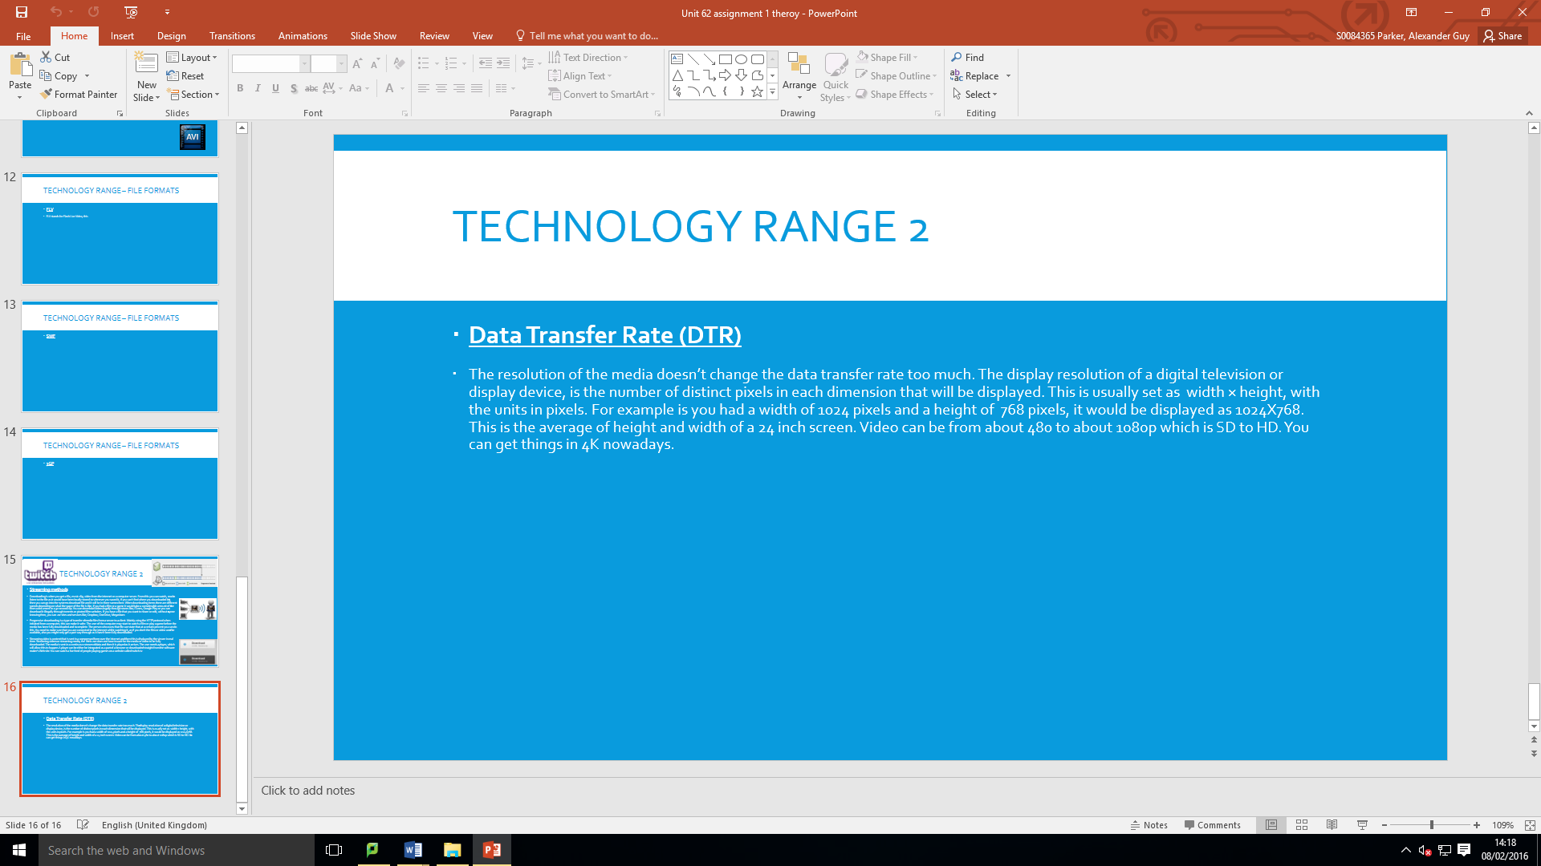
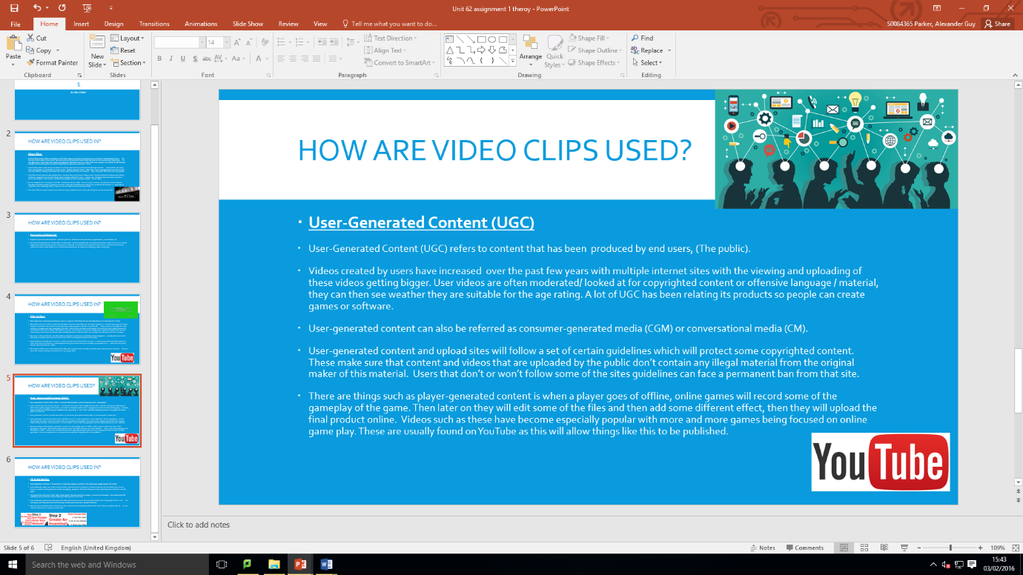
In this session I covered from film trailers to viral marketing. I used the shared example and some online information to create all of the content for the following slides. 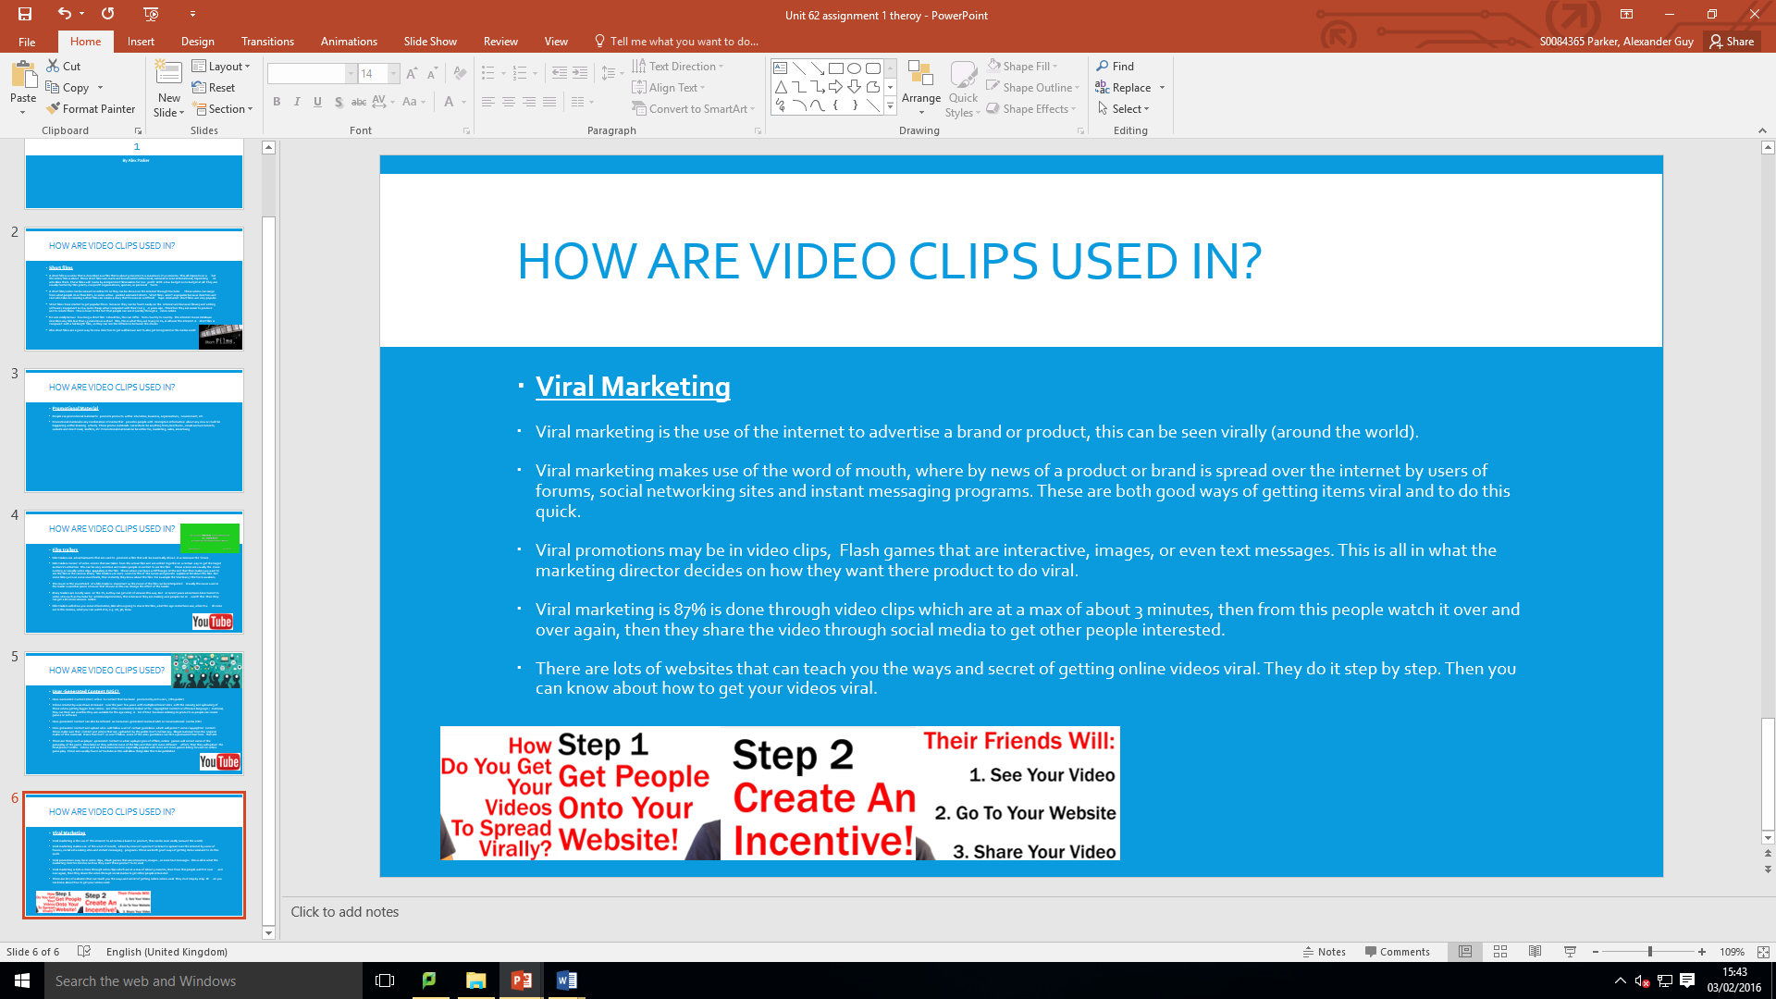
After these slides I went back over the promotional material, I added some more information and then I added a few images.
Learnt: I learnt how to make a viral video, this can be good for when I do other tasks as I can get their attention. I also found out what UGC is and what they do for things.

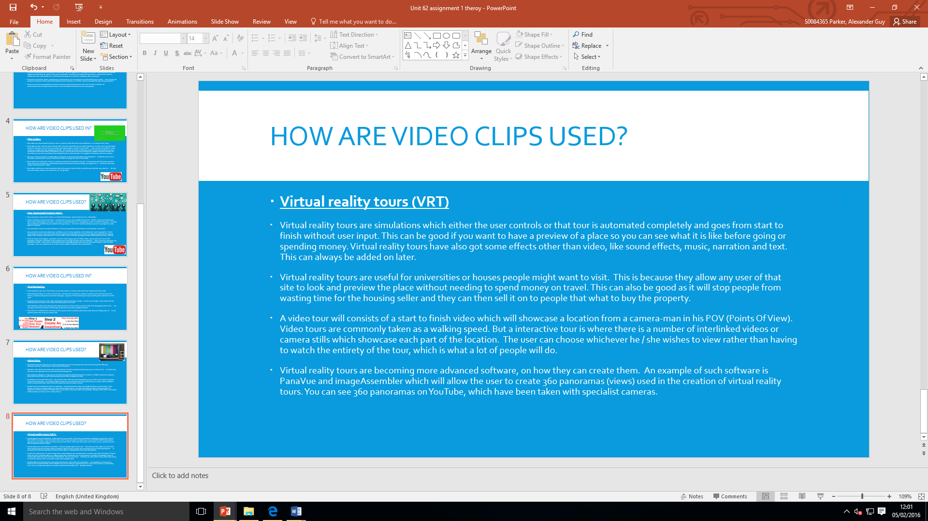
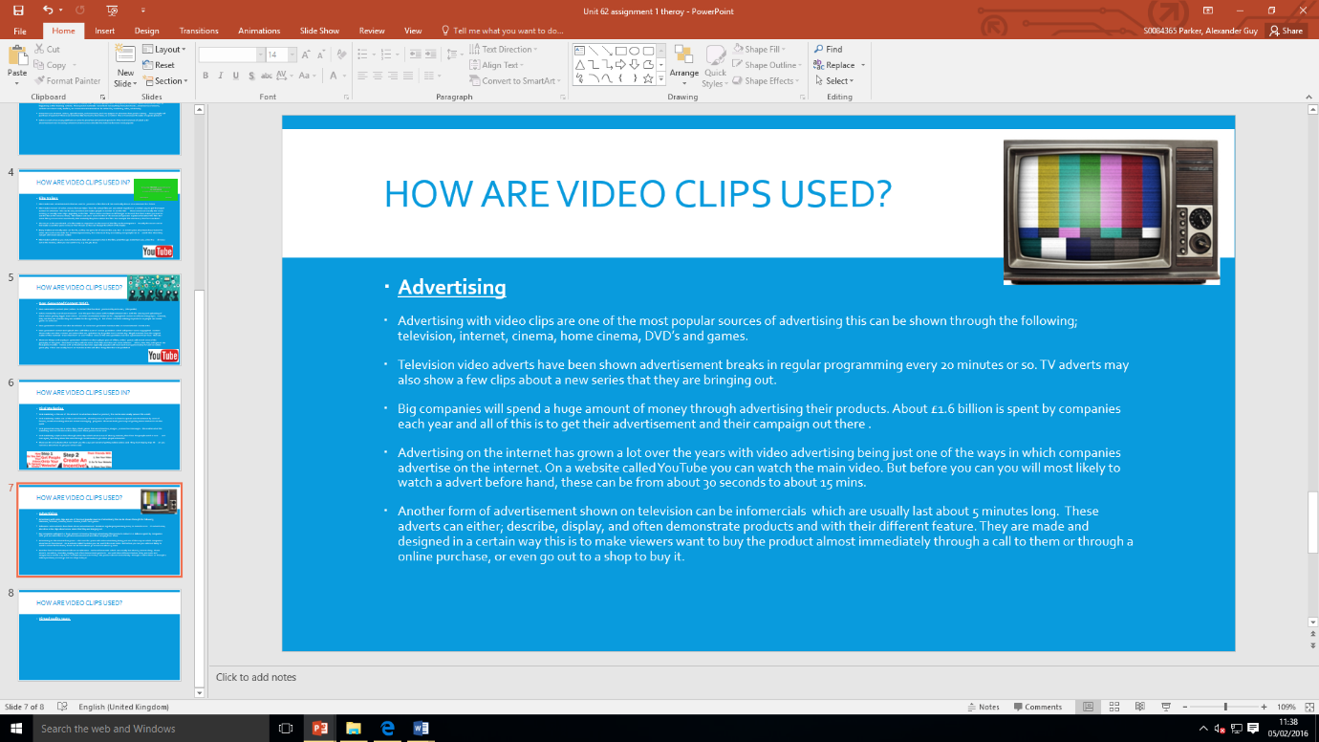
5/2/16 - In today’s lesson I did the advertising slide and I also added image of a TV, Then I went on to doing about virtual reality tours. I made sure that I had added an image to it.

Learnt: today I learnt about what a Virtual Reality Tour is and I will at some point do about how videos are used in games.

8/2/16 in today’s lesson I did the whole of the technology 1 and technology 2, this was because I had a double session. This included the digital file formats, streaming methods, data transfer rate. I didn’t get through all the file formats but I will do this as homework,
Learnt: I learnt that there are a lot of different streaming sites.
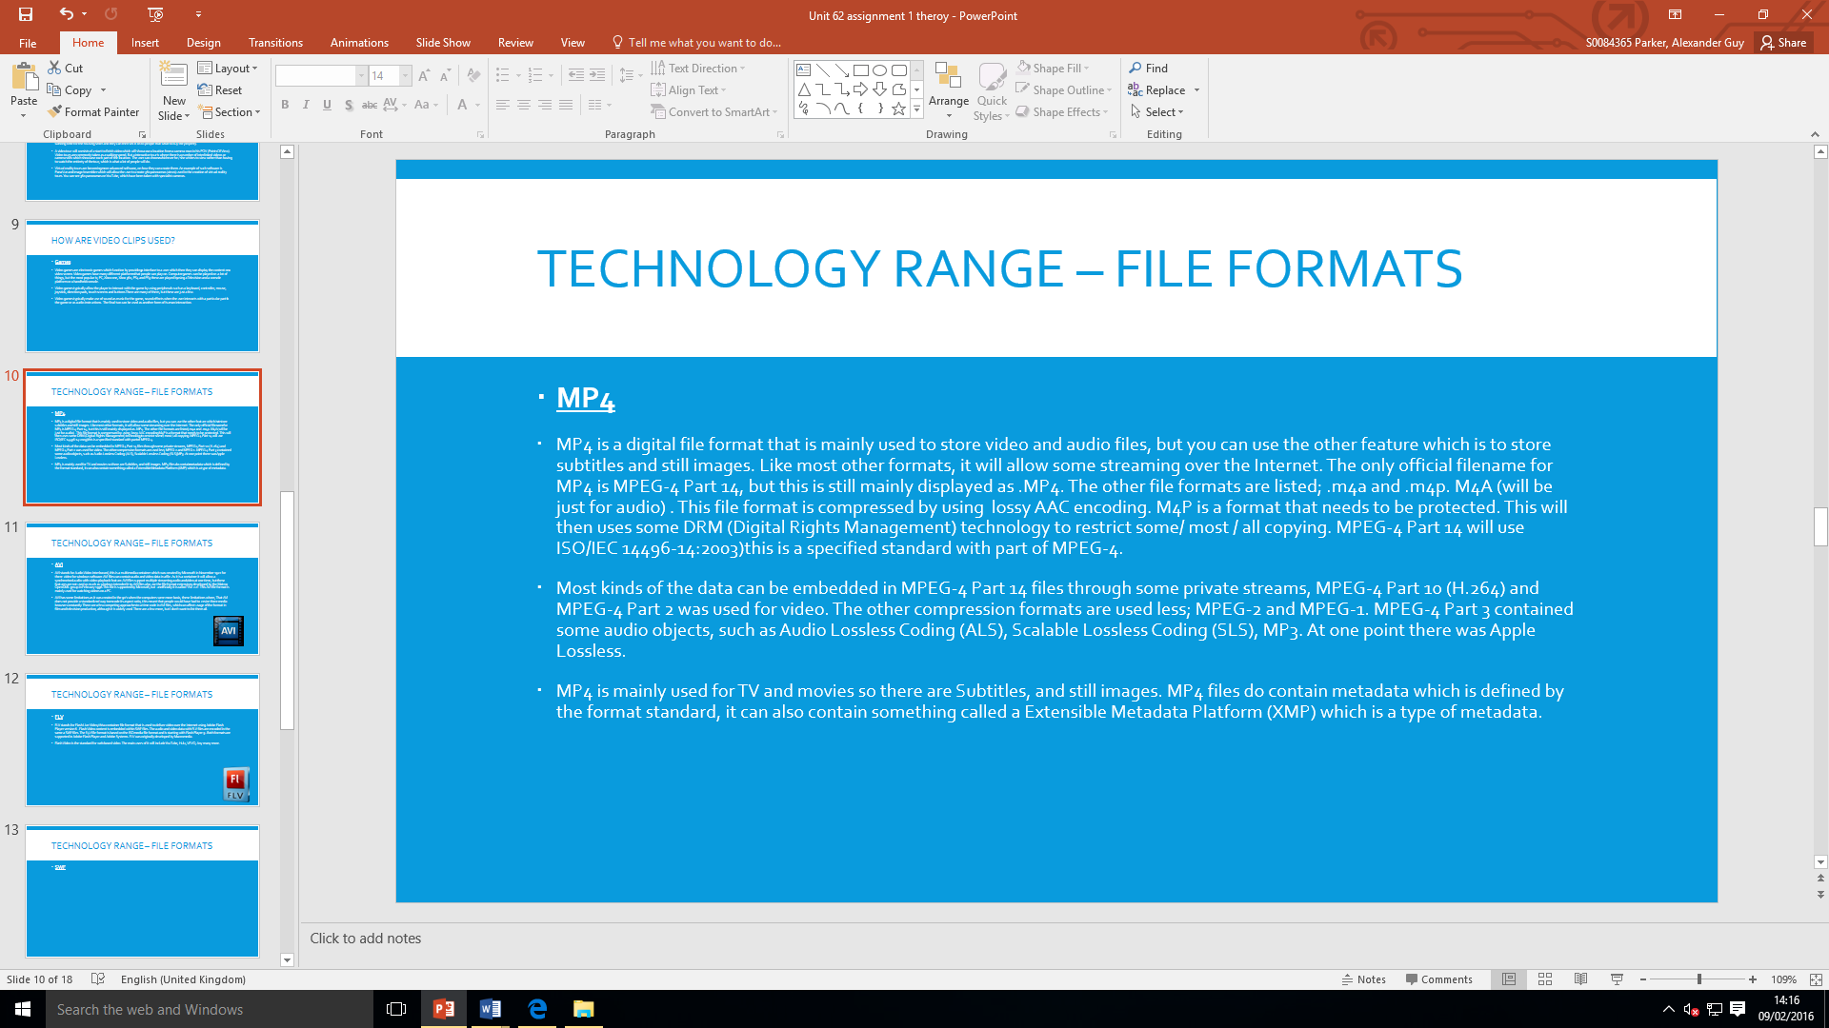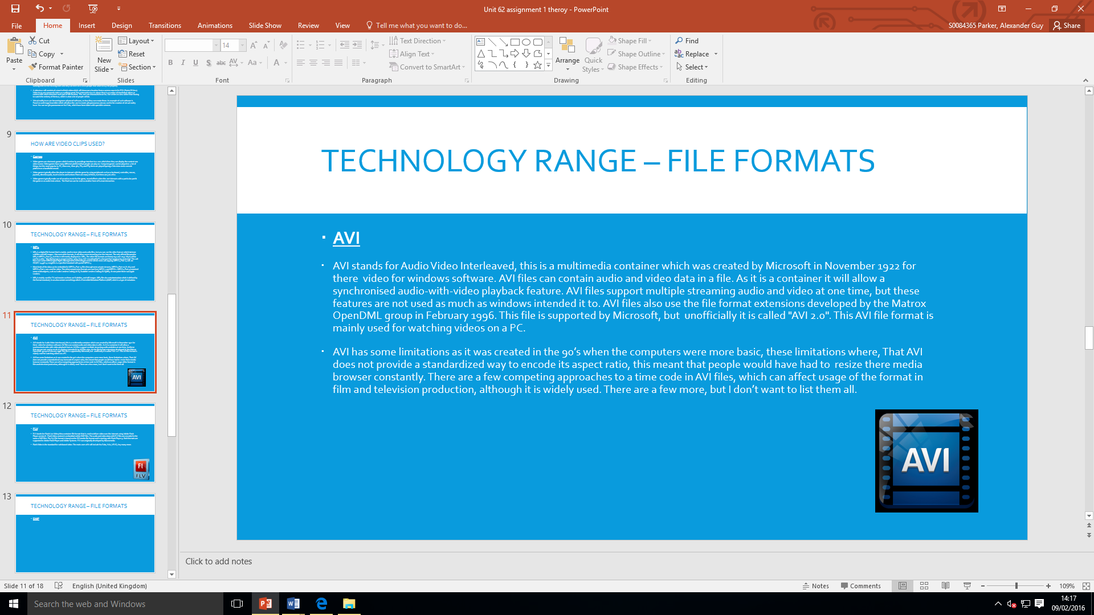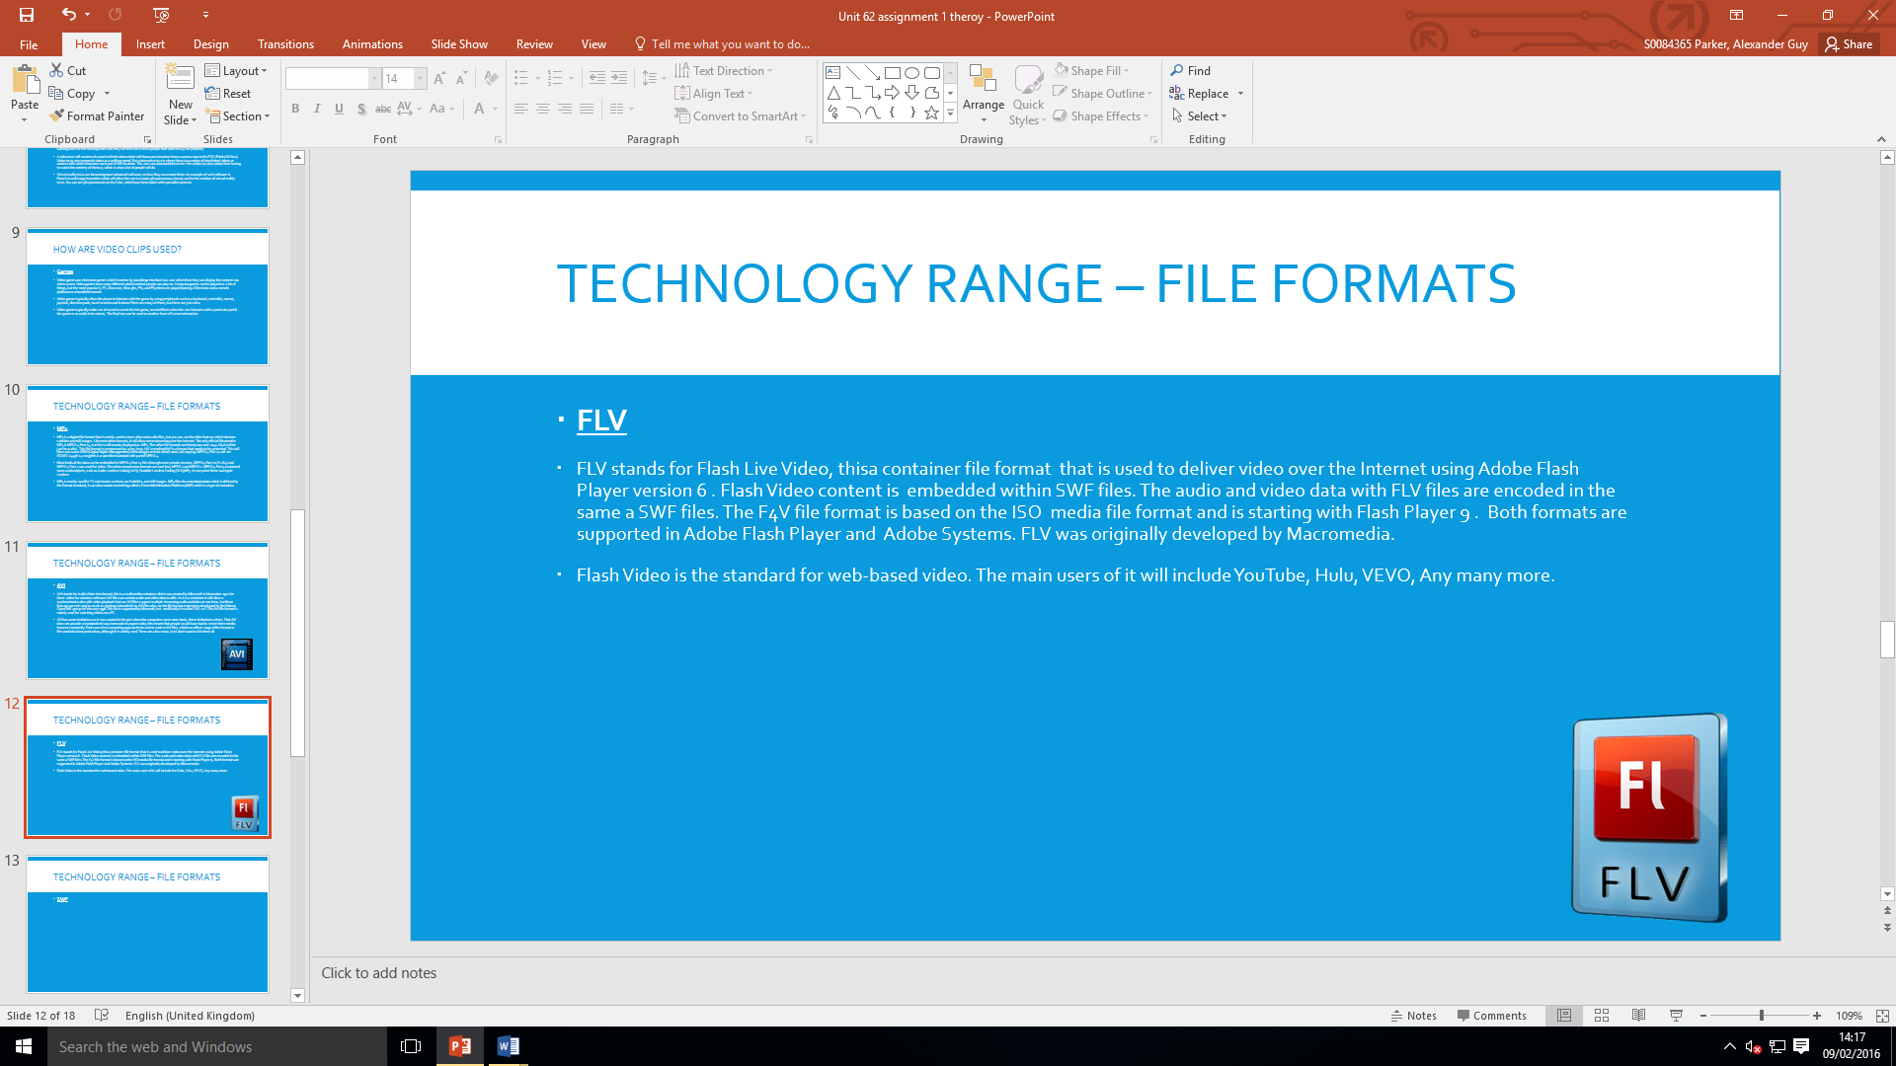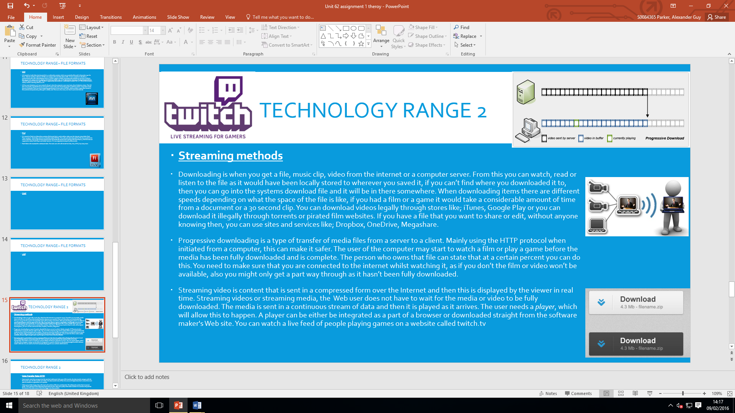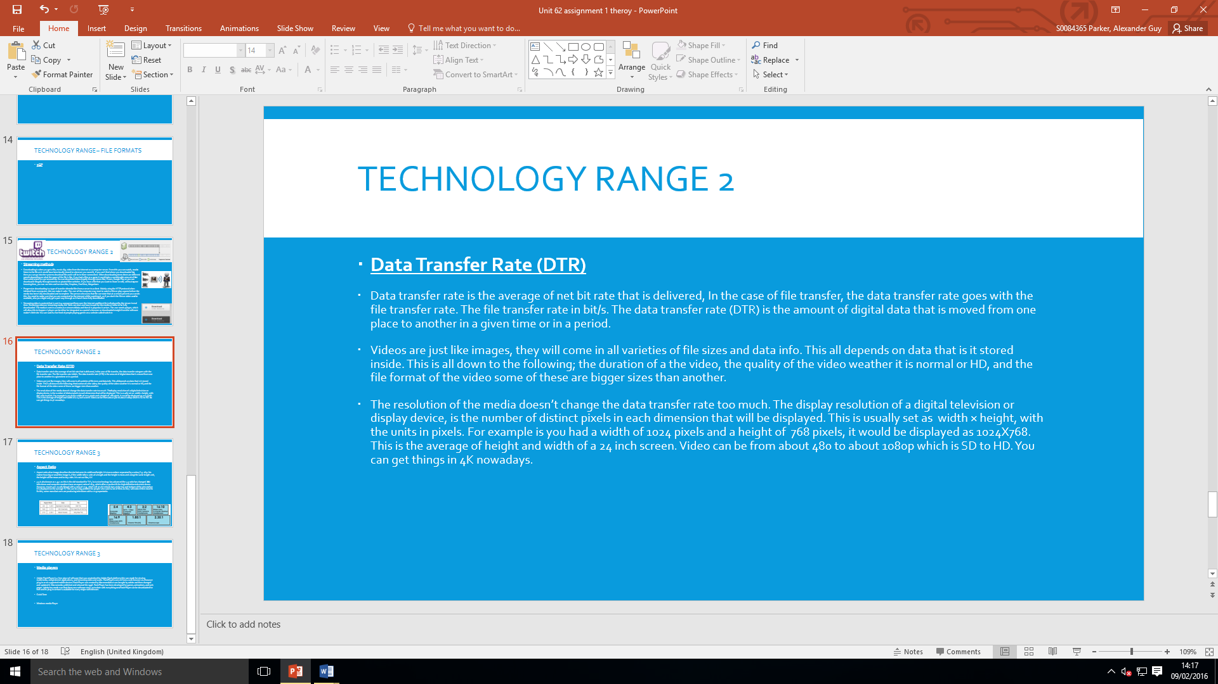

9/2/16 today I did the technology 3, this was all about the aspect ratios and the media players which is flash players/ quicktime/ wmp. I didn’t finish it, but I will do this by tomorrows lesson.
Learnt: the flash was originally owned my macromedia before adobe took over. 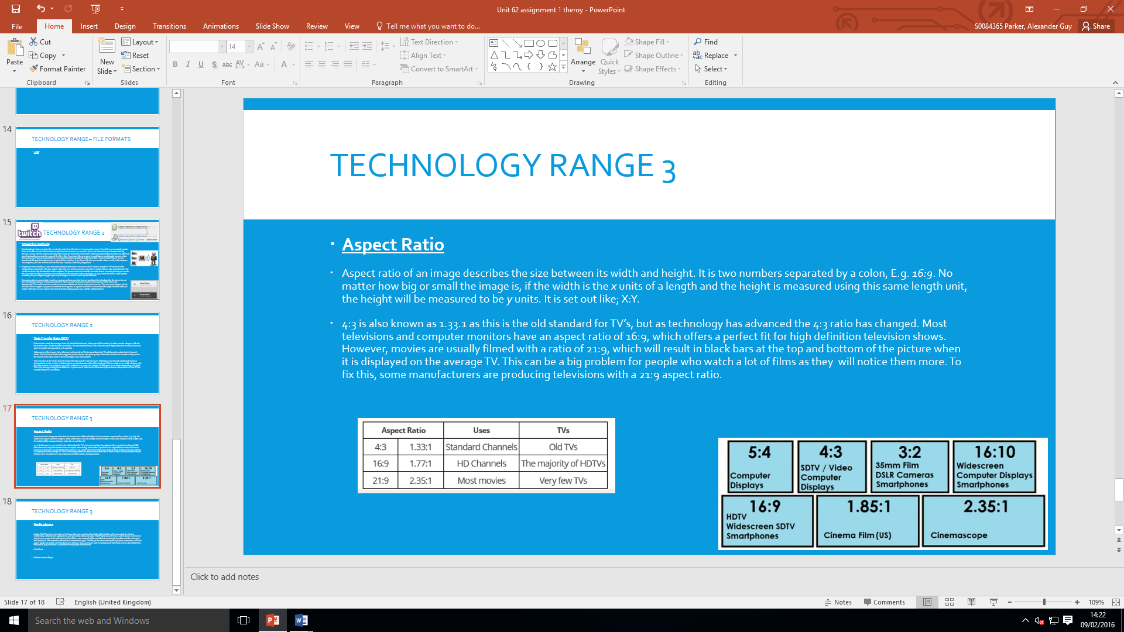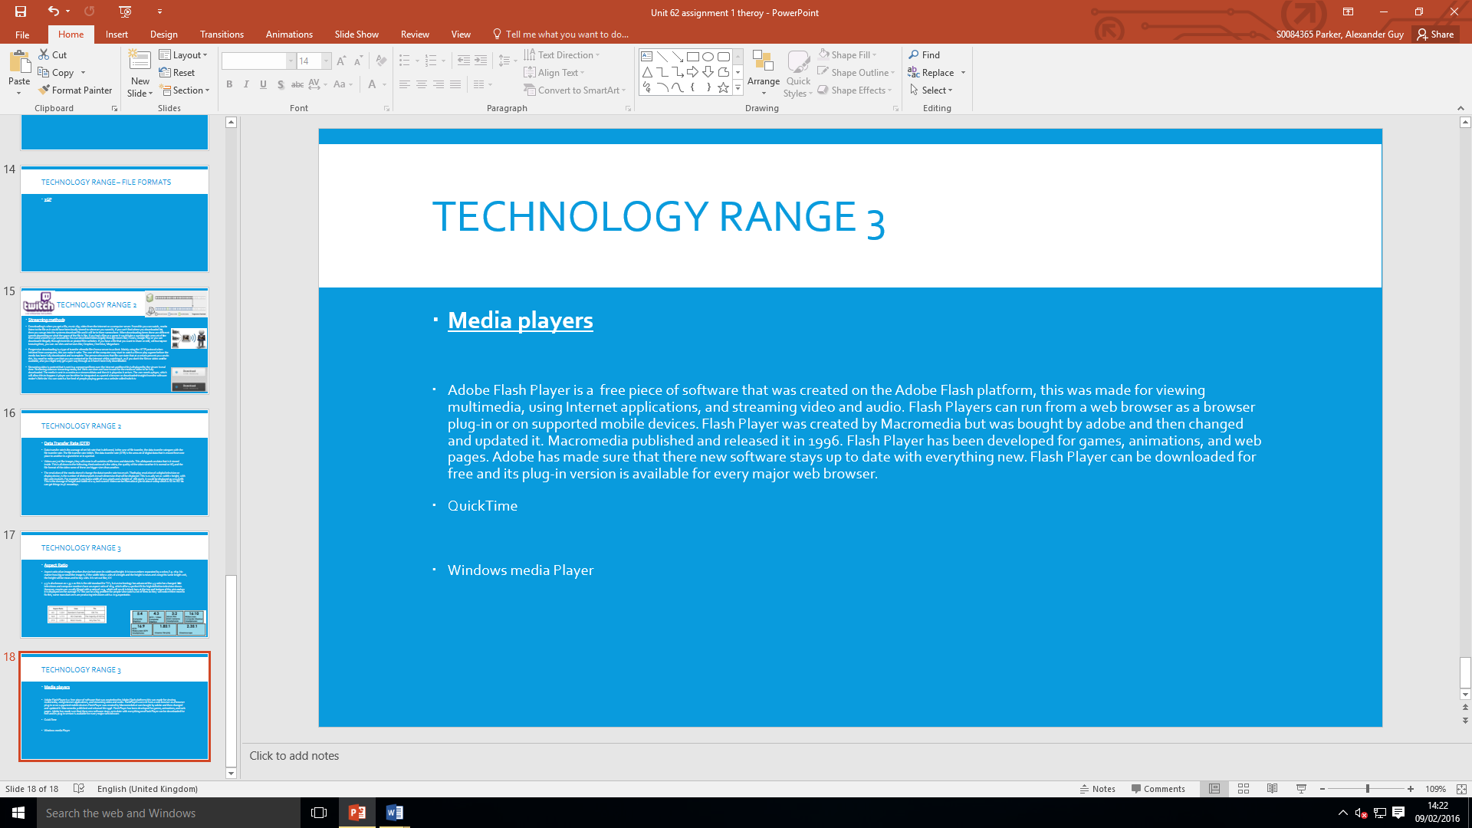

10/2/14 – in this lesson I am going to be starting the e-learning platforms. I will try to cover the e-learning, email, DVD’s and kiosks.
Learnt: I learnt that the first email was sent by ray Tomlinson in 1979 and he said “Hello World”.
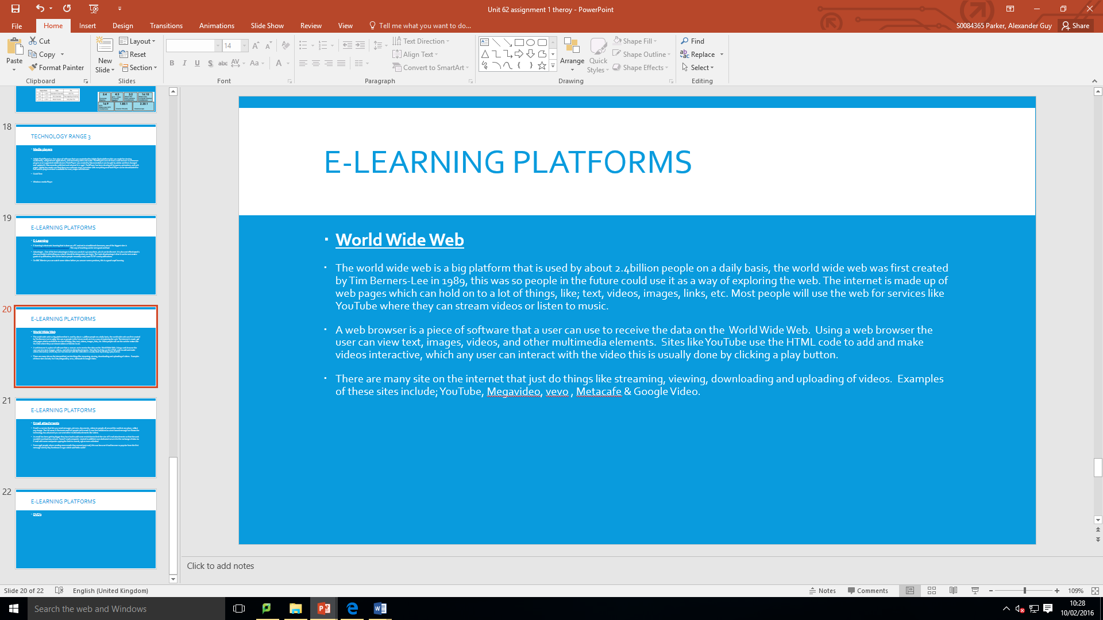
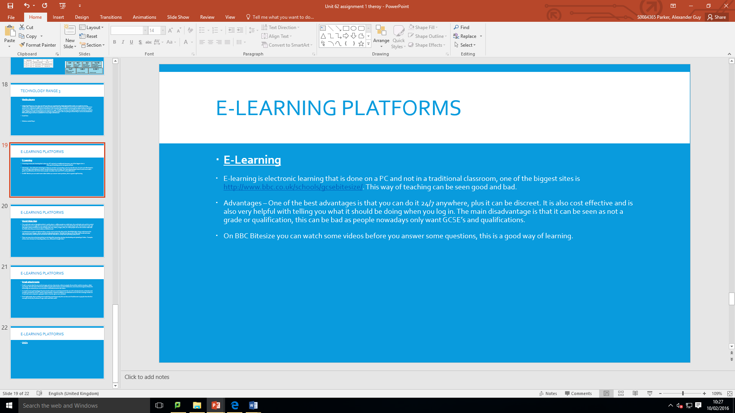
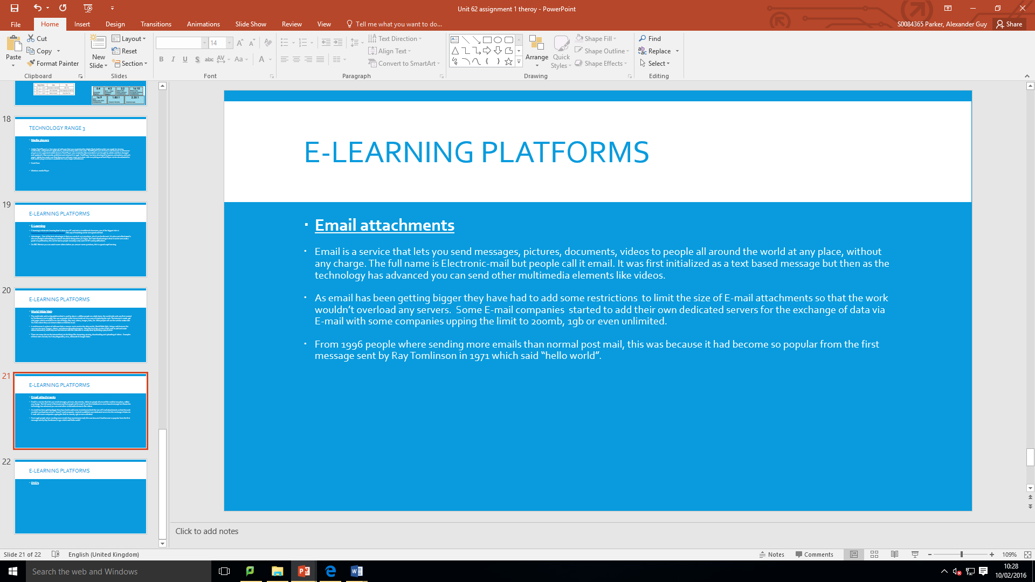
Aim: today I am going to complete the last slide, I will then print all the work off.
Learnt: I learnt that digital rights management can be done on anything that has been digitalized.
