Unit 59 – Testing Table

Test No. | Test | Purpose | How To Test | Expected Result | Actual Result
1 | The first test I did was to see if the website would load on the server. | So I can use it online and I can use a different computer to see it on. | Upload it and see if I can connect to it, I then went onto another computer to check that it works and it has uploaded all right. | It should be their when I did the  http://cstuweb/s0084365 | It loaded up correctly as it was supposed to.

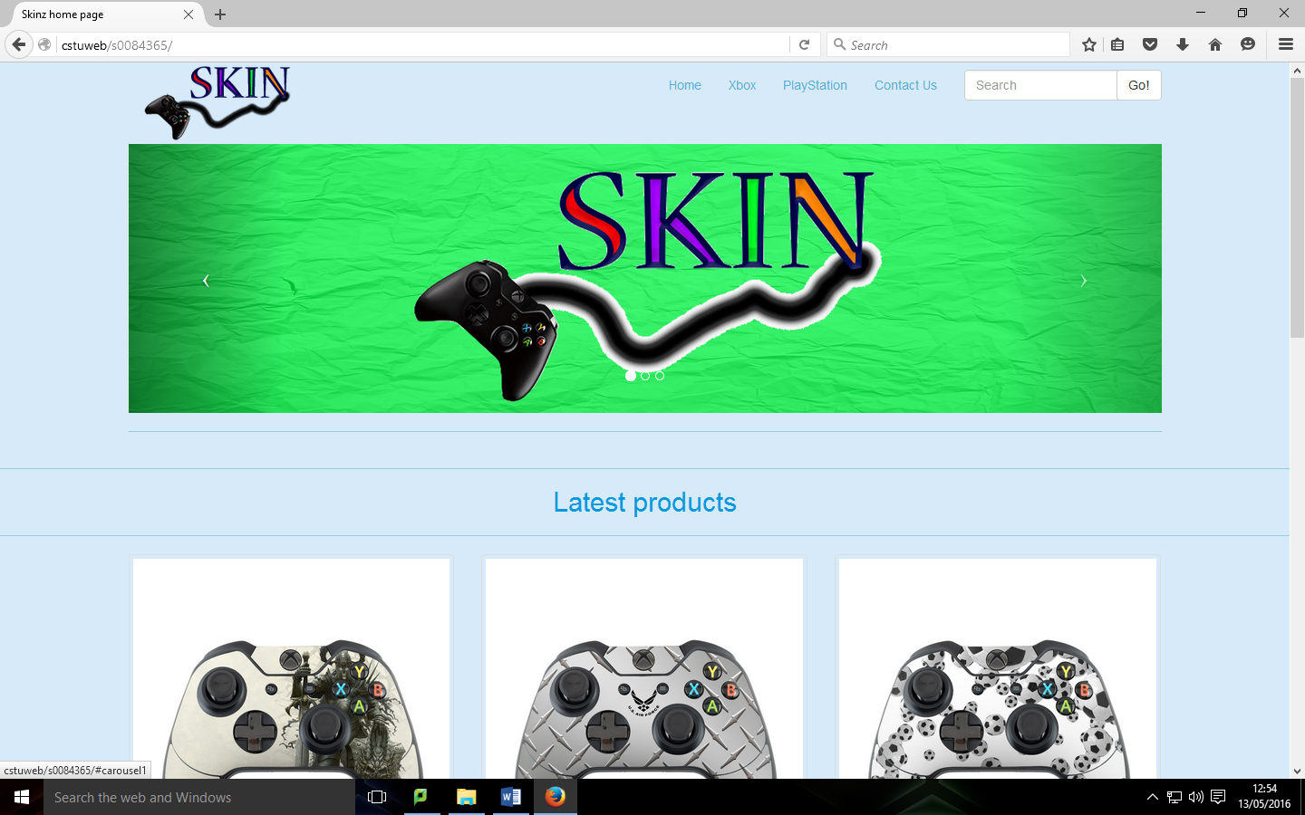
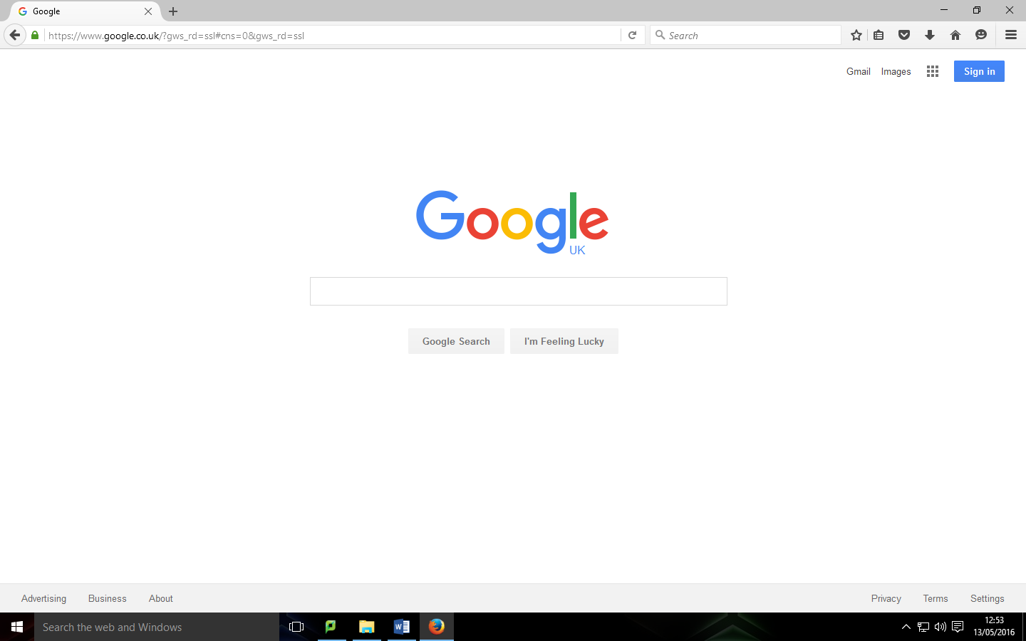

Test No. | Test | Purpose | How To Test | Expected Result | Actual Result
2 | I wanted to test whether the buttons work on all the pages | When clicked on it should go to that page. | By clicking on the button to see if they do so. | They should go to the correct page | This didn’t work for a bit, but now it works I had to upload a newer version.
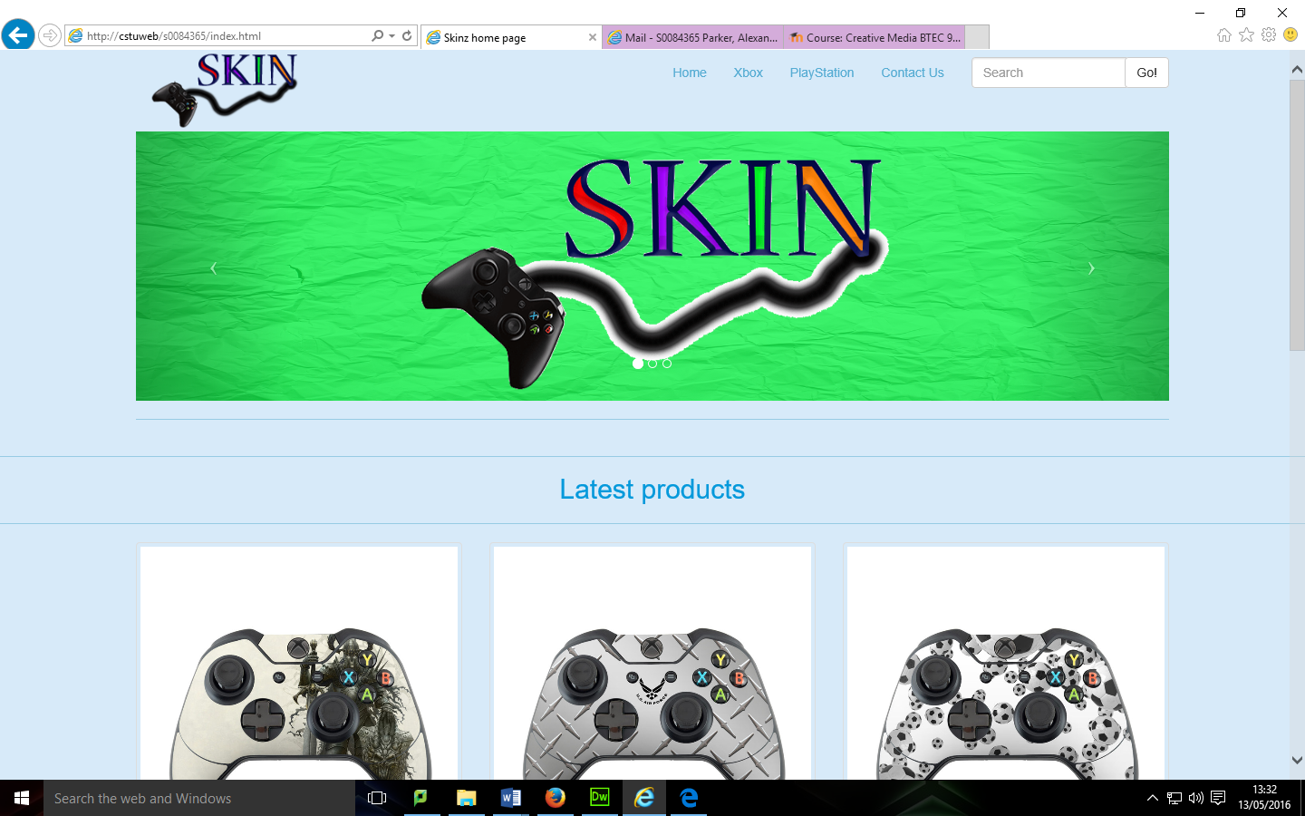

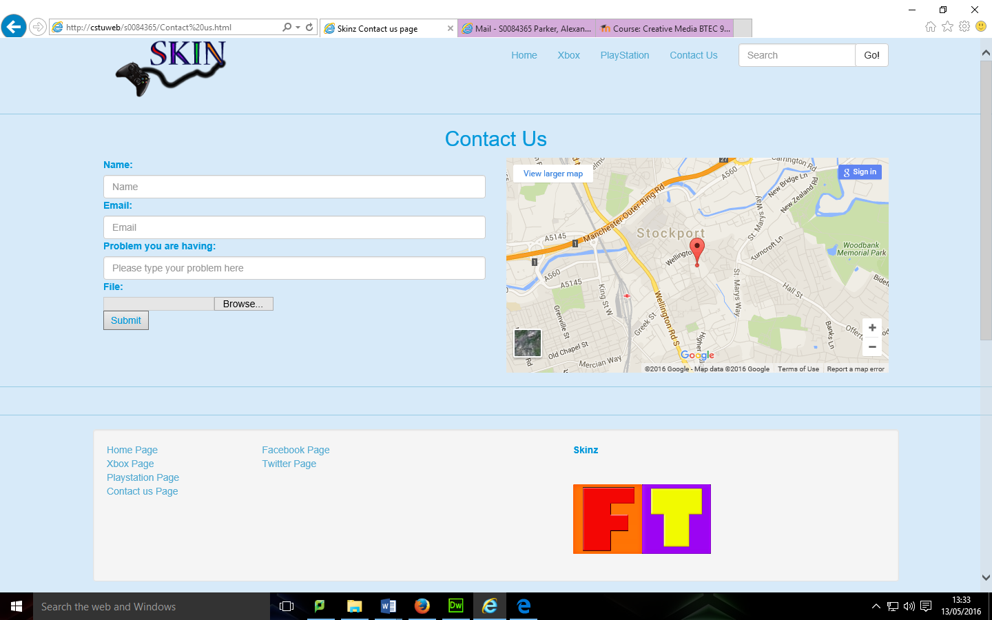

Test No. | Test | Purpose | How To Test | Expected Result | Actual Result
3 | Test that the website works on multiple device sizes | Check it works on mobile devices correctly | Preview and resize large, medium, small for each page | They should look like they would if you did make it smaller, things should fit | They looked like the following pictures bellow.
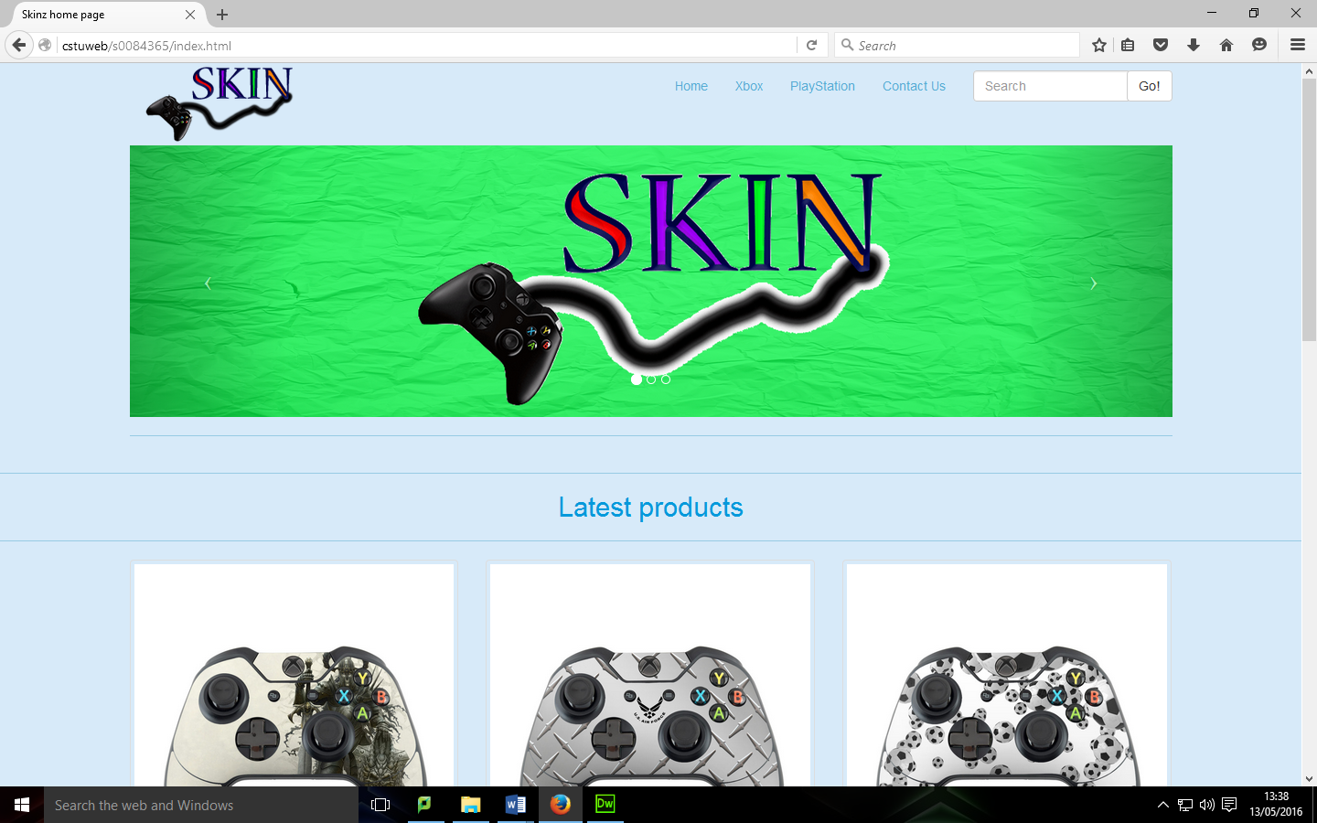

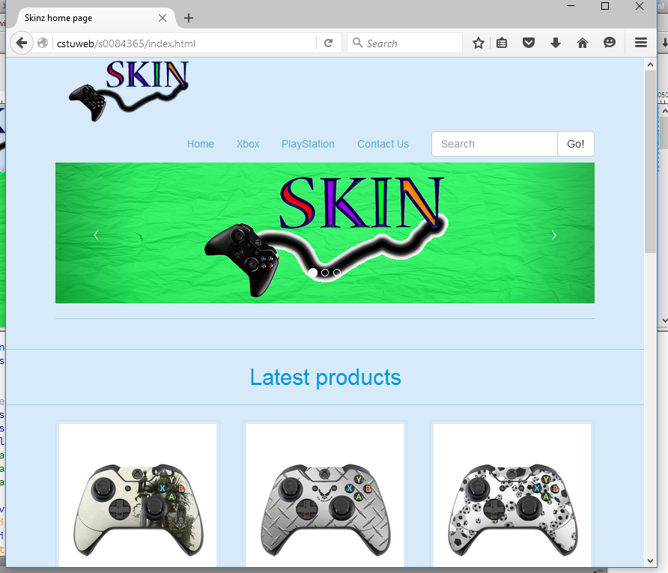
Computer size Tablet size

Mobile size
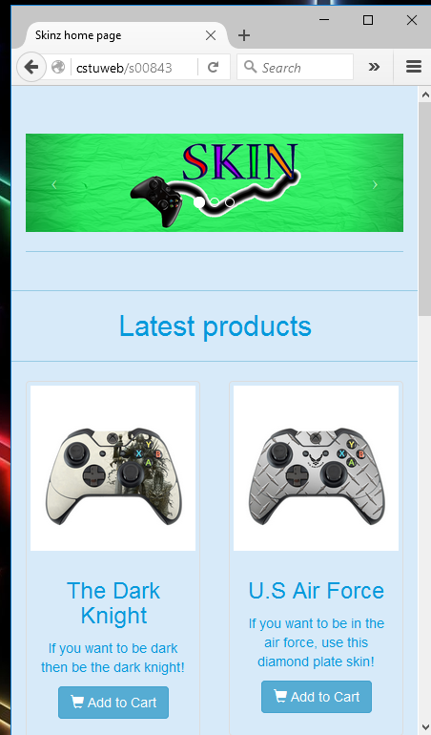

The only size that doesn’t look right is the mobile version as the navigation at the top had disappeared, also the tables have been messed up.

Test No. | Test | Purpose | How To Test | Expected Result | Actual Result
4 | I am going to test if it will work in different browsers | To make sure all people can access it | By going to each browser and to check if it works. | They all should load up and work fully | They did work correctly.
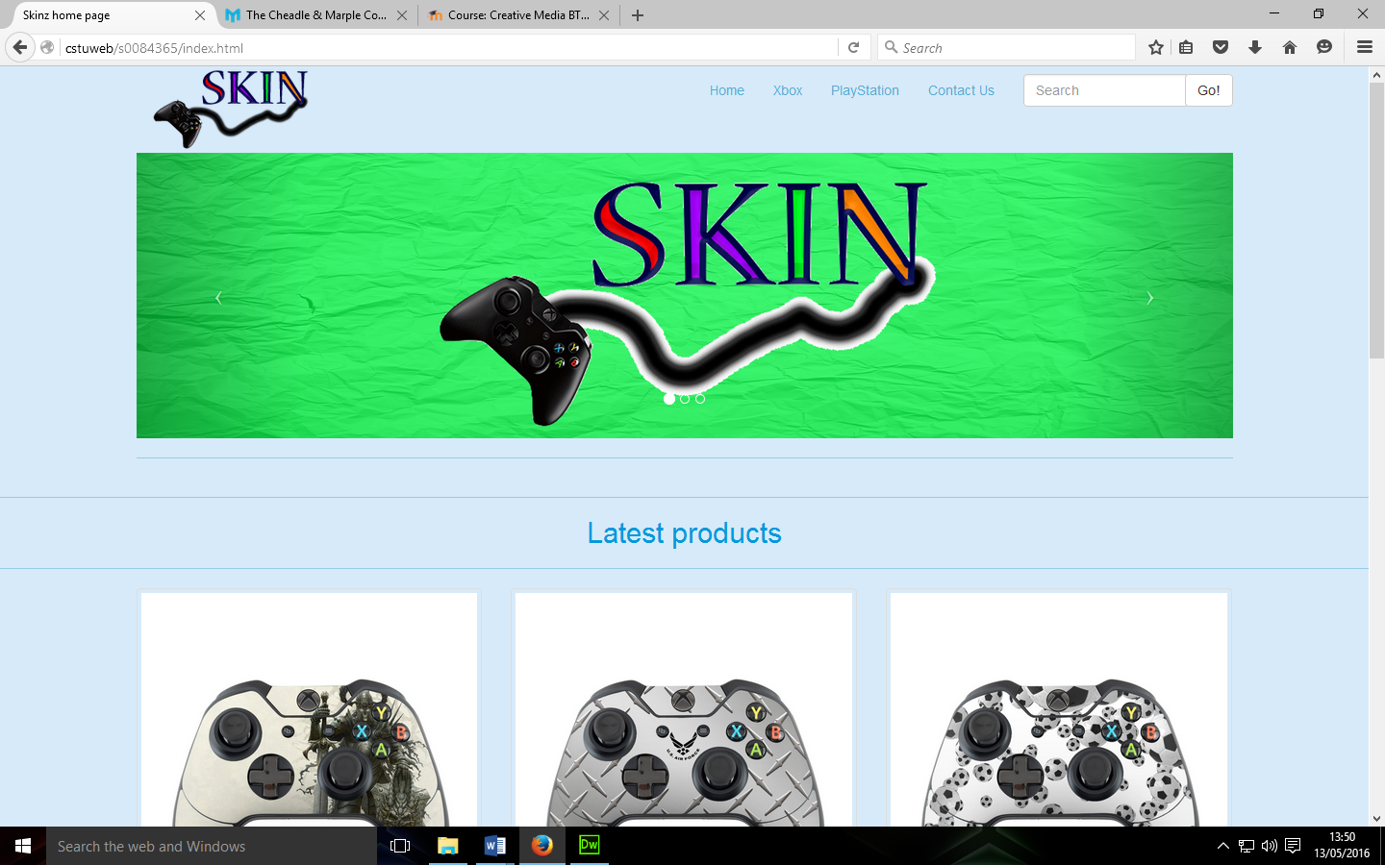

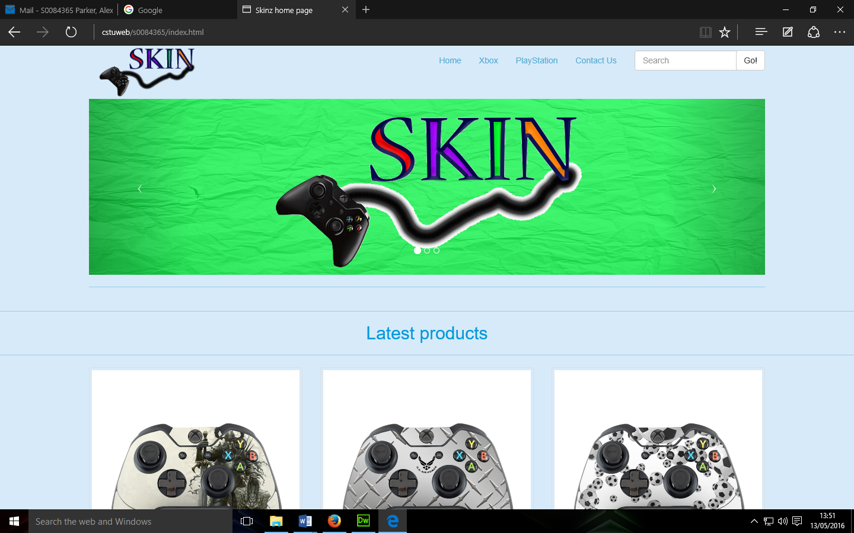
Mozilla Firefox Microsoft edge

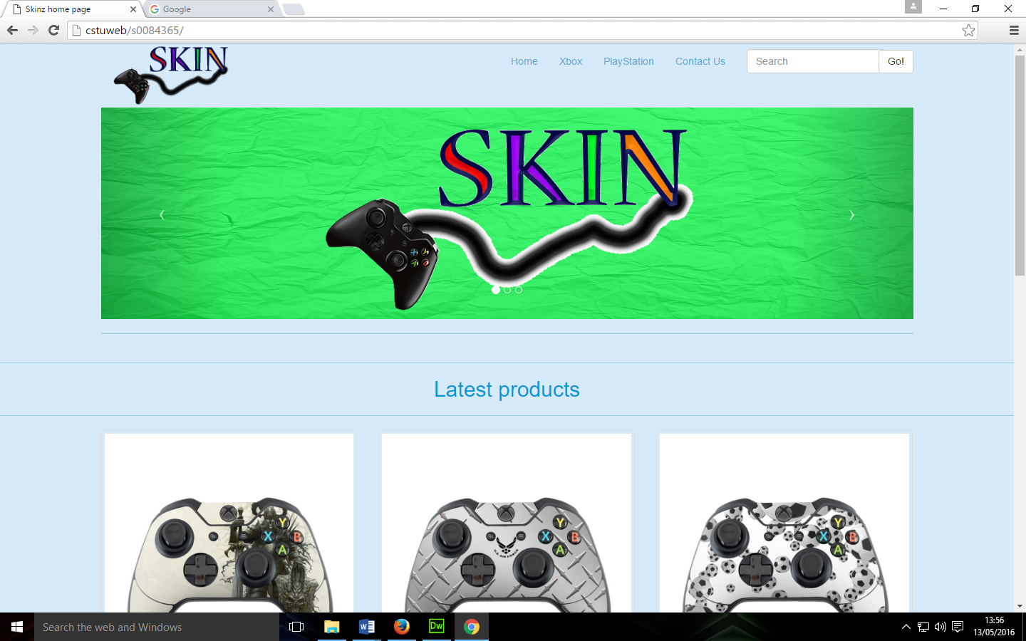
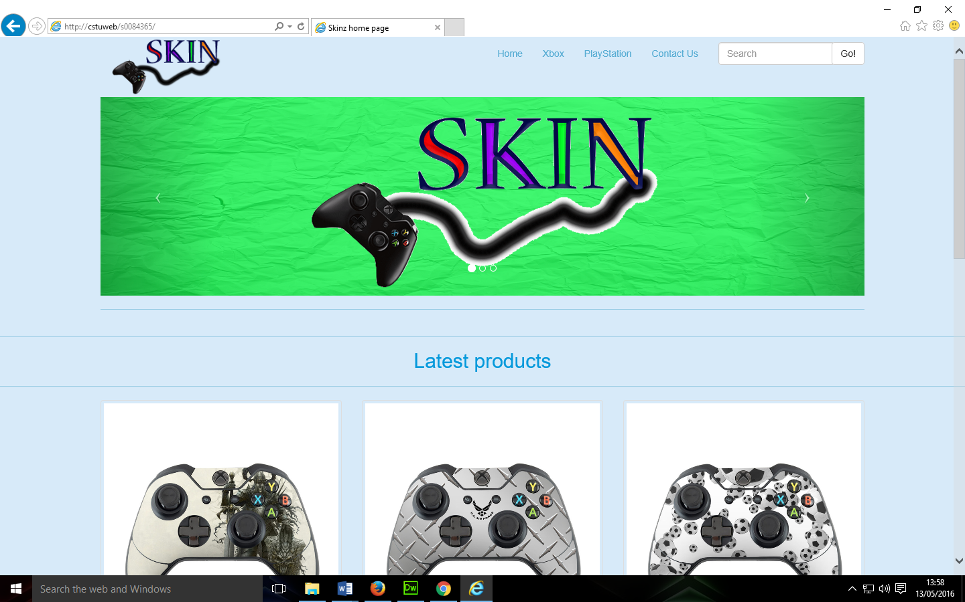
Google Chrome Internet explorer

Test No. | Test | Purpose | How To Test | Expected Result | Actual Result
5 | If it is accessible | See if it is legally compliant | File > validate > validate current document | It shouldn’t have any errors | I had a lot of errors, that I could go back and fix at a later point.
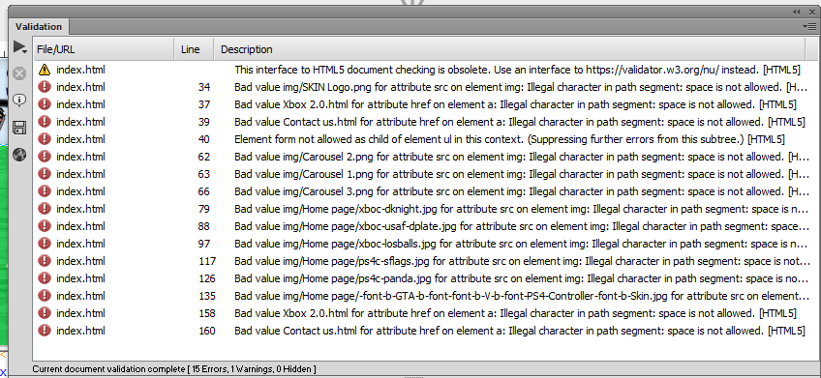

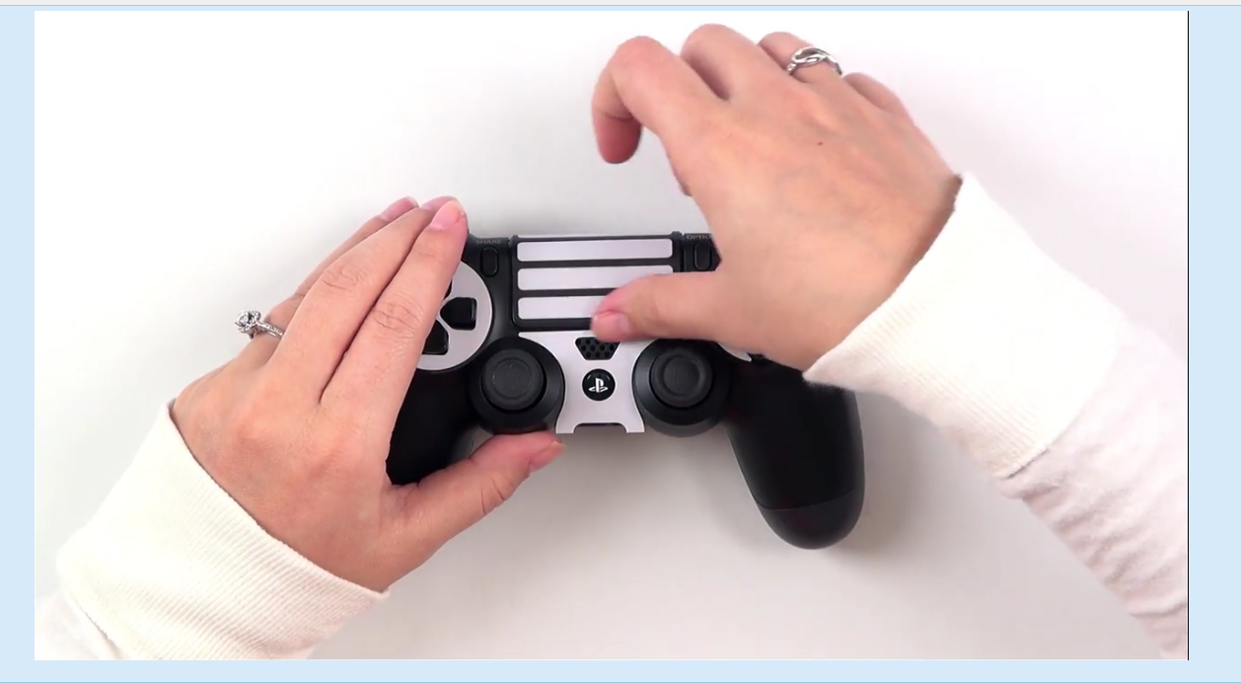
Test No. | Test | Purpose | How To Test | Expected Result | Actual Result
6 | See if the videos work | They instruct the user about how to put the skins on the controller | By clicking on the red YouTube play button. | It should play, | It does play on both PlayStation and Xbox
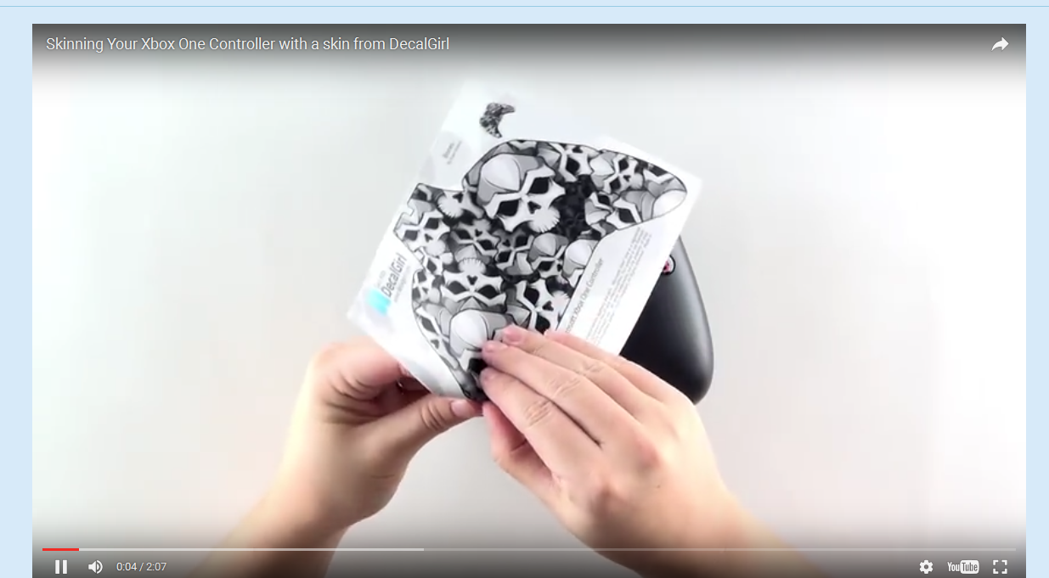

Test No. | Test | Purpose | How To Test | Expected Result | Actual Result
7 | See if the map works | So the customers can see where the company is based & where it lives. | Going on the page and seeing if the map interacts | It should interact | It does interact very well as it has a interactive feature.
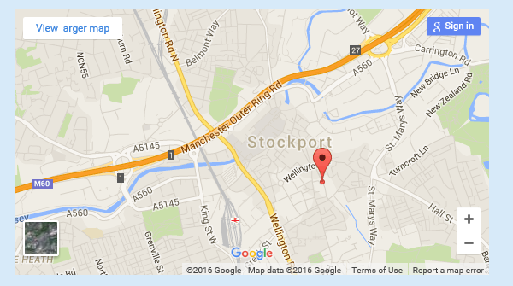

Test No. | Test | Purpose | How To Test | Expected Result | Actual Result
8 | See if the form works | So the customers can get their problems to the company | By using the form and seeing if it will work | It should interact | It does input the text and does work.


