Structures of web pages
This is a website that helped me find out about HTML code: http://www.w3schools.com/html/html_basic.asp
Terminology
Authoring
Authoring is when you get different assets like pictures, videos, text to create a piece of work. You can use different and more advanced assets like animated gifs, games, interactive images. Authoring is how the final product can be saved as and what it is used for, in different purposes. This is called HTML which stands for HyperText Markup Language. You can create html in software’s such as Adobe Dreamweaver which is for people that is advanced or you can use basic notepad, to software that is mid-range like C++ and Notepad++. Most of these software will have a view or a live feed that you can see what the website will look like when you produce it. If you don’t have enough time to create all the code, then you can use different websites like weebly.com to create them. From this you can buy that domain name.

Sites
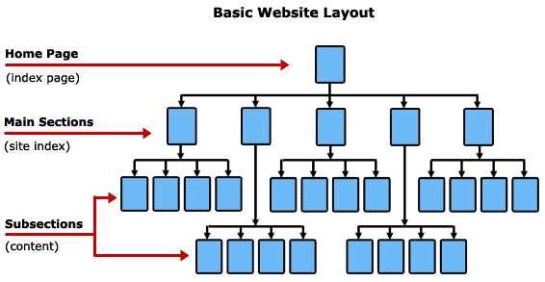
A website (site) is a collection of different pages which can be hosted online and the internet when you type in a certain domain name, each webpage always starts off with http://www Or https://www. A website needs to be hosted, you can get a free contract that means you have to have the host’s domain name. Or you can pay a small fee to have your own domain name, each host can charge whatever they like. If you are a company that has their own website, they might invest in getting a server which is a computer that is constantly online, this means that the website won’t ever shut down and get broken. Some hosting services will give you an offer that is good, this consists of their warehouse that they can host the website for you 24/7. A website can be accessed and viewed in every country in the world as long as they have some sort of internet connection.

Uploading
Uploading is when you load a page/ image/ video from a computer or site, to another site. An example of this is when you upload a photo/ video from a computer to a social network site, such as Facebook. By choosing to transfer (or move) the file/photo from one place to another, the place you are moving it to is where you upload it to. This can be done on lots of sites, but the most sites that upload are social media sites and YouTube. Uploading can be done on a small scale or on a much larger scale when businesses upload important files or documents to servers for their customers to see. Servers are the same thing as a simple computer which is constantly online to hold websites and pages for the web.
File transfer protocol (FTP)
An FTP (file transfer protocol) is a software or programme which allows you to easily transfer files between computers, but it is used to upload files from a computer to a website’s server. If you wanted to create some web pages on your computer to add to a website, then by using an FTP, you can easily upload them to the hosting server. This is done by logging in to your hosting through the FTP client, you can get these online. This will ask for a username, password and host website. The client might ask for a server IP so that you will only upload to your own domain and no one else. Once they have logged in, they can see their files which are already saved there and either upload extra files to them, delete some of the files, or even just move them around, this is quite easy to do so. An FTP is just a quicker and easier way to edit or upload some files on a specific website. There are many websites out there that help you do this.
USER ID/ PASSWORD
FTP -> FileZilla
FTP
READ AND WRITE

Client
= browser
Web server
READ ONLY

RESPONSE
INTERNET CLOUD

REQUEST

Web page
Web page construction
A webpage can be constructed as either basic or complex. All HTML coding will start off with <!doctype html> this will tell the computer that the type of the document is going to be in HTML. Then it is <html>. These are the first two phrases you will use when creating a web page. Then if you want some page text, you will put this in the body section. There is also a way to change the background colour, this can make the white space disappear. Then once you have done you need to close the tags. To do this you need to add a / in the <>. For example: </html> and </body>.

Text
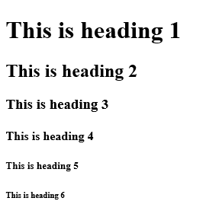
For a good webpage you need some text. If you want to create some headlines, then you first need to decide which size you want it to be. You will set it out like <h1> TEXT </h1>. Then there are different sizes 1 being the biggest, then there is size 6 which is small.
Then once you have the heading you can write different paragraphs, with the tag <p> and </p>. Inside this section you can write anything, what is good is that there isn’t a limit of what you can write.
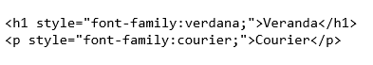
If you want to include text in this that you want to be in bold or underlined. You can use the tags <u> and </u>, as well as <b> and </b>. This will do as you want. You can select different sections where you want. As long as you include the tags before and after the bit of text. If you want some italics, it would be the same code but with <i> and </i>.
Fonts
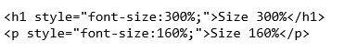
When creating a webpage you don’t want to use the same size and font all the time. With different html You can change all the fonts, sizes and where it is on the screen. To change the font, you will put <h1 style=”font-family: Calibri;”> writing </h1>. This will change that font type in that section you have typed in.
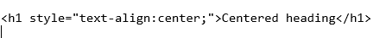
If you want to change the size of the text you don’t put .pt as it confuses it, instead you have to use the percent format. <h1 style=”font-size: 200%;”> this is the format you need to use. You can also do this in the paragraph section. This is a good thing to do in a webpage.
You can change the region where you will have some text is, by aligning it to either left, centre and right. This is the tag for it, <h1 style=”text-align:(where you want it);”> text </h1>.
You don’t have to do this like this to align something, you can use these: <center> and </center>, you and use <left> and </left>, and finally <right> and </right>. This makes it simple, but you can’t change the padding (space) between the ends.

Lists
A list can be made in HTML by using this code, you can make the list ordered or unordered, by putting either <ol> or <ul> at the start. Then you will go on to writing down the items in the tags <li> and </li>. You can have as many of these as you want. But when you have finished the list you need to close it with either </ol> and </ul>. Make sure that you use the right one as it can confuse the program/ computer.
Colour
Colour is one of the most important things in HTML, as it would always be in black and white. You can add colour with 3 different varieties. This is either RGB colours, Hex colours or the colour names. If you wanted to use the colour names, then there is an example to the right and this has some of the basic colours. if you want to use a different colour than these then you can select your own on a colour picker.
Now to incorporate this into the text is by adding, the <font color= “colour name or hex number or RGB number”> TEXT </font>. The colour of text is easy as that.
Background
There are two things you can change the background to either just colour or you can make this into an image as the background.
The first is the plain colour: <body bgcolor=” the name, RGB and HEX numbers”>. Then the second type is by adding an image which is <body background=” this is either the image name or the internet URL to it.”>
Images
There are many different things that you can do with an image in HTML. Such as changing the width and height. Then you can change the alignment (the area) where it is in the preview and browser. You can add some text to it as well.
The normal image code is: <img src=”image URL or name”>.
Then to change the height and width: <img src=”image URL or name” width=”300” height=”200”>.
To add some alternative text is : <img src=”image URL or name” alt=”image of the computer”>.
To align the image by: <img src=”image URL or name” align=”right/ centre/ left” >.
Tables
In HTML you can create a table, but this is quite complex and can be frustrating, you first of by putting <table> this tells the computer that there will be a table. You then carry on by adding <tr> and <td> these stand for table row and table box. Then you will write your text within this and then once you have done a row or a box you will put </tr> or </td>. When you have finished making a table you will put the closing tag which is </table>. You can add titles to this by adding <td> text </td>. You can make a coloured border which will be <table border=1 bgcolour=” Hex, RGB or Name”>.
Hyperlinks
Hyperlinks are things that will take you from one thing to another. These can be internal, hotspots and external. The internal link, will select a document, image or video that has been downloaded to the computer. This can be easy to setup you do this by typing the following; <href="name of the doc”>. this will then display what you want it to. You can also set up an external link, which could be to another webpage, you will do this by using the following tag; <href=” this is the webpage html”>.

Metadata, Language and Terminology
Metadata is some type of data that provides information about other piece data. There are two types of metadata: structural metadata and descriptive metadata. Structural metadata is data about all the contents of data. Descriptive metadata uses individual bits of application data or the data content. Metadata was traditionally in the card catalogues of libraries. But as all the information has become digital and then went online, metadata is also describing digital data used. Describing the contents and context of data or data files make it more useful. A web page may include metadata specifying what language the page is written, it then uses tools to create it, this then helps out where to find more information about that subject. Metadata can automatically improve the reader's experience.
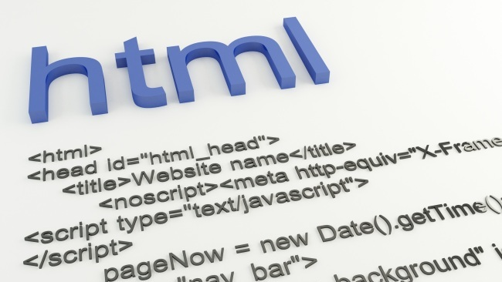
Nature of HTML (hypertext mark-up language)
The nature of html is to make and create web pages, this can be done along with CSS and JavaScript. CSS (Cascading Style Sheets) is a style sheet language used for describing a documents presentation written in a mark-up language. A high level, dynamic, un-typed and interpreted programming language is called “JavaScript”. Html makes the user able to use images and objects so they can make their webpage unique and personal. The code of html consists of things called tags, these tags are not displayed on the final product. This is the starting and ending point of code. Within Html you can use colours, change fonts, add images and background colours. Html is used and created in advanced programs like Adobe Dreamweaver or C++, there are basic programs like notepad and notepad++. this is how to create them; you can then use the internet or FTP to post the final product so people can see.

XHTML (extensible hypertext mark-up language)
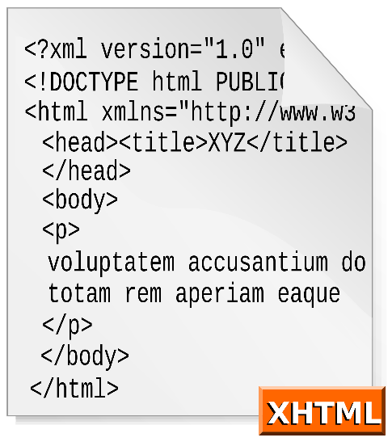
XHTML is a combination of HTML and XML (EXtensible Mark-up Language). XHTML consists of all the elements in HTML 4.01, combined with XML with some strict syntax. The combination of displaying and describing codes and tags provides a powerful tool for use in expanding technology i.e. tablets, mobile phones etc. XML is a mark-up language that can make a set of rules and guidelines that makes sense for humans and computers, whether they are readable or machine-readable. Xhtml is what services use so people who don’t know code can create a webpage, without asking for someone to help them out. Anyone can invent a set of mark-up for a particular purpose and as long as everyone uses it, however this can be adapted and changed for many different purposes.

CSS (Cascading style sheets)
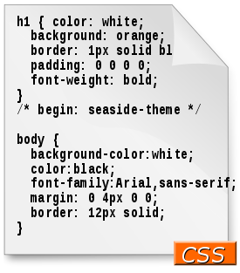
Cascading Style Sheets (CSS) is a style sheet language used for describing the presentation of a document written in a mark-up language. Although most of people use CS to set the visual style of web pages and this is written within HTML and XHTML, CSS can be written to any XML document. As well as HTML and JavaScript, CSS uses the technology mostly through websites and webpages to create visuals for a webpage, but you can use other interfaces for things like mobile applications. Or games aesthetics. The extension name for these documents is called .CSS.

