Client specification
Client requirements
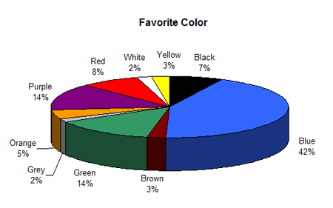
The client requirements are that it needs to be a new energy drink, that no other companies have seen or made before. The whole task is making an advert that needs to be between 30 to 60 seconds. Close to 30 seconds as it is more cost effective as it costs so much per second. I need to mind map the name and label of the can. I need to research other competitors, find out what they are doing and how they made their company so big. I need to identify the labels contents and what it needs going on it, this means I have to have a barcode. I need to think and Identify a secret ingredient or a catchphrase. I need to think of a target audience for the energy drink. I need to design a suitable logo, and can label, then I will make this. Film and create footage, max 1 min advert, I have to limit the amount of RAW data filmed. Before I use the camera I need to make sure the video and sound works properly, I then need to do a test run of adobe premiere to see if it is compatible with the software. I need to use build and transitions effects and I can use after effects to do this. Convert the end result into a suitable format, get the right format.
Target audience
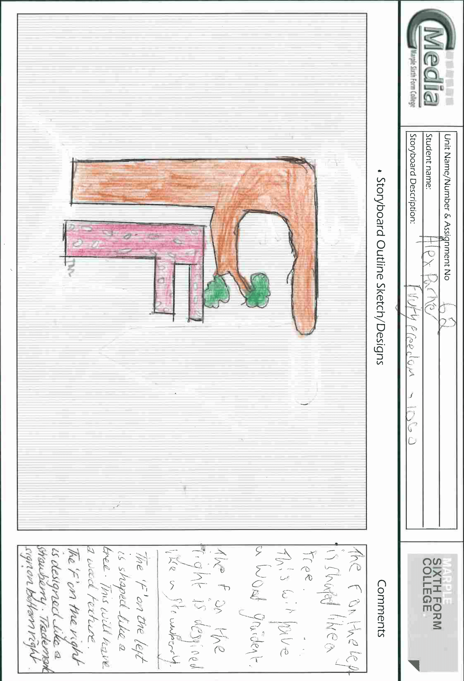
The target audience for my energy drink will be males from the ages of 14 to 19. I looked at a website that told me the statistics of people who drink energy are mainly between these ages. This means I am going to make sure that I make the drink appeal to this range of people. The colour scheme of this will be greens, blues, blacks. I looked into this on a study of what people at that age and gender like. So if I use these kinds of colours I will generate the most profit from that gender, that drink more.
Scripting
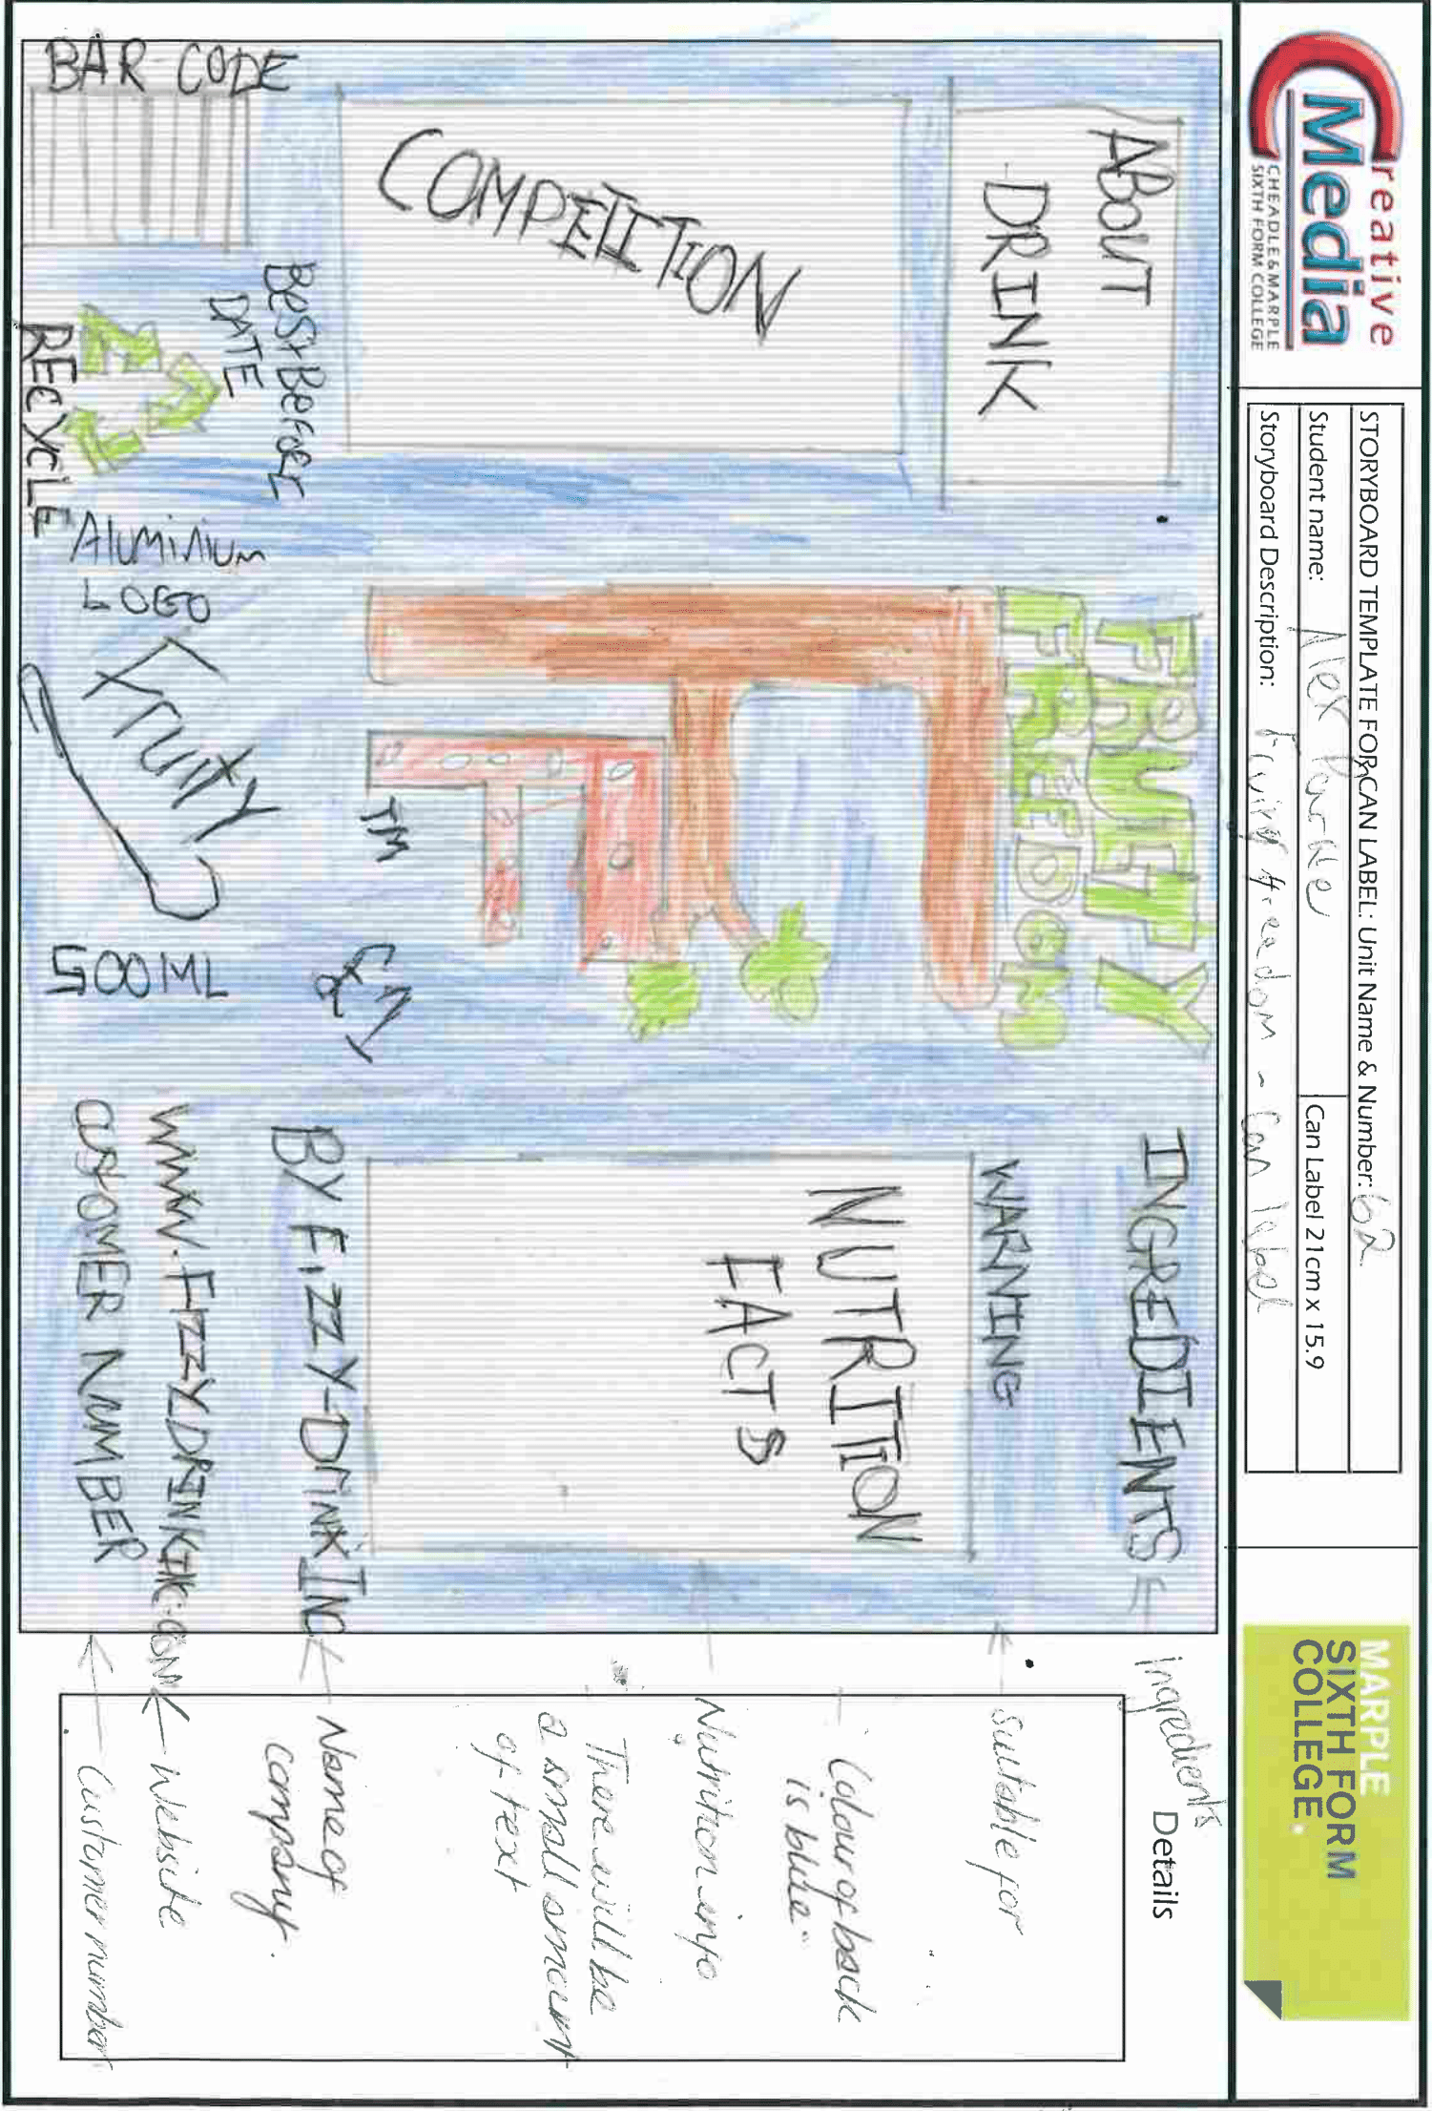
There may be a bit of script for the advert, this is for the spoken bits, I will have some music over the top so there isn’t any silence in it. The characters will be played by myself and a friend. The script will be only for a quick glance so you know what to talk about in the ad.
The video is going to be about a person who struggles getting up hills, but with the energy drink he can run up and down it. There will be a voice over, this will be scripted and then recorded.
Voice Over: Do you find it hard going up and down hills, well try this fruity drink, you will be up and running in no time. This is all in the power of fruity freedom.
There won’t be too much speaking in the advert as it will mainly be to do with the music and sound effects that will play.
Storyboards
The storyboards have been created already. I only needed to create 2 storyboards for this task. One was for the logo which I feel like it is colourful. The other one was a bit more detailed as it was the label of the can. If I need to I can create a few other storyboards for video and what the layout will be like. I will use this when I create the actual one for real. This is good as I can see the different sizes of the boxes I created.

Technical considerations
Platform
I will try to make my advert suitable for a lot of platforms, but my main platform will be for the television. I will do this so I can get the maximum views possible. But then I can have it on YouTube and Facebook to get a few more views. I need to make the advert available to as most people that I can. This can have a downside as television companies have to get money for every second of adverts they include.
File format
The final file format will be either a AVI file or a MPEG4. I can select the correct file format closer to the end but this needs to be in the right setting for publishing to the TV. The AVI file format is great as when I looked into some of the formats that TV companies use, this was on the list. If needed to I can go back into Adobe Premiere Pro and change the file format so it fits the right format.
File size
The file size will need to be as small as possible, this means that I can use the advert on websites, Tv, YouTube easier that a high sized file. If I need to I can use some software to make it compressed, this can help. The maximum size for YouTube is 2mb so I will try to use this as a guideline, I not my file needs to be less than 5mb.
Compression
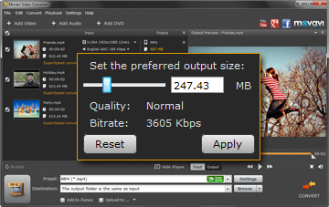
With compressing a video, you need to start off by finding out if the camera can do it, if so then use that but because I am using high spec camera I may need to compress it more. This is because it creates very large HD files, but for the task at hand the standard compression rate is fine for what I will be producing. If the advert was going to go onto the TV I may need to shoot the video in 4k so the picture looks good. Then I will make the file compressed as it will be massive.
Streaming method
I am making an advert for the television, so for this task I can’t stream the ad. The advert also needs to be available for use of a website and therefore needs slightly different specifications but this is the video’s second streaming method. If I wanted to stream the advert I would use the website formats this will include FLV, QuickTime, Windows media and Real-Media.
Media player
Media players is all about the file format the video is used for, and what it is compatible with, If I was to save the video on the internet I would use FLV or QuickTime as I can then add it to the following websites; Google video, YouTube, Twitter, Facebook. I won’t be using a media player in the project, but if I do then I can use the FLV or QuickTime player.

