Review of the animation I created
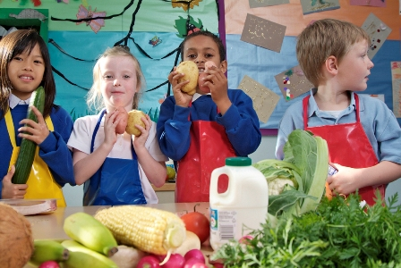
Genre
As this show is made for children aged 3- 5 year olds, I needed to make sure the genre is suitable for them and therefore I needed to make it simple, cheerful and exciting, they might get the story confused and lost. Therefore, the animation had to be thought out and made so that this would not be such a big problem. The characters are made to fit this genre as I want them to be big, they are a kind of animal that they can remember, and so this will be good. The genre is a big and important thing about and animation as you need to know what it is about and without this it can become a big problem. Since my target audience is for under 5 year olds, I needed to make sure the genre is suitable for them and therefore I needed to make it simple and cheerful (since young children can get scared easily). I will also made sure that I was happy with the end product, so I showed my family about it and especially my cousin who is that age and he definitely liked the final outcome, this was great and it was good to see the end result. I feel like it has definitely has reached its overall purpose as it has covered and appeals to the target audience of 3- 5 year olds.
Content
The content of my animation needed to consist of mainly voice-overs and sounds with no real text to read since the children will be too young to understand how to read properly, however I did have some animated text to come on for the title of the show. This means that the animation is suitable for the target audience and also that it fits in well with my idea of keeping it simple, as I don’t want to confuse the children and that they know what it is that’s going on. I had planned all of my content before I actually started producing it so that I was certain about all the details before I began. I also made a script that meant that I know what was going to be said before and this now means I could use this when shooting the images so I knew what was going on. The content of my animation needed to consist of mainly voice-overs with no real text to read since the children will be too young to understand how to read properly, however if I needed I to include a bit of text so that people can start to take interest and can start to learn how to read.
Style
In terms of a style, my animation has been done so that it entertains young children and that is what the main purpose was and I feel like I have achieved this according. I want it to be engaging so that they will not lose interest but also have a simple storyline to it so as not to make it too complicated. The style is a Claymation and stop motion style as this is what it is that I have achieved, this was made so that the characters would be too top heavy and then they would fall over and this became a big problem but this was resolved in enough time for the next shot. The style was good but it was mainly difficult to shoot all the pictures but I did manage to do it, the claymation was hard as you couldn’t sculpt and make everything the way that you wanted to do. The style was also not good as I couldn’t make a good set or background as It was too realistic for the characrers but It would have taken too long if I wanted to have a background or set as the style it would not have worked out to be good.
Narrative
When looking at the narrative used, I created a script and then chose people who I thought would suit my specific characters and asked them for their permission to contribute their voice-overs. When I was writing a script, I kept in mind the fact that it needed to be quite simple so that young children can understand it, yet also interesting enough to keep them engaged. The narrative was hard as the brief was basic and that meant that I had to think of some of the other stuff, this became a problem with the whole idea, as I did not know what to make. From the narrative I feel as if I have made the best out of what I had in terms of ideas and the resources that I had and where available for me, the narrative was broad so I had to make sure that my ideas where all done well and good. I wanted to still to the brief as much as possible and I feel like that I did it well.
Character
In terms of characters, I chose to do a whale since I thought that they must have been to the beach at some point in their life, children can relate to the characters since most of them at some point will have seen some fish and some sea life. In addition, they are quite simple so they could be understood easily, they are a simple creature to create and if they had a problem then it would not be that hard. The only problem with this is the fact that the voices as I did not know really, what voice to give them and in the end I gave this to a friend so they could be creative about it and then they knew what it was about. The characters that I made are realy good but with more time I could have made them better and smoother and if it wasn’t done good then I could have just incorporated some more of the Claymation style into the project. I feel like I also spent far to long on working on the whales that with the girl it was small and the characters legs kept on getting more and more smushed and worse throughout, I did try to add a skeleton but it ended up just getting worse and this is something that wasn’t good.
Techniques
The technique that I used was Claymation and stop motion animation. This method and style of animation meant that I had to create some plasticine models and then take individual photos of them as I manipulate and move them around the stage. Once I have hundreds of pictures, I could then animate them all together to create a moving, motion animation. This was a long process as in one single second I had to have 12 frames or images in so for a a30 second animation in the end I had 360 images that would all needed to be placed and aligned in flash to make the animation run smoothly. This technique like all animations are all so time consuming and what didn’t help was that people where also going to need to use the camera and workspace to create theirs and this is what I did try to do take into consideration as I onl had 3 hours to film it and I could have spent more time on it to make it good, I did try to accommodate but it was just a lengthy process.

Technical qualities
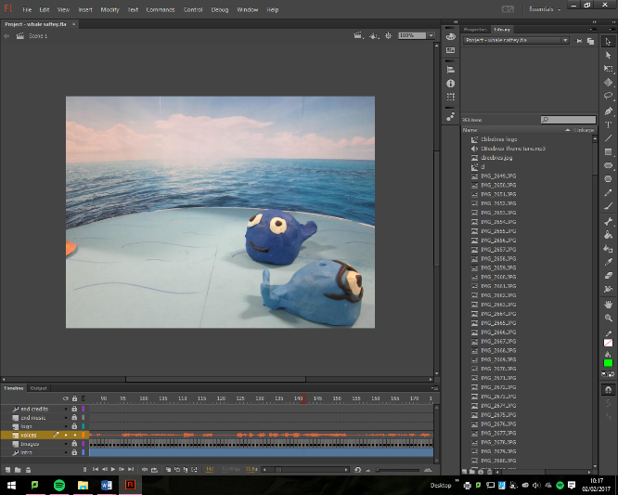
To create my animation I used flash this program was completely new to me and I had never used it before and this was a difficult program to use as nothing would work correctly the first time, I had spent a number of hours just trying to get the program to work. I used one of the booklets but this was a big help and that made me even more confused. The other programs I used was audacity and premiere pro to get the audio and this was easy to do and then they can get the audio onto flash was surprisingly easy to do. Flash is just a complicated and a big and annoying pain as it just didn’t do what I wanted it to do and I wanted it to be easier, if I do this again then I will make the animation in a different and more comfortable software like Director that I have used before, but flash is a program that I need more time to get into and then everything should be fine.
Aesthetic qualities
In terms of aesthetic qualities, my animation is very colourful and the characters are nice and bright are there are no long pauses where literally nothing happens on the screen which means that the characters are constantly moving to ensure that the children do not get bored. I also think that the characters are made and the whole story keeps them engaged and that then the children would not get too bored. My animation is very aesthetically pleasing and the characters are nice and bright are there are no long pauses where literally nothing happens on the screen which means that the characters are constantly moving to ensure that the children don’t get bored. I am also happy with the fact that it looks good and I have to work on the intro and outro but I feel like those are just the only niggly bits to this animation. But I needed them for the brief and to meet the clients needs.
Creative qualities
When thinking about creative qualities, the whole idea behind the project was that it had to appeal to under 5 year olds and therefore it needed to be quite creative in order for them to keep them interested. I also designed my set to appeal to this age range, as it is simple. The creative ideas where all decided to go through a child, I went to one of my younger cousins that told me that it was a good idea and he thought it was creative and was a new and fresh unique idea. The whole idea behind the project was that it had to appeal to under 5 year olds and therefore it needed to be quite creative in order for them to keep them interested. I also designed my set to appeal to this age range. I made sure that I made it creative so I got in touch with my own 5 year old self and that then ment I could have it set out the way I wanted it to.

