Researching my Idea- Advert for new trainers.
Audience research
Age
The age audience for trainers will be everyone, but not everyone will like the same shoes as other people. Some people might choose the shoes as they have different features such as; the comfort, the design, the brand, etc. But there are shoes that people like at different ages as children will like dinosaurs and hello kitty shoes when they are younger and when they get older they adapt and change to liking the style and the comfort of the shoes.
As I am going to be creating the shoes and the advert I will need to have an audience range so the age of the people that are going to be getting the shoes will be for students between the ages of 16 to 21. As I will be doing this I need to know the kind of shows that this age likes so I can place the advert in it. I have found that they like dramas and reality shows. So if I where to place the advert on a channel it would be ITV and the sport shows for the boys. I have also found out that it would be a good idea to include the whole social media side of things. I know that the brief has to be for the Tv but the social media use in that age range is a big thing as we can’t get off it. If I wanted to boost my profits, then I would use Facebook and Instagram to boost the market scale.
Gender
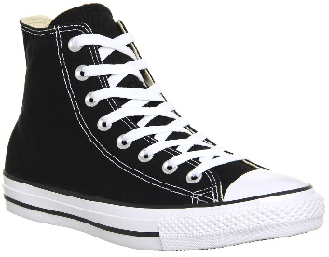
The gender will be one of the most important things about shoes as girls don’t want boy’s shoes and boys don’t want girl’s shoes as there is a big difference in them. Most boys will also have bigger shoes than girls as their feet are bigger and the girls will have smaller shoes. This would mean that I need to have a price that is right for both genders. When I go to make the shoes brand and the shoes I will make them uni-sex which means that they will appeal for both genders, this means that I can get over the problem of making the colour and style just for one of them. This does mean I will have shoe sizes from size 13 child to size 12 adults. A popular brand of shoes is called Converse which is trending with both genders is a trainer. Converse trainers have a simple design, but there is a wide range of colours and patterns that are available, as well as different fits of shoes. This is the kind of thing that I will be doing as it makes it unique and quirky.
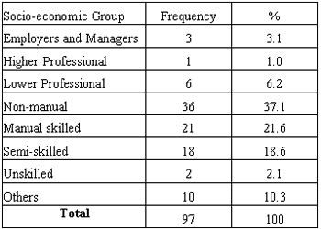
Socio-economic grouping
Socio-economic grouping refers to how high/ low a person is in society and their income, as my target audience is aimed at the ages 16-21 which is students, this means that their income is not as high as a person who is in their 40s and has a good job, Because they average income for a student is often the minimum wage of £6.50 an hour the trainers would need to be made in a way to keep the cost low so that they can afford them the price, I can also have an offer scheme so if they prove that they are a student then they can have the shoes at a lower rate than they actually are.
The cost of the shoe should be in a price range in which the buyer would be able to purchase a pair after putting money aside for at most three weeks’ worth of pay (if paid weekly). This means that I will have the cost of the shoes at £25 to £40, but if I go for the highest I will have the offer scheme in. The cost of other shoes is around anywhere between £30 to £100 depending on the brand of them and the style.
Lifestyle
The lifestyle of the target audience is a student, this will include a lot travel by walking, jogging, cycling and standing. There is also the additional purpose of shoes for students which is for fashion as they are conscious about it, also they can be ready for sports and their party life. There-fore it is important that the trainers will appeal to them aesthetically, as well as offering comfort for the hours they spend working or studying. This affects the materials of the shoe, as they will need to be breathable fabrics. This would not only prevent sweating or smell; this would also make the shoe available for people with sensitive skin who can only use natural fabrics as they have a problem with others. For many students struggling to live within a limited budget, a lack of money may be seen as a barrier to leading a healthy lifestyle. But although super-foods and gym membership may be beyond the typical student loan, healthy foods and exercise need not be. This means that as well as traveling they need to walk a fair distance and do thee gym so you can have a deal to make them go to the gym with their trainers that I will make.
Audience figures
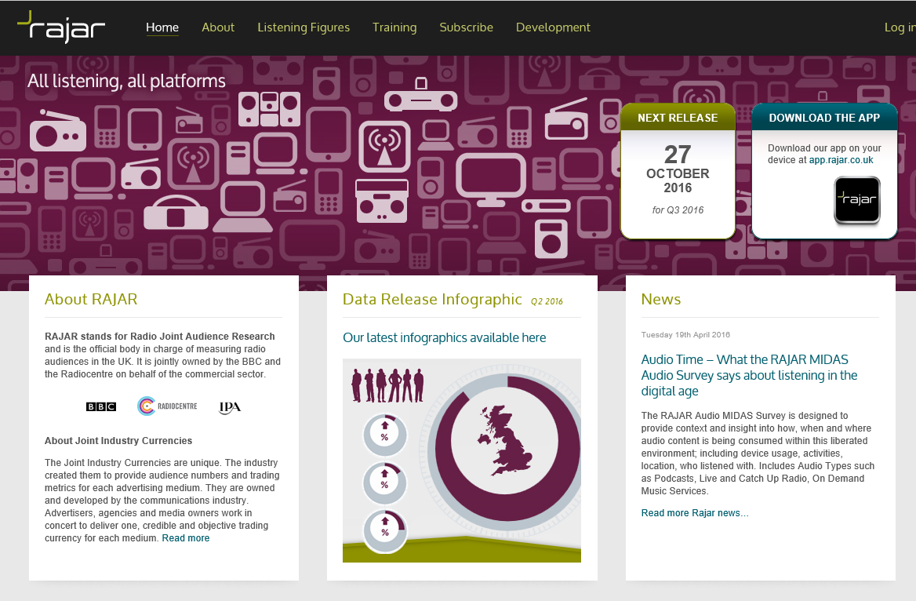
RAJAR
RAJAR (Radio Joint Audience Research) and is the official body in charge of measuring radio audiences in the UK. It is jointly owned by the BBC and the Radio-centre on behalf of the commercial sector. RAJAR is also responsible for setting the research specification, the awarding of the research contracts to third party suppliers and the overall quality control, management and delivery of the service.

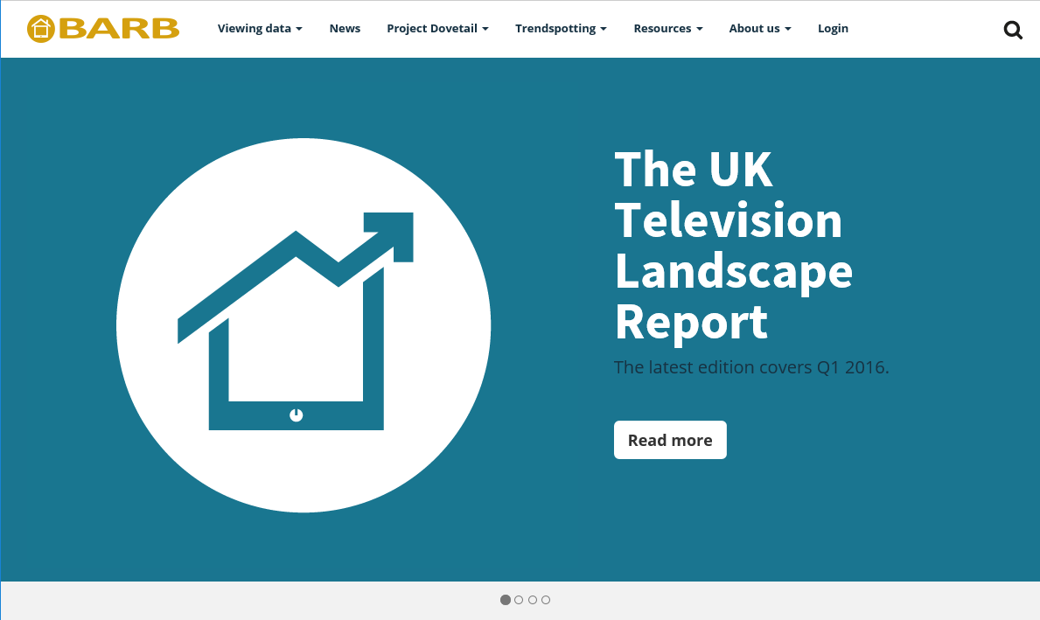
BARB
Since 1981, Broadcasters’ Audience Research Board (BARB) have been delivering the official viewing figures for UK television audiences. We commission research companies Ipsos MORI, Kantar Media and RSMB to collect data that represent the viewing behaviour of the UK’s 26 million TV households. In order to estimate viewing patterns across all TV households, a carefully selected panel of private homes is recruited, to help do their task.
ABC
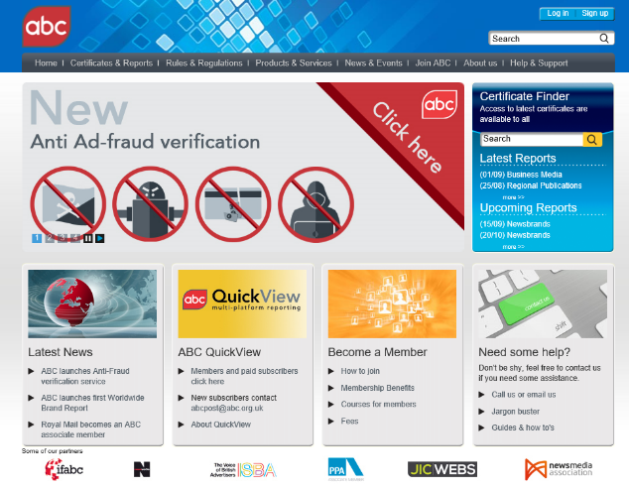
ABC (Audit Bureau of Circulations), the industry body for media measurement.
They inspire market confidence by delivering a valued stamp of trust across the media world. Their data is used by a wide range of decision makers: Media owners, Media agencies, Advertisers, Rights owners, Investors and Management.
The Board will include representatives from advertisers, media agencies, media owners and trade bodies. They represent the interests of the media industry and meet regularly to agree new standards for industry data and processes and to agree the strategy for ABC as an organisation. As they’re a membership body, any funds generated are invested back into the business to keep it going and they have great services for their members.
CAA
The main function of the Cinema Advertising Association (CAA) is to promote and monitor the standards of cinema advertising. This does mean that they will go through numbers of tests with the cinema commercials to ensure that they are comfortable with the British Codes of Advertising, sales promotion and direct marketing. (CAP Codes). The CAA will provide the UK with market information, this is the terms of admissions and the screen numbers, these are released monthly and the screen information quarterly.

ELSPA
European Leisure Software Publishers Association (UK) Ltd in 1989, ELSPA's goal was to establish a specific and collective identity for the interactive leisure software industry across the European community. ELSPA's Membership includes almost all companies concerned with the publishing and distribution of interactive leisure software in the UK. As a gateway to Europe, ELSPA works to protect, promote and provide for the interests of all its members, as well as addressing issues that affect the industry as a whole. The ELSPA was closed in September of 2010 as it was rebranded to UKIE.
Primary content research
Interviews
I would have an interview, with the CEO of Nike, Adidas and Converse. The interview would be a great thing to do as I could get tips and information about how to brand the shoes and I would want to speak to their designers to see how the design of the shoes are. This can be a good way off finding information from them. I can also have an interview with the testers as I will want to know what they thought of the shoes, the best option to do this would be through an interview and this the best way of communicating with them. If the person can’t meet up as they are busy with work/ course-work, then they can have a video chat over skype to do it. These are a few example of the questions that I would ask in the interview:
What where the trainers like to wear?
How did you come up with the idea so the trainers advert?
After wearing them constantly do they still feel like they are new and fresh?
Questionnaires
In the questionnaires I would have some photos of the trainers and there would be some questions like: What aesthetically looks appealing and then what looks the comfiest. I can then find out what students like about their trainers. I feel as if the questionnaire will be good as they it is a simple thing to do, and also if I can’t get people to do it then I will give them a bit of money to gain their views I can do this on Opinion Outpost as you will do it.
in the questionnaire I will ask the audience questions like:
What are the best type of trainers that you’d buy?
Out of any trainers you would get, why would you buy them?
The trainers that we create, what kind of price would you put on them?
Secondary research
Newspapers
A newspaper would be a good approach as I would be paying for a decent advertising space on a newspaper but the fact is, people at the ages 16-21 on average are not likely to pick up a newspaper. However, if I did the age group of 30-45 I would get a great response as this is the ages that people start reading them. This means that it is more likely that a relative of the student would notice the product; this would present the potential of them being purchased as a gift. This means that their could be a chance of putting it on a newspaper but this might also be a waste of money and time to do it.
https://www.behance.net/gallery/22388521/Adidas-shoes-Poster-Press-Advertisement --> this link is a advertisment catgalouge/ newspaper is a addidas press advertisment that has influnced me and my ideas into the ones I now have. This newspaper is a good start if I ever wanted to have one of my own.
Electronic
An electronic device are what students of 16-21 and they are things like mobile phones, computers, tablets and other devices and one of the biggest things that people do on the devices is social media, videos and video games. These can all be good ways of doing it. I was also thinking of placing the advert on a billboard in places that students go, such as shopping centres and lots of places that they like such as a club or in a busy place as it is good get the attention of more people at the same time. The electronic area is a great place in the world, the electronic things that I can do is good. The electronic equipment such as speakers and microphones could be good as that I could have a live concert to promote them as well. This will be a good idea as we can give away the new trainers to the audience by throwing it. I could also give away some headphones and this is what some companies have done, they team up with people and they can get some promotion themselves. I know that Pepsi has a phone, I could do this but I don’t feel like this would be well worth it.
Internet
The internet is a great source for any project, so this might be a good place to have the advert on. I can also find out information about adverts and the competitors. The internet could also be used to post videos and adverts on YouTube and this site contains videos and some of them will be trainer adverts, therefore it would be a good source of reference, I can use the videos, to see what doesn’t work, ways to improve, and importantly how to avoid what has been done before. The internet is also good to shop around and see what they are like. The Internet is a place where you can find lots of data. The internet Is a big place and if I want my company to be big then I need to make the internet show the trainer all over it. This means that the more people who know about our shoe will bring in the company more money, but money isn’t the only thing that I want, I want to create shoes that make the difference. I need to get things out there and this will be good. If I can then I will do this but the whole idea of placing the world I need to have money and this is something that my company will not have quite yet.

Research into competitors
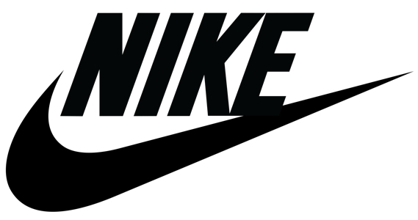
Researching competing trainer brands will give some good ideas when it comes to design, by looking at what is already on market we will give some great information on what to create or design. An advertisement which has not already been done and create something which will stick in the viewer’s head, which is great thing as a lot of people love as they can remember it better.
Nike- Is an American multinational corporation that is developing and designing and also manufacturing and worldwide market of either footwear, clothing, equipment, accessories and services. The company is one of the world's largest suppliers of athletic shoes and a is a major manufacturer of sports equipment, with them making US$24.1 billion in 2012 alone, and since then the sales and revenue has gotten bigger and bigger making it the company it is today. The company has employed more than 44,000 people worldwide. In 2014 the brand alone was valued at $19 billion, making it the most valuable brand among sports businesses. They even sponsored the Olympic games athletes with suits and shoes to fit there needs. They are also working alongside Apple computers to bring out a Nike IWatch.

Adidas- is a German Multinational company that designs and manufactures sports shoes, clothing and accessories headquartered in Herzogenaurch, Bavaria. It is the largest sportswear manufacturer in Europe and the second biggest in the world.
It is the holding company for the Adidas Group, which consists of the Reebok sportswear company TaylorMade-Adidas, golf company. Adidas owns 9.1% of FC Bayern Munich which is an Austrian fitness technology company. Adidas revenue for 2012 was listed at €24.88 billion.
The company's clothing and shoe designs typically feature three parallel bars, and the same motif is incorporated into Adidas's current official logo. The brand name is appropriately un-capitalized, with a lower case "a".

Vans- is an American manufacturer of shoes, based in California. The company also produces clothing and other products such as T-shirts, hoodies, socks, hats, and backpacks. Since August 2013, the brand has invested heavily in the action sports industry and sponsors skateboarding, surfing, snowboarding, BMX, and motocross teams. Since 1996, the company has also been the primary sponsor of the annual Vans Warped Tour traveling Music festival, this is mainly rock artists but it is a gift from Vans to their customers. The company built its first free skate park in Huntington Beach California which was opened to the public since 2014. It includes a 17,500-square-foot (1,630 m²) skate bowl and a 25,000-square-foot (2,300 m²) skate plaza. The park is 42,500 square feet (3,950 m²) and Vans pays the city US$1million per year for the 20-year lease. This park is open 7 days a week. This is a great way to bring in their customers and to make them feel happier, this is a great way promote themselves and it is unique to them.

Converse- is an American shoe company with a production output that primarily consists of clothing, skating shoes and lifestyle brand footwear. Converse is known as one of America's most iconic footwear companies. Converse manufactures its products under the names of Chuck Taylor All-Star, John Varvatos and Jack Purcell. In addition to clothing and footwear, the company sells other items globally through retailers in over 160 countries and through approximately 75 company-owned retail stores across the United States, and employed 2,658 in the U.S. in 2015. This has been improved since then, plus this means that people can get the footwear at a lower price than they were when they were released about a few moths before. In 1986, Converse released "The Weapon" basketball shoe. Manufactured in two color schemes to match the kit colors of basketball teams, it has been available in both high-top and low cut varieties. this shoe has a leather construction throughout, including the inside heel which is also heavily padded for comfort. That was the first type of basketball shoe from them. Several special editions of Converse shoes have been made, including DC Comics, Pink Floyd, ACDC, Green-Day, Black Sabbath. The Control, green, brown or camouflage edition, Super Mario. Three new designs were created for high tops, inspired by The Who.

All of these companies promote their company in different unique ways that are special about them. Which is great.
Research into market.
The market we are looking into is the shoe market, footwear is a popular market and it has not left much opportunity for new ideas which have not already been used, by other companies. This would mean that I need to generate my own ideas;. Rather than looking at the design and materials used in just trainers it would be wise to research the entire market, looking at different types of shoes, I have noticed with my own use that most shoes are made for comfort and style offer little to no support, however the more practical shoes or business shoes are supportive but have a lack of comfort. This means that I can use this to my advantage as I can make them comforting, supportive and stylish.
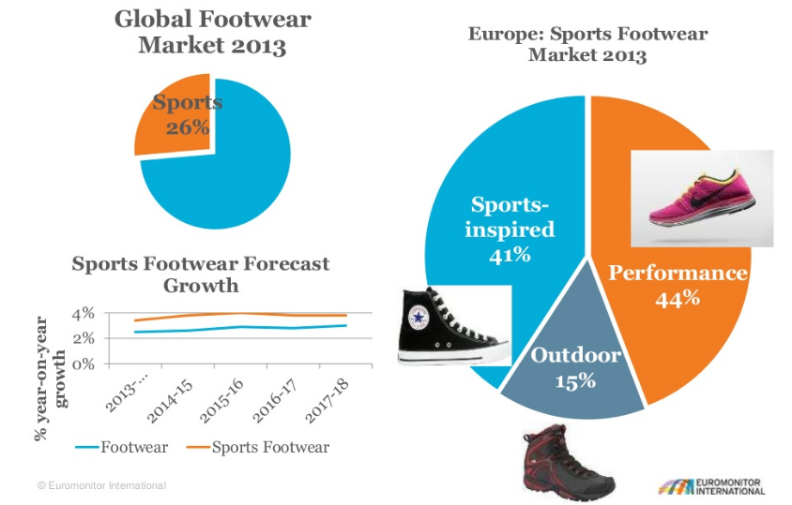
The global footwear industry has been experiencing rapid expansion, primarily due to rapid demand for new and innovative footwear products worldwide. Due to advancements in manufacturing processes, technology innovation and integration, modern, trendy, and comfortable shoes are being continuously developed at reasonable prices in order to keep pace with the growing demand for these products. Different international brands are merging sportswear with fashion wear nowadays. In addition, there has been a surge in health and fitness activities among consumers worldwide, particularly in running and other sports. This is leading sports brands are continuously involved in the manufacturing of technically sophisticated and innovative products. The following are the biggest places in the world that in the the footwear market: U.S, Canada, Rest of North America, U.K., Germany, France, Russia, Italy, Rest of Europe, China, India, Japan, Australia, Rest of Asia Pacific, South America, Middle East, Africa

