Research of children’s programs
Audience
Definition: Audience is a group of spectators at a public event; listeners or viewers collectively they will be enthused or they are just there to listen.
Age
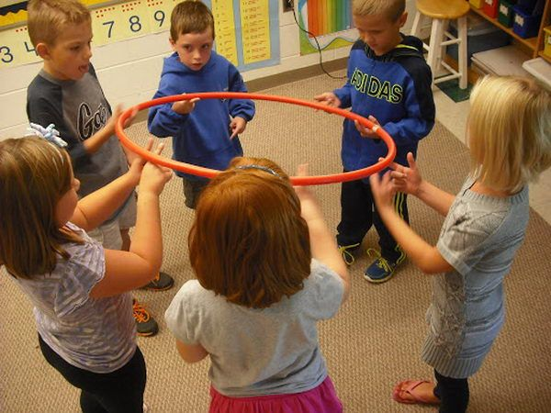
The age range for this task will be people aged 3-6 these people are the age and the target audience will usually start to look at television as a way to learn new things and advance and start their life. They will also not a big attention span, so it needs to be quick and so that they don’t get very bored. Ages 5-7 involves a more interactive approach and more complex plot elements. Most shows are targeted at their audience, but are designed to be entertaining to children above or below the target audience.
Gender
The gender of main people that will watch the shows can vary it depends on what the people would like, such as a show like Everything’s Rosie it is biased around a girl called Rosie so this attracts the girls gender, a show like Little Roy attracts the gender of boys. A show like Mister maker can be for both ages as it shows some creative thinking and this is the kind of thing I would like to go for.
Interests
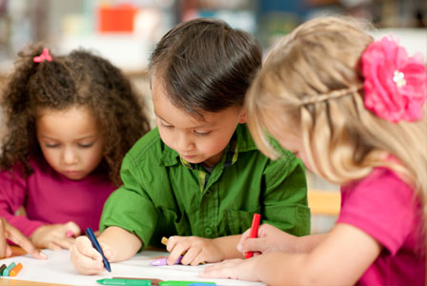
A person’s interests can be influenced into the kind of thing that people watch, so if a person watches the Thomas the tank engine as a show they will love trains and they will play with them, if someone also watched something like a creative show they will like the art of craft so they might get some Lego when they are a bit older. The kind of shows make the person interested in they can make people get into the mood of things and this would be a good idea. If I do something as if It was underwater or to do with water, then the children will want to learn how to swim.
Taste
Different ages will have different tastes in the animation. Boys will prefer car and action animations while girls would prefer for example fairy or pixie animations. Producing an animation that will appeal to both genders is the key to a popular show. I want to use the idea of something that people will like and that is going to be a good idea. I need to make people happy and they want the taste to be good.
Viewing context
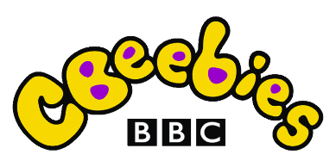
Most children at the ages of about 5+ will watch shows on networks such as Cbeebies, cartoon network, CBBC CITV, the shows that are featured are often made for the slightly older children to use, as they will start to advance their learning and they want things to move on and they can do this with the use of Tv. With the advancement of technology, children can now view and interact with the content on the web making the shows more popular.
I will now in red talk about the show in the night garden, this program is about some characters that go around and play with each other before they go to sleep, this program is good as it does tells the audience and children that they could do with falling asleep at some point. Igglepiggle, Upsy Daisy, Makka Pakka and friends. Play games and sing songs. The characters are Important as the children can relate to this. This program is good for the people at this age as they will be running around and playing a lot as they will have just lots of fun, but then this shoe tells them to slow down and then helps them go to sleep and this is a good thing as it makes them happy. The gender of this show is good as there isn’t vary many people in it and the characters aren’t overpowering. This show inspires the children that watch the show as it shows them that they need to rest and they shouldn’t do very much as they sometimes just need to rest. In the night garden are all there and they look like they should be cuddled and this is why people like it, the viewing context is also not too overpowering as people can watch this as it does have lots of words in it.
Production ideas
Storyline
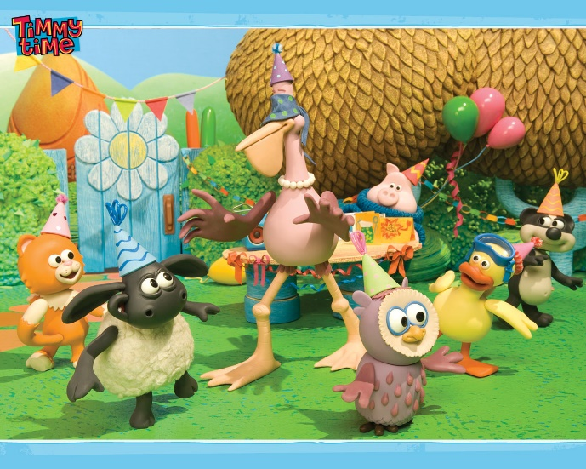
Children’s shows mostly have a set of characters that are shown throughout each episode. There are no specific plot elements that follow through the series, what happens in one episode rarely carries into the next. They want each episode to be one of a kind, in some rare occasions they might have the odd two parted episodes and then they carry it through. But the storyline is mainly just for that one episode. The storyline of more than one episode might confuse the children and that’s not a good idea. Especially if they have to wait for one week to see the next bit to the story. The storylines in a Tv show is good and they are interesting as they can do a lot of things, but the main one is to learn and advance, this is done by showing a new thing and then they can learn from this and that will be good. After the age of 5, shows start to develop the characters more and have episodes that are linked into the main plot of the series. Children under 5 seem to enjoy shows that make them laugh and entertain them without making them think too much about the situation in the show. Each time Timmy time comes onto the television it is a different story and this is good as people can watch it without struggling and this is what can be good. Also with Timmy time the show is colourful; and bright and this is what is good as it keeps them interested in it and that is good.
Sets
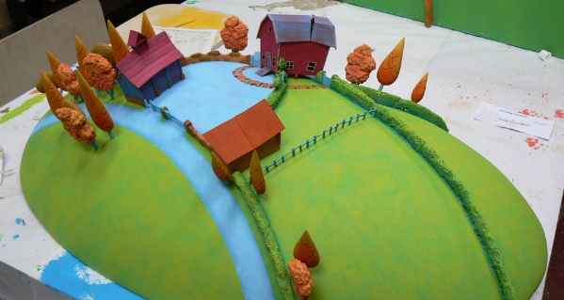
A set is something that can be used in the filming process that the characters can interact with and that would be good, so if you wanted the story to be about a character that is learning about time then the character will need a clock as a visual aid to help them out. The sets can be basic but they need to be effective and that’s what it will be about. The sets can be really big this can have the use of grass or a house, but these need to be created well. The sets will be needing to be created and their needs to be a budget and whatever the budget is you might need to cut down on a few things or it could be really good and that’s will be making it better. A set might also be restricted to time and resources and this is what everyone will struggle with. The sets like in the image above are good in Timmy time as they are used to make the characters look like they are in a forest area and this is what is good and then we can see that the animals are used in it are made to look like they are supposed to be there, as you wouldn’t have a fish into the dessert. The Timmy time show set is made to look like the whole place is a nursery and that the people are there to make the characters are going to be good. The characters their make the place look like they are learning and that’s what will be good.
Backgrounds
The backgrounds on a Claymation set will usually be static and won’t move, this will also be big as It needs to cover a different stage. The backgrounds in many children’s animations are the simplest. Effects like sun and cloud movement can be edited in using software. Usually a basic sky background will be painted, or in some cases green screening is used for special effects. In some productions such as Wallace and Gromit, the sets can reflect the level of detail in the animation including realistic cloud and sun effects. The background will also be bigger than the box or set as they will be curved around to make the feel like it is an extended background, this can give it more of a realistic background. This will also be placed a fair way back so that you feel like you’re going to be more immersed and that’s good. The backgrounds for Timmy time are usually placed on after as the set will be in front of a green screen and then this will be good to do as it will be made in a photo editor so that the background will work out good. The Timmy time show background is made to look like the whole place is a nursery and that the people are there to make the characters are going to be good. The characters their make the place look like they are learning and that’s what will be good, so throught the window you might see a small crack as they will have the swing outside.
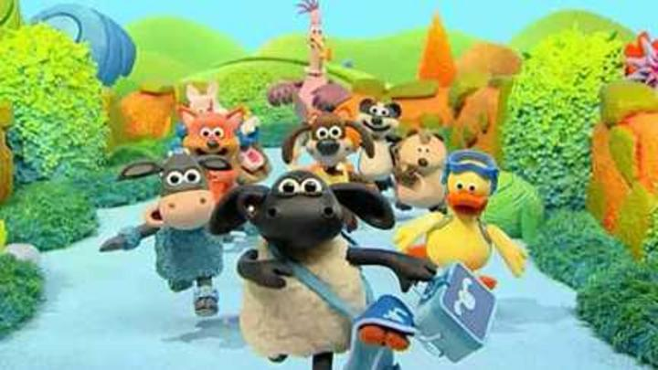
Scenarios
As many of the children’s animations are focused around individual adventures within the episodes, the scenarios in which they take place generally follow certain unwritten rules. Firstly, they will include the main character, to introduce any plot of the story or help it along; this makes it easier for the child to relate to the episode, even if it is focused on another character, so if it is biased in the water you can’t in another episode have it in the city, as the children might get confused and they might think it’s a new series and they will be lost, secondly there will be needing to have used the set as it won’t be good and it won’t fit. And the scenario has to be very simplistic, if there is a plot or story, it has to be simple enough for an under 5 to follow it and that’s what needs to happen. The scenarios in the Timmy time arte a different story in every different episode and this is good as people can watch it without struggling and this is what can be good. Also with Timmy time the show is colourful; and bright and this is what is good as it keeps them interested in it and that is good, as it attracts the viewers.
Audio
Each children’s animation has an extra soundtrack. Most have voice over’s, but not all are English speaking. Pingu for instance has a voice over, but the dialogue is all squeaking between the characters, this is just sounds and different noises. As children under 5 haven’t developed intellectually as much as older children, they are far more likely to notice the audio in the animation. The audio can make the difference between a dull uninteresting animation, and one that is very fun and entertaining to the younger audience, this needs to be used to make the audience interested into and that’s what it will have. The audio for Timmy time is not bad as they used real-life sounds for the characters, they will have a sheep’s bah for the voice but they do it in such a way that you can kind of tell what they are saying.
Possible formats
Plasticine animation (Claymation)
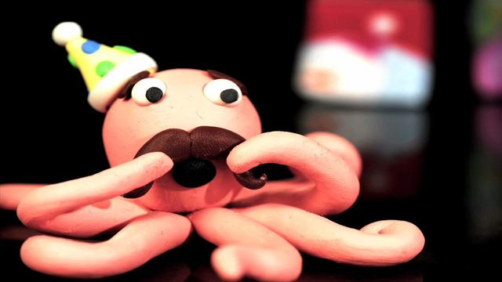
Clay animation (or Claymation as it is known) means each animated piece in the set, be it characters or backgrounds, is deformable and usually made of plasticine clay and sculpted around a wire skeleton, which you will be able to move around so that it just does not stop. The animation process is done in a similar way to other types of stop-motion animation. Each frame, or still picture, is recorded on film or digital media and then played back at a rapid phase. When played back at a frame rate greater than 10–12 frames per second, a fairly convincing illusion of continuous motion is achieved. The frames that are created are taken before and then you then move it a bit a then it should look like it is moving. One big company called Aardman uses the exact same method and that I can use to look at is the Claymation effects that they have, Although Aardman are famously known for their Claymation productions, there are actual elements of a mixture of formats even though the main appearances of the characters are constructed with plasticine. They are famous and the plasticine models are used on a day to day system. The famous TV children cartoon series that Aardman have created are the shows like Wallace & Gromit, Shaun the Sheep, Morph and the newest Timmy Time.

