Report on the Theory of Digital Graphics

Artistic styles used in computer games
Photorealism
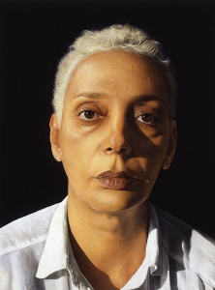
Photorealism is a type of art that when an artist uses the use of a photo taken by a camera and then you use this then you re-create this in another form then to make it different, people can use various different methods like; Painting, Drawing and using different graphic media. Photorealism is an impressive kind of art as it can take a long time to do and this is with the use of dedication and that’s important. This kind of art started to pop up in the late 1960s and early 1970s. The movement came about within the same period and context as Conceptual art, Pop Art, and Minimalism and expressed a strong interest in realism in art, over that of idealism and abstraction. The picture on the right is some work from a photorealist called Michael Gaskell and this is amazing as it looks like it is a photograph but it isn’t as it has been drawn. Photorealism shows that a computer generated graphic can look as real as real life, so that the game is more captivating. Photorealism isn’t being used a lot in the industry especially as it takes a lot of time to do and this would make the development of the game take too long, like the game can be made and then you have to extend and the game would just take a long time. It is very competitive in the gaming industry as companies are competing to have the most realistic looking game. The most realistic game at the moment is the Grand Theft Auto Five game and this is made through the use of Motion capture and that is what the game will be about and the photorealism is an interesting method but it just takes too long.
Cell-shading
Cell shading is a form of non- photorealistic art rendering that has been designed to make a 3D computer graphic. The cell-shading method is used to make 3D computer graphics appear to be flat by using less shading colour instead of a shade gradient or tints and shades as this would create more of a 3D effect. It is common for the characters to mainly be of block colours will minimal/some shading and highlights. The cell shading needs to be implemented into any game and it is mainly going to be used for the 3d models and characters. This process is fairly simple, first you have to draw the object, then secondly you have to draw the outline of the object with a texture and then you use a concept of shading and then work out how to do this. The shading object will need to be different as it will be to do with movements and then this has lots of different programing as the shading and shadows don’t stay the same throughout everything.
Abstraction
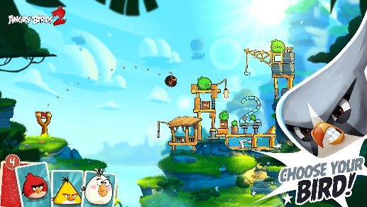
Abstraction games can be made using any platform with any pixel rate. Abstraction games tend to use a lot of colour and they use lots of basic shaping and different models. An example of an abstraction game would be angry birds as this game is very good and addictive to play with lots of different levels into it. The goal is to destroy the tower only with the birds and bird types they have given you, these will change throughout the different levels. In general abstraction the main goal is to survive as long as possible, in this case (angry birds) it is to get as far as possible, using the birds that you have in the littlest of moves as you can gain lots from it. Abstraction games don’t tend to have a plot or running storyline as the goal is to survive. Abstraction games such as angry birds have score charts where you can see what score you have compared to other players online.

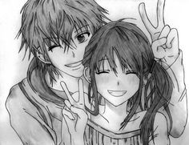
Exaggeration
Anime- Is a type of ‘cartoon’ film has very exaggerated features as their own kind of anime style the creators and designers like to make certain parts of the characters exaggerated to give them a certain look, they are Japanese normally and they are then created like this with exaggerated style on top. A common exaggeration of a female character is large eyes, brightly coloured hair/eyes and disproportionate bodies/enhancing certain parts of the body, they are an interesting design and not everybody likes this about them. A typical exaggerated look for male characters Is smaller eyes, overall broad shoulders, very tall, bright coloured hair/eyes. Anime has become so popular that anime ‘style’ is now making it into the gaming industry and has been for a few years now, this gaming community are getting bigger and the anime kind of style is also quite good as well nowadays. It can be created in either 2D or 3D, 3 dimensional models, motion capture. Some popular anime style games would be final fantasy, Kingdom hearts and Pokémon. These games are also made into a tv series like the pokemon adventures.
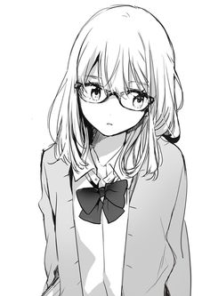
Manga- Manga games are like dolls but virtual and then you have the chance of making them look the way you want. This can be done by changing their hair/makeup. In each of these games the player is given an anime graphic on their screen and then they can interact with it and making the person wear clothing that you want them to wear and then you can play with them then in another world this type of game doesn’t take a long time as them isn’t very much things to do other than just playing dress up. An example of a manga game is called Kingdom hearts. A manga game would only need one person and wouldn’t take too long to make. The main difference between manga and anime is that anime will have animation and the characters will move, talk and are interactive there are also playable characters and non-playable characters and tend to be in 3D whereas a manga game is a commonly a 2D game where it is a still image and isn’t interactive. A manga kind of game would usually be for the mobile device market or online as people don’t want to spend a long time on a game that you will be able to play for only a few minutes. These types of games will be played by young girls as they want to learn about manga but they don’t want to be getting into anything to much yet and they will just be able to download it on a mobile device or on a tablet and play it so they don’t get bored.
Graphics research
Picture element
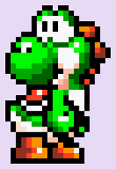
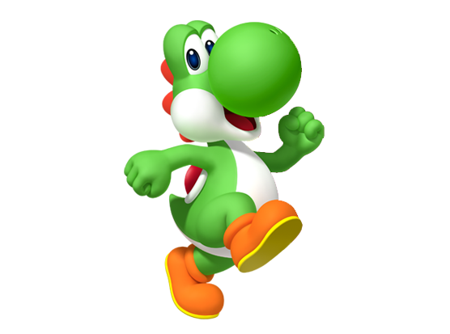
A pixel is what an image or picture is made up of. This is represented by thousands and thousands of different pixels. Pixels are shown and produced as different squares horizontally and vertically, they are all joined together like a square grid. Each and every square has a different colour, you will never get a pixel with two or more colours inside.

Image resolution
Each photo or image has a different resolution which is the total number of pixels, so if you had an images with a low resolution it will be easier to see the pixels, whereas if you had a high resolution image it would be much harder to see the pixels. The image resolution can change as you edit and stretch the image, but you will definitely see the pixels clearer.
As you can see from the left picture it is very pixelated and unrecognisable. Whereas the right photo isn’t and you can see it.
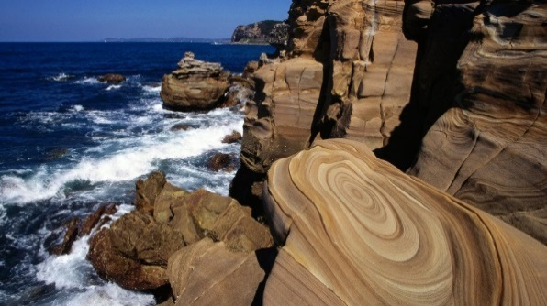
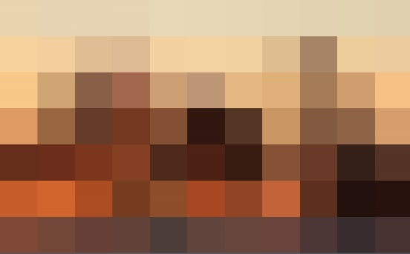

Colour Intensity
The intensity in pictures has three colour channels and these are; yellow, blue and red. You will use these different colours to create different atmospheres like bright, light and dark. You will be able to change the intensity of your picture by yourself through bundles of colour. The more intense you make the colour the sharper the photo will be.
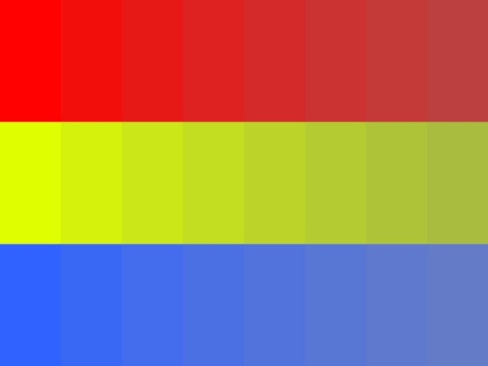

Raster images
Data compression
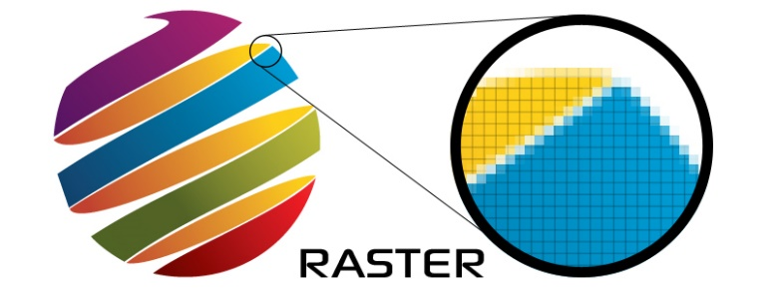
Data compression is a technique that is used for reducing a file size of different images, so it allows the images to be stored onto something like a disc. The quality of an image is reduced when compared images so some of the information is lost and this makes the file size a lot smaller. The high resolution can’t be scaled on raster images as it leads to disadvantages of the image losing quality in the picture being a high resolution. On the other hand, lossless is when images can be undone and can be a result of the picture being in a high resolution, this is used for vector graphics is because the size will be same quality. Raster images are used in paint programs such as Photoshop. A raster image is also called a bitmap. Raster images can take a whole range of formats. A digital camera has the default format as a PNG, but this is hard for people like photographers as they can’t edit them as well as they like, so these photographers will change the file format from a PNG to a raw file. A raw file is a file that will capture the original state, but it will add the image presents. These are things like ISO, Colour temp and f-stop. The raw file can still keep the original data in case you don’t like the new effects. The raw file images is good for photographers as it can give them some more help in other programs. These are some raw file extensions: NEF (Nikon), CR2 (Cannon), ORF (Olympus), there are many more.
Image formats
BMP – (Best Management Practices). This is an image format used to store bitmap digital images for Microsoft Windows and OS operating systems.
PNG – (Portable Network Graphics). This is a raster image file format that can support lossless data compression. A PNG was created as an improved and as a replacement for GIFS. A PNG is designed so that you can transfer it through the internet, this image type is not recommended for printing. A PNG will allow and support transparency. A PNG cannot be used to scale as it will not look good. This is a raster type image.
GIF – (Graphics Interchange Format). This is a bitmap image format that has been used on the World Wide Web and its wide support and portability. A gif is use specifically for online uses. A gif can be used for animation as there are small file sizes and supports transparency. A gif is like a PNG but a lower quality. This is a raster type image.
TIFF – (Tagged Image File Format). This is used to store grey-scale data, it is the normal format for scanned images, and exporting grey-scale and colour images to other programs.
JPG – (Joint Photographic Experts Group). This is the same as a GIF but can contains more colours, and usually results in loss of quality. A JPG is mainly used for high quality photos and will not support any transparency. A jpeg is not recommended for printing as it won’t be a good quality. This is a raster type image.
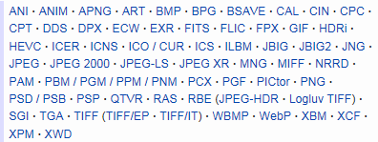
PSD – (Photoshop Data File). This is used on Photoshop which is a graphics editing program. It is a file format that is made up from layers which are joined together. This has a lot of support when it comes to layers, in Photoshop you will use a lot of layers like this is to create what you want. This is a raster image type.

Vector images
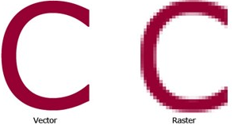
Vector images are more flexible than Raster images because they can be recognised more easily as they can be resized and stretched. Vector images are known to look better on devices like monitors and printers as they change depending on the device resolution. Vector images are created on software’s like Adobe illustrator, Corel draw and many others.
You will find a vector image in logos as you can rescale them. They are used for mapping software, which means you can zoom in and out to find different places or find smaller routes. A vector image can be used in cartoons as you can see them in a better quality.

Zoomed in

EPS – (Encapsulated Postscript Vector Graphics). This is a file extension that contains text as well as graphics. It will also contain a bitmap version of the image for simpler viewing.
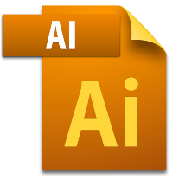
AI – (Adobe Illustrator Artwork). This is the file extension for adobe illustrator, it is used to represent single- page vector-based drawings in EPS or PDF.
FLA – (Flash Document). This is a file that can be edited, but when you convert it or export the flash document it becomes a SWF document that you will be able to see in most browsers through a Flash plugin.
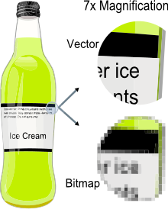
Vector images have line segments which comes between two different anchor points, a main image is made up of lots of smaller individual lines. Theses line segments are what makes up a Vector image.
Vector images also have polygons to allow any paths on the image to create three or more line segments to join together. A curve will be calculated and drawn by knowing the position of two end points and the central point.
A vector image will stay the same when being moved around, this will also not have a background but a transparent background. A Raster image will have a background and this will mean you will have to crop it down and resize. A vector image is easier to use.

Bit depth
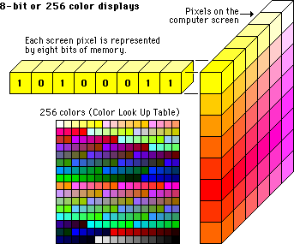
Bit depth looks at how many different colours there are in a colour palette, this is determined by how many bits are in an image. Images with a high bit rate will have more shades of colours as they have more zeros and ones in the code, for example 10100011. The bit depth will also have a high level of precision when it tries to specify the colour, inside each single pixel. These primary colours are red, green and blue these are from the colour channels. Monochrome is black, white or greyscale. This allows different shades of a colour to be stored on the computer’s memory. The High colour is a way of making different colours brighter. The true colour is a way of storing information about a big bunch of colours and shades.

Colour space
Colour space is also known as colour model; this is a system that is put in place to help you show colour in a pacific order.
Greyscale
Greyscale are different shades of Red, Green and Blue (RGB) to make up a different shades of colour. These colours have the same intensity space; this means that there is less information for each pixel. The intensity of these colours will be the same as the RGB image because there are less pixels needing less information.

RGB
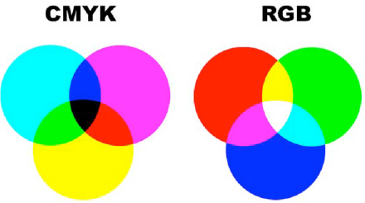
RGB is colour made up of Red, Green and Blue. These are colours that when put together make a colour that can be seen on a displayed device. These colours can also be used in changing the colour on an image, it is popular in game graphics. You will use RGB for computer monitors, email, television, all digital files. CMYK uses the colours Cyan, Magenta, Yellow and Black. CMYK also has about 1 million different colour variants, CMYK is used for posters, business cards, brochures and leaflets.

YUV
YUV is used for video and TV. The colour information is used for things like luminance, The Y is used for bandwidth or chrominance and the U V is used to reduce the chrominance. They are used when the colour is full resolution while the U and V are not good quality.
HSV
HSV stands for Hue, Saturation and Value. The Hue stands for colour. Saturation is the richness or vibrancy of the colour. The Value is the light that comes of an object.
Image capture
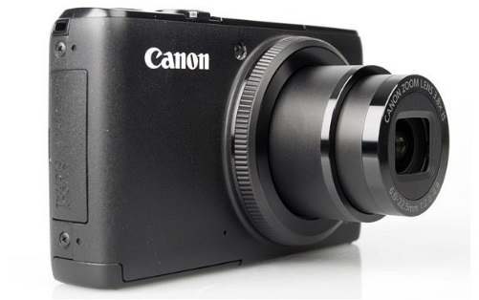
Cameras
Compact (point and shoot) £60 - £400: A compact camera is what people use if they are going on an adventure or a holiday, it is easy as it can be placed into your pocket. This is often the best choice for everyday snapshots. The problem is that it is not a high quality, it can’t work within low light so it has a built-in flash. One main problem is that you can’t change the lenses. The average resolution for a point and shoot is about 14 megapixels.
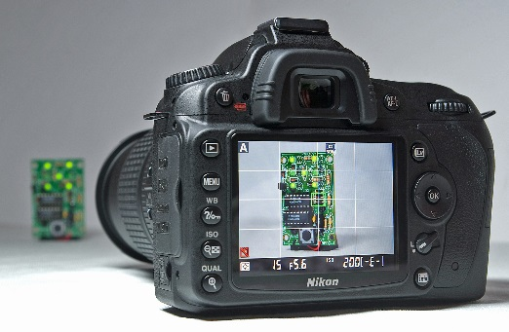
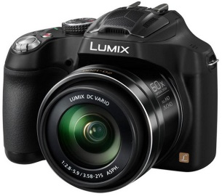
Bridge Camera £150 - £800: A bridge camera is the cross between a compact camera and a DSLR camera. The camera has the same manual controls as a DSLR but has a higher quality than a compact camera. A bridge camera has a good lens as they can reach 35x, this has a big problem as it can’t be changed. This means you can’t take it around with you as it is less portable. The average resolution for a bridge camera is about 22 to 28 megapixels.
DSLR £550- £3000+: These cameras are used for professional photographers as they have the best quality for taking images, The DSLR Cameras are easily changeable as you can change over the lenses and you get a larger quality of resolution. The problem is that they are more expensive, with this it means that you have to have money to get additional parts. The average resolution for a DSLR is about 40 to 60 megapixels.
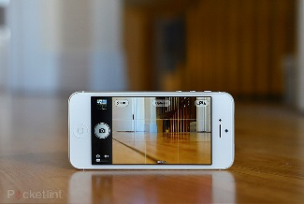
Phone camera Free - £500: Everybody has a phone that comes with a camera and this is very portable. The phones in this day in age are getting better, the new IPhone 6S has full HD 1080P and the video shoots in 4k. This is means that they are better than some DSLRS. Phones can have low quality. The average resolution for a phone can be from 8 to 20 megapixels.
Scanners
3D scanners: A 3D template can only read by 3D scanner. They are mostly used for cataloguing and archiving objects, the only problem is that you have to glue different point of reference.
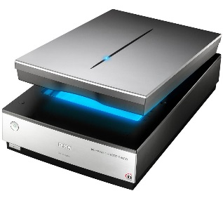
Book scanners: A book scanner is used for reading script bound documents. This has special version for scanning records and maps.
Document scanners: These are for placing real life documents onto a computer, this is then for you to print of or to edit a document, the scanner produces the file as an ADF document, this stands for Automatic Document Feeder.
There are many more.

Resolution
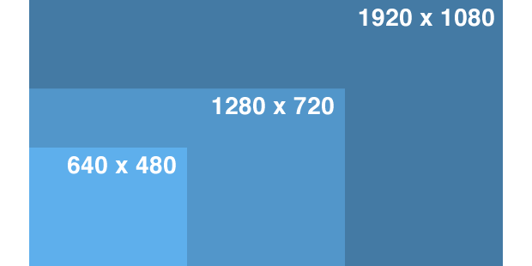
There are different sizes of resolution there is 320P which is very low to 720p and 1080P these are high resolution and are in HD quality. The main image resolution on a computer is about 72 to 96 DPI, but the print size is usually set to about 300 DPI. You can usually enlarge or adjust this through graphic software such as Photoshop. You can change to resolution through a cameras setting to get a better quality. A cheap camera will be produced at 256x256, a mid-ranged camera is 640x580 and 1216x912 and finally the best quality camera is 2240x1680.
High resolution: 300 DPI, this is used for magazines and high quality prints.
Low resolution: 75 DPI, this is used for online and screen use, this is not good for printing.

Storage
There are many different types of storage devices for different devices, every piece of electronics needs a storage type, and this is to store different types of data.
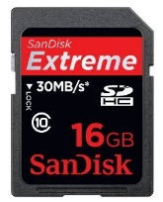
SD cards: SD cards stand for Secure Digital. You can get different sizes of them, you can also get SDHC and SDXC. These both stand for Secure Digital High Capacity and also Secure Digital eXtended Capacity. These were created so that you can fit more data on them.
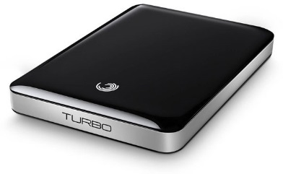
Standard- up to 2GB
High capacity- 2GB to 32GB
Extended capacity – 32GB to 2TB
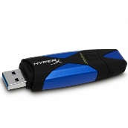
Memory sticks: A memory stick is also known as removable flash memory card that came out in 1998 by Sony. The memory stick is something that people will carry around with them on a day to day basis.
Hard drives: A hard drive can be internally inside a computer and an external hard drive is something that you can carry around but it is not too easy to do so.
Online: You can store items on the cloud, this can be done through OneDrive, iCloud, Dropbox, etc. The items you can store photos, music, documents. People can even access your account and copy the files across to their own computer.

Optimising
Optimising is used every day in the worldwide web (WWW), this happens when you get an image that is too large for the webpage, this is then resized and made sure it fits for the webpage. A disadvantage is that people won’t wait for a long time for the webpage images to load in, they will just find another website to get a picture. You can use software’s such as fireworks that will help to reduce the file size but then won’t reduce the quality. If a computer size resolution is 72ppi, then the images on the worldwide web will usually then be set to 72ppi. Some computer screens can be set to 96ppi, but the internet will just produce the images at 72ppi. The size of the image that is being viewed on the worldwide web wouldn’t make any difference because it’s to do with how it’s been viewed.
These are the Different file formats, the biggest file size is a .TIFF and a .BMP. The smallest file size is a .GIF and a .JPEG. You can use software’s such as Adobe Photoshop to generate these other file extensions.

Computer game graphics
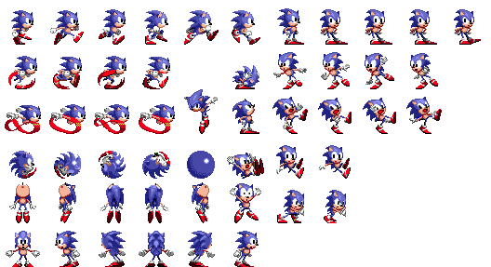
Pixel art
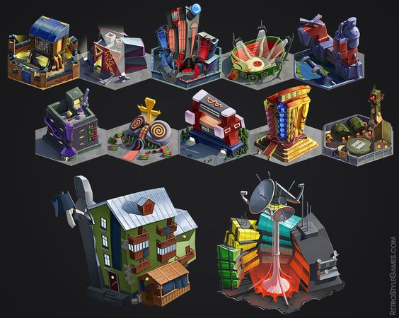
2D Sprites- A 2D sprite is an object or item or character that is in a 2Dimentional form and these sprites are interesting things. Use of the term "sprite" has expanded to refer to any two-dimensional bitmap used as part of a graphics display, even if drawn into a frame buffer (by either software or a GPU) instead of being composited on-the-fly at display time. The use of a sprite is a process that the computer uses and makes. The use of pixels is there and they will make the game retro and old. Pixelated art with the use of 2Dimentional sprites are what the games and what everything was like earlier on in the gaming history. The sonic hedgehog games are good and this is the sprites movements throughout the game and this is the pixel art for it.
3D isometric sprites- A 3D isometric sprites are where the viewpoint is rotated slightly to reveal other facets of the game environment than are typically visible from a top-down perspective or side view, thereby producing a three-dimensional effect. A 3D sprite is when something has some depth and then therefore is made to look like it is in a 3D mode this is mainly what games were trying to do in the early stages of gaming and then this took off and now everything is made to look like this. The 3D perspective in a game is fun as it makes things look different but that is used to make some depth.
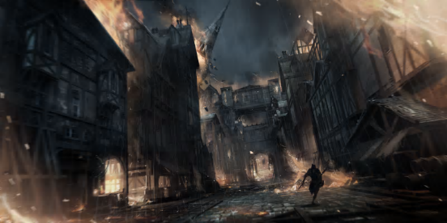
Concept art
Concept art for games are important as you will need to use this in order to get some good ideas. Concept art is a form of a image and is used to enhance an idea for use in films, video games, animation, comic books or other media before it is put into the final product, this is so that they can get a good feel for what it should be like and then you can use this to change things around without compromising any problems with it. A lot of concept art is made so that you don’t have a problem with it and a lot of people’s work will generally get rejected and put to one side as they don’t like it. The Artists will try several designs to achieve the desired result for the work, or sometimes searching for an interesting result. Designs are filtered and refined in stages to narrow down the options. The concept art for lots of games or things are made so that people have a big industry for their minds to work.
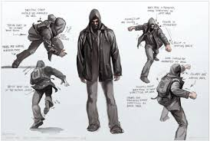
Characters
Another big thing that you need for a game is a character, once you have created the concept art for the character(s) you need to make sure you then create them into a virtual world and then they have a chance to start to adapt them and change things that they didn’t need or just didn’t like. The character needs to be fully correct and then added to a skeleton so that once they are ready they can animate it and then they will be able to be placed into the world. The character will be exciting as you can do a lot of things with that character.
Weapons
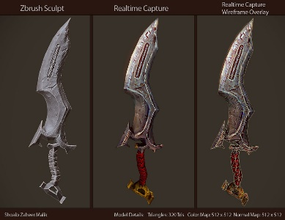
Weapons are the best thing usually about a game as you can do a lot of new things with it. The weapon is a device or interactive object that can be used to hurt or seriously harm another player or character. A lot of games use a weapon to make people aware that this game is going to be a violent game to be around. The weapon is used to make sure that people are scared and this is what makes the game fun at the same time. A weapon is made from concept art like characters but this need to inflict pain so therefore the characters will need to have some kind of a bloody clothes and that’s not easy to make so the weapons themselves are easy to make it is the other things that happen with the game around it. The body needs to be dead and this needs to look like it as it needs to have something about it.
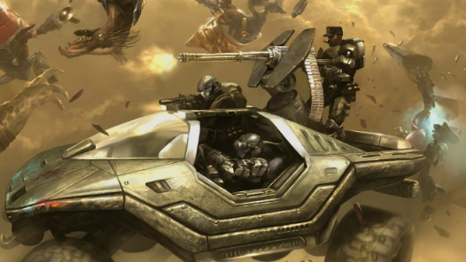
Vehicle
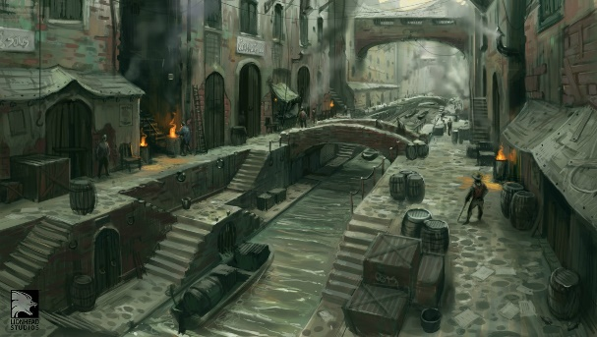
Vehicles in a game are usually used to get from one place to another faster and then making the game fun as you have to chase them or find them to do something to them. The vehicle in a game can be fun as you can get things like tanks or bomber planes and then you have to use something that you wouldn’t normally use to kill something or someone with. A vehicle might not move or do anything if it is a NPC and therefore you might be able to cause damage and pain. A vehicle in some games might and probably will be hard to control as you won’t normally know unless you’re a professional gamer. A vehicles design will have started from the start from the concept art and then designed and changed throughout different things to get to the latest designs, in some games like GTA you can use a vehicle to then modify it and then change different features about that to get the best designs.
Environment
The environment for games are different depending on what it is about. The environment is going to be interesting as you have to make the game feel realistic and the surrounding environment. The surroundings are good as they need to make the sounds and the graphics for pretty much everything. The environment needs to go with the choice of the game and the genre otherwise the people will be confused and they won’t have a lot of problems with things. The environment is a good way for people to enjoy the game more and then this is a fun thing to do and to add to it.
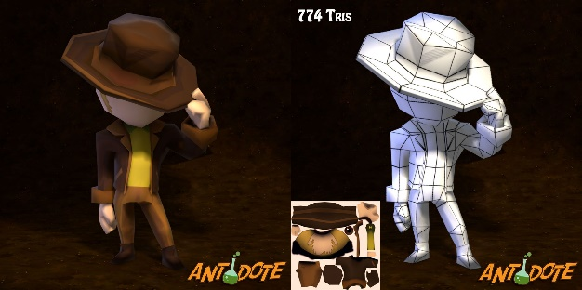
Texture art
Texture art is used on an item and then the artist adds a texture and this can then add some depth and this makes items look good. The texture art is usually added into the design process as the designers want the game to look good and this can just be a fun addition. The texture art of the games is a process that can take a long time as the game needs to look aesthetically pleasing and therefore good.
Background graphics
Walls
Walls on the background can be used to help you hide from opposing players and they can be useful for a lot of different things. The walls are going to be good as they will allow the player to hide and then take cover from people that might be attacking them and then this makes the player then be able to heal and recover health. A wall might also be used to climb on and then you can get into different areas of the map and then do all the work. The walls in a game might also be a way to block the user into not going into that section until you get to a high level and then need to go through that into the story mode and to advance it. The walls might just be used for aesthetic purposes only.
Forests
A forest in a game can be used in very many different ways. The forest in a game just will be helpful as you can hide from people and then people won’t go into your area as you can stop them from taking over. The forest can also become a non-interactive as they will just be either cartoon or just don’t do anything. The forest in a game is fun as it tells you where about’s you are instead of a colourful plain background. The forest means that there could be a survival element to it and this also might have some dangerous animals in their as well. The forest might also tell people that they are going to be set in a primitive land or this place that they are in is going to be a place that hasn’t been built up yet. 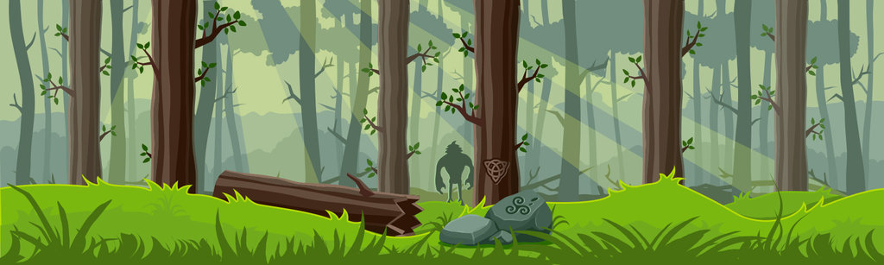
Clouds
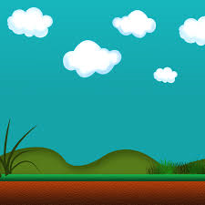
Clouds in a game are used to make the game feel more realistic and that makes it more fun. Clouds can be animated so they move but this makes the game more fun but this needs to have the physical side to it and this is something that could be a problem as you need to make sure that it goes at a certain speed and that it looks like it should do. The clouds in a game are used to make it realistic and it can just be an addition to whatever the game will be. You can even colour the clouds if it is a war game as it makes the battlefield grimmer and more dark. The clouds are also used to make it rain and that is fun and they need to implement this into the game as it needs to have water coming out of the clouds and then you also have puddles on the floor.
In-game interface (IGN) + Head up Display (HUD)
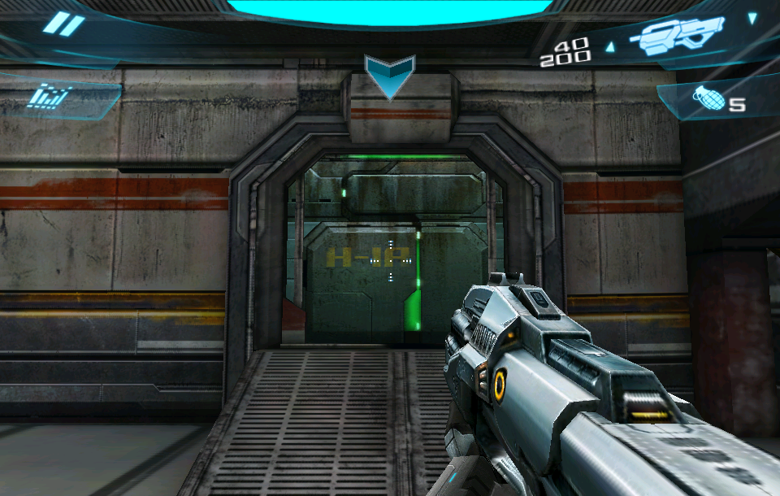
An in game interface is a layered graphic that shows the different things on the player. The HUD is used in a game to tell the gamer whatever the game creator wants us to see. The HUD is exciting as you can see what the map looks like in the top corner usually and if you have a weapon out in your hand then you can see the armour and the amount of bullets that you have left for that particular weapon. The HUD is used to make the display on the screen easy to see, another thing that is good is the fact that if you had a chat group you will also be able to see this as well. The HUD might be a bit different if your character is wearing a helmet as it will be visibly restricted and hard to see as the game needs to be the same throughout. The vehicle settings and seeing distance is also going to be hard to see as you’re going to be in something like a plane and you can see all the normal controls.
Print Media art
Game packaging (Console cover/ box)
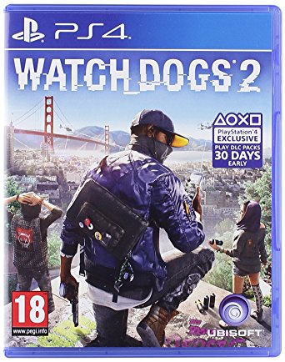
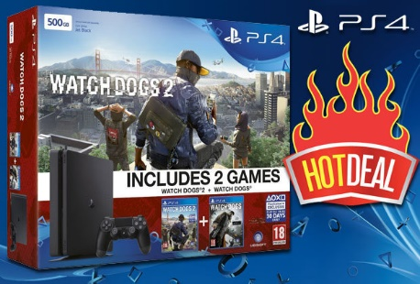
If you create a game and you are partnered up with a company such as Sony and Microsoft. Then you can use a character or some type of graphic or concept art so that people will buy that one as it could be a limited edition console. You can also get custom skins that you could put onto the console about that specific game. Games are usually included as a bundle or a deal so you will get promotional images and screenplay and logo of that game as it is a new one.
Box Cover (DVD container)
A box is used in a game to promote the content on the disk, the disk will usually have a detail set of information, the story about the game. It will also have a logo, title and the brand of the people who created it. There will also be an age rating from Pegi and this means that they have to be a certain age to buy it. The box cover is important as well as it will keep the disk in place and safe so that people don’t lose it or get the disk scratched. The box is a unique way to sell the game without them ever actually seeing anything.
A3 Poster.
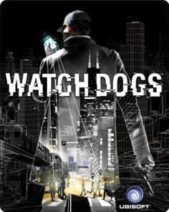
A A3 poster is like a Box cover as it will show the games character and then this makes it so you will be interested by this in that game. The poster will show a lot of the cool features on it, it also might show a release date of when it will be coming out. The poster will be pretty simple and plain as they don’t what them to show to much of the game away and this game will be good to see as a different perspective as well. A poster is just another way of selling the game to the market as they see it in their minds.

