Other competitors
Red bull
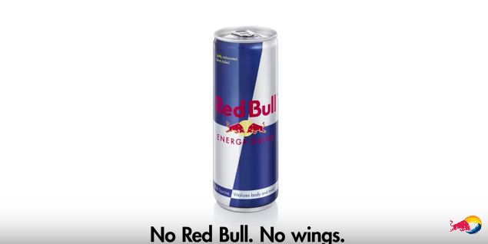
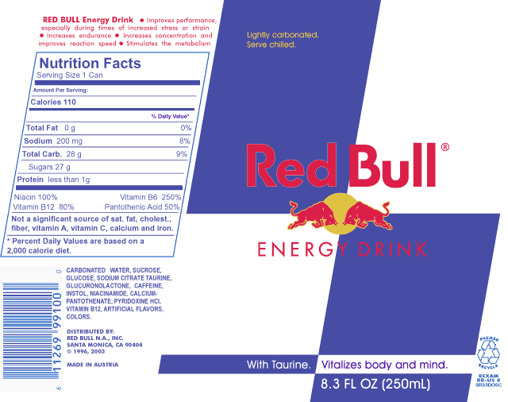
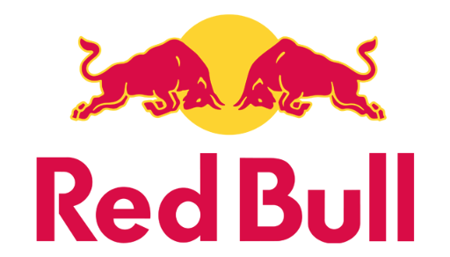
Red Bull is an energy drink sold by Austrian company, this was created in 1987. In terms of market share, Red Bull is the highest-selling energy drink in the world, with 5.387 billion cans sold each year. This drink contains caffeine, taurine, B vitamins (B3, B5, B6, B12), sucrose, and glucose. This is an Australian company but it sold and drunk in lots of companies across the world. The net worth of red bull is around $5.3bn. Red bull has made many different variants of it, these include; Original, Sugar-free, Cola, Total Zero, Red Edition, Blue Edition, Yellow Edition, Lime Edition, Silver Edition, F1 Edition, Orange Edition Zero and Cherry Edition Zero. The red bull logo is 2 bulls in red about to fight each other. Red Bull's slogan was "it gives you wings" until they were hit with a $13 million class action lawsuit in late 2014. Red Bull's international marketing campaign targets young men mostly with extreme sports. These range from mountain biking, BMX, motocross, windsurfing, snowboarding, skateboarding, kayaking, rowing, wakeboarding, cliff-diving, surfing, skating, freestyle motocross, rally, Formula 1 racing, to breakdancing. They advertise their company most on Formula 1 racing cars, an average can of red bull costs around £4 for a pack of 4, which is quite pricey. Red bull has a few adverts over its time, one of these advert consists that these two animated people are stuck on an island and then a voice says “No red bull, No Wings.” This is to promote their catch line which is “red bull gives you wings”. There are a few advert that are in an animated cartoon way. They also have made an advert in 2010 which consisted of two people who have travelled a long way to ask a gene to get some energy, then the gene gives them the red bull. It then comes up with an image of the can and the narrator says red bull gives you wings. From this I have realized that red bull make there adverts in a cartoon/ animated way.
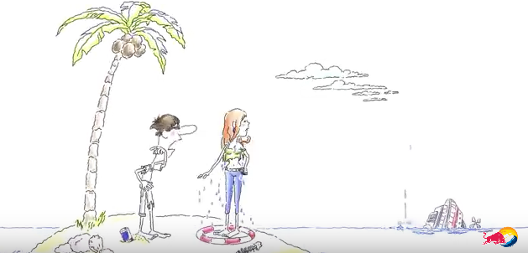
Red Bull advert 2010 ad: https://www.youtube.com/watch?v=LbtKAXaf9QA
Red Bull advert 2015 ad: https://www.youtube.com/watch?v=8rd3_ybdckQ

Monster Energy
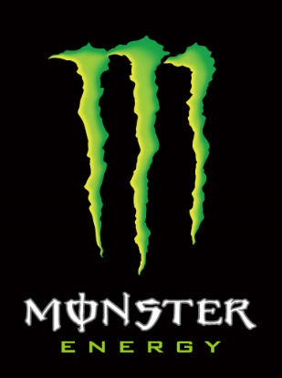
Monster Energy is an energy drink introduced by Hansen Natural Corp in April 2002. The company is also known for supporting many extreme sports events such as BMX, Motocross, Speedway, skateboarding and snowboarding, as well as eSports. As well as supporting all kinds of different sports the Monster Energy drink also promotes a number of music bands, like Asking Alexandria and The Word Alive. Monster energy has 34 drinks in its brand in North America including, Java Monster, Extra Strength, Import, Rehab and Muscle Monster. This company sells around 4 billion cans each year making around $1.9bn to $3.5bn. There are different types of flavour from; Regular, Low-Carb, Cuba Lima, Absolutely Zero Übermonster, Assault, Khaos, M-80, Import, M3, VR46. Monster sponsor mostly on BMX and bike, this is where they mainly get their money from. The caffeine content of most Monster Energy drinks is approximately 10 mg/oz (33.81 mg/100ml), or 160 mg for a 16 oz can. This drink by the officials are not recommended for pregnant women or people sensitive to caffeine, this is in place to warning people that they might need to be careful. A monster can cost about £1.35 for a 500ml can. Monster Energy’s logo is very distinct and can be recognized easily at events. The design was created by a California-based strategic branding firm. The logo is made up of a vibrant large green ″M″ on a black background. The monster company when advertising they do videos of their sponsors, they haven’t made an official advert. They have some videos where they have their M stamped on vehicles, with sports.
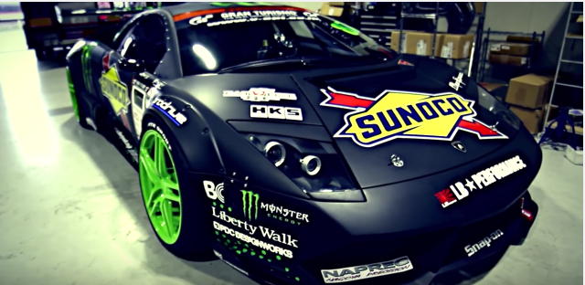
Monster DOONIES 2 Vid: https://www.youtube.com/watch?v=2J8dtE9mlBg

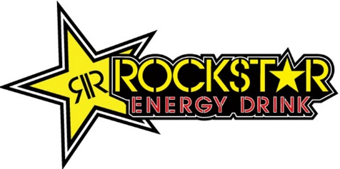
Rockstar
Rockstar which is branded ROCKST★R this company was founded in 1998 and then was released to the public in 2001. Most of the people that drink it is in the US market in 2001. Rockstar is based in Las Vegas, Nevada. From January 2013, Rockstar Energy Drink is available in more than twenty flavours, and is in more than thirty countries. The types of drink flavours are; Energy cola, Guava Punched, Horchata, Juiced Guava, Juiced Mango, Organic Island fruit, Original, PerfectBerry, Punched, Pure Zero Punched, Pure Zero Silver Ice, Recovery Grape, Recovery Lemonade, Recovery Orange, Recovery Tea Lemonade, Sugar Free, Super Sours Bubbleberry, Super Sours Green Apple, XDurance Performance Energy, Zero Carb. These all have different colour labels from; yellow, purple, gold, orange, white, grey, pink, black, white, green. The average price is about 98p per can. Rockstar wanted to change and differentiate itself from the market leader, Red Bull, by using a 16 oz can size and marketing itself as "twice the size of Red Bull for the same price. This made the drink sell a lot more than it did before. With this advertising scheme they had reacted number one of the top three energy drink brands in North America, they had sold over a billion cans. It had 14% of the US energy drink market in 2008, and as of 2009 was available in over 20 countries, in addition to the United States. Rockstar switched distributors from Coca-Cola to PepsiCo in the summer of 2009, as they could produce the drinks better as they had a lots of customers. As rockstar’s main competitor is red bull, they sponsored a range of action sports and music events. As rockstar has tried to make there drink popular they haven’t made an advert, but they get most of their support from music festival, especially rock concerts, this is where they got their name from.
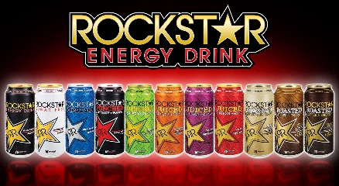

Mountain dew
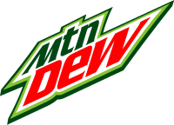
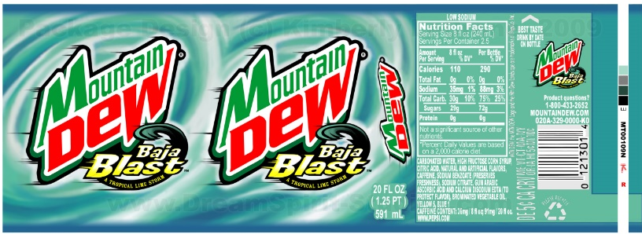
Mountain Dew (currently known as Mtn Dew in the United States) is a carbonated soft drink brand produced and owned by PepsiCo. Between the 1940s and 1980s, there was just one variety of Mountain Dew, which was citrus-flavoured and caffeinated in most markets. Mountain Dew is originally known as moonshine by the Scots and Irish. This drink is very old, but has been revamped so that it fits the new era of energy drinks. Mountain dew has Carbonated Water, Sugar, Citric Acid, Antioxidant (ascorbic acid), Caffeine, Flavourings, Preservative (Potassium sorbate), Stabiliser (Gum Arabic), Colour (Beta Carotene). They sponsor gaming, sports, music and more. A 500ml bottle costs about 99p and a pack of 24 at 330ml costs £16.95. In 2001 there was a product called “Code Red” this was basically a cherry flavour mountain dew, from this the company have sold more, as there is so many different flavours. The company first made the name as “mountain dew energy” in 1996 but then was changed in 2010 and 2011 in Ireland. Mountain dew have made a drink called Kickstart, this is where they have made all their adverts for.
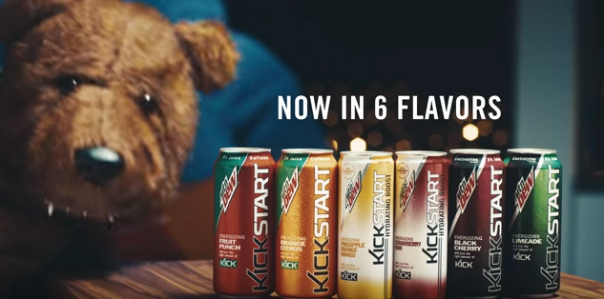
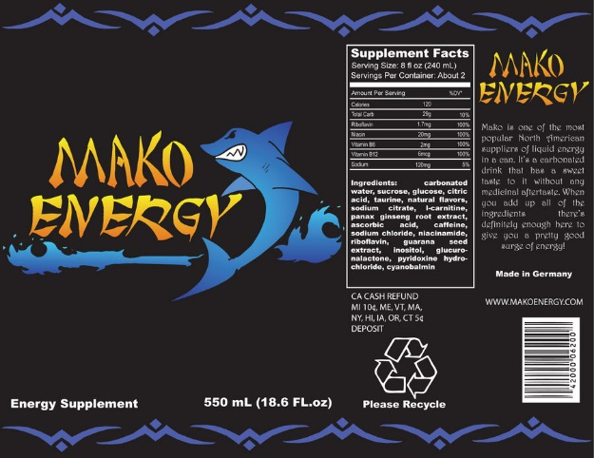
What needs to go on a label?
- Logo
- Company details – address, contact details
- Name of drink
- Text – ingredients / what the drink is
- Use by date/best before date
- Storage details
- Exclusions – allergies
- Warnings – eg High Caffeine Content
- Recycle logo
- Aluminium logo
- Barcode and product code
- Amount of liquid
- Calorie details
- Serving details – serve chilled
- Web or email details
- Catchphrase
All of this can’t be misleading.

