Proposal for the animation
Storyline
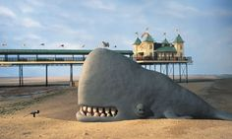
The story will be about the fact that you should not litter near the beach as it can harm the animals at sea and that we need to protect them. Therefore, I will have the child struggling to move and breathe and then the dad comes and helps his son out, then the dad says that you should never litter especially near the seaside as it can affect the wildlife as it has done with my son. Then towards the end, the whales will come together and they will say what is going to happen next time. This is a simple concept but I do feel as if the story will be good, the concept of this Is that people are just starting to learn about the sea and what can harm the animals and they will go out on day trips to the sea. Depending on how long this takes, to create I might add some different scenes onto it by having a child placing the litter in the bin, this makes it longer and then it adds people into the story to show that it is a real problem now. The subject that I will do is good as this is an important threat to the people of the world and this is going to be a big thing, we want our sea life to stay alive. So therefore, I feel like this idea can be a good idea, the whales that are going to be a good character as you would not expect it, the storyline is definitely unique, and the children will be able to see a new animal that they just might not have come across before today.
Characters
I will have two characters for this show, one will be an older and bigger whale called Wilber, the other smaller character is the son, and he will be called Swish. They need to be learning about the world, this concept will be ok to do, I could have had them in the water and then using string to keep them there. I have decided that I will have them on top of the water as if they are sticking their heads out of the water. As I will be making them out of plasticine as it is to do with Claymation, I will need a character that will take the shortest amount of time to create as I will have everything set out and ready to do the filming. The whale will be a child friendly kind of character, one of the whales will be small so that’s why I need to make them look good. As I said before I might be adding a child into the story so I will have to create that one as well. The character is going to be good as they are going to be in a Claymation style and it will be good. The characters are called Wilber as this is a name that I feel like explains the whale, the other character is called swish as it is like the waves and this is what I could think of, the other girl character doesn’t have a name as she doesn’t really speak. The girl wears a pink top and blue top. These characters make the story good as they are creative and they look like they could have been created by the children that make it.
Visualisation
I want the animation to run smooth without any hiccups; I will try to make the best out of the items that I have to offer. The visualisation that I want it to be is to be able to make the film longer but if I do this then I will be running out of time and that is not a good Idea. The visual style is Claymation, so I will have to make the characters look like they are that type. The other things I will be using is going to be about the frames will need to be thought about as they will be going at a rapid speed and the images will be weird and misplaced if they were mixed up. So I will make sure that I have a separate camera storage device so other peoples work will not be a problem. The target audience is 2-5 year olds, so I have tried to make the characters very simple and the set easy for them to understand. The animation will try to focus more on the comedy, and funny characters, to keep the children entertained. This should appeal to both girls and boys. Which it will do, as it is more informative and not too character intensive. I am hoping that eventually it will look great and that is what I want to happen.
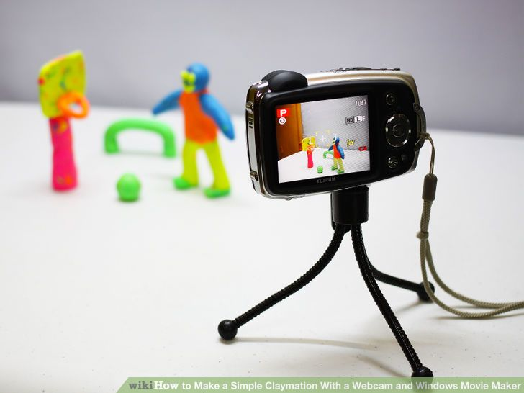
Technical limitations
I wanted to originally have them in the water but I have decided that this will take far too long to create as I will need them on string and they will just be stuck and they will move around too much for this to happen. I have had a thought and the idea being that they will be on the water and then it won’t move, I might move the card underneath that looks like the sea and I can move this side to side every 2 pics, this will make it better and it will be good. The technical limitations are the problem for a lot of things, but hopefully everything will turn out the way I want it to. If the images get corrupt or get lost then I will have a big problem with the fact that the animation shooting will be bad and that’s something that I just can’t deal with, everything needs to be correct and then the animation will work right and swiftly. If the camera gets broken or if there is, a problem then we will have a problem and the filming process and then if that happens it could place the shooting process at a distance. I might have to do it another time.
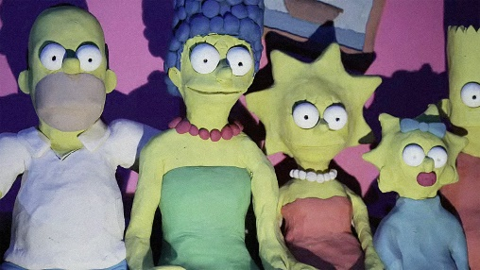
Format potential
As the format is Claymation I will have to make the images good and I won’t mess any of the numbers up but then I will also use each frame perfectly I will insert each photo into flash the same. The potential of this Claymation can be good this depends on the different colours and items that I have that I can used. I do want to have the animation to be good quality so therefore I will need a high resolution or high definition camera but I can’t as people will struggle with the fact that the space on the computer. I have done many other projects and I will need the space, I can work from an external drive, which is going to make it all look good. If the project looks, good then it could turn out to be very good and that is what I will want to have happen, but I will put the mode and settings onto a high quality to get the best result. The auto focus might be a problem but hopefully this will be ok and if not I can turn it off but hopefully this won’t come to this.
Storyline
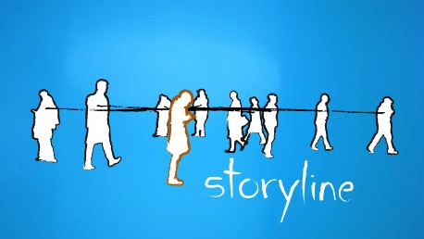
The story will be about the fact that you should not litter near the beach as it can harm the animals at sea and that we need to protect them. Therefore, I will have the child struggling to move and breathe and then the dad comes and helps his son out, then the dad says that you should never litter especially near the seaside as it can affect the wildlife as it has done with my sun. Then towards the end, the whales will come together and they will say what is going to happen next time. This is a simple concept but I do feel as if the story will be good, the concept of this Is that people are just starting to learn about the sea and what can harm the animals and they will go out on day trips to the sea. Depending on how long this takes to create I might add some different scenes onto it by having a child placing the litter in the bin, this makes it longer and then it adds people into the story to show that it is a real problem at the moment. The storyline will be good and effective as it will get the job done correctly and this will work out good. The story is one of a kind and it is going to get the point across correctly.
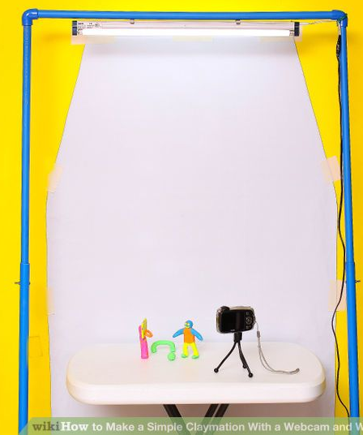
Set and props
The set is going to be simple as there is just going to be a background and then the characters; the only other prop that I will use is going to be the litter and the junk on the beach that some people have left out. The background is going to be simple but effective as it is just going to be a sea as it is going to be set there in the sea so that would then be good, I will be having the characters on the top, but it shouldn’t be that hard. If I add in the other character, then I will need to add in the bin and some other litter around the bin. The set is going to be simple as they will be into the middle of the sea and then they will just not be doing very much. The props that will be on the set/sets will be used at some point throughout.
Scenario
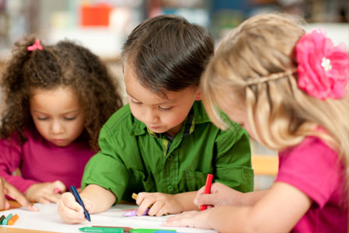
The scenario of this project is to create a 30-second pilot film for a new pre-school children’s animation program. Therefore, I have to use this to create whatever I want to make it about, I can do a number of different things but I want to teach and also give entertainment to a person that has started to learn but they need to learn into a way that benefits people. I wanted to talk about water safety as we have a lot of it inside us but they do not know what it is that can be deadly and lethal. I will also need to incorporate some storyboards, a detailed dope sheet, with some detailed characters. This animation scenario seems to be a good one, I will make the project interesting, the stop motion animation will also appeal to them and the fact that I went with a whale family makes it exciting to watch.
Target audience
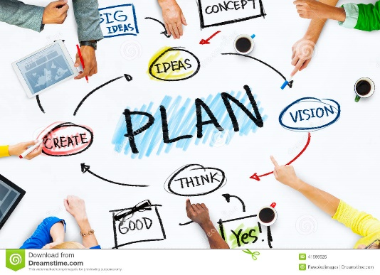
From the scenario, I will need to make sure that it will appeal to pre-school age of people, which are about 4 to 5, as they want to get some skills learnt before going into school. As most people at this age will start to enjoy certain different hobbies I have decided to make it, so that if people like the seaside or like swimming then they can learn about some of the dangers of water. I have set my programme to target both boys and girls, so it is not restricting my viewers to just one gender, its set to appeal to both. In terms of level of interest, I am guessing that most under 5 year olds have similar interests and that my theme of water so characters should appeal to all. I want my show to be popular so I have made it fun and exciting.
Planning
When thinking about planning, I will be producing drawings of each of my different characters, they won’t be that good but you will get the point of what they will turn out like. A background idea and some of the set props, which I will use throughout it. In addition to these, I will be producing some storyboards, which will give more information regarding each different animation, which is occurring during the production, the amount of frames, which I will need for each and a small picture drawing of what I want it to look like. This gives extra detail about camera positions etc. to provide readers with a real in depth idea regarding what the animation will look like.
Script.
The script will be something that when looked at the voice person will have to look at and they can see what the character will say. The script will probably will be better but here is just an example of what it will be like.
Swish: HELP!!! Dad help me.
Wilber: Its ok son I am here, (takes off the litter)
Swish: (Deep Breathe) Thanks dad, how did this happen I could not breathe.
Wilber: It is when a person does not use the bins to get rid of their rubbish.
Swish: well we should tell them, but I am scared, you say it for me.
Wilber: Okay son, (turns to camera- Zoomed in) If you don’t want sea-life to struggle then place that rubbish into the bins, Please it doesn’t take long to do.
CUTS to Girl putting the rubbish into the bin.
Cuts back.
Both: Thank you, we can now rest easily and have fun.
Cuts to end credits.

This script was the kind of idea that I was thinking about going for, as it is simple but effective.
I will make it then and I will be using a friend as they can make lots of different sounds and different voices. The audio track will be the only thing that the people will hear. The audio will have a sea wave sound over the background to make it better.

