Proposal
Client meeting
I met up with the client to have a meeting about what they want and then what I should use in this unit and this task. The meeting had been done to help me and the other people to establish and get to know what we will be doing for this Unit. I typed them down and here are the notes bellow.
Here is what I need to include and to check for:
- Working for a group called the pixels, as many people in the group, as I want.
- I am going to create promotional materials.
- I need to create a logo; I can create or use one from another Unit.
- I will need to create this onto a storyboard- detailed.
- Create an A3 poster- correct size. So right software.
- It must need the logo on it.
- The poster must include, - Dates for the tour and the venues.
- CD cover- check the size.
- In proposal, find out the size for a dual case, with the insert. – must include the Logo.
- Research the mandatory things that need to go onto a CD cover.
- Front, back and spine.
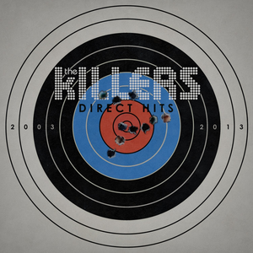
- Quality of the graphics need to be good.
- I can use Photoshop, Paint and Illustrator. Books available
Concept
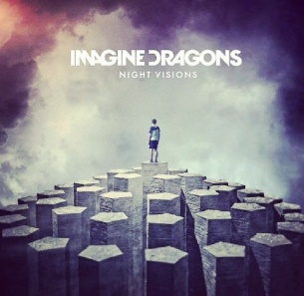
In this unit we have to come up with a bands identity and what their songs and the type of genre that the band is like. The name “the pixels” sounds like it is an electronic genre group or a pop group kind of group. Therefore, I will be going for the whole electro-pop kind of group and I will mash them together. There are many other bands that people like with this kind of genre like; the killers, Maroon 5, years and years, imagine dragons and many more. So looking over some of these covers and the style of them I have decided to go for something like this. The killers are a group that have made their genre speciality of being an electro-pop group. This album is a pain and simple kind of design but this looks great as the shooting target is like the title of the album, which is direct hits and that this fits and that it looks good. another group that is popular is imagine dragons and this is their album and this looks different as it fits more into the style and this looks different. Looking at these two groups the concept for mine looks clearer and I am happy with the genre. The group “the pixels” will consist of having a Singer, DJ, Drummer and a guitarist. I need to have a DJ as it I can have that electronic type of vibe and this is what I want to happen.
Format, Length and nature of content
For this Unit I will need to create an A3 Poster, CD cover and then a possibility of a logo if I do not use the other one. I will need to use a software that will be easy enough to navigate around. I will be using adobe Photoshop as I know how to use it and that I can use some of the harder tools, but if needed to then I could use the many YouTube videos, as they are good at explaining things. If I want to use a higher quality software then I can use illustrator. The Photoshop document format will turn out to be a .PSD file or I can create a PNG.

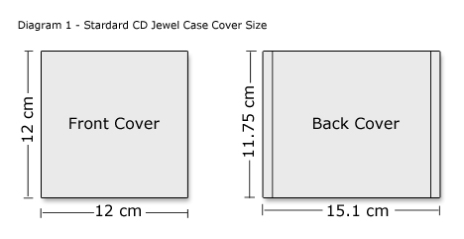
The size of an A3 piece of paper is 297mm × 420mm or 11.69'' × 16.54'
The size for the average album cover is 12x 12. When I say average, they come in different shapes and sizes but to the right is an image of the dimensions on an average CD case. This image below is what the sizes of the front and back of the jewel cd case cover.
This means that whatever I am going to use is going to have to be smaller and enough there to be good. I will also need to include some other things like the name, list of songs, bar code, the artist’s name, a warning of any explicit content, name of artist and the name of the album.
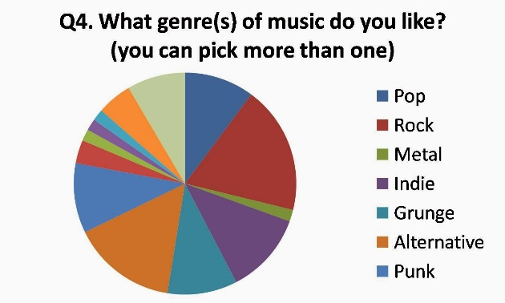
For a poster I need to include some mandatory information such as the name of the artist, the name of the tour or the name of the new album. I will need to also include some dates of the tour and the name of the venues and a possibly of including some other interesting facts, but that isn’t too much of a problem.
Consideration of audience usage
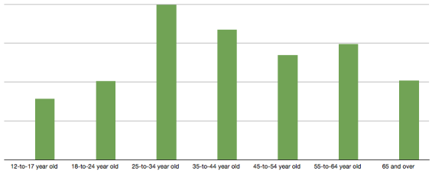
The audience is the people that will want to come to the tours or the person that wants to buy the album. Teens listen to pop music a lot most of all because 24/7 all the radio stations in the country play pop music and they are just too lazy to search and find some real and better music. I found out some information that pop is one of the biggest alongside rock and alternative, so with focusing the group as an electro-pop group it is going to be different. I will also be focusing the audience for this group for the ages of 18 – 30 year olds as this is the biggest time that people will go out to clubs, parties and listen to music the most as they are going out to have fun and this new ish group will be focusing their music for this age. However, this doesn’t mean only those people can listen to their music, everyone can watch their music and can be interested into it.
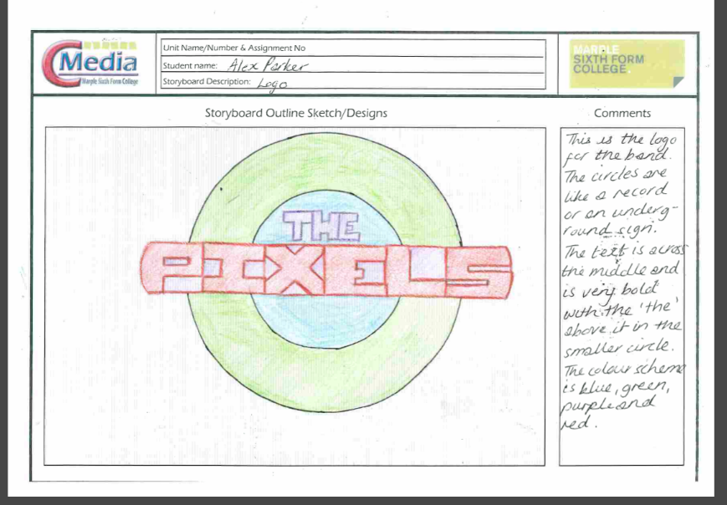
As the audience is going to be made for the people of the ages of 18- 30 it means, I can have songs with explicit content in it. I do then need to warn parents or other people that are younger or people that are unsure that it has content that would not suit them, it is just more of a warning. It is a boy band but this does not mean that people of just one gender can listen to their music, but this music is suitable for everyone.
Layout
The layout of my logo, Poster and the CD cover will be on the storyboards that I have scanned in below:
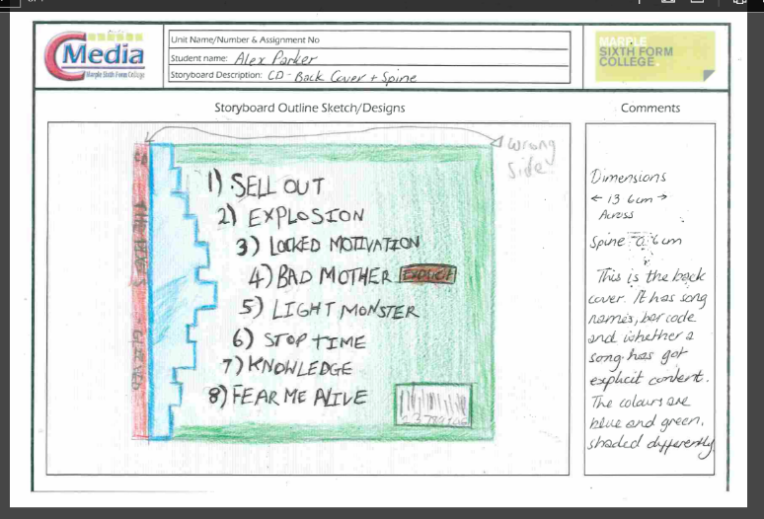
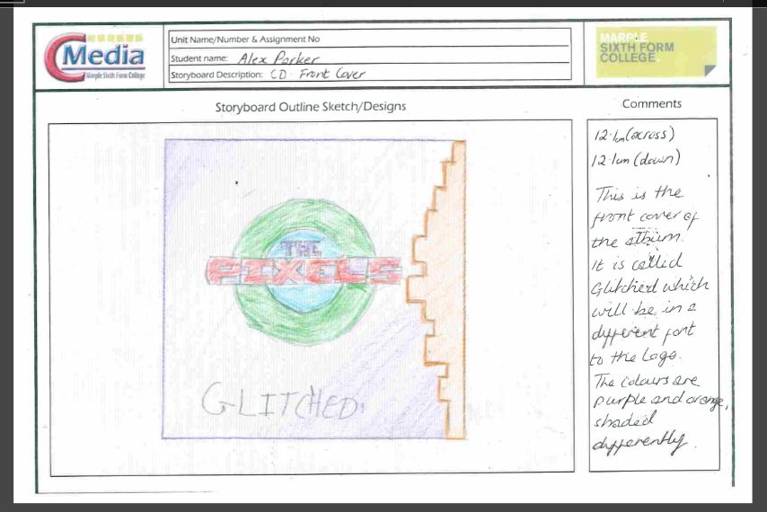

Input and manipulation of images
The images that I will be using for this task and they are going to go along with the theme about pixels and a band, so I will be using some band equipment and some graphics of the audience and it will be pixelated so it will look good and that’s what I want. I need to create the graphics to a high quality as they are needed to show off this band and you don’t want to have a successful band with some bad CD’s and art, otherwise people just won’t buy it as it isn’t interesting to them.
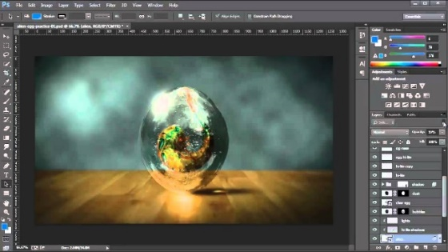
I will be using Adobe Photoshop, as it is an extremely powerful application that is used by many professional photographers and designers. You can use Photoshop for almost any kind of image editing, such as touching up photos, creating high-quality graphics, and much, much more. This software will be used to create the different graphics for the A3 poster, CD cover and the Logo as this application is extremely popular and is very adaptable so I can achieve the desired look that I want. Photoshop is a software that can either be easy to grasp or it can be insanely hard and it will easy for this task as I can use different tasks in different layers and tabs and then switch them. I will be able to integrate them into something that is easy to use. As I have used this software before so I can manipulate and change the images as I go forward.
Style and tone
As the band is called the Pixels, then I will be making the style kind of pixelated but this is good, but you can see it coming, as it is the pixels so you would just presume it would be pixelated. So the style will be done differently, but I am still unsure about how I can do this, I might go for a normal thing but then use the different coloured boxes or something along those lines.
The colour scheme that I have gone for, I had to make sure that people of both genders would like so they are Red, Blue, Pink, Orange and Green. I looked at the people’s most favourite colours and then chose these ones, as they were at the top of the list, most of the text will be in either black or the same colours. The typography is the text and the font of the text, the text that I am using the web banner. The font of the text is going to be Calibri as this is what I use on a day-to-day use. This is because it is easy to see and to read. The font size will be different depending on how much I need to fit on to a page.
As I have previously done a web banner for this band in another Unit, I will be using the same kind of things as before with the corners of the poster as the smashed out brick with the corners left as it just made it look good and I was happy with it last time.
Limitations
The limitations are going to be the things that I need to look out for or they are the things that I will not be capable to do. If there is a feature like 3D then I will have to go and look at doing some software skills for this, I will make sure that I can fully understand what is going to happen. I can use the internet, more specifically YouTube to watch videos about how to do something that I am unsure about.
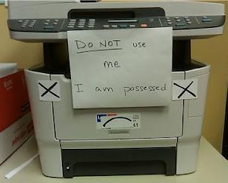
Another limitation is that the images or graphics can be size as in memory too big so I will have to think about disk space, as they are a problem. Another problem with images will be that they are going to be copyrighted (©). I can get around the copyrighted images, which is to ask for some permission to use them or I will just use them for an educational purpose so I really do not think that it will be a problem.
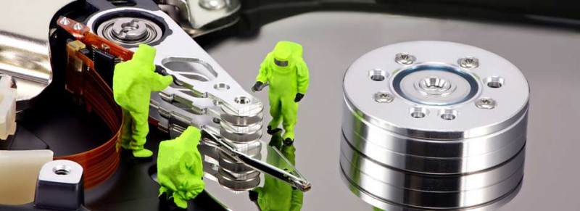
The printer does not work; this is a problem for a company as if you are trying to get the posters and CD covers printed out. Luckily, I do not think this will be a problem at college as there many printers around the place. However, if you do not have a printer or it gets broken, then it could cost a significant amount more of money.
Another limitation could be that the designs or the problems just get broken, corrupt and then this is a problem. As I will be using a computer to create, the posters I will need access to the college network to do the work, so if this goes down or I cannot access it then I will have a big problem.
Advantages
An advantage is that I can use a computer with a good image manipulation and graphic creating software called Adobe Photoshop. I can use this to make my assets and then this means that I do not have to create it all by hand, as I would find that it would be annoying. As I would have to create, the logo, the poster, and the cd cover all by hand and then the quality would be bad quality.
Another advantage of creating the graphics digitally is that I can move them around portably and I can work on them from different places without any big problems. I will be able to just upload it and then grab it again so I can work from where I was last time and that is what makes it good. I can do this through OneDrive and Google- Docs.
Deadline and schedule
As the pixels are going on tour, they will want me to get their promotional products out into the world. Therefore, I have about 2 weeks of creating the assets and the other items such as their documentations. I will not have a lot of time to do very much time to do this so I will be using an Individual Learning Plan (ILP). I also be using a diary and a possibility of a Gantt chart to keep myself to the deadline so I can get it out to them as I don’t want to have a problem with running over.

