Production Management Report
Management Techniques
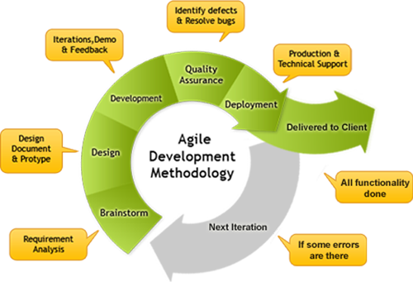
To manage the project, I will use an ILP. This will keep all the dates of the lessons and what I needed to complete. I found this useful as It helped me keep in time with what I need to be doing, showing me how much time I have until the deadline, this will help me out a lot. As I were going along I wrote in each lesson section what I had done. This helped me keep track of what I had done and also what I needed to do in future lessons to be done by the deadline. I kept on top of it all by planning out what I would do for each session. I created a time line, Gant chart and ILP that will help all the tasks that I need to cover. This means I can keep on top of all the work that I need to cover and do and this needs to be finished by the deadline.
Agile methodology is an alternative to traditional project management, it will typically be used in software development. It helps teams respond to unpredictability through incremental, iterative work cadences, known as sprints. Agile methodologies are an alternative to waterfall, or traditional sequential development.
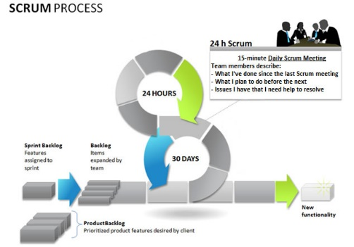
Scrum is the most popular way of introducing Agility due to its simplicity and flexibility. Because of this popularity, many organizations claim to be “doing Scrum” but aren’t doing anything close to Scrum’s actual definition. Scrum emphasizes empirical feedback, team self-management, and striving to build properly tested product increments within short iterations. Doing Scrum as it’s actually defined usually comes into conflict with existing habits at established non-Agile organizations.
Contingency plans
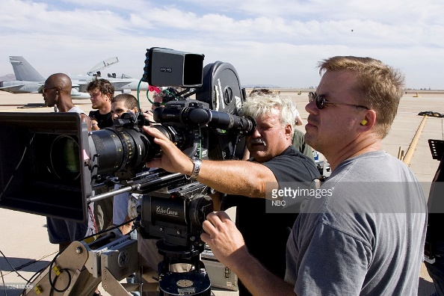
When filming my project, I will need to have staff this means that I can split the rules over a few people, I will have 2 people on the project including myself. The first person I need is a person to film, this will be my brother and the second person is myself and I will be the one to do the editing and the acting. If I don’t have the staff with me then I will manage to do the work on my own as I will be able to use a tripod and this will be helpful. But ideally I will need to have the staff as I can’t get all of the different angles and shots without someone.
Monitoring and Reviews
To monitor and review the work as I will create a Diary and ILP. This means that when going I can keep my ILP and Diary updated with what I had done with the session, this will be done with the aims and what we have learnt. I found that monitoring my work will help me keep track of what I need to be doing and what I have already done, this is needed to keep up and to get to the deadline. I will also do class reviews such as diary checks and ILP checks where I will read out to the class the ILP. I can tell people that I know what I want to achieve this tells me what I need to cover and if I have done it.
Crisis Management
To manage any potential crisis’s/ risks that can happen whilst filming or editing my advert I created a risk assessment form that states any potential hazards/risks, who’s at risk, the probability of a risk and what we could do to avoid the risk from happening, this was done in another project, so I copied it as this is the same kind of thing to what I am currently doing.
When I am filming the advertisement I need to keep in mind the risks that could happen and how I could avoid them; not filming on roads, stationing lookouts in case a car came on a back street, having someone constantly with the camera so it wouldn’t brake etc. This is all what I need to do in the filming section.
Quality Control
To make sure the quality of my video is of a high standard I will make sure that all of the equipment I use is the best available. I will use my own camera and tripod as these are a higher standard than the cameras college provided, this isn’t good as they are really old and don’t work the way I want them to. I will create the shoes and the logo at a good quality making the resolution and shoes a good standard. This product in my advertisement will be of my own design and creation, so no-one can copy it. This makes it more personalised and will give me more ideas to creating the video.
I have also decided to use the best settings/scenes possible. I decided that I would film in Stockport rather than around the park and my house, so I could get across to the audience that the shoes could be worn anywhere as the setting changes. I think it will improve the video to have the background change as it kept the audience engaged in the video.
Meeting submission Dates
Whilst creating my advertisement I kept on track with our ILP’s. I did this so I were on time with all the tasks I had to complete with the final submission date. I split so it was easier to complete all the tasks in time. This also made it easier if I was absent for a lesson it would be easier to catch up as I didn’t have to complete the entire task.
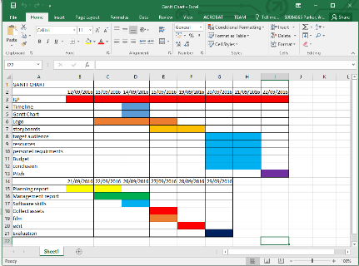
Keeping an ILP will make sure I am ready to hand in all of my work completed by the submission date which is 3/10/16. For each lesson I plan, I needed to do in that session and carried out this task, I have mapped out all of the things I need to do in each lesson. I have decided to do all of my filming in one off the lessons so I could use this valuable lesson time to work on the editing and the tasks that need completion. Doing this ensured I had all of the tasks completed by the time of the deadline.
Modifications after pitch or completion
I didn’t need to change any of the pitch and ideas, this is because the client was happy with all the things that I am doing in this project. I will also use these designs in my project and this will be good.

