Planning Report
Possible roles within the project
The roles within the project are as follows; Filmer, Editor, Actor, Collector, Creator, Director. All of these roles apart from one is going to be done by myself, the one that I am not going to do is the filming as I have a brother that can do this for me.
The role as the camera man will be to capture the work that the actor does, or the Director tells them to do. The editor is there to edit the footage that the Filmer will give them. The Collector and Creator are there to do as the name suggests, create the shoes and collect the items needed in the project. The actor does the acting that the director wants them to do, this is to get the best results in it.
Task definitions and Deadlines
ILP- The ILP is also known as the Individual Learning Plan, this is a summary of what you do in each lesson. The new ILP that has been given so we can see what to do over the next assignment 3 periods. I have been given a few lessons which are an hour and a half to do the work. I also have a week near enough to do the filming and editing and then after I have to do the end results and festival after.
Timeline- I have already got a timeline from the last assignment that I can edit and add the new things to it. This then looks something like this:

Gantt Chart: I have also completed a Gantt chart but I can also edit this one as well and this will get a different colour for the next new thing I am doing, this will look like this:
Proposed schedules- I have chosen to film the footage on the Tuesday this means that I can collect the assets and the things that I need and then I will be off on the Wednesday filming and collecting the footage.
Agreed content
From client and ideas- I spoke to the client in a feedback review and they said that the designs and storyboards are great and that I can use this in my project and this is good as I need to. They are happy with what the film will be like and this is a good thing as I can now do the work that I need to do.
Designs- I don’t have any designs of the shoes, this is because I ran out of time to do it and I didn’t feel like creating them. The designs would have been good as they are a good reference to what they could look like, but I know what they are going to be. The designs will be lots of different colours and patterns, but when creating them I will just pick the ones that I have in my wardrobe or under my bed.
Storyboards- I have created one storyboard which is for the logo, this will be explained more thoroughly why I chose the designs below and this is what the shoes will have on them. The storyboards are good as I can see what I need to do when actually creating the project. If I had done the designs, then they will be on the storyboards. The storyboards are also good as they can have some text on them saying what I would like on it. This can be good to have on it.
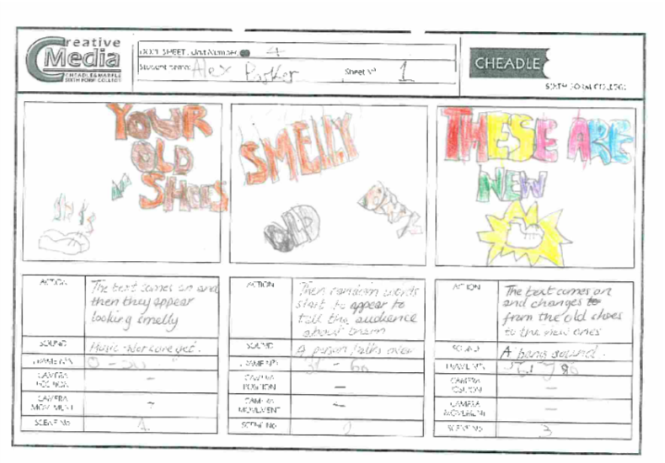
Dope sheets- I created two of the dope sheets which are below and the first one on the first page is about the old shoes and that they are beaten up and aren’t good for anyone and then there are words to explain how they are, then things look up as there are the new shoes that appear and they are really nice and fancy. They are bright and vibrant and they are amazing. The next page then explains how they are called SpeedFire with the logo and they are fun to use. Then it tells the audience that the shoes can make you walk/run/jog twice as fast.

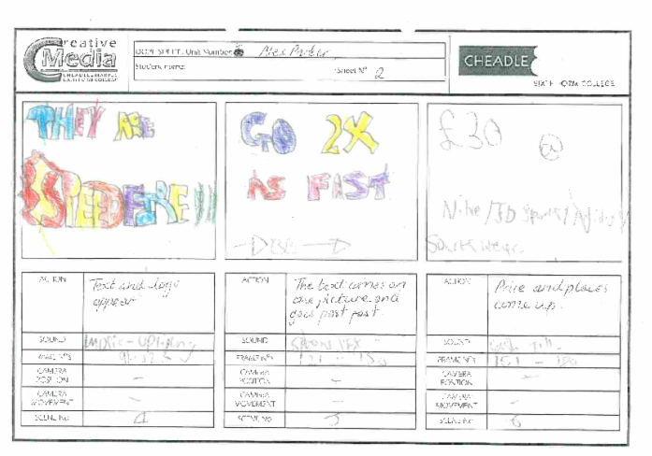
Logo- The logo has been designed by hand so far and I am still not sure how I can create it in the Adobe Photoshop software, This is because the logo will be hard to make and this is down to the fact that the software isn’t the easiest normally. The text will be easy to make as this is good and the flames will be hard, but I might just get a few online and use this in it. The logo Is simple and will be memorable, the whole logo will be created over the 1 maybe 2 lessons but this depends how long that it will take.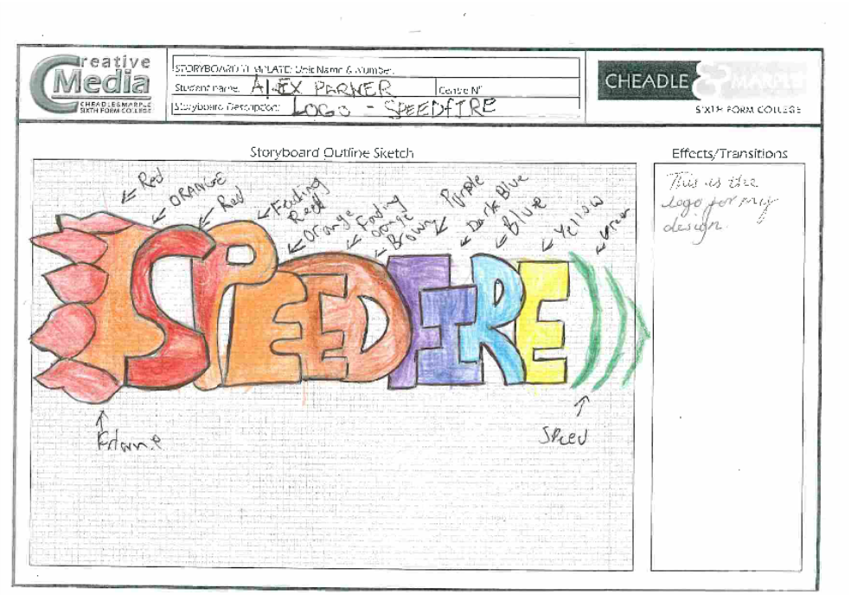
Meetings
I am not going to be having any meetings with the client as there isn’t enough time to do so, I can then make sure that I am not going to be wasting time. If I am going to have some meetings, then I will have some during the project so that this will count towards it.
Logistics
Equipment- I will need to have a camera, tripod and these are the things that I have at home, this is all great. The other equipment like shoes I have are going to be good for the advert I will create and make the logo and then stick this on it. I won’t take too long. The other equipment will be easy to get or collect and if needed then I will get some shoes from a place like TK-Max. I will then film using the equipment that I have.
Locations- The locations are going to be either at my house in the back garden, or the park in High Lane as this is close to where I live. The other location is in Stockport near the bus station and McDonalds as there is a water and garden near and this will be convenient. These are all suitable locations and the time that I will be doing it will be ok. The only thing that will change these locations is the weather and this will be a deciding factor into which location I go to.
Additional facilities- I won’t need any other facilities as I will everything that I already have and the facilities are not going to be a big problem in creating the advert. The only thing that might be a problem are the toilets and there are some in Stockport that I can use and the one in the public. If I film in my house then I will be able to use that one, if I go to the park then I can use the village hall one or the scout hut one that I have the keys for.
Identify any risks to the project
Risk assessment- The document below was used for a previous project and this was relevant to the one I have at the moment. The table is just a risk assessment to the one that I would make, plus the teacher/ client said that I can use the other one that I already have.
Backups- I will make sure that the footage that I create make sure that I have a copy at home of it, the memory will also have a copy of it on so them isn’t too much to worry about. The backups are going to be used if something goes wrong with it. This hopefully fingers crossed won’t happen to this project.
Time scale project maturity- The time scale of the project is small so I will make sure that I make the advert as quick but as professional as possible this means that the work will be ready for completion, the one thing I will have to take into consideration is that I have to create a dairy to show how I make it.

