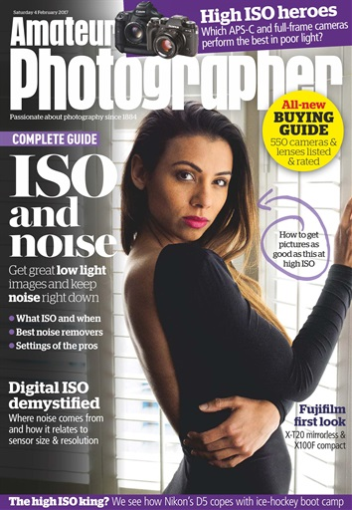
Unit 6 - Assignment 2

Addressing audiences

Selection of content
When producing any magazine it is vital to think very carefully about what content goes on the front cover, as the cover is the first impression of the magazine a customer gets. Because of the limited space on the cover only the most important information is put on the cover such as the title of the magazine, the main content of that issue of the magazine, and some other bits of text that can vary depending on what the magazine is about. The title of any magazine will mostly be found on the cover as it helps grow the name of the magazine, and can be another reason why someone may buy the magazine. This title is mostly located at the top so it leaves room for other content.

Words
The choice of words and language that this magazine uses is aimed towards a higher target audience. Some of the stories are also aimed at an older audience, this is because there is more complex matters that people that didn't know about are all confusing, especially because the magazine is based on photography, which is a subject that not all people like. As you can tell this type of content isn’t suitable for young readers or people that aren't into photography as not very many people are like that and the type of words that are used can be so confusing if that you don't know about. Some of the complex words are things like; APS-C, low light, noise, ISO, Digital ISO demystified, sensor, Nikon D5, etc.

Images
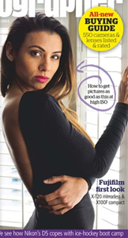
All the way through the magazine is loads of pictures as this is what magazines are mostly made up of. All the images are relevant to the news articles, which means that the article will be easily seen. The images have been selected specifically to relate to the information in the magazine and the style of magazine itself. You wouldn’t use images of something that is completely irrelevant to that topic, however there is no limits or right and wrong images, especially if the magazine is your own. These images are based around the products that you can buy from them and there are a big amount of them, this is all important to some buyers as it is laid out as a catalogue for them to see what there is.

Sound
As magazines are mostly paper based there is no need for the use of sound however if a magazine is being shown or published there may be use of sound effects if a button is pressed or it makes a noise when turning to the next page. The sound effects are used to make it more interactive and appealing for the audience to read. If the magazine was online it would be through an app and that could be about the magazines and then there would be some sounds and the noise of the pages turning.

Sequences
Because of the limited space on the cover only the most important information is put on, such as the title of the magazine, the main content of that issue of the magazine, and some other bits of text that can vary depending on what the magazine is about. The title of the magazine is almost always found on the cover as it helps grow the name of the magazine, and can also be another reason why someone may buy the magazine. This title is mostly located at the top so it leaves room for other content.

Colours
Colours is the main feature that attracts people to a magazine to start off with. For example if one magazine uses dull colours and another uses bright colours then the likelihood is, is that the brightly coloured magazine will appeal to more people. If the colour scheme of a magazine is simple like the May version of the photography then it may still stand out because the title is coloured differently. Colours are very useful and important for magazines because it sets the tone and style for the company’s magazine. The Amateur photographer magazine has the purple accent with white text, and as this is on a photo background with whatever the photo that someone wants.

Fonts
All of the text on the front cover is written in a bright colour and not black or white like conventional text is so it fits in with the other colours on the cover. The advantage of having text like this is it makes it more exciting for the kid to read which is important when trying to teach them The text on the front cover it all written in the same font as it’s bold and stands out nicely from the background, the text is also very easy to read which is important.

Construction of content

Narratives
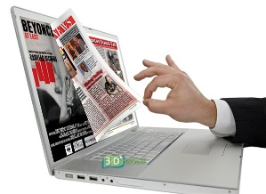
The narrative of the magazine is that it is informing people about things that are currently on trend in terms of clothes and advertising them. The magazine has many sections throughout where the narratives are written along with whole pages of photos. If the magazine is online, readers can send those messages and they respond in the magazine, and then send it off to the magazine company. This is a good way of keeping in touch with readers because a lot of them will want to give opinions to the magazine. They do have a page where you can see what the weekly favorite photo is that someone brought in.

Layout
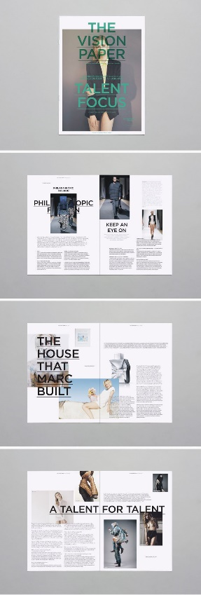
The layout of most magazine covers generally tends to be quite simple with the title and logo at the top with a main graphic in the middle to instantly catch people’s attention. The reason magazines are laid out like this is so that you can easily look and identify which magazine you want. The title is always at the top so that there is plenty of space for things to be advertised. Magazine covers aren’t usually crammed with a lot of images as it detracts from the overall look and makes it difficult for readers to see what they want to at a glance. You normally find the barcode on its side, along the edge of the front or back cover of a magazine.

Captions
This is known to be the text underneath an image that explains what it is and gives the viewers small details of the image. You tend to find captions put into speech bubbles on the front of younger aimed magazines as they won’t want to read a lot of text, especially on the front cover. If you look at a magazine such as Cbeebies, you will see that the captions are used as simple, short sentences to tell the reader what sort of things they will be able to do and find within the magazine. However, because mine is more advanced and some people don’t know very much about, it has more complex kinds of words. By giving the readers some captions it means that people aren’t reading big chunks of writing, which is likely to bore readers. The image on the front is a woman posing and the caption says “How to get pictures as good as this at high ISO.”

Anchorage
This is text that is used to draw people into the magazine, with usually a single line of text as a heading of a main story within the magazine. It basically anchors/fixes to one spot the meaning of an image. Anchorage of a magazine is useful because the writers will pick a specifically interesting story which they think will grab people’s attention and make them want to read more about that particular article. Most of the time if a person buys the magazine every week they won’t be affected by the anchorage since they buy the magazine anyway.

Codes and conventions

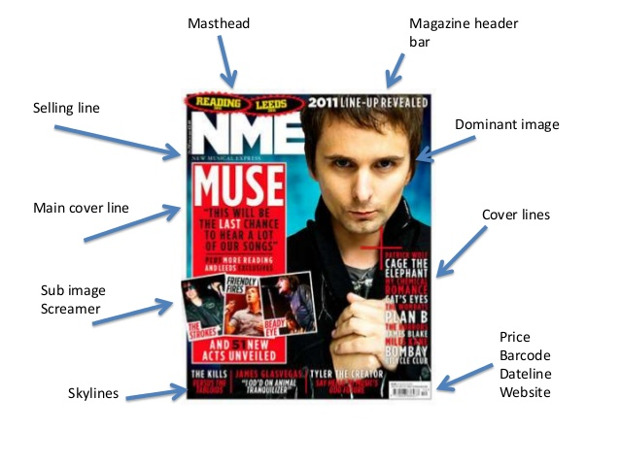
There are many different codes and conventions which need to be used in order to make a
successful magazine, some of the main ones include:
Masthead – the title block for the magazine, usually this is the most eye-catching convention on a page and has to be distinct.
Menu – the list of contents inside the paper.
Pugs – to catch the reader’s eye they are well placed. A pug is the top left hand and right hand corner of a magazine. The prices, logo, position are placed here.
Secondary lead – a sneak preview of an inside article or story usually a picture.
Splash – main story of the front page accompanied with the headline and a photograph.
Spread – a story that covers more than one page.
Box-out – a coloured box behind some text, usually used to make the text stand out.
Credits – in the form a beeline the author is usually credited, some photographs may have the name of the photographer below it.
Crosshead –a subheading that shows in the body of the text and is centered above the column of text.
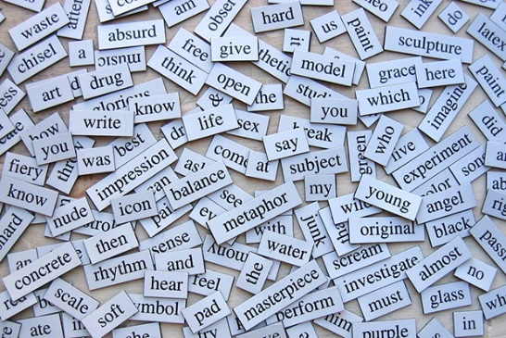
Headline – main statement, usually in the largest and boldest font, describing the main story. A banner headline spans the full width of the page.

Linguistic
Linguistic refers to the language used on the cover and throughout the magazine, depending on who the target audience for the magazine is affects the writing style used. For my magazine, since it’s targeted for people who are advanced (hopefully) in this subject then they will already know the complicated linguistics. These are not simplistic terms due to the sentence size and complexity. The words used are also very simplistic as the reading age of their target audience is low.

Visual
When producing any magazine it’s vital to think very carefully about what content goes on the front cover as the cover is the first impression of the magazine a customer gets. Because of the limited space on the cover only the most important information is put on the cover such as the title of the magazine, the main content of that issue of the magazine, and some other bits of text that can vary depending on what the magazine is about. The title of the magazine is almost always found on the cover as it helps grow the name of the magazine, and can also be another reason why someone may buy the magazine.

Audio
This is a paper magazine which means it doesn’t have any sound. If the creators really wanted to they could add small features on certain pages so that when a button is pressed a sound is produced. If a digital version of the magazine was created then sound could easily be added to that, unfortunately there is no digital version of this magazine available, that I am aware of. Since the magazine is for photographers then they could create the sound and sound effects themselves I they really wished as this would make reading through it more interesting.

Symbolic
Magazines uses many images and words to try to symbolize a certain meaning to their readers without actually saying anything. When creating a magazine, the writers and editors will add in particular images that portray a different image. However, if you look in a magazine that is geared towards motorcyclists, you tend to find bold images of expensive motorbikes with women wearing not very much. Having all of the smiling characters on the cover is an excellent way to show that the magazine is fun though because most of the time if you see someone smile you smile back as it’s just a human reaction.

Technical
As this magazine is paper there is not anything technical about it since it is just a normal magazine. If there was a digital version of the magazine then it could have some technical features such as when you go to a certain page a game appears that you could play. Other features that could be applied are sound effects; these would play when you perform a certain action on the magazine. The benefit of having something technical about the digital version of the magazine is it would give the person using it more to do meaning they will use the magazine for longer. If they also really enjoyed the magazine then they are more likely to buy the next one that comes out.

Modes of address
There are several different way to address the reader, one is through direct address where the terms “you” “we” are used. Direct address is a way of being more personal with the reader as they feel like they are being spoken to individually and not just part of a group. The other mode of address is inclusive. These types of address are used on the cover of my magazine, for example when the characters are talking about the game and activities that are found inside they use both direct and inclusive address. The advantage of using direct address on a magazine is that the readers feel encouraged to read it since the magazine is talking directly to them which makes them feel more connected with the characters.

Audience feedback

Focus groups
Focus groups are created so feedback can be gathered on something before it gets released to the public. This is done by showing this group of people the product and then having them discuss any issues that they may have with it. All of this feedback is very useful as it allows the product to be refined before release rather than having to fix the issues after the release. A focus group may be created by recruiting people online and then asking them to come to a meeting point at certain time for the discussion, a more modern way of having a focus group would be to have a video/voice call with all the members on.

Audience panels
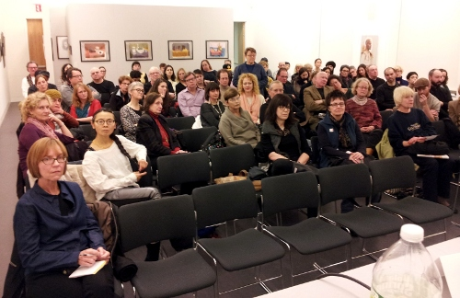
An audience panel is a panel consisting of several members who are asked questions by a larger audience. The members on stage are either a representative from an organization or someone else who has excellent knowledge about the topic which is being discussed. Audience panels are an excellent way of gathering large amounts of feedback in a short amount of time as the questions can be answers instantly by members of the panel. An audience panel would have been a good way of getting feedback on the digital photography magazine as they could have handed out copies to the audience when they came in so they can come up with questions about the product as they look through it.

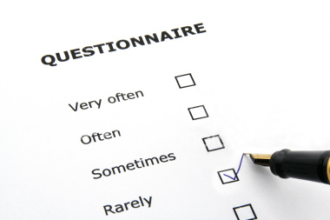
Questionnaires
The questionnaires that can be given out could be implemented into the magazine and this would be a quick and easy way to do this. The questionnaire can be a link on the page that you can type in on a computer, this means that they are then can just be a different way of submitting it in to the public and then it will be their choice on whether enough they are going to fill it out. A questionnaire can also be from the public to the magazine, as they could answer questions that people might not know about but this can be altered to what you like and this then gives the magazine company some clue to see what people would like to see included. One of the questions in the magazine I looked at had a question, which was; “What is the point of film simulation?” and there was a big explanation, but this was important as you can see what the other readers are looking at. (Page 24- 25)

Trailing and testing
When it comes to trialing and testing a magazine it is usually done by publishing the magazine in a small area and then measure the success of the magazine by seeing if it has raised awareness or sales in the area. This is mainly done to check that the magazine works well with the chosen demographic which it could have released the magazine among and to see if the magazine fulfils its objectives. If the response from the trial is that the magazine is good then a few other places will be tested which will then lead the magazine to be fully published everywhere. If however the results are bad and they didn’t like it then the magazine would be changed and then released again to test if the magazine is now effective in its purpose. I am pretty sure that my magazine would have been tested on a whole big group of amateur photographers to see whether they liked it. This method though can be a long and lengthy process as it needs the audience to be specific and this could be quite hard.

Reviews
Reviews is one of the biggest ways in which you can receive easy feedback about your magazine from a range of audiences. Many magazines get many reviews, with a mix of them being both good and bad. Reviews are often left online, on websites that are related to that particular magazine or on social networking sites. With reviews, people can give their personal opinion on a magazine and leave there name or say anonymously. The problem with people, who review anonymously, is that it makes it very hard to figure out which demographic is making what comment.

Complaints

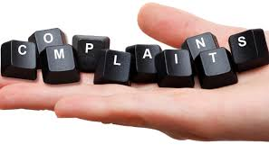
Complaints are only a possibility if the magazine is either pushing boundaries or is using a topic that is controversial. People also complain about ethical considerations in a magazine, for example if something is against someone’s race, they may complain that it hasn’t been considered beforehand. As most magazines are checked before being published a lot more than they used to be, there isn’t that many complaints that you hear of these days and companies don’t really worry about them at all. There is rarely any reason for complaints these days unless political views occur. Complaints do not restrict what you can show, as it is mainly the ASA that have to be happy with the magazine, people have a right to be offended but the magazine has the right to of freedom of expression.

Audience feedback for the Amateur Photographer (Saturday 4th February 2017)

I had a focus group session with Priya about the magazine and what she likes about it and what the magazine is like. Here is her short report on the Amateur photographer Saturday 4th February 2017:

This magazine is very appealing because it has a great layout. Everything is very nicely placed and has its own personal space where everything go’s. The use of the imagery especially the background image would all definitely catch my eye as a consumer as it is large and bold and therefor stands out from any other. The text used is predominantly in white and contrasts well with the dark background. Overall, I think this magazine has a good look and so I would defiantly get my attention if I were going to buy the magazine.

