Legal, Ethical and Constraints.

Constraints
Time
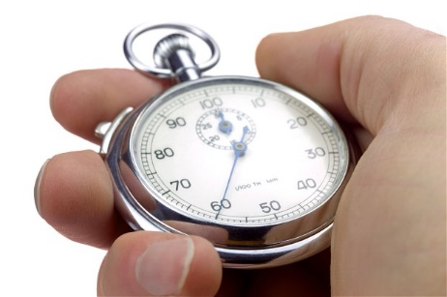
There will be a time constraint on everything, but somethings will take quicker than other things. In this section of the project I will need to film, design, edit the footage that I create. I will also need to get some models of the shoes such as getting the logo and the branding. Also the time that I will have set to do the filming I will also need to allow time to set up my camera, tripod and the other accessories, for the shot. Time considerations would involve tasks such as when and where we will be meeting up to film, as well as where we will go to gather the raw footage and how long it will take to collect the footage. I will need to precisely keep to my project times, this means I can make the work as time efficiently as possible.
For the advert I might go to different locations to shoot different scenes, this will mean that I might need to use a bus/ public transportation, so this would be another time constraint as it would require gathering the bus timetables and working out how long it would take us to collect what we need at each destination, this can be a bit of a pain. I will also calculate how long it will take setting up and putting away, as well as including walking time, with all these considered we could then determine which bus/train to get on. This all depends on whether I chose to go anywhere or not, I haven’t fully decided yet about it.

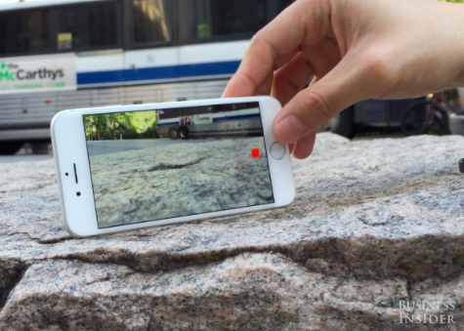
Costs
The advertisement that I make will be limited to a budget which will need to be carefully used, as I don’t want to ruin the plans. This budget will be spread out to cover the costs of; travel, equipment, personnel hire, editing software, vehicles and sets.
I can do something that will make some cuts and then I can use this money for other things, I can use my iPhone camera which has 4k capabilities then this will be good as I don’t have to go out and buy a new camera which can cost a lot of money. I can then use this money for something like an iPhone tripod and a microphone. Then when I edit the videos at the end then I can use the CS6 suite for the editing this means I don’t have to get Adobe cc suite and this will keep the costs down. The money I don’t use can be for the crew and the people that are in the video. For this project I have been given £4,000 to spend on items:
I will need to get a camera, Tripod, Computer and editing station, and maybe a microphone.
I have found online a good camera which comes with lots of accessories: this is all the things that I will need, this is all for £999.00
I can also use the money I don’t s I have also found a good computer that will do what I want with it: this has enough ram to hold the programs on it and this also had a 1TB of storage on it and this is enough to keep the files together, it is also a good price at: £289.97
I also needed a program to edit the footage in: this is going to be adobe suite I will get the CS6 section, I have found the whole suite for £1,3999 at a website and this is a bit pricey but this will do the job that I need. Spend and I can just put it back into the company.
The money I spend is: 2,687.97 – This means I have £1,312.03 to spend on bus travel and other equipment if needed.

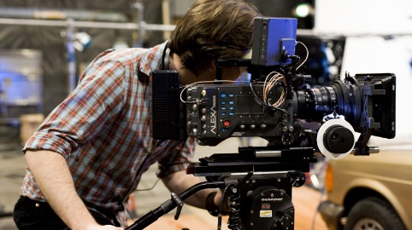
Personnel
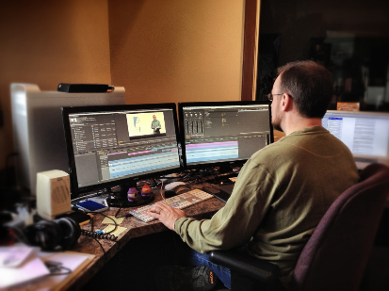
For this project there will only be two personnel working on the assignment (Me and My brother) if this were a larger project there would be a possibility of hiring more people and specialists to aid in production, such as camera crew and audio technicians, this would mean that I can be the director and I can focus all of my time into it. The tasks will be done over the two people, I would be the actor with the product and then my brother would be the camera operator. I then in the lessons would do the editing on my own.
This means that because there’s only two working on filming and editing there will be some constraints the main one of these is the level of detail will be put into our work. This will constraint the time that there is and the jobs which will need to be accomplished, which is why I need to divide the jobs between the personnel that are there.
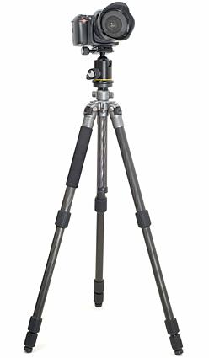
Resources
For this production I will need to use a number of specialist equipment this is the: camera, tripod, Adobe Premier pro, Adobe Photoshop, some older blank canvas trainers, fabric pens/paint.
The program is available at college for use during lesson time, plus if I don’t have the time then I can do this in my spare sessions. But the trainers and pen dyes are not available, this means that before filming we will be required to go out and collect the materials needed to design the shoes, this might take some time to do and is another thing that I will need to put in my designs.
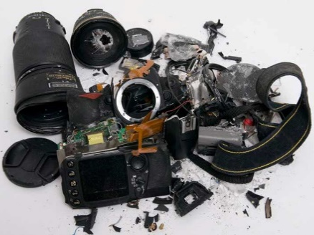
The other technical resources that I will need are a camera and a tripod, I already have a camera which is good, this is a Cannon 200D and I have a tripod that is light and ready to go. If I make the video on a day where it is raining, then I will switch it out for my iPhone camera as I don’t mind if this gets wet.
I need to get myself and the equipment to the place I want to go then I will need to plan the bus times then I can get to the place easily and safely. There is a problem which my kit gets broken or if it gets stolen then there Is a problem but I will always have a recovery switch that I can activate.

Legal and ethical
Legal
The copyright, designs and patents act was created in 1988. This was put in place to make sure that people can be rewarded for their own work, otherwise people wouldn’t know who work it was. The other purpose is that you as a creator can feel safe with their work isn’t going to get stolen. Before 1988, people had a hard time as people could steal their work and you couldn’t do anything legal to stop them. This copyright law makes it so that people can’t copy software, mp3 files, songs, videos, image, text, blueprints etc. Anything that someone else has created you can’t take it without their permission as you are within breach of breaking copyright law.
In terms of getting software, if you buy a software package then you have done is purchased a licence and you can use the software at your own free will. Each software package will usually contain one licence this means it can only work on one computer, so if you want to get the software on another computer you will need to buy another licence for that computer. Sometimes the software companies will give out a multi-user licence which means that your computer will log into the network and use the program, this can only be one computer at any particular time.
In obtaining photos and images you can gain access to them if you can get in touch with the creator, once you have got in touch with the owner, you can then see if you have it for free. Or you might need to pay for it, only the owner can decide how much he wants for it. You don’t actually buy the asset, but you do buy the right to use it in your product.
In gaining access to music you can get authorization from websites such as YouTube and VEVO but you can only use it as a listener. If you want to manipulate or change it and post it, you would be at breach of breaking the law. If you want to do this, you can ask the manager for the artist but you may have to pay to use it.
This would mean that I would be breaking the law because I took photos, music and videos without permission from the internet. So if I wanted to use these assets I would have to ask the artists manager so that I may gain the access for them. I would also have to buy the software for my project as I can’t use software illegally. I would apply for a multi- user licence so that I can use different computer if I wanted too. For this project I am alright with using Photoshop, Director and Premiere as it is on the school system so I have a multi-user licence. But if I were to copy the files and codes, I would be in a lot of trouble with school as it isn’t mine to take. If I take all the necessary precautions, I won’t have any problems. I am only using the files on my computer at school, but if I were to publish it online I could be sued as I am not using it for educational purposes.

Ethical
When working on a DVD menu you will have restrictions on what you can say or what you can actually do. This will protect people from things such as racist comments or negative comments that will offend people.
The decency and libel this will cover and ensure that you haven’t said anything that I fake and untrue, about any product indecent information. You can’t make a fake written statement about anyone as it can be seen as abusive or this may lead to harming their self’s and reputation. You also can’t make a verbal statement about someone as it will lead to the same thing.
When talking to someone online or in real life you need to make sure you are both unbiased and accurate. This will apply to:
- Race: Black, white and Asian
- Gender: Male and female
- Sexuality: Homosexual or bisexual or heterosexual
- Religion: Catholic, Islam, Judaism, Hinduism etc.
- Any negative words: swearing, sexual.
This means you need to think about what you are going to say before you say it. There are some laws which work alongside rules, these are the Race Relations Act RRC.

Privacy
As my filming may take place in parks and other public land we have privacy limitations to take into consideration. There a going to be areas of places where the members of the public’s faces will be on our footage, this might mean I have to blur their faces or I could just ask for their permission. This will also apply to using a person’s voice, if a person doesn’t give permission for their voice to be used then it will need cutting, muting, or editing when the raw footage is being altered. This can be a big pain so I will make sure that the public isn’t in eye-shot or earshot, just to save myself from having problems.
Libel law
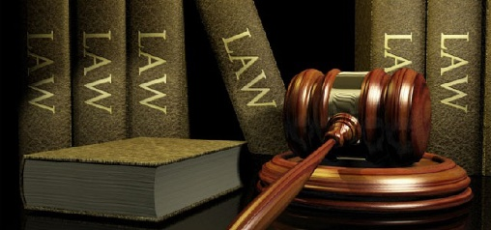
Liable laws cover both libel and slander. Libel refers to the discrimination of a person through written content, such as writing a report about a person and ruining their name by printing lies or rumours and releasing this to the public. Additionally, slander is similar only it is verbal; verbally stating rumours or lies of a person again in order to ruin their name or reputation is also liable and illegal. As I will be filming I will need to ensure that there is nothing visual or verbal is causing slander or libel harm to my actors, I cannot make them do anything degrading or socially unacceptable that would harm their public view and chances of further work, this is a difference.
Data protection
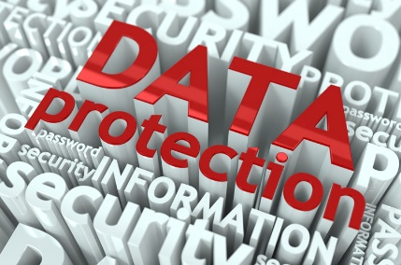
Data protection is an act which is used to protect privacy of personal information, of everyone, weather it is online or on paper they must remain protected. I will have the names and contact numbers of the actors so if we are separated or if somebody is late then I will be able to contact them. It would be my responsibility to keep all of the information to myself for their intended purposes and not leak them. This also applies to personal information collected from questionnaires and other information collection formats. I can’t give away any of the information that I get given. I would also expect them to do the same thing.
Codes of practice
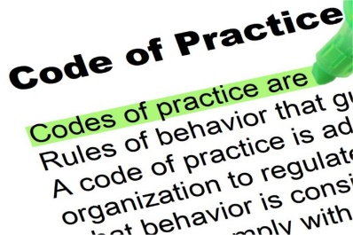
The codes of practices are done through an organization called Ofcom. They are the company in charge of media broadcasts such as TV, radio broadcasting and magazine/newspaper industries in the UK. It is Ofcom’s job is to monitor Medias. Promoting completion amongst the Medias, and also checking them from harmful or inappropriate content. Content such as the points listed above such as racist comments and disability discrimination. They also check works for items legal necessities such as licences. So if I were to show my advert on the public Tv then it would have to go through them before it can go out there.

