GRAPHICS CHECKLIST
RANGE/ELEMENT | EVIDENCE
Work Area | I did use the work area during the creating process as I needed to use the canvas to move things around to create the graphics. 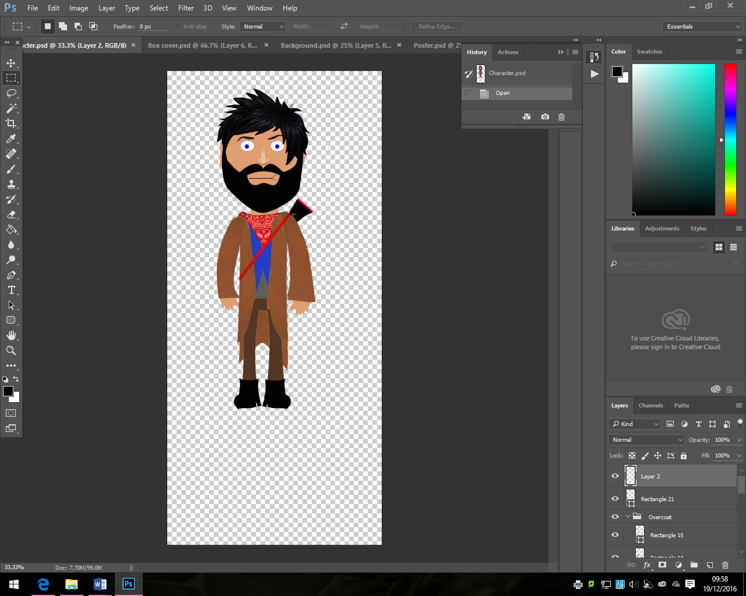
File information | I used the file information tabs as I needed to find out what the size of the canvas was but this wasn’t needed a lot as I knew a lot about the types of files before this project.
Tabs/ window control | I did used the tabs bit I mainly closed them down tough as they got in the way of me working and I wanted to keep to a strict deadline.
Reference images | The images that I used where my drawings and concept art I wanted to keep to these as much as possible, I also need to make sure that they have been made to a good spec and I can every now and then look at them to make sure that I am following.
Optimising | The resolution and dimensions where changed from the standard sizes and the new ones are going to be adapted for the later ones.
Open | I opened my documents every lesson to start doing the work on it.
Save | I saved my document during and at the end of the lesson to make sure that I could go back and do some other work.
New | I created the 4 different documents and some other ones to create the ones at the end.
Import | I imported the different graphics that I couldn’t create myself due to problems, these imported images a written down in my diary.
Export | I haven’t yet done this but I will be exporting the graphics towards the end and the deadline.
Size resolution | The size resolution where all set at the start when I was creating this document, the resolution was normally set to 72 but I changed it to 200 and 300 Pixels Per Inch
Width and height | The height and width of the documents was changed so that I could make the graphics the intended height for the document.
Transparent | The background on the documents will be made as transparent so that I can use the different graphics on them so they don’t look bad, I did also delete the white pre-set graphics that I imported so that they were there to look good.
File names | The file names where changed so that I knew which document I was going to be working on.
Brush | I used the brush tool to colour in the blank white hat to make it colourful, this process wasn’t a quick process as it took a long time, I wanted them to be colour that is why I added colour to make it good and that it then matches my designs.
Duplicate | I used the duplication tool a few time to get one thing so that I don’t then have to do the same process again and It won’t take a long time.
Fill | I used the full tool to change some of the colours onto the system, the fill tool is also used to colour in the background for the different documents. The Fill tool can also be used for other things but I only used it for those different features.
Stroke | The stroke feature is used to add some outline effects to the shape and this can make things pop out, I used this on all the different texts in the different documents.
Shapes | I used the shape tool a lot, the shape tool was used in the character the most as I made it with rectangles and then I just changed some images using the free-transform tool and that made it look good.
Zoom | 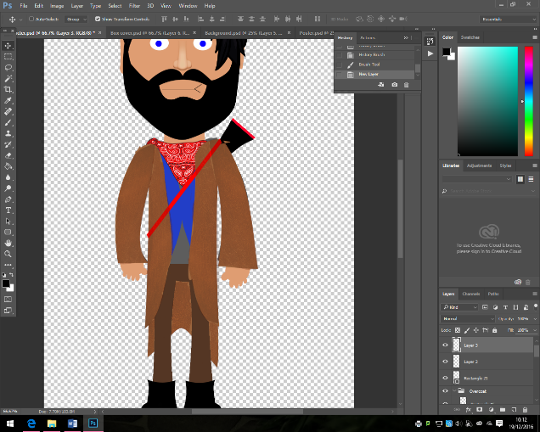  I used the zoom tool to enhance the picture so that I could see the different images bigger so that it would be easier to see what I would be doing, this was helpful when I was doing the different colouring and painting.
Guides, Grids and rulers | The guides grids and rulers where used when I was making the DVD cover as I needed to have the spine in the middle.
Colours | The colours where chosen to make my whole project look like it was western. I then made sure that this looked god and It matched my designs.
Layers | I have many different layers in the different projects, but they all look good, I did group them all together and I did also flatten them towards the end so that they are all the same image and they move the same way.
History | The history box was used, it was used a bit whenever I got something wrong I used it so that I could go back and could do it all again without any problems.
Flattening | I used this tool towards the end so that all the different layers and groups where all together and that they would be compressed and that them wouldn’t be any problems.
Eyedropper | The eyedropper tool was used to make all the different shapes the same colour throughout the process.
Selection | The selection tool was used to select an item and then I could then add a different thing to it and then either delete it or move it about.
Magic wand | The magic wand tool was used to select the item and then I could remove the background from it. This tool was used a lot and it was very helpful.
Deselect | The deselection tool was used to deselect an image or item that I didn’t want to change so I wouldn’t have any problems with it.
Rotate | I used the rotate to obviously rotate an image I also used the flip tool to make something like a hand look the other way so that I wouldn’t have any problems with it.
Flip | I used the rotate to obviously rotate an image I also used the flip tool to make something like a hand look the other way so that I wouldn’t have any problems with it.
Copy, cut paste | I copyed, cut and pasted different images from the internet and then I incorporated them into the project. This was easy to do and it was quickly done with different keyboard shortcuts.
Undo | The undo tool was used, it was used a bit whenever I got something wrong I used it so that I could go back and could do it all again without any problems.
Layers | I have already talked about the layers but I also used the opacity tool to add the texture to it, this was made to be make the image stand out.
Texturing | The texturing that I did was to add some different textures like leather to make the person feel as if that they are more realistic.

Software interface: eg work area, tool box, status bar, file information, window control, floating palettes, palette docking, tabs

Workflow: eg reference images, plug-ins, optimising (bit depth, resolution, dimensions)

Menus: open; save; new; import; export; edit; view; help

Image settings: size; resolution, width; height; colour mode; background; transparency; aspect ratio; file name

Drawing tools: tool options; brush; pencil; duplicate; clone; fill; text; line; stroke; shape; zoom; guides and rulers; grid; snap; palettes, eg colour, gradients, layers, object, brushes, history, actions, size, resolution; layers, eg copying, saving, arranging; flattening; colour selection, eg foreground, background, colour swatch, eyedropper

Editing tools: selection, eg marquee, lasso, magic wand, magnetic lasso, deselect; transform, eg scale, rotate, skew, flip; cut; copy; paste; crop; trim; erase; undo; fill

Advanced tools: effects, eg layer effects, filters, channels; image adjustments, eg brightness, contrast, hue, saturation, colour balance, gradients, transparency, invert; masks; paths, eg vector paths, converting text to paths; brushes, brush plug-in

