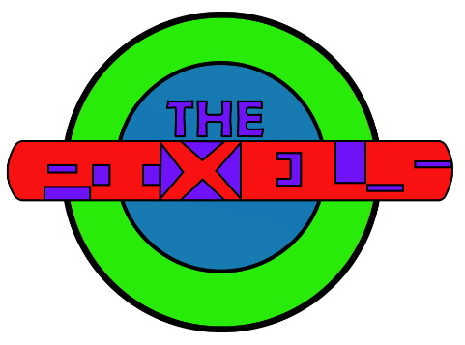
Unit 54 – Digital Graphics for print Evaluation

Effectiveness
Extent to which brief has been realised
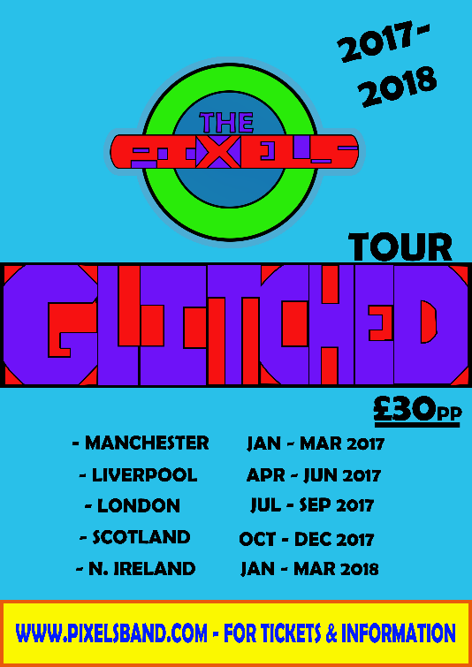
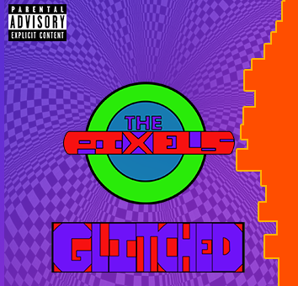
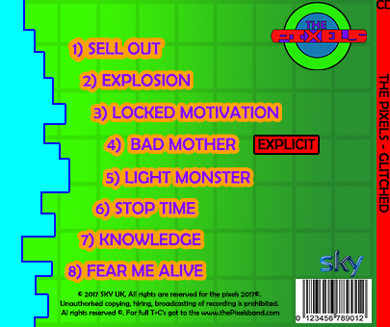
Throughout this assignment, I feel I have worked well and to as much effectiveness as possible. This was because of the fact that I knew what I wanted to create and then I then just made sure that I followed it, there were a few different bits that I added that were not on the storyboards. Overall I think I have made some appealing looking graphics and I will talk about my graphics throughout this evaluation to show what I have done and what has been done well in this assignment, in this evaluation I will be going through what I think are my strong points throughout this assignment. The graphics that I have created they are something that I would make and that I love them so much that I probably if I liked the artist and the songs then I would buy the album. The poster also makes me want to go and by the tickets to their concert as it is all nice and bright with good colours.
Use of appropriate methods and techniques
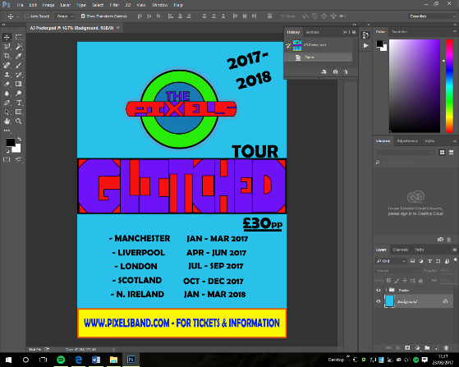
When creating the graphics for this task I used lots of different techniques and skills that I had done before, but their where a few different techniques that I did not know about. The techniques that I know about can’t just be told in this evaluation, as they are just too many as I have been using the Adobe Photoshop software for a long time and just most of it comes naturally. The thing that I just could not find or grasp is the triangle. The triangle is not a tool on the program as it was just too difficult to find myself, in the end I had to watch a YouTube video in order to understand the skill, it was just a Polygram but I had to change the sides to three. Another thing that just didn’t work out was that the text just didn’t want to go into the way I wanted it on the boxes and the logo, so In the end I had to just use a load of boxes to do the same thing but I love the way it looks. I used other different tools throughout creating the graphics and these are only a couple which I have gone into detail about. I made sure, when using the tools that I made the graphics look good and they looked professional as the detail for this unit was important for it.
Level of professionalism achieved
As the digital graphics for this unit was supposed to be for print and that the graphics had to be detailed from the client meeting I had to make it look good, so good that someone will see it and want to go to the concert or go and by the albums. The graphics that I have created all do look like they have been created in the best way possible. I used Adobe Photoshop, which is a software where I feel like I am advanced in so this meant that I could create some better graphics for this task. If I went and used Adobe illustrator, which was a software I have used before now but I don’t think that I could create very much to the high standard that I did with Photoshop as I just haven’t used it a lot and don’t very much now what things to do. The graphics that I made are as professional as much as my ability is and they could be better but not for me. I do like the concept that I went for as it just fit, with the pixels and the pixel theme.
What message your final versions communicates
The final message that I was trying to communicate to the audience was that I wanted the audience to go to a store or online and buy the CD and the concert tickets. I do think that I have achieved this and then this would make people go and buy the promotional material. The final version is what I feel like I will make people to come down and get the album and go to the concert as the colours are all nice, bright and vibrant and therefore people will be attracted to them.
Problem solving
I did solve a problem that was to do with a triangle and that I just for the life of me could not figure out how to create one and this was just the only big problem I had. The thing that I just could not find or grasp was the triangle. The triangle is not a tool on the program as it was just too difficult to find myself, in the end I had to watch a YouTube video in order to understand the skill, it was just a Polygram but I had to change the sides to three. If the YT video did not help me, out then I would just have gone insane and I just would not have been able to do any of it, I would have had to get one of the internet to just get it to work. There was also a problem with the fact that the text just didn’t want to go into the way I wanted it on the boxes and the logo, so in the end I had to just use a load of boxes to do the same thing but I love the way it looks. I also missed out the letter ‘C’ so I had another problem that I had to figure out and solve but then I just budged the words over so that I could fit it in. I was happy that I saw it then. I didn’t have to go back at the very end and then insert it in again as that then I could fix it.
Skill development
As I have been using Photoshop for this task that I have used I won’t have picked up very many skills, that I didn’t know before but I have enhanced them and gone on to do some advanced features in order to get the graphics the way I imagined and pictured it. Without previous skills, I probably would have struggled and this means that, I would have been learning on the job. I did pick up one important skill, which was to create the most impossible thing about this assignment, which was about trying to conquer the triangle, and this skill was difficult but I did get through it all right.
Areas for improvement
When the images were then being made, I came to the final product and when looking back over the product, I thought would there be anything I think I could have changed to make the product better. In certain areas, yes, I think there were other options I could have gone with which could have made it look better. This would be things such as the border to my album cover and that it could be made better and the colours were not really all that there. The colours and the gradients could have been thought out more correctly but then when I look at it I still do not think there problems with any of it. Overall and I could have researched more on what albums people are attracted to, so that then I will get a better overall look to my album cover.
Sources of information
Self- evaluation
I think I did a good job creating my graphics because I have been aiming for a merit and therefore I could advance to get a distinction but I don’t think that it actually looks professional I feel like it is good but it could be better as it is a bit tacky in some areas. I stuck to the brief and did what the client wanted, which was something to do with pixels and this is what I did and I am somewhat happy with the end result. I have kept to my designs and I think I created some very well designed products for our clients and all within the guidelines of the brief. To stick to the brief, I made sure that I made an original design and this was done on Photoshop to make sure that I then get the look that I after. Overall l am happy with the graphics and the way they turned out to the brief.

Documentation – Notes, sketches, production logs, comments from others, peers.
With this unit there wasn’t very much as in terms of documentation, this was because it is a digital based course although there was storyboards which then was the main piece of documentation that we had to do. There was also a diary that we had to do and this was to keep anything that we did so that if someone wanted to create it then they would just be able to follow it in order to be able to create it. The storyboards consisted of creating a front cover, back cover, logo and tour poster and these were out drafts that we had to create and I think it came out the way that it should have compared my Photoshop file. There were obviously a few tricky problems with the fact that I added a few more things to it than I should have done. The ILP and diary also helped me keep to schedule the only other documentation was some research and a proposal that we did to introduce into the unit.
Tutors – Client
Even though I haven’t had very much feedback I do feel like I have done well and that they will like it, the only thing that could go wrong or not do too well would be that it doesn’t look too much like the storyboards. I have not had many of my peer’s feedback overall but I have had some being sat next to me and they enjoyed the design of it. I think overall that it came out better than expected and would definitely say that it came out at distinction grade work, but I am still thinking that it will be a merit as it is good but just could be better. I consulted the client quite a few times just to keep them updated on the work that I was doing. My LSA liked the work and the way that it turned out and this makes me happy, as they can see that I have created something good.
Production process
Pre- production, planning preparation
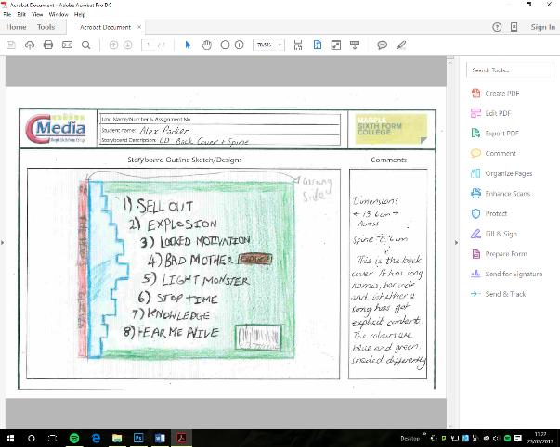
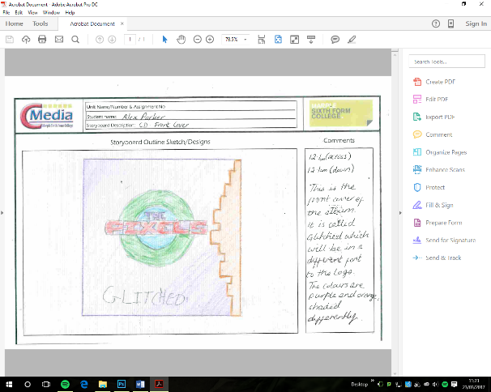
During the planning stages, I got some concepts of design ideas and then once the ideas became my own I began to storyboard them for the client to see because this way I would know what I was doing once I started actually creating the graphics in Photoshop. The storyboards that I created were my original design which made it much easier for me as I had already created a draft first idea before this and then once that was then created I could then use this as a base for my creation. You can never just start creating so you always have to plan; this then means that you know exactly what you are going to create. The planning needed to be done with a lot of detail if not then the client just doesn’t know what’s going to be on the graphics. As I did a storyboard for the graphics, it meant that I had a visual representation to see as you are creating and to get the right measurements. This also means that if you don’t know what something should be like and then you can follow it along when creating it.

Production – time management, project management
The creation of my product had to be created to a specific timeline and you had to keep this strict and then I had an ILP to make sure that I will do it before the deadline. If needed I could have done the checklist at home and then brought it in, but in the end this was not necessary. I do also have the specific dates on when and how long it took me to create the graphics in the diary, which also show the dates of which where I did the most work and how I created all of my graphics within that time and every lesson. I had a timeline to work to that I had to be done by a certain day within however much time we had overall was just enough. I did finish creating the graphics beforehand and then I worked on my checklist. I did have a bit of a problem which did run over to another day because of the printing as the printer just didn’t want to print my work off or didn’t do it in the right size but after a night’s sleep the printer finally worked and then I printed everything off.
Monitoring work in progress
To monitor the work and the progress and the time that it was all going to take me was all useful information that was tracked through a ILP and a diary. The ILP was used to sum everything up about what I did in that lesson and the when I was able to check and see if that I needed to do any extra work at home to make sure that I had hit the deadline. The diary also made me do the same but I do also have the specific dates on when and how long it took me to create the graphics in the diary, which also show the dates of which where I did the most work and how I created all of my graphics within that time and every lesson. I had a timeline to work to that I had to be done by a certain day within however much time we had overall was just enough. The monitoring helped me reach the deadline, which I was relieved about and this was good.
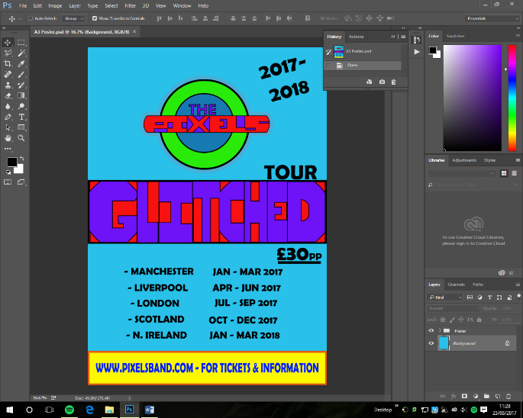
Technical competencies
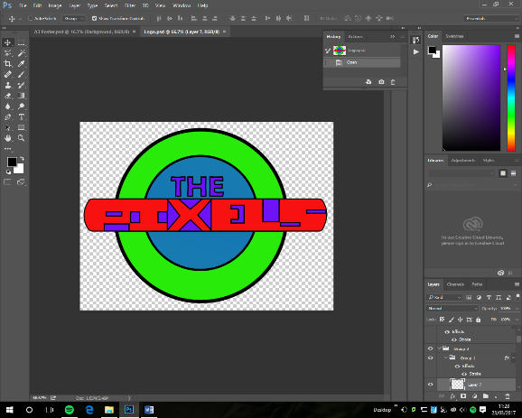
The technical competencies within this are what I already knew how to do, but this did not affect me that much as the only software we were really using was Photoshop. I know how to do many things on Photoshop but if there was a bit of a problem with it but that’s future down. I did have the advantage of that if did not understand or know how to do it then, I could ask a member of staff or one of my peers. Which would help with the issue but usually if I had an issue I would be able to find a fix online or if I just spent a bit longer playing around with the software to find the fix. I did use YouTube to help me find out how to create a triangle but apart from that, there were not any other problems with it.
Creative ability
I think that I am creative as I am doing a creative media course. The designs and the storyboards were all created by myself. I do think that this worked out well for me, as they look the way I imagined it and I just thought that a circle isn’t really what the client or the bands audience would associate a circle for the logo. They would have thought it would be pixelated and boxy. However, I wanted to do something different. I didn’t want to incorporate this as I feel like everyone would be expecting it and therefore that will be a problem. Therefore, I do feel like I am creative as I can imagine something and follow it through as it will be made for my skill set level and then I will be able to have made it.
Own work and Teamwork
As this assignment was for the pixels and I had to create a logo, poster, cd cover, they were all done myself, and they are all my own work. As it is mine, I can also patent it and can copyright all of anyone else from using it. I am happy that I created it all myself as then it has my saying into what’s going on and I created them the way I wanted to. Teamwork was not really anything to do with my project, but in the past, we have had peers answering a questionnaire afterwards to see how things have gone on. I do feel like a collaboration would be cool as that you can make the time efficient and then you can also have some inspirations and some words with the client at the same time. The team would probably consist of a graphics designer, project manager and a legal person. However, I didn’t have these so in the end I only had myself. However, I am still happy with this as sometimes adding another person to the team can cloud your decisions and the choices that things are going to go around.

Finished product
Compared with original intentions
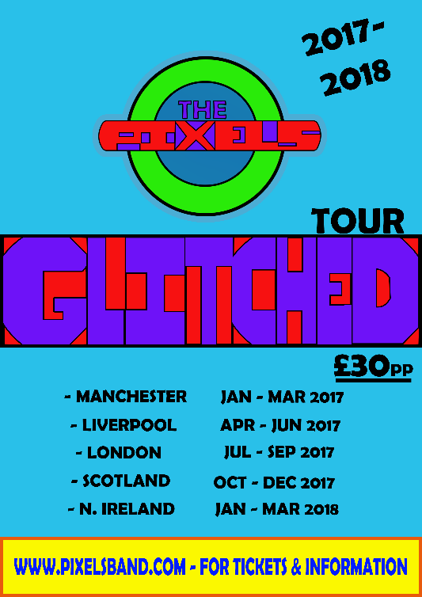
When looking back at the storyboards and then comparing this to the graphics that I actually did create, I am happy with the designs and the way that everything turned out. The logo looks like a split image of the storyboard as I worked extra hard on this as I used it pretty much for my whole assignment, I do still love the way that it looks and I don’t think that I would change it for the world. The poster also looks like the original designs, I did have a few problems with it along the way but I am still happy how that you can also see it all clearly and from a distance without really struggling too much on reading it, I think that it looks good compared to the original designs.
The cd case was a bit different to the original intentions and the designs as the front has the boxed ‘glitched’ word on it instead of the written one, there is an explicit content sticker on the box now to warn people about it. I also added a spiral grid box on the background, which made it look different, but it looked a bit plain and boring before had and I wanted to do something that was just a bit different.
The back cover pretty much changed for about 70% of it, I changed the terms and conditions and the legal and copyright stuff all at the bottom so it was out of the way. The back cover had the bar code and the sky logo in a different place and they have been moved down to the bottom right corner so that everyone can see that it is not in a place that is too big. I also added the logo to the top right as that then people know who the band is; this helps if they have not seen the front of it yet. Another thing that I changed was the text, as I wanted it to be as a different colour than black as it just did not go.
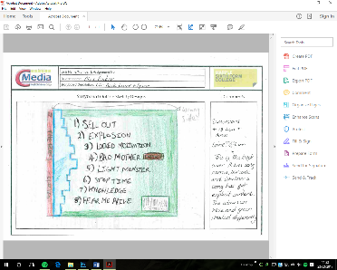
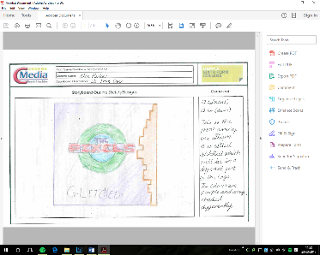
The last thing that I added was the grid on the background I also like the way that it is un-intentionally fades over on the left and it is a bit bolder on the right. Therefore, with these changes I made still make me feel happy and proud with the overall look and the way that everything looks but the original designs do just make it look good.

Appropriateness to audience
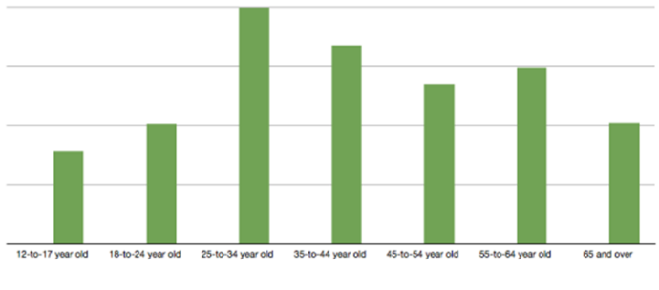
As the audience is going to be made for the people of the ages of 18- 30 it means, I can have songs with explicit content in it. I do then need to warn parents or other people that are younger or people that are unsure that it has content that would not suit them, it is just more of a warning. It is a boy band but this does not mean that people of just one gender can listen to their music, but this music is suitable for everyone. This is what I wrote in my proposal and from going over and reading it again I do also think that the end product would be appropriate for the audience. The colour schemes that I went with also attracts the audience and I feel like that people will see them as being a unisex group, the colours are also the main colours that people like. The audience should think of that the group are good for them as they are just different to what you would have thought.
Technical qualities
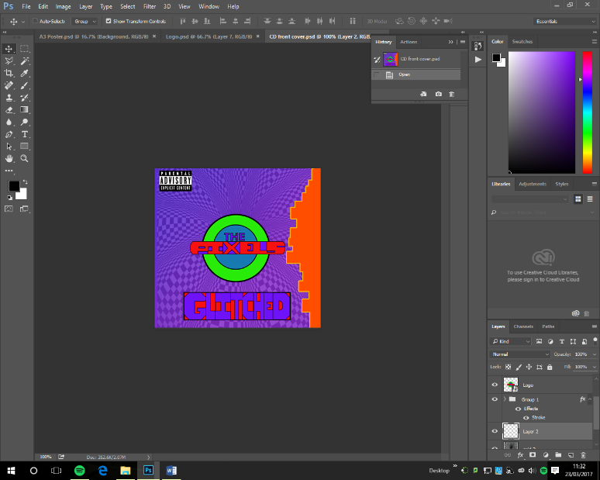
I used a computer for this assignment, which therefore meant that I did something technical and did something digital. I used Adobe Photoshop and this is available for both Windows and Mac, Adobe Photoshop is an extremely powerful application that's used by many professional photographers and designers. You can use Photoshop for almost any kind of image editing, such as touching up photos, creating high-quality graphics, and much, much more. This software will be used to create different characters and graphics for an animation as this application is extremely popular and is very adaptable for the animation. Photoshop is a software that can either be easy to grasp or it can be insanely hard and it will easy for flash as it’s in the same software family and that I can integrate them into something that’s easy to use. This software helped me out throughout this process and I would choose this software application for photo manipulation, creation and editing, each time as it is just a solid piece of software that is out there for this type of product. I could have used another software called Illustrator but this software is too complex and I am not entirely sure what everything does, I could have chosen to do this but as I am more experienced in Photoshop, I chose to do it.
Aesthetic qualities
As the band is called the Pixels, then I will be making the style kind of pixelated but this is good, but you can see it coming, as it is the pixels so you would just presume it would be pixelated. So the style will be done differently, but I am still unsure about how I can do this, I might go for a normal thing but then use the different coloured boxes or something along those lines.
The colour scheme that I have gone for, I had to make sure that people of both genders would like so they are Red, Blue, Pink, Orange and Green. I looked at the people’s most favourite colours and then chose these ones, as they were at the top of the list, most of the text will be in either black or the same colours. The typography is the text and the font of the text, the text that I am using the web banner. The font of the text is going to be Calibri as this is what I use on a day-to-day use. This is because it is easy to see and to read. The font size will be different depending on how much I need to fit on to a page.
As I have previously done a web banner for this band in another Unit, I will be using the same kind of things as before with the corners of the poster as the smashed out brick with the corners left as it just made it look good and I was happy with it last time.
This is all something that I had to think about in terms of colours, I had to make sure that It looked aesthetically pleasing and that they are all looking good.
Content and style
The content and style are all different and definitely not expected, the content is that I have covered all of the necessary items that needed to be used, I had to make sure that with the poster that it had the dates and the places on the tour, the pricing and where to go and get it. The cover had to have a bar code, legal info and also the manufacturer. These where all used in this process and the content that’s needed was all fully understood and this is good. The style on the other had is something that’s different as I did it nothing to do with pixels as I just didn’t want to do this for this assignment as people would be expecting it to have happen.

