Unit 58 – DVD menu design. – Theory-
DVD - Digital Versatile Disc or Digital Video Disc.
DVD’s I will be comparing are Shrek and Skyfall.
Authoring conventions
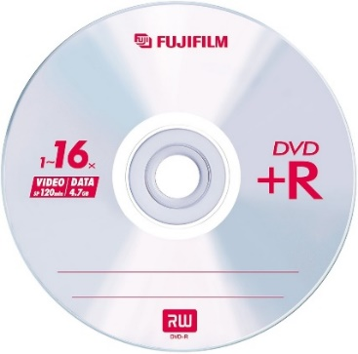
R
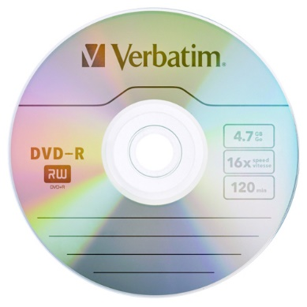
DVD-R means that you can only write and publish it once, this will typically be 4.7GB but has 8.5GB as it has a dual layer. These DVD’s where made and sold at stores in 2005, it can only be recorded once, this data will therefore become permanent. This format is supported by some big companies such as Sony, Phillips, Dell, Hewlett-Packard, Yamaha. The R means Recordable, you can get them in two additional standards, DVD-RG is for general use and DVD-RA which is for authoring. This means it will be supported be Panasonic, Toshiba, Apple Computer, Samsung, Sharp.
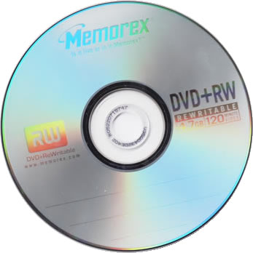
-R
There is no physical difference between a DVD-R/-RW disc and a DVD+R/+RW disc. There is a series of technical differences between DVD-R and a DVD+R recorder format. The DVD+R/+RW format offers subtitle are an extra feature for people who record their own movies and audio. The main functions are that: the DVD recorder's built-in defects management, it records a format and rewrite DVDs, the price this is the cheapest disc type.
+RW
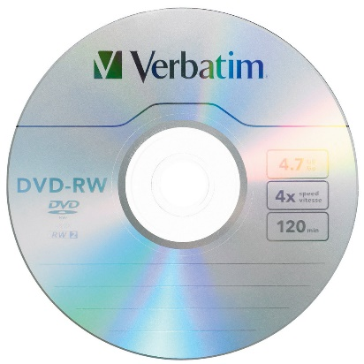
DVD Re-Writable (DVD RW) discs are designed to store up to 4.7GB or 120 minutes of DVD-quality video. You can add to or write over content on a DVD RW disc, making DVD Re-Writable discs ideal for backing up video and home movie collections. This would be one of your standard DVDs, therefore you can get these at the shops more easily.
-RW
With a DVD-RW you can rewrite any information up to 1000 times before it definitely needs replacing. This DVD format similar to CD-RW or DVD+RW. The data on a DVD-RW disc can be changed up a number of times, but the last time it will just stay the same and won’t be erased. DVD-RW’s are supported by Panasonic, Toshiba, Apple Computer, Hitachi, NEC, Pioneer, Samsung and Sharp. These formats are also supported by the DVD Forum.

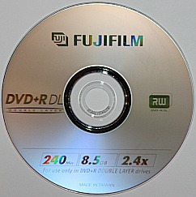
Dual layer
Dual layer (DL) DVD-R DL discs hold 8.5 GB by utilizing two recordable layers, each capable of storing a little less than the 4.7 gigabyte (GB) of a single layer disc, almost doubling the total disc capacity to 9.4. Discs can be read in many DVD devices and can only be written using DVD-R DL compatible recorders. A dual layer is when you have the capacity of 2 single layer (SL) inside 1 disc. The price can vary in price from £6 to £12. A dual layer has 2 different lasers that will do dual layering.
Writing speed
Most discs will support a writing speed of 52X and higher, with some modern DVDs supporting speeds of 16X and higher. It is important to note that the speed of writing a DVD at 1X (1,385,000 bytes per second) is approximately 9 times faster compared to writing a CD at 1X (153,600 bytes per second). The actual speeds depend on the type of data being written to the disc.
Blu-ray discs, 1x speed is defined as 36 megabits per second (Mbit/s), which is equal to 4.5 megabytes per second (MB/s). However, as the minimum required data transfer rate for Blu-ray movie discs is 54 Mbit/s, the minimum speed for a Blu-ray drive intended for commercial movie playback should be 2X.
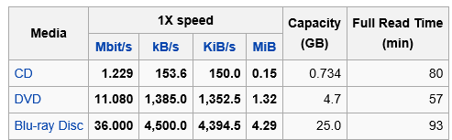

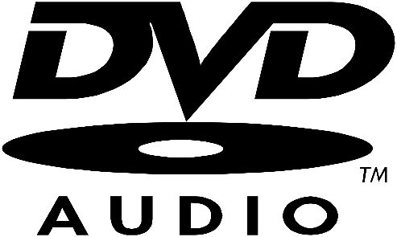
Audio
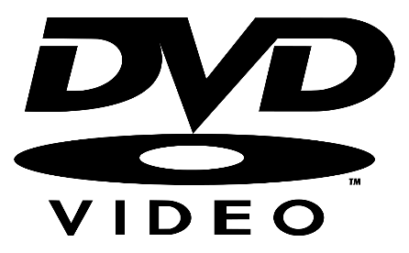
DVD-Audio this is Audio that is high-resolution audio and video format. DVD-Audio players could play both stereo and 5.1 surround sound discs. They had video output, as well as backwards compatibility with DVD-Video disc. All of the audio is set up so it is on a different multi-channel. All DVD’s now come with audio and it is in high quality. Both of my films do contain a lot of audio, but there are some films that don’t, but they will contain sounds instead of words.
Video
DVD-Video is a type of DVD that people that are not professionals can use to store videos on, most discs using the DVD-Video requires a DVD drive and an MPEG-2 decoder, this is important for it to work. There is a DVD specification this can be obtained by paying a fee of $5,000. The specification is not publicly available and every subscriber must sign a non-disclosure agreement. All films do contain video as it won’t be any point of seeing it.
Menus
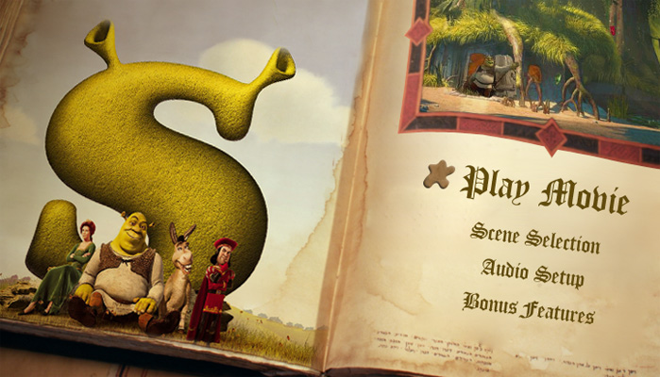
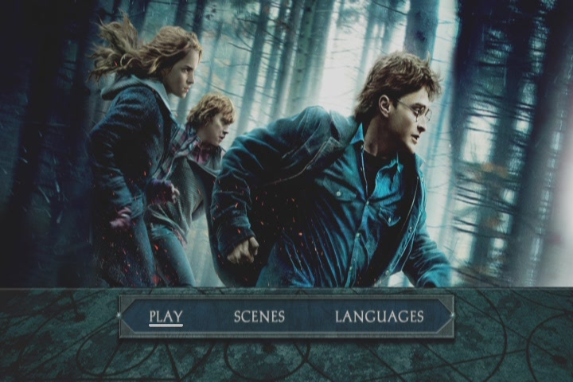
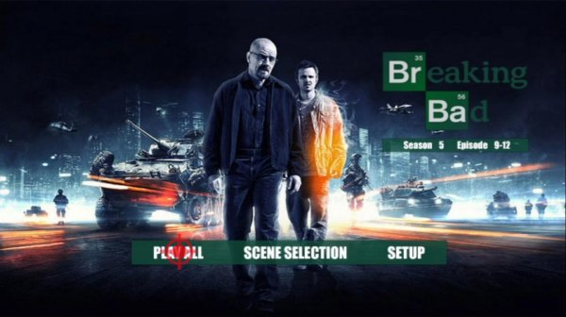
A DVD menu is when you insert a DVD to the TV or computer, you will get a menu where you can choose to play it or to change the play in to 3D, you can get chapter selection, this means that you can go to a scene that you prefer. There will be some settings where you can change something. In this topic I will be doing things about a music artist, so for this I will have music, video and some information about them. In order to publish them you will need to use some authoring tools that will be available online. There can be a few clips of the file on the menu, this will be there as a preview. To the right and below are some examples of DVD menus for either films or TV series. These are completely different depending which film it is, this will be created at the end of a film, as it may contain some of the video in the films. Both of my DVD’s have a menu, like the rest of DVD’s do.

Additional DVD features
Subtitles
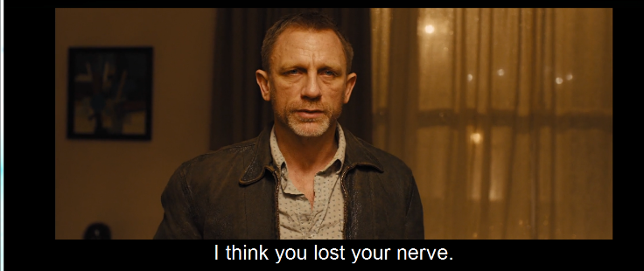
Subtitles are used as over 9 million people in the UK with a hearing difficulty who may be need on subtitles in order to enjoy DVDs. An enormous amount of lost profits for the DVD makers who do not add any subtitles to their DVDs, and are missing out a lot potential on the market for people with hearing problems. There are some websites that promote subtitled DVDs this making that subtitle users are able to find subtitled DVDs, that they want to watch and therefore trying to get all studios to release some more subtitled DVDs. Subtitles are found in the settings or in prefferances. The first subtitle was made in 1909 this meant people could keep up with the rapid pace of the movie. I know that you can get Sherk and Skyfall with subtitles. This may not be in the movie thetre, but at home once you have bought it. You can see special veiwings which contain subtitles and other difficulties.
Different languages
Nearly every DVD contains a feature that you can change language, this is used so that if you speak and use a different main language instead of English. On every DVD that has the feature there will be at least English and Spanish. This is because these are the two most spoken and preferred languages in the world. There might be a film that you want to watch from another country, and there aren’t any language features, then you can add some subtitles to help you out. About 90% of films have English in them. These films are originally in English but have been modified to get most other languages. Skyfall is originally a British based film, so it won’t have as many different languages as some others.
Easter eggs
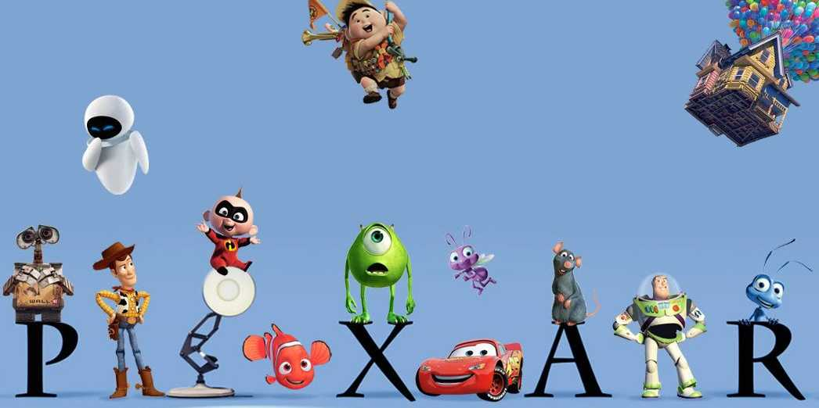
Easter eggs are hidden items from other films or funny things, that are not to do with that film. You won’t really be able to find any Easter eggs the first time watching it, but after a few times you will be able to see them a bit more clearly. Easter eggs are placed into the film by film editors and film producers as they are funny gags. After people have found the Easter eggs people will go onto different forums to post about it. http://www.eeggs.com/tree/1899.html <-- This is a website that specializes in the Easter eggs and puts them together. From this website I managed to find some Easter eggs in the film Shrek, but I didn’t manage to find any for Skyfall, this may be because it has only just been released. There are 3 Easter eggs in Shrek and there are also 4 Easter eggs in Shrek 2. I will look at another website in the future trying to find Easter eggs for Skyfall.
Animation
There are films that nowadays that are fully animated, this has been developed so much that some of the characters feel like they are realistic. You can watch these films in 2D and even 3D. there is a lot of TV series that are animated. There are 2 main companies that make animated films, these are Walt Disney and Pixar. Disney have made the following; Aladdin, Peter Pan, Snow white and the seven dwarves, Pinocchio, bolt, etc. Pixar have made the following; Monsters inc, Cars, Toy Story, inside out, incredibles, Wall-E, ratatouie, etc. These companies make the most incredible films and they are both good in their own ways. Both of these companies do collaborate with each other to make some films. There is another film company called DreamWorks that have made lots of different films, this includes; Kung-Fu panda, how to train your dragon, Madagascar, etc. The film Shrek is made by DreamWorks. Skyfall is not an animated DVD but I can talk about another film. The other film is Bolt by Disney; these two films are completely different. This is because the companies do things in different way, they both use different software to get the end product.
DTS
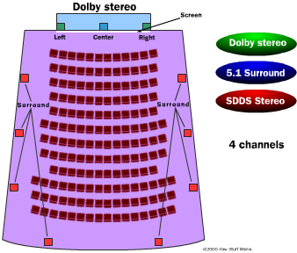
DTS means Digital Theatre Systems, this an American company specializing in digital surround sound formats used for both commercial and theatrical grade applications. The company was originally known as The Digital Experience until they changed it to DTS in 1995. DTS has lasted much longer than anyone expected. The original concept was that it was a temporary solution while theaters made a transition to digital technology. But from the ease of use, the low cost and that many theaters have already made the investment into the format this means they are going to keep DTS an alternative to the sound-on-film digital formats. But this was changed and now a lot of people use it.
Dolby
Dolby is a company that makes sure that you get the best out of surround sound systems at the cinema. They will go around to cinemas and place the right amount of different types of speakers, they make sure that anywhere you sit in the cinema you will get the best sound experience. Dolby Digital Cinema ensures that you see the images and hear the audio exactly as the director imagined it to be. Dolby wanted the cinema sound and video so it doesn't fade or scratch like the traditional film prints. The hundredth showing of a movie looks and sounds as bright and clear as the first time you will see it. With Shrek the sounds with be quite natural and different, but if you had Skyfall it would have a louder sound this means that you can have all the gun chases, action scenes. This makes the watcher feel scared when the actor is scared, this makes it more dramatic overall.
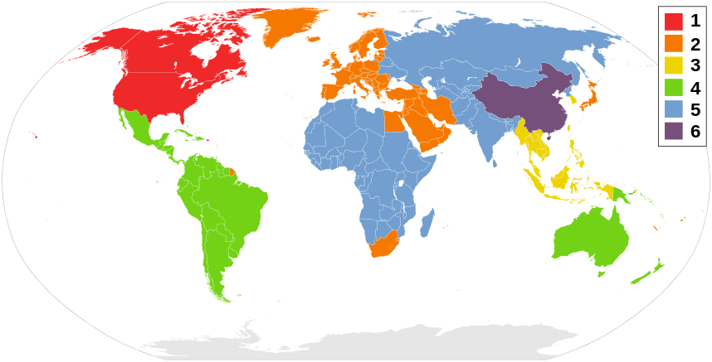
Regional codes
DVD regional codes are also known as digital rights management this is a technique that help designers of films allow the control of a release. This can be the content, release date, prices, according to the region. So this means that you can charge a higher price at the start, then you can later on change it to a lower price. Most films cost a lot more in the first 3 weeks as it is a good money scheme for film companies. If you get a DVD at the store and go into another country and try using the DVD in a player, then the DVD won’t work properly as it isn’t in the right regional area. You can get region-free playback DVD players; this means that you don’t have to worry about being in a specific place to play the DVD.
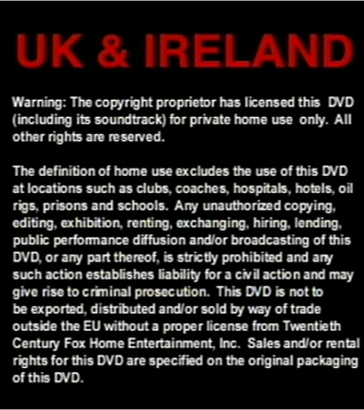
Copyright
The DVD copyright law prevents people from copying anything from the disc to a computer or removable disc. If you have been found to do this then you can be sued or have to pay a fee, either way you will still have to delete the content of the computer or removable disc. The fee can be dependent to your country and the company who made it. Most DVD’s have a warning page at the start that tells you that you can’t copy the content. This is a reminder for parents that they need to make sure that people don’t use it anywhere else, as it is for private home use only. If you want commercial use rights then you need to obtain a license for this type of use.
Protection
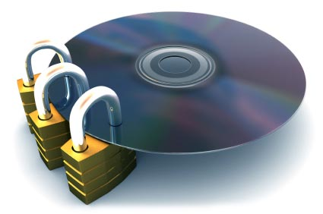
DVD copy protection is a basic term for various methods of copy protection. These methods include digital rights management (DRM), DVD-checks, Dummy Files, illegal tables of contents, over-sizing or over-burning the DVD, physical errors and bad sectors. Many protection schemes relay on breaking compliance with DVD standards this will lead people to playback problems on some devices. This means that companies can sue you for fraud and they can make money out of it. There are some companies that do DVD protection schemes this includes; Analog Protection System (APS), Sony ARccOS Protection, Burst Cutting Area (BCA), DVD-Cops, DVD region code, LazerLock, Cactus Data Shield (CDS). There are many more but these are the main companies.
Parental controls
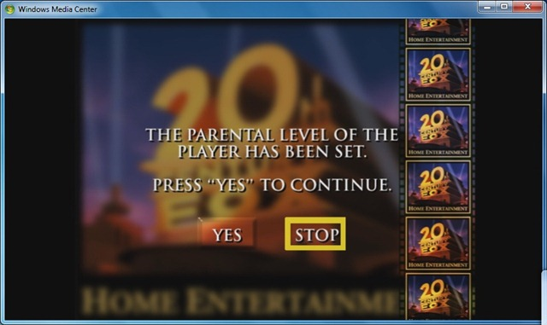
There are not parental controls on DVD’s, but they can be set up by the home owner on the TV. This can be set up in the settings, this can mean that if your child under a certain age wants to watch a film and isn’t old enough there will be age restrictions so they watch the right content. The parent or responsible adult can insert a pin code then you can watch it after. This means that you can leave age restricted content restricted, for your children under a certain age. If you want there to be parental controls on a video, then you set it up on a computer, that has some sort of media player. Once in that then you can set it up in a DVD control in the option settings. This will save and so you don’t have to keep on adding this options to them.

Functions and Elements
Buttons
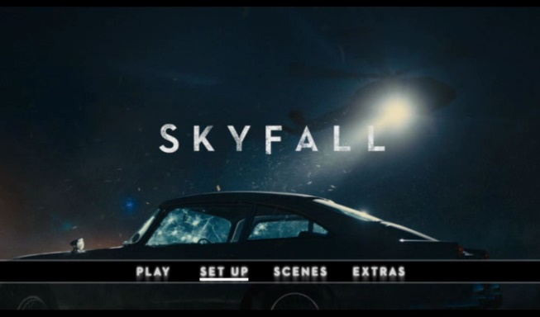
The interactive DVD button will allow you to switch between menus and play the video content. You place these buttons strategically on each menu, customizing them to the theme that the menu has. In almost every film button there will be a rollover animation. This means that users can see what they are clicking on before they press the enter button. On a remote you make the selection with the arrows on the center. But with the computer that you can use, you will have the arrow keys on the keyboard. On the Shrek DVD menu there is a star on the left of the button that can select what you want to happen. On the Skyfall menu the buttons are highlighted underneath on each section you are to select.
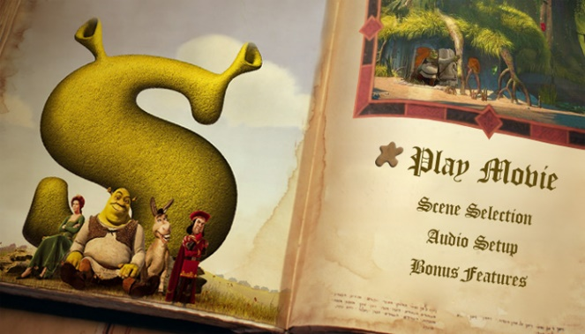

Still images
A still image is an image that doesn’t move about, this means that there could still be a section that has moving content. Most DVD menus have a contestant amount of still images, but can have a section where there is moving content. In different software they are known as ‘Cycle graphics’ this is in Director. There are some websites that can teach you how to make these graphics. The Shrek DVD menu has certain still images which is on the left. Whereas with Skyfall there is only one which is the SKYFALL text and the movie bar.
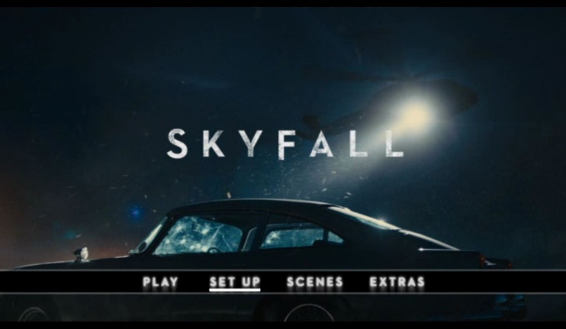
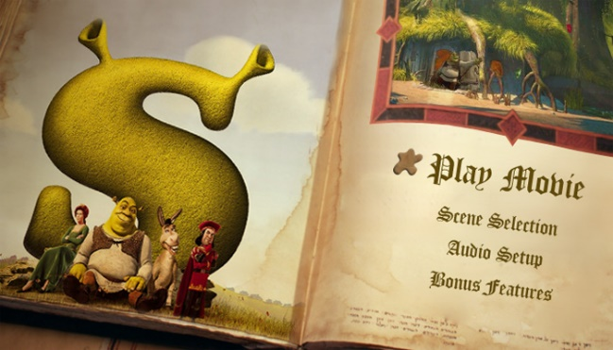
Still image

Still image

Moving images
Moving images are also known as film clips, this is what people can look at to see a quick preview of what it is like. This preview is a quick preview of what people can see in the movie. It is like a trailer. It can contain some action scenes a that may be in. This is exactly what Skyfall has, it has a few clips of what the action scenes are going to be like. The Shrek film has a small bit in the right corner. It has a few clips of the film. These do not try to ruin the film before you can see it.
Moving images
Moving images

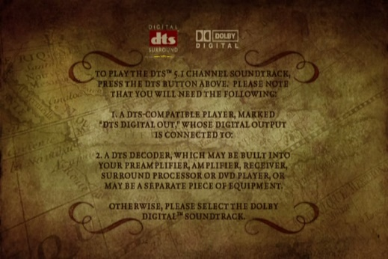

Text
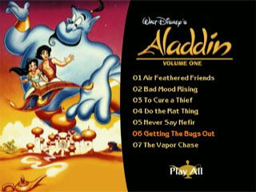
There usually isn’t much text on a DVD, the most amount of text used is the selection names such as ‘play movie’, ‘extras’, etc. The only type of DVD that may contain text would be a promotional DVD or commentaries for commercial use. This is going to be what I will be creating when I make my menu as I need to include some artist information. You may see some text if it is a band on when they maybe going on tour, such as tour dates. Also most DVD’s will contain a bit of text near the bottom or somewhere throughout where it tells you some of the cast members, who are playing the main characters.
Sound
When you play a DVD and its menu pops up, you are more than likely to hear sound from the original sound tracks. Or you may hear some of the voices of the characters. Skyfall has just got the music playing in the background, this is the music from Adele. Whereas with Shrek it will only just contain some lines and words that make the story seem fun, from somewhere in the play. If they do this they can never spoil a good bit, this is for people who might not have seen it.

Uses and Application
Interactive media
Interactive media is all of the DVD menu, because you are constantly interacting with it, such as when you click on ‘play film’ you are using this to interact and then get to another page. There can be things put in place such as a rollover, which you can see when you are interacting with the page. Interactive media is all throughout a DVD menu, as there are boxes that light up or things that get underlined or an image goes to the left or right. In my case the Shrek and Skyfall have these on their menus. Skyfall has the underline feature and the Shrek has the image to the left. It doesn’t just have to be this it can be an animation that loops around. It is like the image to the right, when it is playing the belly of homer goes up and down, like as if he is sleeping. (https://vimeo.com/45972135)
Text-based files
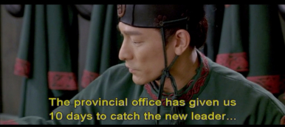
Text-based files are films that entirely relies on text, subtitles or titles, something that must be read by the audience. They often have text based files at the start of a DVD when it tells you the age rating and warnings etc. This can be on a foreign film and needs the English so you can read and understand the content. The warning is put in place so that you can see that you can’t copy it as it makes you go into break of breaking the law. It is in every film.
Image- based files
This could be a family or friend slideshow created for the family to remember events or even share with loved ones via YouTube or having on the family computer for others to see. This could be the image printed onto the front the DVD. Photographers at weddings use software online to create a wedding video that the family can buy. This can be a real DVD and you can get a digital download. http://www.timelessDVD.com/DVD-design/DVD-designs-photos-1.html <-- this is a great website to do this.
Image Slideshow
This is a presentation of images that a user can see. Some DVD creators like to show photographs in a timeline, that allows the audience to go through them as they want. This is an easy thing to set up in the image properties. You can set it up so it becomes automatic and so you don’t have to move a finger. An image slideshow is a bit like a ‘cycle graphic’ and this is automatic. An image slideshow has some controls to the left and right to navigate through.
Additional material
There is usually an extra DVD in the DVD box this will contain some additional material. In this additional material has some content from behind the scenes this will show you how they created it, they do keep it quite brief so you don’t get bored. This is great to watch after the film, as you can see exclusive content from the cast, like interviews. If you don’t want to watch it then you don’t have to, as it isn’t compulsory. With Shrek it has bonus DVD material such as a singing karaoke section and an interviewing section, they also have a mini show called Far Far Away Idol which is a singing content between the characters. Skyfall has a behind the scenes section and an interview with the cast. This is material that is unusal to the film and this is also fun to watch.
Additional features
Most DVD’s have additional features; this can be from advertisement through to games. I have looked at a film that had some advertising in the menu, it showed songs and promoted or DVD’s and music. There are many Languages that you can change between there are some extras that you watch this can be fun and it can make the time quicker. Then you can get some games, then there is an interactive element. Skyfall has the languages feature, but whereas Shrek has a lot of features such as games, you can change the language and has a bit of advertising.

