Diary for logo
The first thing I did to make my logo was to create a new project in Adobe Photoshop, I called the project “The Pixels logo”. I changed the width and height to be 1080X920 this meant I had enough space and I could always cut it down later on.

I wrote the letter P and this was set to “Terminal Regular”. This was set to the colour red and then it was moved towards the middle. I changed the size to 200 pt as It would make the logo work.

The next thing I had to do was the letter i. this was going to be in green and in the same format “Terminal Regular”. I then had to make the P go on the top and then make a green rectangle to fit in the open space. Once I had done this I dragged the letter p on the top layer for it. this means the P is dominant.

The next letter was X. I wanted this to be a different type of font so it looks different. I went with the font called “Source Code Pro Regular” this looked great. i then changed the colour to a pink. I moved the X to the be in line with the i.

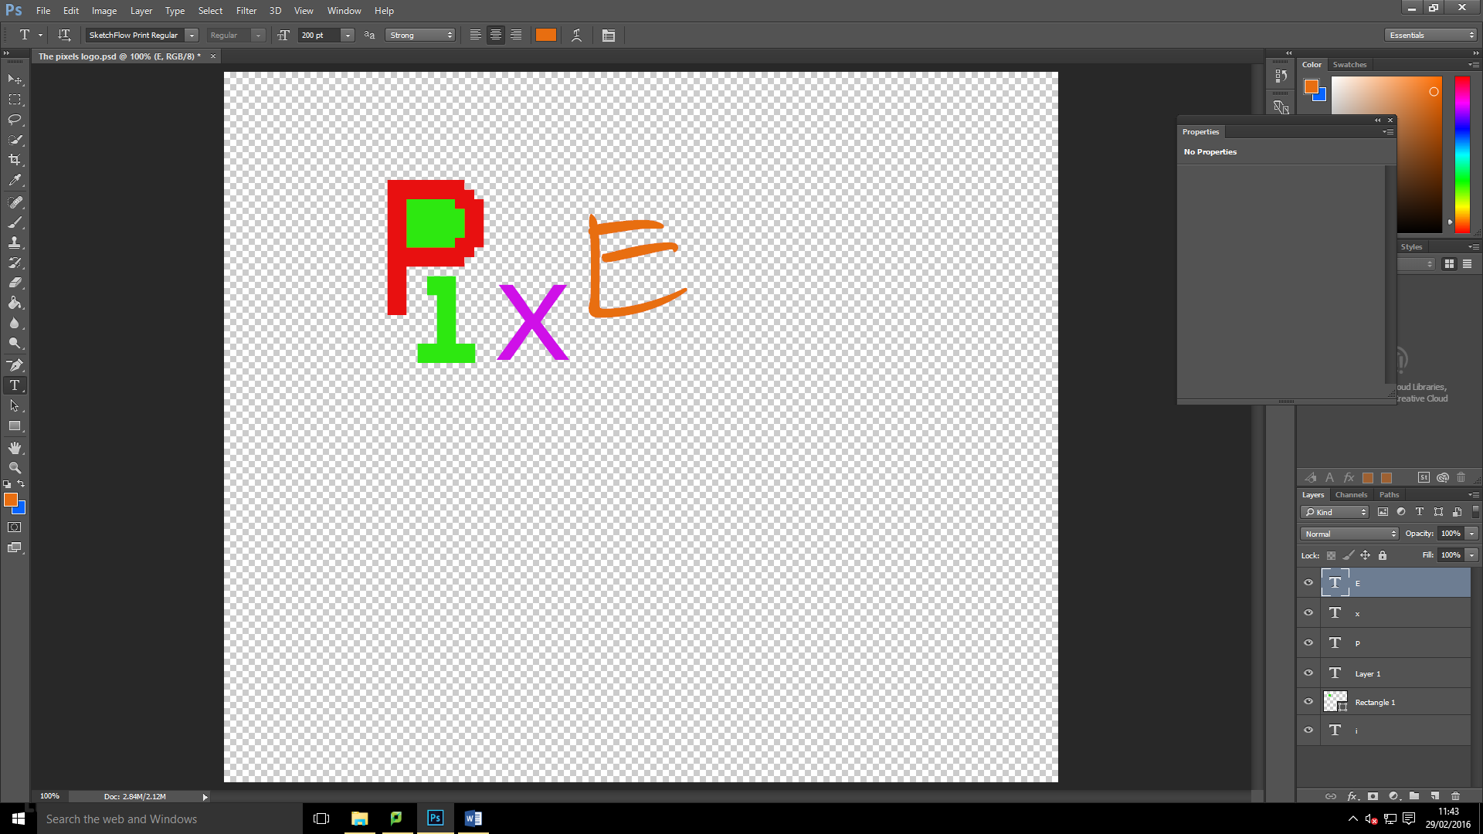
The next letter is e. I wanted to change It to look like someone had drawn it so I went with “SketchFlow Print Regular”. This makes the text still work out. This looked great so I changed the colour to orange. I moved this a bit higher to make the format different and not centered.

The second to last letter was L. this will have the most amount of effects on. I wanted to add a 3D design to it, so I went for a stroke effect at 6pt.
To create the L, I started off by typing it and then I changed the colour to blue.
I then change the font to “Sitka Subheading Bold” which will look good with a stroke effect. I then moved it to the required place and then started to add the effect.

To do the effects, you need to go into Layer > Layer Style > Bending Options > Stroke.
I set the opacity at 100%and made the size to 6pt.

From this point I need to add the Z to it. The Z is going to be the colour red as this is what I went for in my storyboards. This font will be set to “Segoe UI Semibold Italic” this adds an italic effect to it. I then moved it next to the L. I then occurred a problem which meant that the z needed replacing under the l.

I then swapped the layers over in the layer’s section.

It then looked like I wanted it too.
Then I wanted to crop all the outside transparent background out. So I got the crop tool and did this.
BEFORE

AFTER

I then made sure that I had saved the latest copy and then started to export it.
To do this you do File > Export > Export As (the shortcut is Alt + Shift + Ctrl +W). Once the popup has appeared I then checked to see if the file had been set to PNG and set to transparent. Once I had checked this I clicked export, I then made sure I knew where it was in the folder.

