Diary for graphics.
12/12/16
Aim: I need to login check emails, open documents, look at brief, I can use Moodle to help me out, I will make sure that I create the ILP, get the sources document, Create Visio timeline and then start creating the documents.
Evidence: I started out by getting the file sizes and making sure they would be correct.

I then opened the document so that I can work on the images.

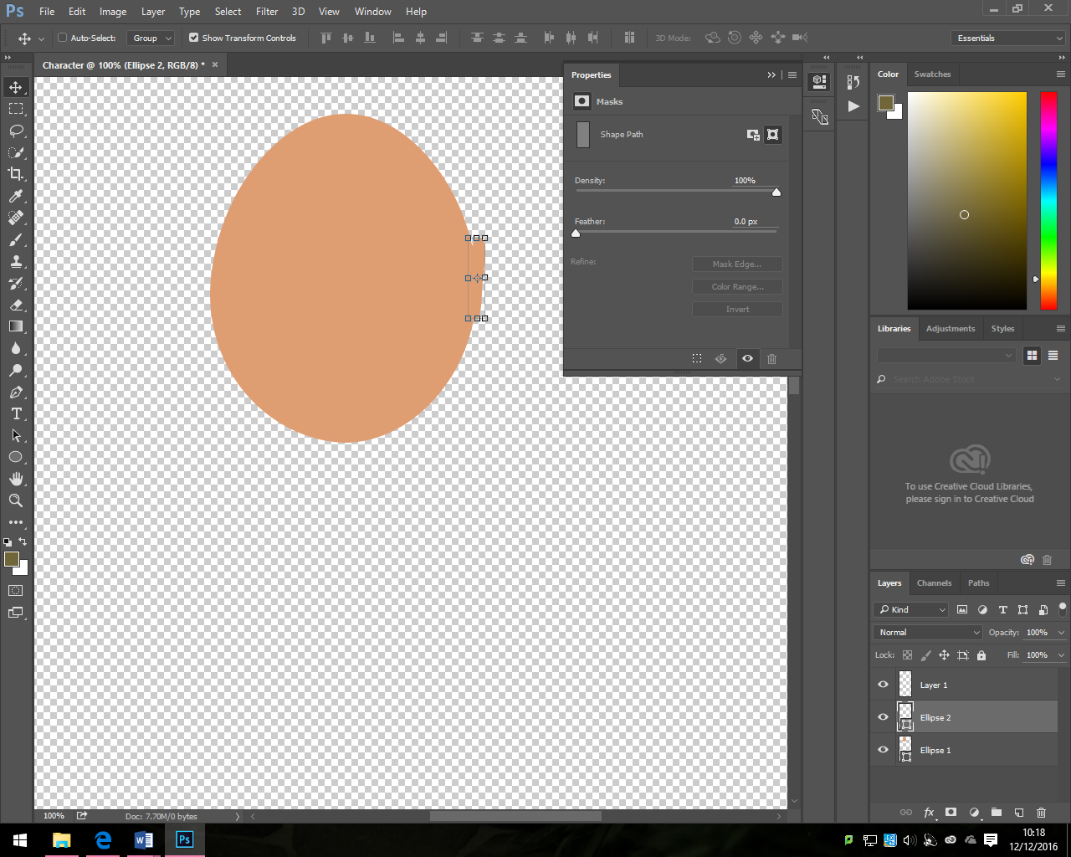

I firstly used the ellipse tool to make the face.
I then used the same tool to make the ear and then I saved this file so I didn’t lose any of the work.

In order to get some eyes, I need to get them online as they are hard to make online without making them and that would be hard and difficult. I would have made them but then I created them in the end as they are going to be much easier to do.
I then created the eyes and the mouth, but also copied the beard and nose from google images as I needed to. As these features do take a long time to create on Photoshop and I want to make this as quickly as possible.

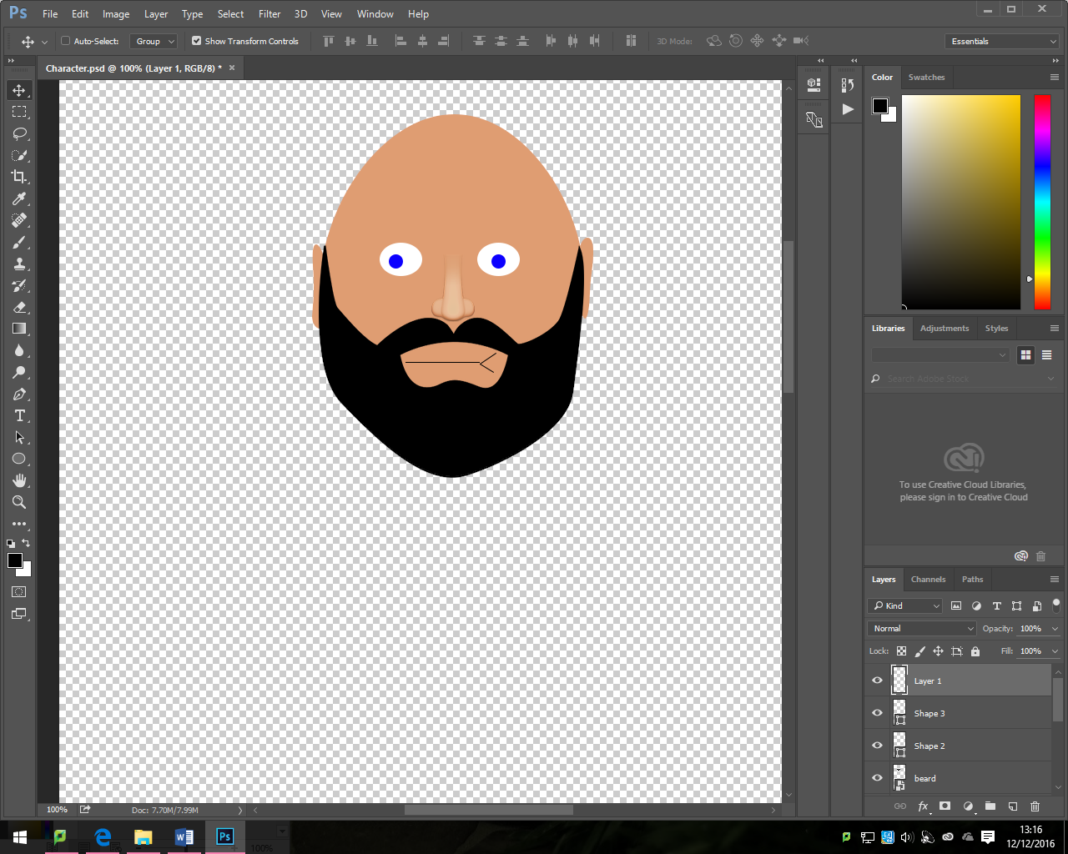

I then used the free transform tool to flip the right hand side and flipped it over and this should be easier to do.
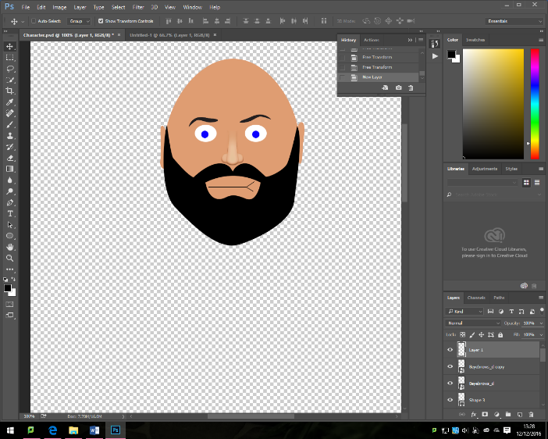
I then needed to do the hair so I copied this from online as I don’t want to have to draw every single line of hair as this will just take a really long time.
I then imported some hair onto the guy and he looks more normal than it should do.

To create the neck, I made a rectangle but then I free transformed it into a neck and that works.
I then used blocks of grey and transformed them into making the shirt and the arms
I then tweaked the clothing so that it looked good and made sure there weren’t any problems with my character.

To get the pants and the waistcoat I copied the files together to make sure that they fit together and then I did the same method as the shirt and arms to make it look good.
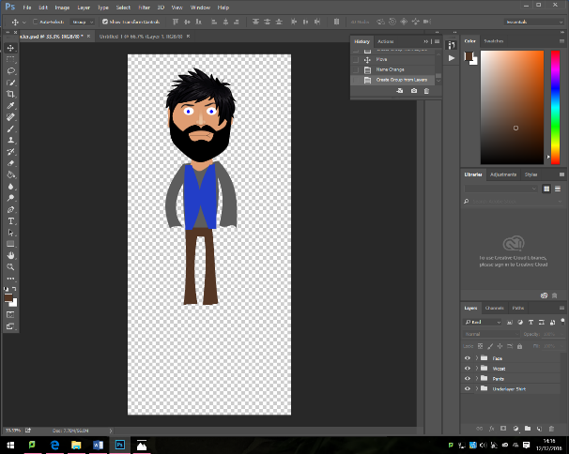

Learnt: Today I learnt how to make any character or person look good by making everything look good from blocks and that makes things work.

13/12/16
Aim: I need to login check emails, open documents, look at brief, I can use Moodle to help me out, I will make sure that I create the ILP, get the sources document, Create Visio timeline and then start creating the documents. I will also make sure that I complete working on the character today as I have spent a long time doing it so far.
Evidence:
In this lesson I worked on adding the over jacket and then I made the hands. These two things didn’t take long to create – about 20 mins. I used the same free- form method like last time and this is the simplest and quickest thing to do.
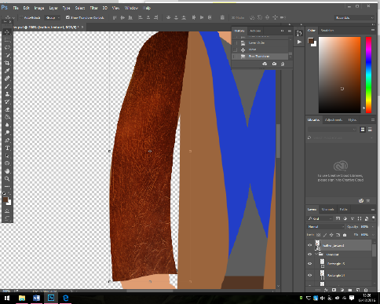
I then decided to add a texture to the jacket so I copied the leather layer on the top and then pasted it and then free transformed it into the right size and then I turned on the opacity down to 30% and it looked good.
I make sure that when I do the texturing I erase the bad bits out to make everything look good. I did try to use the lasso tool and the auto selection tool so that it would look good but in the end I had to do the other method so that it would fit properly, but I did try to do it a different way but that failed.
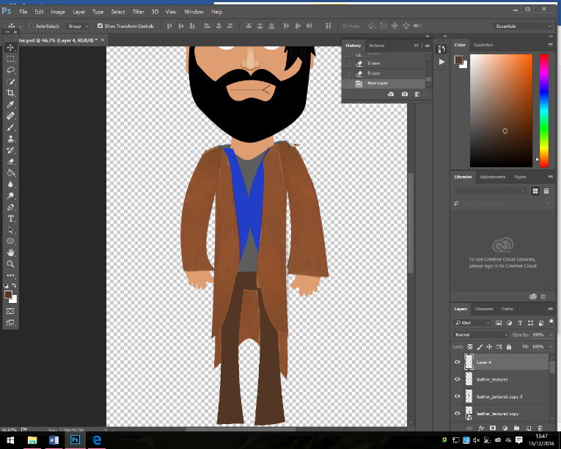

I am now going to work on the boots and then I need to make the scarf and gun then but I am happy with the texturing.

Once I had found a scarf online I saved it and then copied this to the document, I made sure that it was underneath the jacket layer and that then it looked good.
I then made sure that I made the boots and I did one and then duplicated it and flipped it to make it look good so that it wasn’t the same way.
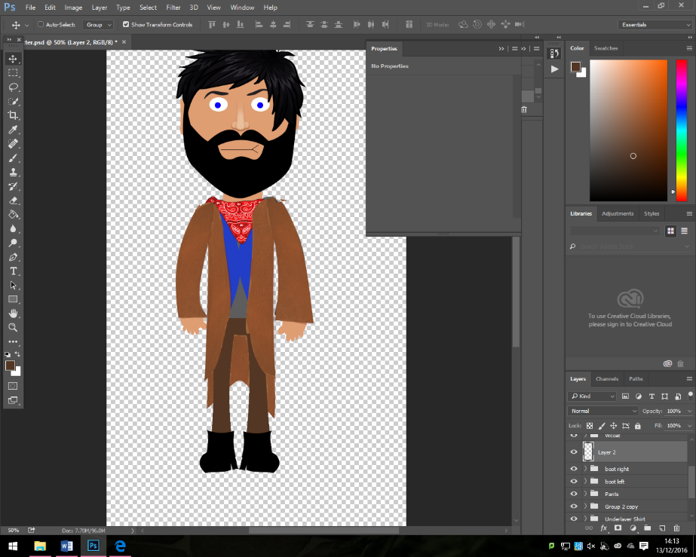

Once I had my character, I knew I had to make the gun but I just made sure that after that I had made it fully.
To create the gun, I made sure that I did the end of the gun on his shoulder and then this was made in black. I now need to add the little red line to the end of it and to do this I duplicated it and then I moved the end up to make it red.

I know need to use the rectangle tool to go from one end of his chest to the other.
I then completed the character so I can now start on the other objects, the next thing I am going to do is to create the background.
To create the background, I will be using some sprites from online but the actual background will be good, the next thing is going to be 27.9 centimetres x 21.0 centimetres.

The smaller mount that I had made fits in and I used the free transformation tool to do so, I will also make this into a sand pile for later on.
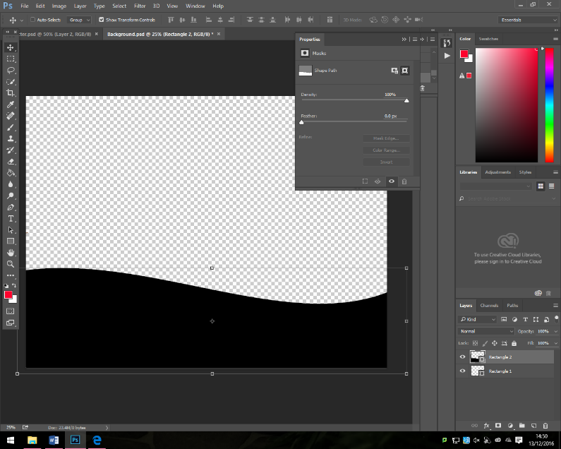
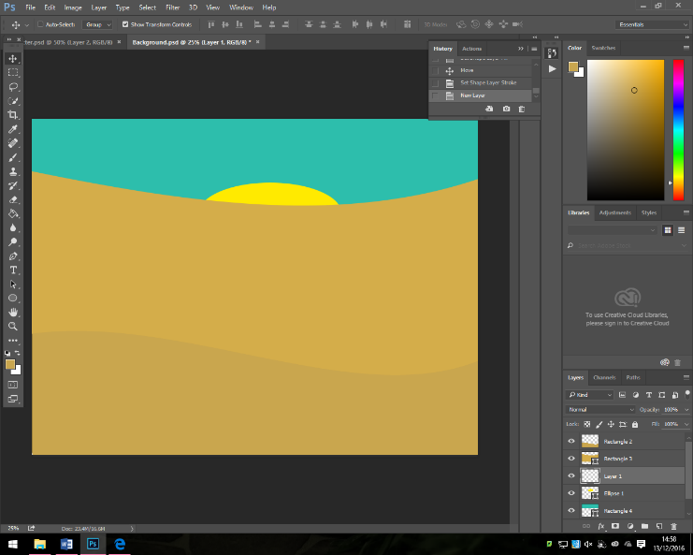
I can now change the colours and add some other graphics onto it
I also used the ellipse tool to make this look like it is a sun and I made it yellow and this looks colourful and great.

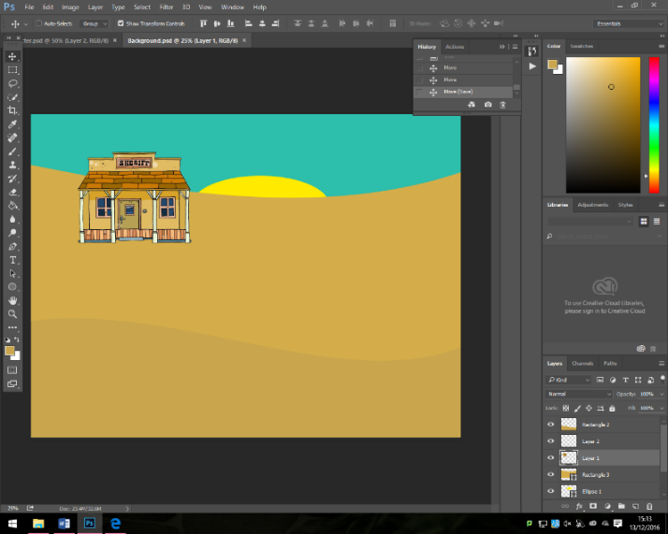
Once I had done this, I worked on the sheriff’s hut by making the background which was white disappear so I could move the object around without any white bits and the outcome was what I needed. I then did the same method for the barn house

I now need to get a noose for the middle to add a big effect, I did try to create on outside of this but I found out that they are hard to create so I got one from online as it was easier and the time effective way to do so.
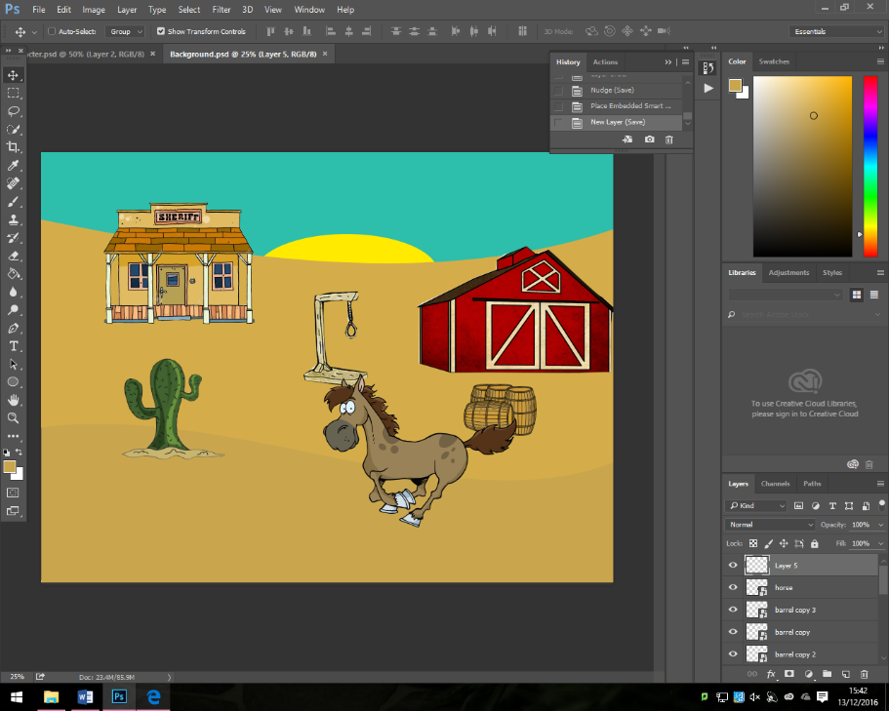
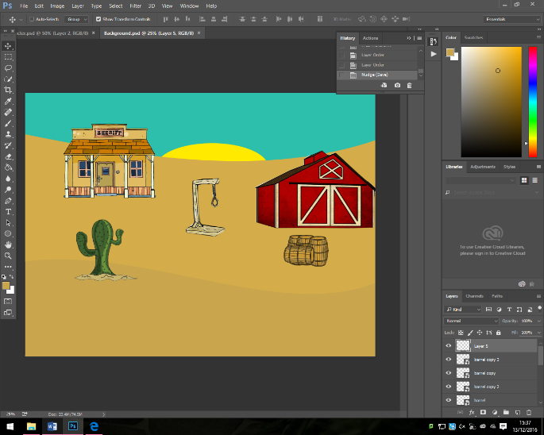
Once I imported the cactus and moved it around and the duplicated the barrels and nudged them also around the final piece was looking almost ready I just needed to implement in a horse and then It will be done and that means I have effectively made the work good and I am happy with it.

Once I had done this I am able to start the next one and that is what I will do to create the poster next.

Learnt: I have learnt that the games background was easier to do that other things, this one was just me compositing different elements together to make it work and it did.

14/12/16
Aim: I need to login check emails, open documents, look at brief, I can use Moodle to help me out, I will make sure that I create the ILP, get the sources document, create Visio timeline and then start creating the documents. I will also make sure that I complete working on the character today as I have spent a long time doing it so far. I will try to complete all the graphics today in 3 lessons that I have.
Evidence: Today I started the lesson by creating the poster, this hopefully should be easy to create.

I first used the text selection tool to get that desired text that I wanted to have at the top.
The font is going to be Perpetua Bold at 178pt size

I then need to change the colour so that it isn’t this sandy colour, it will also be a nice colourful green colour, I will also add some strokes to it as that makes the text pop.
I am now happy with this bit of text I will now add the next lot of text towards the bottom.

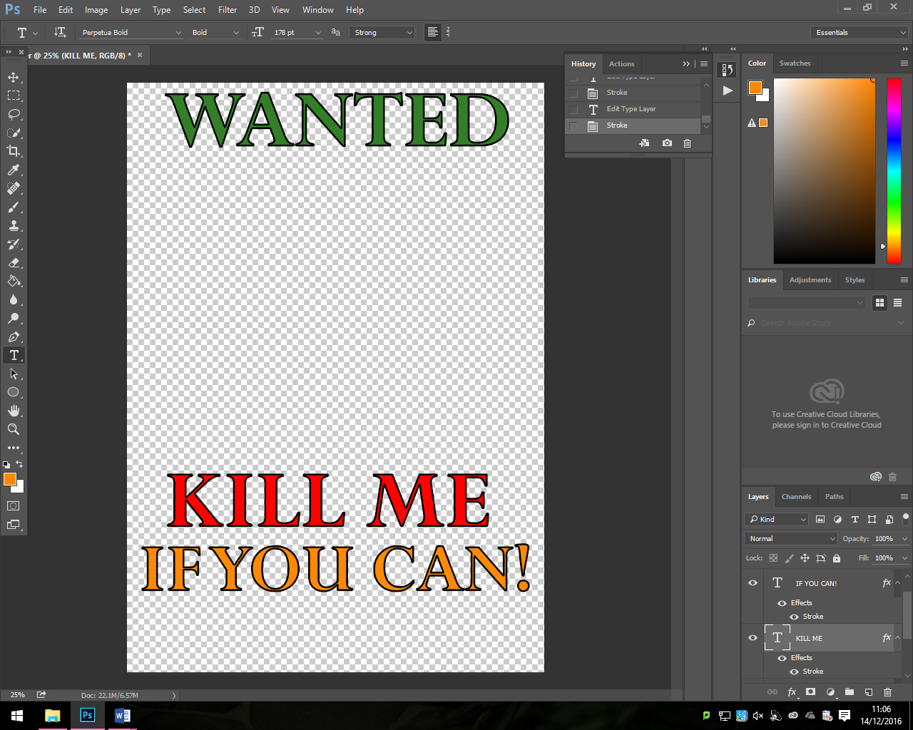
I used the exact same method as before but just for this bit of text.
I will now from that work I will import the cowboy hat from before.
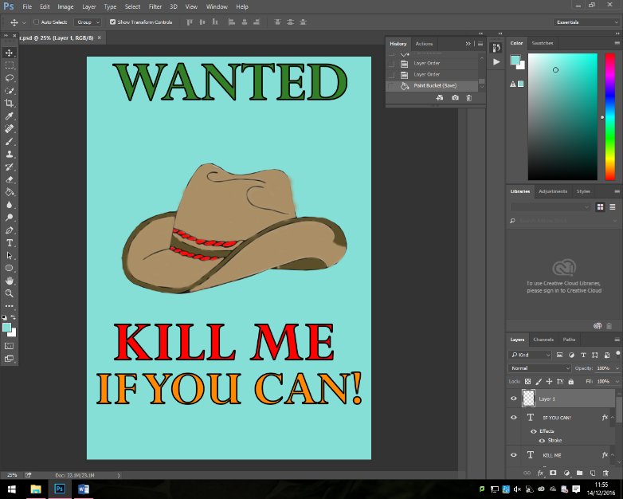
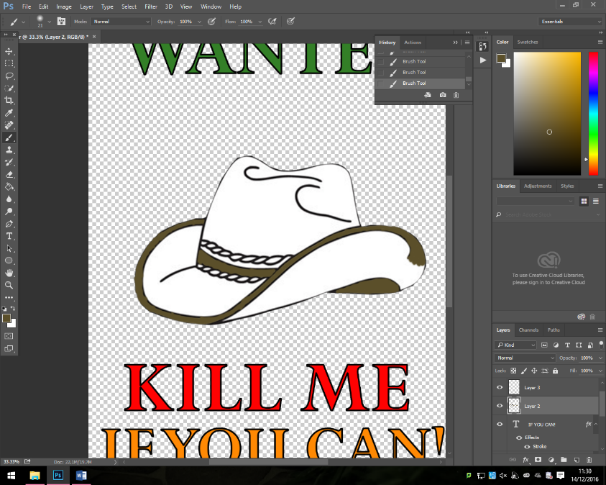
To create the hat, I imported it and then used the pointer and selection tool to cut out the background and then I deleted the white background, I then now need to colour it in and I might add a leathery effect.
I then changed the background, I then also made sure that I added the Rockstar logo and then the coming soon tomorrow.
Once I had done this I had done the poster and technically the front cover.
I have used all of my assets plus, logos and some ones online I created this my game box, I was too busy that I forgot to add this to my game and I then didn’t do my diary. But this is the end result that I have got:
I then changed some of the words and added some more information to make it to look better.

