Diary
16/03/17
Aim: I will login-in, check emails, I will then need to create logo, poster, CD covers and the checklist for this unit.
Evidence: I will be creating my logo today. I will make sure that this looks good quality and to make it as professional as much as possible.
To start off with I created the document and then I went straight into making the first outer layer by using the oval tool and making it green. I then used the oval tool again to make the smaller blue circle.

When looking at them I figured that the colours and the boldness just did not seem to be good so I went and added some effects, in order to get the desired look that I wanted. These where a stroke, satin and the colour overlay.

I then proceded into then creating the text, I tried this a few ways, by using text to create it but in the end I went for making a red curved rectangle with a outside stroke and then going into making the little purple boxes to make the text.

To create the triangles I struggled with this as I could figure it out, in the end I watched a YT video to get the answer as you just use the polygon tool, but change the sides to 3.

I then looked at it for a while and then figured out how to that the words just don’t look that good, so I went back and added a stroke to them, I had to make the 3 boxes for the E are made from a sub-group in order to make it.

Now I have done with this I will go and add the text.
I did this in purple and then just added the stroke to make it into this.

I then went and cropped down the background and then I was left with this logo, which I am happy about. I then needed to export it as a PNG so that I can get it onto the other items that are needed for this unit.
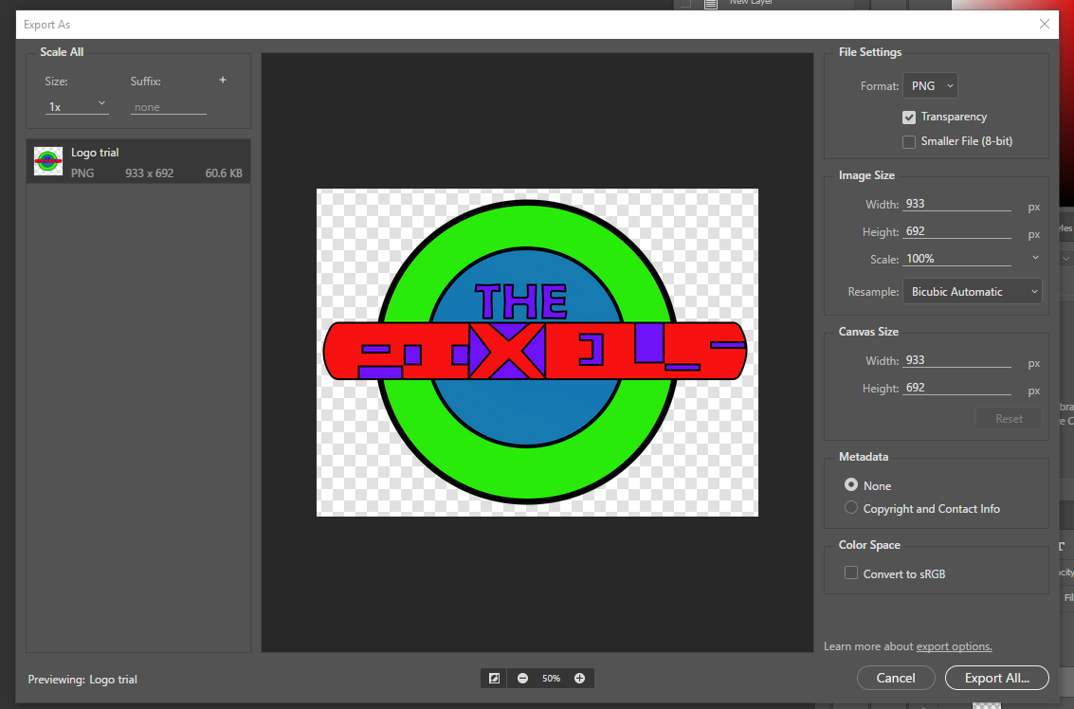

I then went onto creating the poster, to get the settings right for the size I went onto making the poster.
You need to change the document type from custom to international paper, then change the size from A4 to A3.

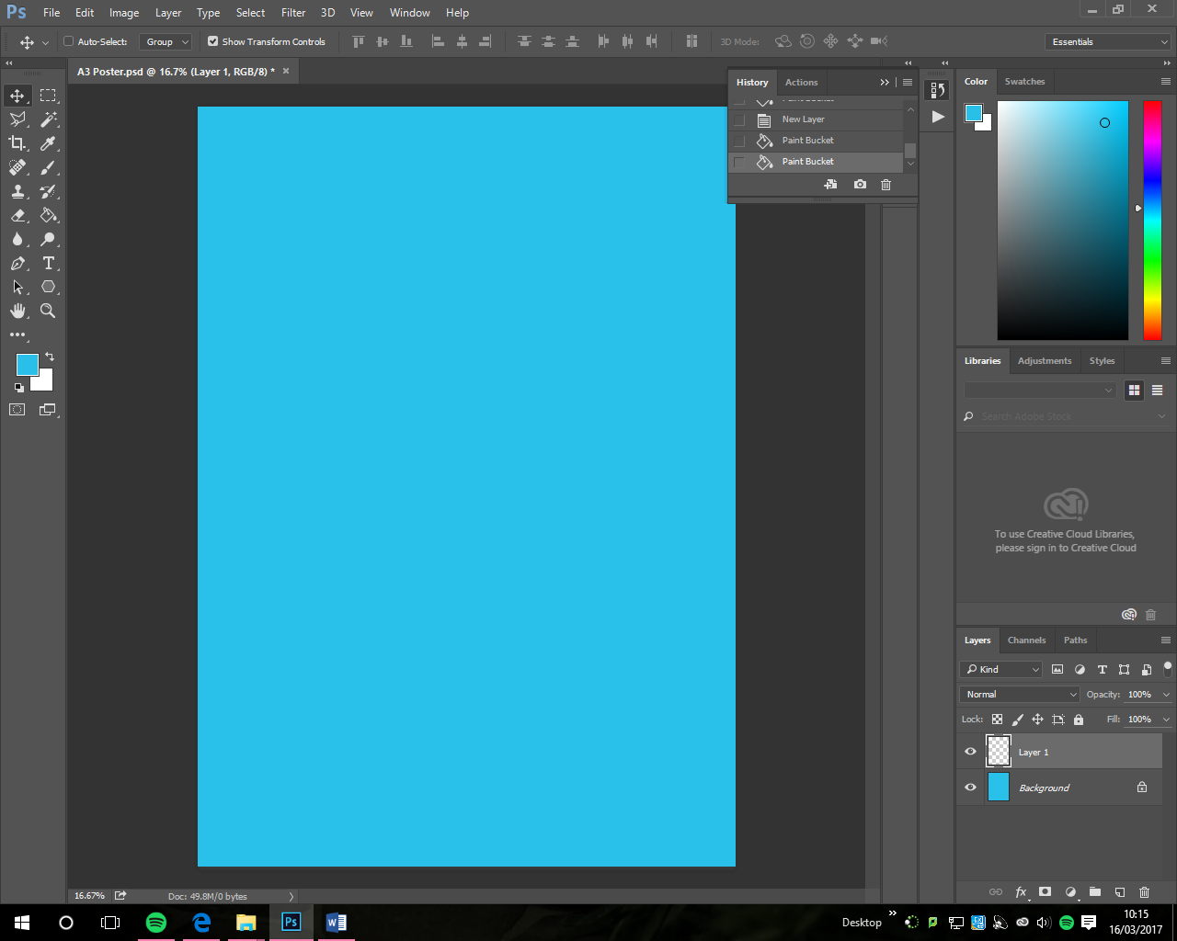
I then started to create the poster to the storyboards. I then firstly changed the background colour to the blue that I wanted to have it as.
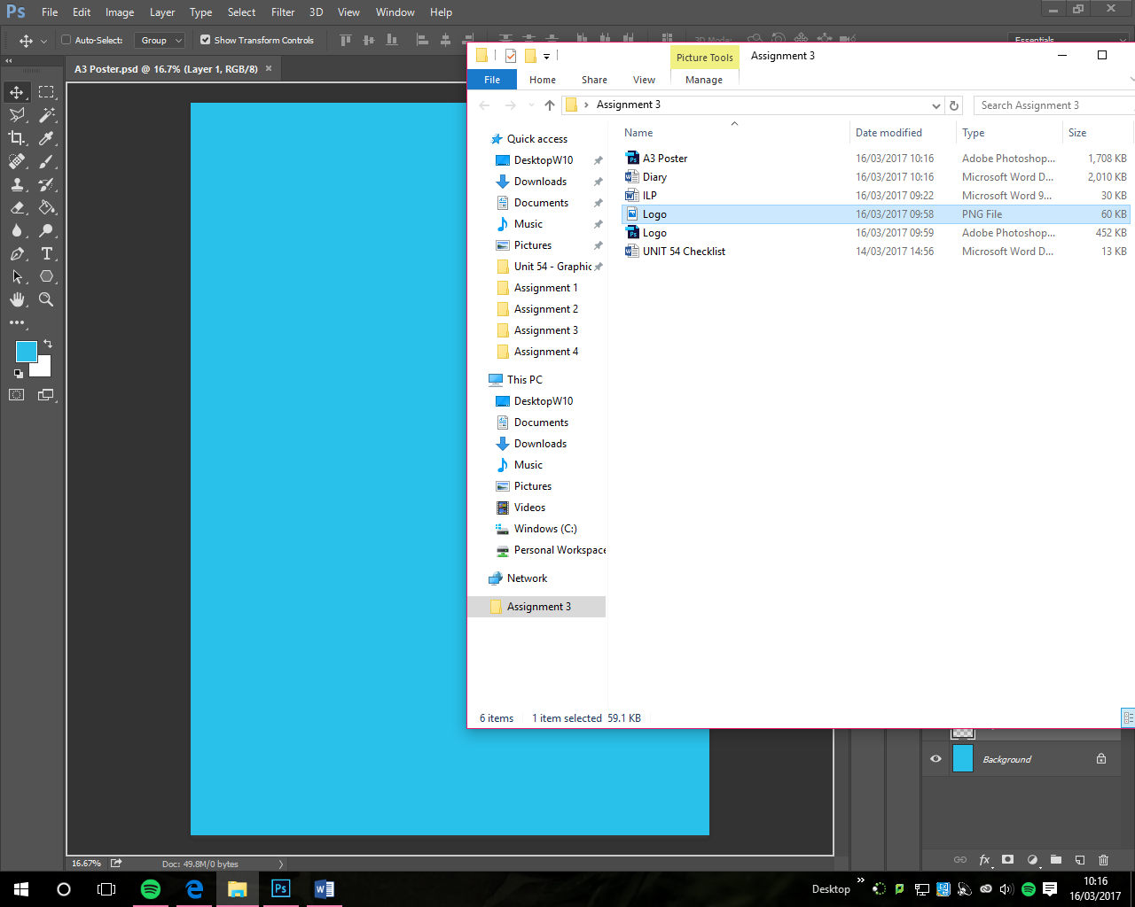
I then imported the logo to it by dragging it from the saved place.

It did look bad though as it wasn’t fully placed and looked a bit pixelated until I clicked the tick to place it.

I will be going from the top downwards, so the next thing is that I added the year that its on.
The text that I will be using for this task is Berlin Sans FB Demi Bold as it looks good and it is easy to read and adds some fun to it.
I did go and angle it like I have it in the storyboard.

I then did the purple box as I want it to be done like the logo and I will make it the other way around with the colours.
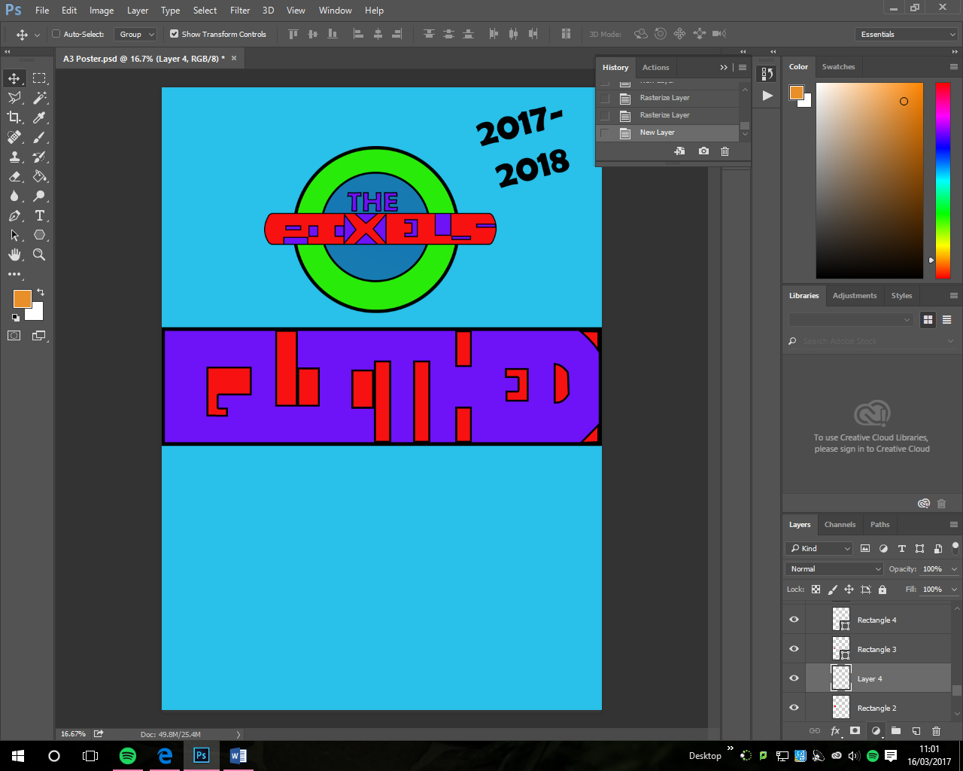
Once I did this I wasn’t too happy with the end result as the red is too overpowering, but this wasn’t the case I did have to just lower the stroke to 10pt so it ,looked smaller.
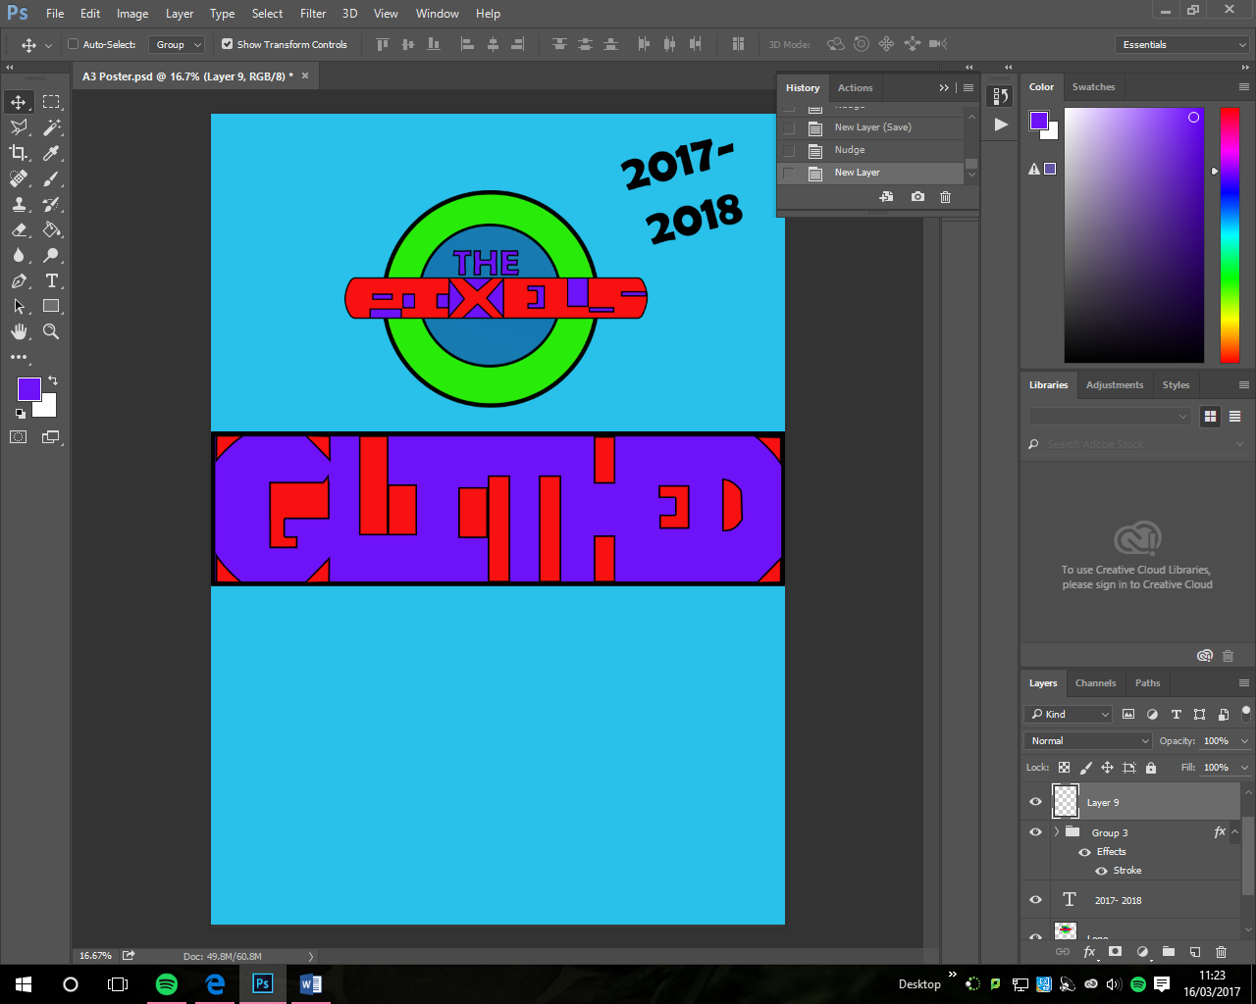
I did add a few other shapes in there to get the look I wanted.

I then added the ‘tour’ text with the font and size that I said earlier.
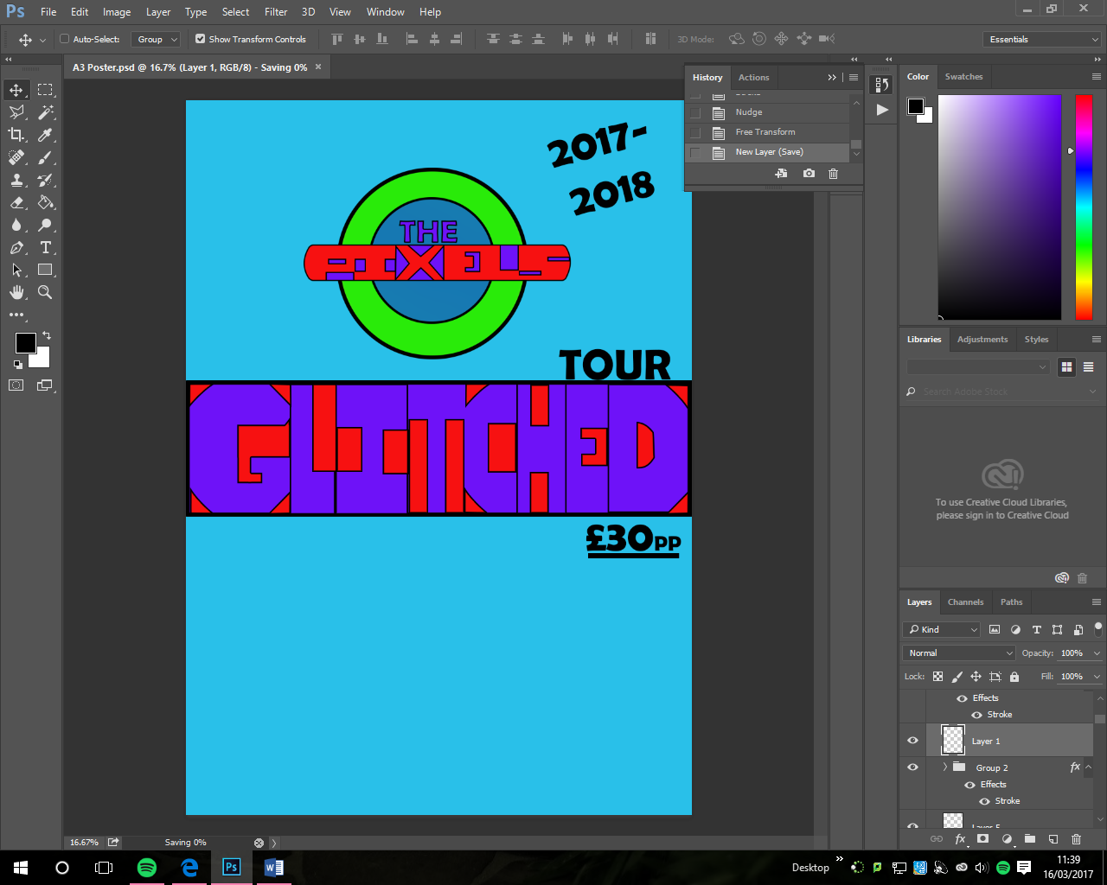
I had to go back after adding the price, to solve the problem with the fact I missed out the ‘C’. I then also added a box around each letter to separate it from the others and this made it look better which was what I wanted and what it was needing and missing. I did think that it looked wrong but couldn’t figure it out until my LSA spotted it and then informed me about it.
I then added the dates and the venues and then the information box below. I am now happy with the result, as it looks clean and professional.
Learnt: I have created two out of the four different graphics that I will be needing to creating.
20/03/17
Aim: I will login-in, check emails, I will then need to create logo, poster, CD covers and the checklist for this unit.
Evidence:
I will start to create the size and the file of the cd cover to the correct size.
The file size and dimensions were all 12.1 centimetres for the width and the height.
I then created the colourful background in a shaded kind of way and the back does fade through to a different colour.

I used the gradient tool, I selected the primary and secondary colours as a bluey purple and a light magenta an then dragged the cursor over the top going in the direction I wanted it to be and then I got this.
It did take me a while to get the desired look and had the colours I wanted.

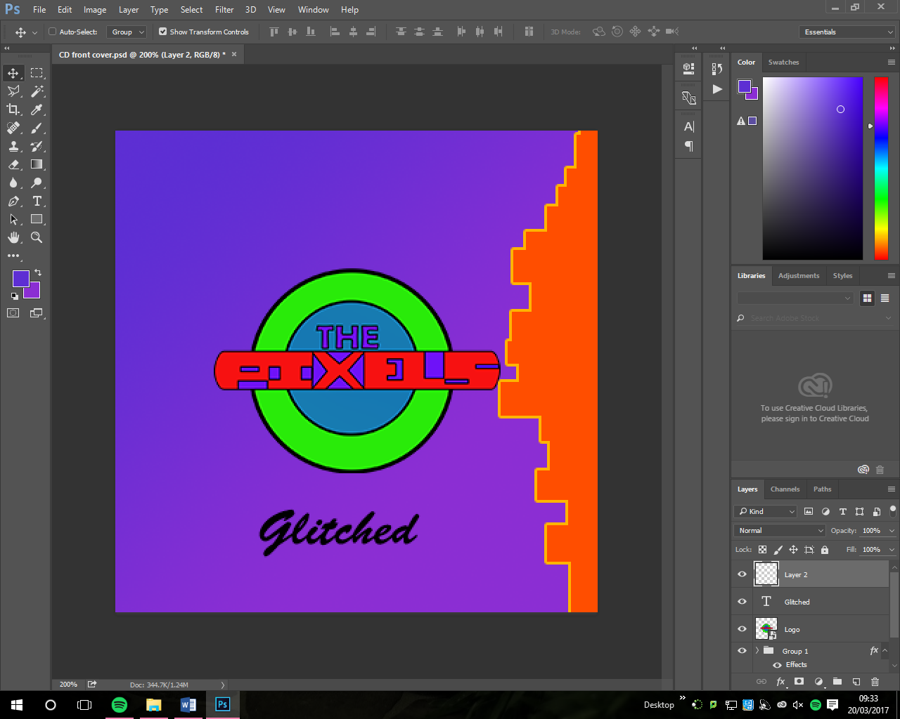
I then added the logo and then I made It look good and then I added the boxes on in orange and then got this.

I then grouped all the boxes and then went onto adding a stroke.

I now just need to add the name of the album on the front.

This looked like this and I was not happy with the result. It doesn’t look good and doesn’t fit too well with the theme.
So I had to take the other one from the Poster as it looks better. To get it I took a screenshot, opened a new document, pasted it, and then cropped it down so I had it and so it looked like this and then I exported it as a PNG and then I used it in the CD cover.
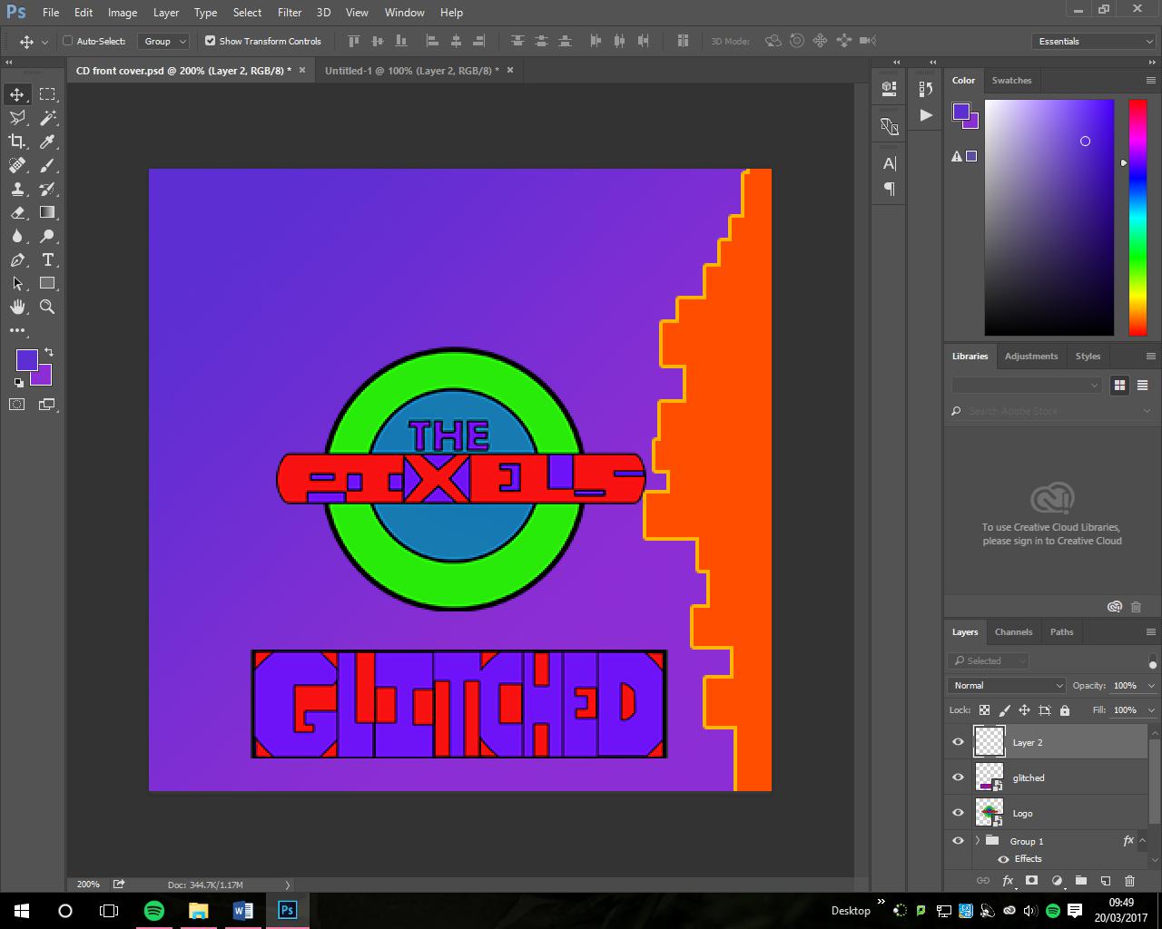
I then moved it and then centred and made it smaller so that I had it like this and then I was happy with the result.

I then added an explicit content warning sign; this is because I needed to add something to the top as it looked plain and a little bit boring, so out of all the possibilities I chose to go with this.

Now I have done this I need to create the spin as I can add this on the side after but I need to do this in order to make it look good. I will add this to the end product after.
I didn’t add very much to the spine but once I did it I added it to the back cover. The spine was 12.1 X 0.6 cm.
I then made the new back cover and made the file size as 13.6 X 12.1cm to get the size to the right size and then this looked good. I then also added the colour background.

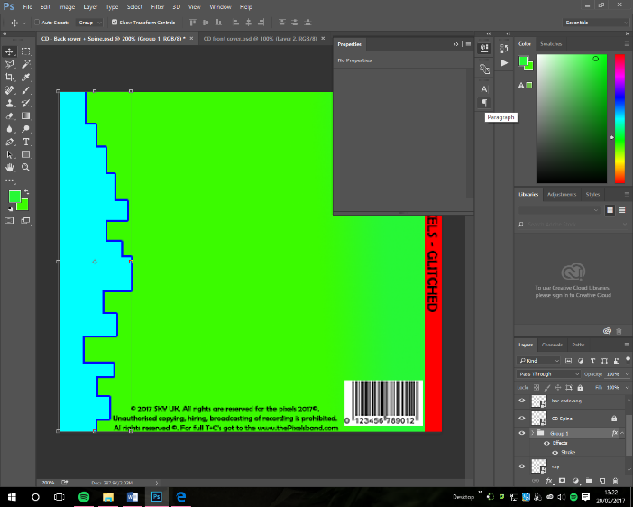
I then added the sky logo, legal stuff and the bar code. The stuff that you need. I will now add the

I then added the songs onto the background and then this looked like this, I did move the sky logo down and then I added my logo to it, so everything looked nice and the way I wanted it too.

I then added a grid on the front so that it didn’t look so plain and boring, so I added it to it so then it would be good.
For the front cover I added a grid thing and I changed the properties so that it would look like this and I love it and it looks EPIC!
I added another image of a grid onto the poster so that it would look better and it does.
Learnt: I learnt that something can look to boring and with a bit of an addition of something it can look really good and better.

21/03/17
Aim: I will login-in, check emails, I will then need to create logo, poster, CD covers and the checklist for this unit.
Evidence: In today’s lesson’s I worked on my checklist and then I worked on it.

Learnt: I did the checklist and therefore I have done the aim for today.

