PANDA
Prince

HELP TAKE THE KINGDOM BACK!

Name: Panda Prince
IP: Original Intellectual Property.
Created by: Alex Parker
Date: 17/11/16

CONTENTS PAGE
Introduction - Page 3
Background - Page 3
Game title - Page 3
Platforms - Page 4
Goals - Page 4
Missions - Page 4
Shops - Page 4
Genre - Page 4
Market research - Page 5
Audience - Page 5
Territories - Page 6
Overview – Page 6
Objectives – Page 7
Theme - Page 7
Structure - Page 7
All features - Page 8
Characters - Page 8
Game mechanics - Page 8
Storyline - Page 9
Game environment - Page 9
Final designs - Page 10
Conclusion - Page 10

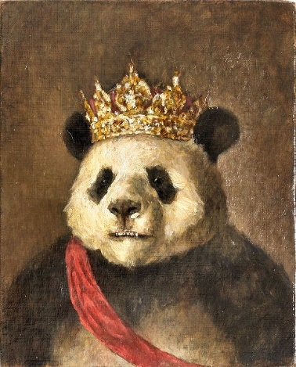
Introduction to Panda Prince
The new game that I am going to be creating is a story based game with the use of Multiplayer to get the crown and the throne back for a character called Paul the Panda. Along the way you will have to go through lots of different levels in order to defeat the evil Francis the monkey. The game is designed to allow you to advance your different skills online and offline. The way to beat the game is to group up with your friends that are at a certain level and then they have to defeat the BOSS at the end. But before then you just need to train with battles and the other monkeys in the armies at certain levels to get enough experience to level up. The game is going to be interesting as once you finish the game you can then just keep on levelling up and getting more armour so you can just keep on battling your friends, this is what the multiplayer section is going to be incorporated into the game. You will also have your own game character and then Paul the Panda follows you around and then you get advice and he tells you how to get through that section.
Background Knowledge- Prologue
The background information about the game is that the Pandas had a very good army and a very good battle to keep the throne for King Pablo, the Panda. Then the monkeys wanted all the power and the last resort was to attack the weakened Panda City and this was a problem as the King had just fallen ill due to the stress that the Monkeys where causing. They then killed the King and took the city for themselves. Then the Prince was evacuated and kept in hiding for many years in the jungle and has recently found out about his past and now needs help to take back his father’s city and reclaim it for himself. The prologue might be included into the final stages but I am not sure I will first see the end for the game and see if it will be good.

Game Title
As you haven’t already figured it out by now the name of the game I will be making is called Panda Prince. As you are helping out the Panda to help get his kingdom back from monkeys. It was the most fitting name I could think of. I could have chosen to call the game “Help the panda prince take back his kingdom”. The game title was going to be too long and I wanted the game title to be short and catchy. The game title does now have a catch phrase which is “Help take the kingdom back” this is kind of the words that I feel work better in the catchphrase rather than in the title and I feel like this works and my game then uses this.

Platforms
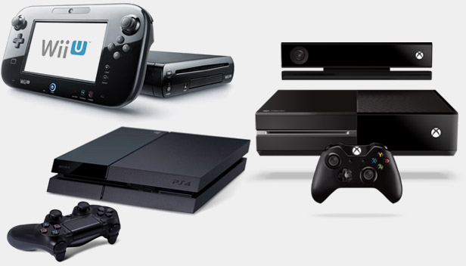
There are many different platforms that you can play different games on. The three devices I want the game to be played on is the Desktop Pc, PlayStation 4 and the Xbox One. The Desktop Pc version of the game will be available on the Steam store as a lot of people use this as a main pc gaming driver and this means that the game has to be optional for 4k gaming. The Xbox one and PlayStation 4 are both great consoles and this means that they are going to be able to play the game. The games do have slightly different controls but this is something that I can talk about in the game mechanics and the game controls later on so people know what each button does. Platforms for a game are hard to choose about what it should be as they are both just different in many different ways and some people like things in a different way. The platforms that this game is for is the Xbox one, PlayStation 4 and finally a pc.

Goals/ Missions/ shop
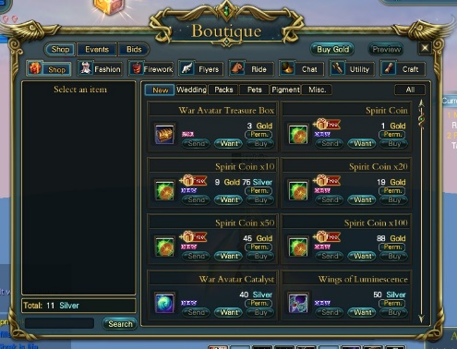
In every game there has to be some kind of a mission with some goals in to it. The missions in the story mode are just to go through the story and then the goals are going to be things in the missions like kill 20 moneys. The mission will give the panda and your character Bamboo and some bananas and these are what’s used as currency and special attack. The bamboo is use as a currency and you can buy many things from the shop. The shop is a place where you can get upgraded armour and then you can purchase some more bamboo with real-life money. The shop is going to be a place where everything is sketchy as you are trying to hide, that’s why if you go to the shop you do have not a lot of time, the game is also going to be different as you can’t be spotted and if you do you will be killed on the spot.

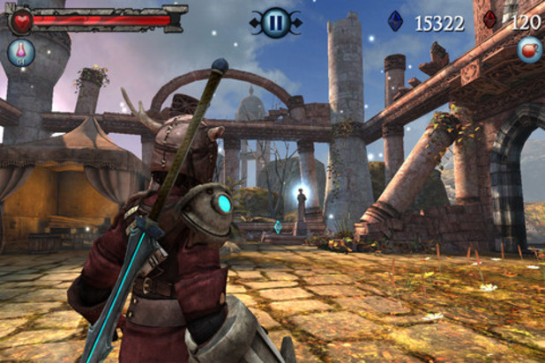
Genre
The genre of the game is going to be an Action/ Adventure genre game as there is lots of adventure as you are going to walk around a lot and then you just explore and find out different things. As you will battle and attack people so this brings the action to the game, this means I will have armour in the shop and this then gives the game a battle element and you have to do this with the genre of game I am going to be creating. The genre of the game is going to be fun as you won’t see different things coming for you. Another game like mine is going to be rare as mine is going to be epic and a bit sinister at the same time.

Market research
I will be using the market research for my game, this makes it easier to make the items for the games as I would have done the relevant research for it. The game I will be making is going to be about a Panda Prince that needs to fight his way back to become the king and take his place and therefore this game is going to be a multiplayer game as then you can tag along with the other characters to get to the top. The BOSS at the end will be so hard that then you will then need to tag along to get more specialist people to defeat it at the end. So this is going to be MMOG (Massively Multiplayer Online Game). Therefore, the game needs to be exciting and fun and this will be done like a cartoon style and this will be fun for people who are into new cartoon fighting games. I have left some statistics for last year below.

Audience
The audience for the game is going to be people that like games and they will like the concept of the game I will be making is going to be for people aged 18+ and people from both genders will have fun as it is a unisex game and therefore the gender doesn’t matter at all. The reason why it is going to be 18+ as it will contain blood and gore and has some use of weapons, they aren’t going to be guns and things but it does have daggers, spears and a lots more weapons. The gender for games like mine is surprising as most people that use it are going to be able to enjoy things. The audience will be what everyone likes and that is good.

Territories
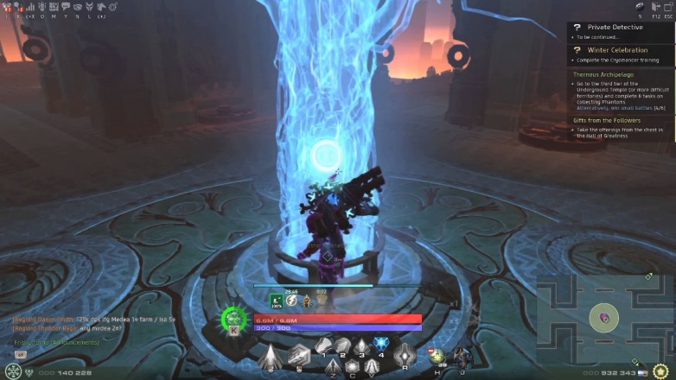
The territories in a game are the boundaries and the things that people can’t do. This might be a section of the map that you’re not going to be able to get to until you complete the storyline or get to a certain level and then this then unlocks the next bit that you go through. You need to battle and defeat people in order to get into the next thing, the next thing that I would also do is that you have to make fields and towns your own and then you’d need to claim and take back from the monkeys. The territories that happen are going to be implemented into the game are going to make the game fun and exciting. A territory makes a games plot exciting and adventurous and that is what my game will use a bit but it will be a kingdom instead.
Overview
The new game that I am going to be creating is a story based game with the use of Multiplayer to get the crown and the throne back for a character called Paul the Panda. Along the way you will have to go through lots of different levels in order to defeat the evil Francis the monkey. The game is designed to allow you to advance your different skills online and offline. The way to beat the game is to group up with your friends that are at a certain level and then they have to defeat the BOSS at the end. But before then you just need to train with battles and the other monkeys in the armies at certain levels to get enough experience to level up. The game is going to be interesting as once you finish the game you can then just keep on levelling up and getting more armour so you can just keep on battling your friends, this is what the multiplayer section is going to be incorporated into the game. You will also have your own game character and then Paul the Panda follows you around and then you get advice and he tells you how to get through that section. The background information about the game is that the Pandas had a very good army and a very good battle to keep the throne for King Pablo, the Panda. Then the monkeys wanted all the power and the last resort was to attack the weakened Panda City and this was a problem as the King had just fallen ill due to the stress that the Monkeys where causing. They then killed the King and took the city for themselves. Then the Prince was evacuated and kept in hiding for many years in the jungle and has recently found out about his past and now needs help to take back his father’s city and reclaim it for himself.

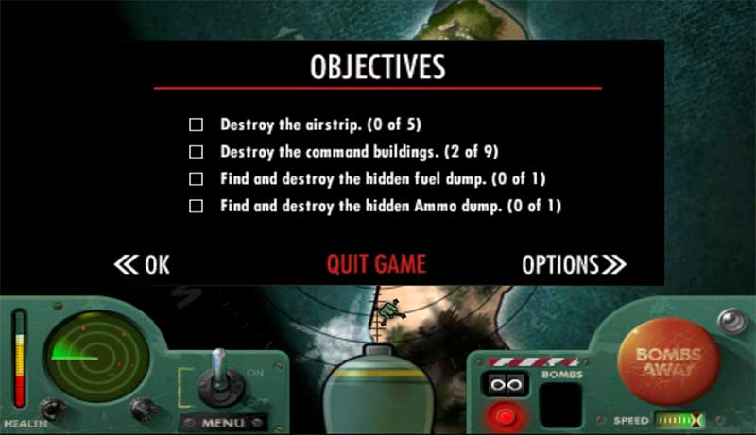
Objectives
The objectives and the aim of the game is to claim back a kingdom, this can be easy or hard but this depends on the story and the way that you would play the game. The objective of the game is going to be simple, kill the major king monkey to win and their might be different challenges and then different methods of killing the monkey but you will just have to battle to defeat the monkey and claim the kingdom that he has taken back for good. Their might be other family members of the monkey that get in the way as they are loyal but you have to slay them down in order to get to him.
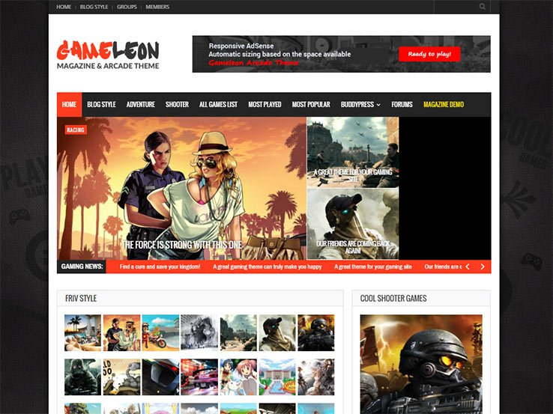
Theme of the game
The theme of my game is going to be about a person who is friends with a panda and wants to take back their kingdom from the monkeys. The theme is going to be where the game is going to be set and then the theme is what it’s going to be. The game will be one of those games that’s going to be set into an old run down china town kind of area and then throughout the game then it will be made so that you can’t do anything else. The game is going to be about the ancient and mystical times and then this will be good. The theme of the game is one of a kind and I like that about it.
Structure of the game
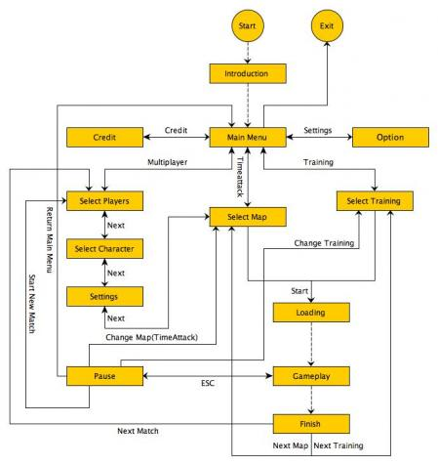
The structure of the game is going to be a complex one and then this will be interesting. As the structure of a game needs to be exciting. The structure of the game will be around the concept and then I might advance on that. The structure of any game and not just mine will have a lot of features that I will need to look at and then see whether I need to have the things that I would like into it. The game structure needs to be right as it needs to show the story advancing through to the end and with a lot of games nowadays their needs to be enough content for at least 40 – 50 hours o-f content and my game is going to be around 60 hours as people can have fun and then if they complete the game then people can just go onto the online version and they can have fun playing it. I do not have a structure but here is one of the other ones for games.

All features
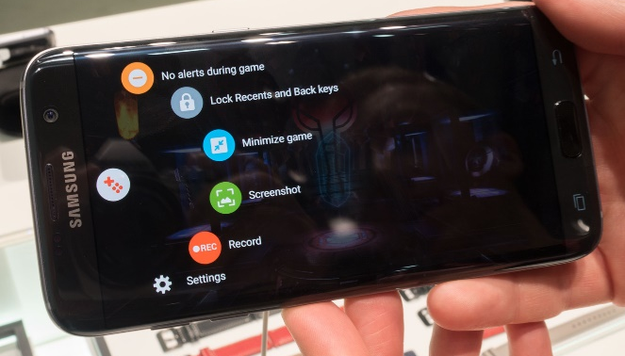
All the features in the game are going to be one of a kind as is my game. The concept of my game makes everything just work out. This game makes everything fun and exciting. the features that are different to another is the fact that you’re going to be working for a panda and that you will get different weapons and armour throughout the game. Some of these items and different weapons can be useful or they may not and they might just be a big annoyance. The features are all there to make the game unique and interesting to lots of different people. The features that can make things fun are the bananas as they are used to make the characters slow down and they might even stop for about 30 seconds and you can be taking damage in that time but then you do get a big boost afterwards and this makes everything about the game fun. A feature on a mobile game is their so that you could copy and paste something and the feature is that you can edit the document and that is fun.
Characters
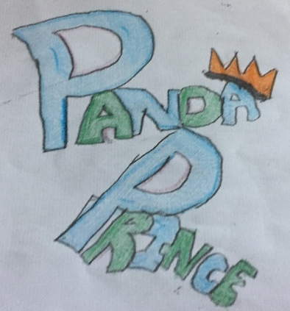
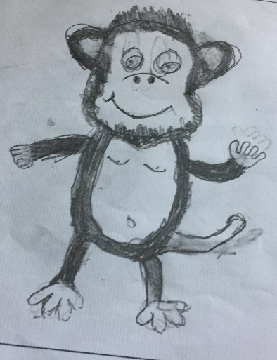
For this game I have a few characters for it, the character that you will be able to play on is the main one that you can adapt and edit but that should just be quick and simple to do. The other characters are going to be guides and that should be good to do and the characters will be easy to control. I have some basic sketches from the last assignment bellow and the final designs are going to follow later on.

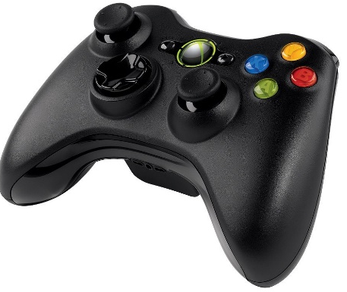
Game mechanics
The game is going to be played as a Pc game and the mechanics will be good as they are going to be about how to control the game and then the game will be exciting and fun the mechanics of the game are basically how and what you would do to play the game. The WASD keys are going to be forwards, backwards, left and right the space bar will mean that you jump and the shift key is how you would crouch and squat from other players. These keys are universal and this is what people use to play games with it.
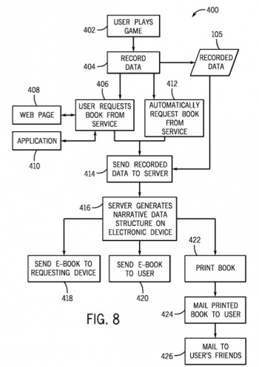
Storyline
The storyline of this game is simple but yet effective, the games story is as followed. The new game that I am going to be creating is a story based game with the use of Multiplayer to get the crown and the throne back for a character called Paul the Panda. Along the way you will have to go through lots of different levels in order to defeat the evil Francis the monkey. The game is designed to allow you to advance your different skills online and offline. The way to beat the game is to group up with your friends that are at a certain level and then they have to defeat the BOSS at the end. But before then you just need to train with battles and the other monkeys in the armies at certain levels to get enough experience to level up. The game is going to be interesting as once you finish the game you can then just keep on levelling up and getting more armour so you can just keep on battling your friends, this is what the multiplayer section is going to be incorporated into the game. You will also have your own game character and then Paul the Panda follows you around and then you get advice and he tells you how to get through that section.
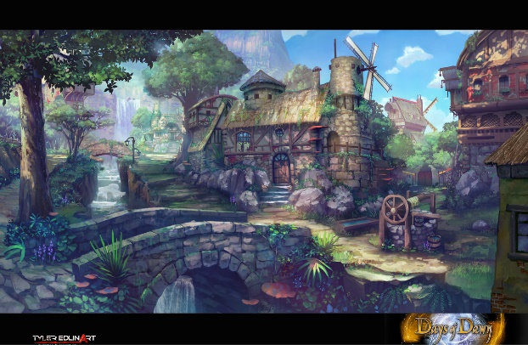
Game environment
Once you’re in the game you can spend as long as you want to as the game is fun but yet exciting to play. The environment for games are different depending on what it is about. The environment is going to be interesting as you have to make the game feel realistic and the surrounding environment. The surroundings are good as they need to make the sounds and the graphics for pretty much everything. The environment needs to go with the choice of the game and the genre otherwise the people will be confused and they won’t have a lot of problems with things. The environment is a good way for people to enjoy the game more and then this is a fun thing to do and to add to it. My game will fit into the right environment and then people will enjoy this.
Final designs
These are my final designs for this game. They are the same as the originals as I liked the way that they looked and I didn’t want to change them.

Conclusion
To conclude I feel like my game will be fun simple and effective all at the same time. There isn’t very much else to say apart from the fact that the game has a certain kind of uniqueness to it and players will have fun with the different goals and the different style of this game.

