The design and purpose of idents

Design
Density of information:
I had a look at a channel Ident this was the Cartoon Network show, this was an animated bit of text, that kept on bouncing around and then the characters of the main shows came on and changed the words to create the name of the show, which is Cartoon Network. This was one from 2008 but the concept is still the same for the channel nowadays. I then looked at another channel which is MTV. This one that I found was good as it is full of colour and this has a real-time recorded and the M is like a bee/ wasp with a red TV stuck on the right part of the M and this is a well-known Tv ident, there are also a few but this is the one that I have seen before. The whole point to a TV ident is to advertise the channel and to associate the next TV programme. In some idents they have a person speaking about what is going to be on. They also have a statement that lets you know that you are watching the channel. The channel might have a person in real-time saying them right after, I know this from CBBC and Cbeebies. In most TV channels the idents it will only include the logo and the name of the channel, such as Comedy Central, this channel doesn’t even have a voice over. This shows that the research and data big companies have conducted have figured that the more simplistic the ident the more success and awareness it will generate more viewers on the channel.
Space and time:
The space and time an ident gets is determined by the channel and which break it is between. Where the break is between a programme that has just ended to another about to begin the ident is given more space and time to advertise the channel this helps broadcast it throughout the world. This would be done with more entertainment and visual aesthetics than the shorter idents that would be seen in the break between the middle of a programme. In these shorter idents that have very limited space and time to advertise the channel, the only content and information normally on show is logo and channel name. There will be more of an advertisement ident in between the programs, but the ones in the middle of the program before the advert there will be a lot shorter and this means that the people that have advertised won’t be annoyed as they are paying to have their advert in.
A lot more money and effort is put into making the longer idents as there is more time and space to create better more complex idents. These idents have enough time to present a more meaningful display of imagery that is relevant to the channels themes. An example of this are idents for channel E4, this channel has younger audiences which it uses when creating them. In their idents it uses vivid, wacky colours and strange objects to entertain the viewer. They will spend time to find out what they like and what they want. The audience does play a big part in TV idents as some are made for families like BBC 1 and then some are ranged for girls like BBC 4.
I have seen that the most of the idents are about 30 seconds long, this has now become a guideline length of most TV idents. But I have also seen that there are a few that are around a minute long this shows that idents can be a bit longer such as a minute to display longer idents, but this will cost the company more money. This means that idents are not limited to 30 seconds and the length of the ident should be the length it takes to successfully convey the message that was intended by the ident. This can range from 5 seconds up to a minute.
Screen tempo:
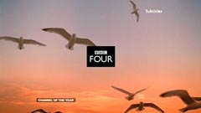
The screen tempo is the same as a normal tempo, one of the adverts that I have found is the ITV-2 foot dance, this is a good one as you can see the feet moving to the beat and the sound of the music and this is kept throughout and this is good. This is very quirky and interesting as it definitely brings in the audience. It has a fast pace and this means that the audience are brought in more and they have a lot of different bright colours to incise them into it. To ensure that the viewer does remain interested and entertained with the ident the tempo must be to a decent speed, this ensures that the content stays fresh and new so that the viewer is always looking at something different and exciting. If the ident were to have a slow tempo and is too slow in presenting its message to the viewer than they could lose attention and change the channel. This is why it is important to maintain a good tempo so that the attention of the viewer is retained. For older people the tempo can appear to be extremely slow but this works well for the older people as the channel would have conducted research and concluded that the slow tempo would be the best option, the older people might also need to focus more as their processing speed is a lot slower than a teenager. An example of a slow tempo ident would be BBC Four which is aimed at older people/ women who are more mature and are not so easily entertained by bright pulsating colours. Also older people may perhaps care more about the programme, than the ident but it’s the channel company. It could perhaps be down to lack of funding and production time allocated forcing the ident to be only, so rather than anything eye-catching.
Interaction with viewers:
Making the viewer interact with the ident is a very successful way to make the ident easy to remember and to promote the channel as well. The interaction that takes part can only be there to make the viewer think about what it is they are viewing or to think in order to understand the content. A good example of this is channel 4 which has an ident that requires the viewer to maintain attention to the ident to see the channel 4 logo. This is a very successful ident and its interactivity makes the channel memorable. A common way to make the interaction possible is if an ident asks of the viewer is to engage after the ident, they will say a statement about a programme or current news. This is not seen as visual content but heard as an audio content this allows for the statement to be changed to a modern scenario without changing the ident itself. This is a common way of doing this but if they have famous actors/ actresses then you can make it interactive with the use of comedy or vocals. For example, the Ant and Dec ITV program called the Saturday night live they had a spoken bit at the front of the program saying that they need to get there and this is a funny vocal sketch. There is also one from Keith Lemon which goes onto his show, Through the Keyhole.
Information-led:
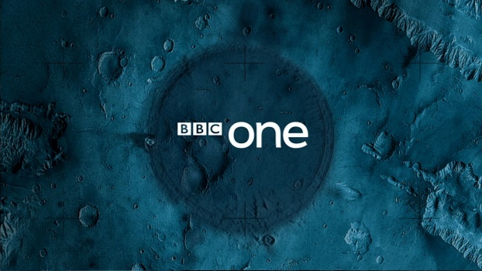
Information led idents are usually used by channels that have already established themselves as a successful channel. Once a large enough audience has been achieved the aim of the ident moves from increasing brand awareness and recognition to informing the viewer of programmes to increase views on new or failing programmes, this means that they can get more information about their programs, and the means that they don’t have to invest in visuals. An example of this would be BBC 1 and 2, both these channels have established themselves heavily and to continue focus on brand awareness. As they cannot increase their brand awareness any more. As this is the case their idents are more information based and tell the viewer when programmes are on, it is now rare to find an ident that is entertainment led for an established channel, but these are the only few that I know about. An information led ident would usually have a slower tempo and a lower density of information in the background so that the viewer doesn’t get distracted. The ident is less visual than others and this means people focus on the information than the entertainment.
Entertainment-led:
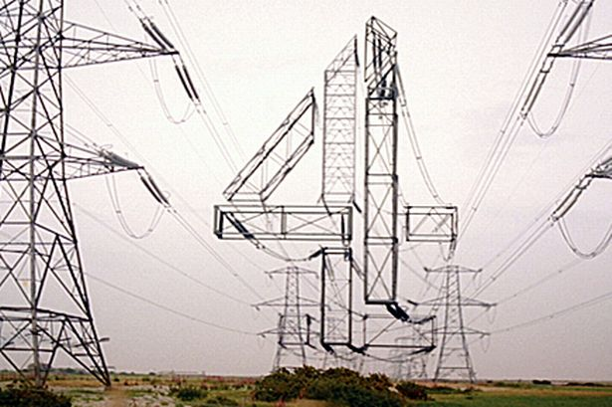
Idents that are entertainment led are used by channels that haven’t fully established themselves yet or want to focus on increasing brand awareness and recognition, this is a majority of programs. To do this the ident will be designed to be as entertaining as possible, it will use a fast tempo and a higher density of information to keep the ident entertaining throughout. Most idents will use bright and vivid contrasting colours to make the channel logo easier to see and remember. In entertainment led idents there will be no voice over speaking of programmes that are to be shown, there will however be music which will also be a high tempo and will be synchronised to the visual content. This is all to get the audience that they want this is what they will use their research for, they will invest heavily in research of their audience, they need this information to do different things.
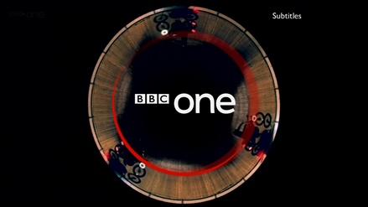
Purpose
Identity:
The identity of a television is usually the Tv ident, it is like McDonalds with the M. They need each other so people know their identity. The ident will convey the identity of the channel through its design, colour scheme, audio choice and screen tempo. The identity must be in keeping with the demographic so that the channel will attract the right people. If this is done wrong and the identity of the channel is different to the programmes it shows, then the demographic will turn against the channel and refuse to watch it. An example of a channel that has a confused ident is the history channel which has a name and ident that match but the programmes do not. The identity of BBC 1 is the symbolic O and this stands for the one and it is effective and this is great to use. The one at the top right is a O and it has a live footage video of the people on bikes going around it. An example of a channel that has a confused ident is the history channel which has a name and ident that match but the programmes do not. The ident and name make the channel sound as if it would show historic documentaries about moments in the past, instead they show programmes such as Storage Wars and Ancient Aliens which are either fiction or have nothing to do with history. This is confusing, for everyone who starts to watch it.
Branding:
Brand awareness is a key purpose for an ident to establish itself and to build its audience, people need to know it and remember what it is that they are watching. The ident must be easy to remember and have the logo at its main front, the idea is that the audience remembers the channel in which they saw the programme. Branding can be similar to sister channels in order to promote all of the channels at once such as sky channels. Channels such as sky 1, 2 and Atlantic all have very similar idents that are used to promote all of the sky channels, they have the sky and then the other bits follow. At the end of the ident the audience should remember the logo and he name of the channel as another purpose of the branding aim is brand recognition. To be able to recognise the logo, name or style of the ident such as BBC 1 having a circular motion to all of their idents. The idents will all be copyrighted this means that no-one can copy it. The logo will be memorable to everyone that watches that programs.
Marketing:
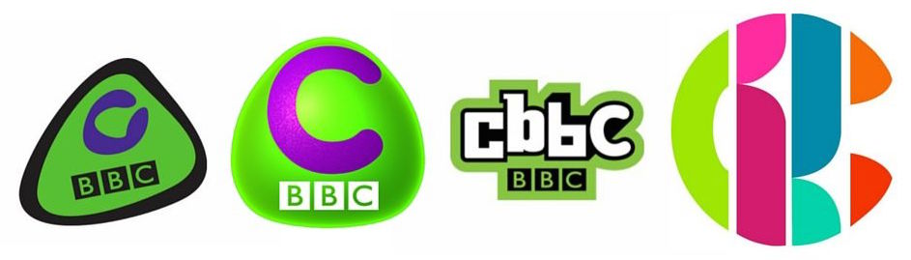
The marketing of an ident is to provide awareness of the brand and to win over the audience in order to gain their loyalty to the channel, this is a very hard thing to do as you are asking a lot of viewers to stay with it. A way to do this is to insure that the ident never evolves to fast as that would completely change the channel from usual audience members. The main strategy would be to slowly evolve the ident and programmes on the channel to slowly grow the possible demographic to acquire a larger audience, the companies that own the networks will do this over a few years. This must be done carefully as a balance is needed between the two if too drastic a change is made then the current fan base will be upset. When a channel has established itself even slightly its fan base will have become accustomed to the style of the idents, so if you change this then you might lose their audiences. This is why the change of style to keep the ident new has to be done carefully as a drastic change would be seen as a betrayal to the normal viewers and that the channel cares more about new demographics then those who helped establish the channel. This act of betrayal would not only cause the fan base to stop watching the channel they would also take to the social networks to spread the word that the channel isn’t very good and is disloyal. The CBBC network almost lost its viewers as the logo got changed earlier this year and a lot of people don’t like it as the old one was iconic and people new it but this new one no one can remember it fully.
Packaging and re-packaging:
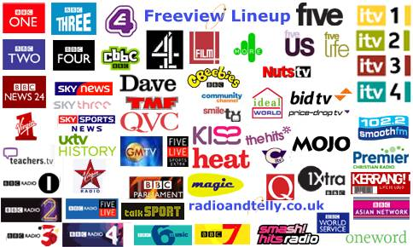
Packaging is where the ident has come together with the use of assets such as a logo and channel name, this means that it is more sophisticated. Re-packaging is when an ident uses another means to show the ident rather than using the typical content of a logo and title. The companies behind the channel which is a packaging one will most of the time never show their name as people don’t like powerful multimedia companies with a lot of control, people don’t want to know about this. An example of this would be either Viacom or the News Corporation who both own lots of channels around the world, they don’t like to advertise themselves and this is a good way of doing it. An example of an ident that is re-packaged is the comedy central ident which shows a list of words, in this ident there is only enough time to read a few words making the ident more interactive and entertaining, they have put time into people seeing this. However, this totally fails at brand awareness and recognition but as it is so short and requires little effort to make it can be used with normal idents. This shows that a re-packaged ident is usually very short and makes up for lack of brand awareness and recognition with entertainment and interactivity. But there are some channels such as Fox and Fox news that don’t hide the fact that they are owned by a parent company that still get a large audience, this is one way that these channels can get away with it.
Scheduling:
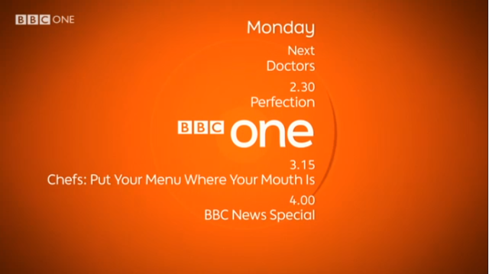
An ident can be used to maintain a schedule to the channel that they need to keep to and this will have restrictions, it allows for a clear gap between two different programmes so that they do not run into each other, this means that no-one is going to get lost and they don’t think they are watching the same program. In the ident it also allows for information about other programmes to be told adding some interaction and personal output. The scheduling can be split up into 2 with the use of adverts in the middle, this then gives the audience to also get a cup of tea and biscuit and this is good, where as if you’re watching the BBC channels you don’t have time to do this. This can be a big thing to do as you have to schedule as it would be a big mitch match. This time between programmes is one of the few places a channel has to inform viewers of programmes, the only other time is in the credits of programmes which have just finished ruining and clip in the credits.
Segmentation within scheduling:
Channels such as the BBC do not have any advertisements in between their programmes which makes idents more important as there are no other ways to split up the programmes. During this time the ident has time to; provide information, promote a programme, regulate the schedule, fill in the time slot and provides a break for news & sports presenters. For channels such as sky cinema they use a long ident to use up the time before the film so that the schedule is filled with some content and to keep the audience entertained, this channel shows films at a certain time and have to keep to this. For the BBC they also use a different ident for their news programme, when it is close to an hour the ident will count down from however long it is till the hour. This is to make up for the space until the programmes allocated spot which starts every hour. The BBC have a big problem with this as they need to have advertisements but they don’t and they have to have something this period of time.

3 TV idents comparison
BBC One
Once I watched the BBC One ident I was all refreshed about what it is about, I chose to look at the one from about a year ago and this has lots of people on bikes on come together and then go around the iconic O but it could also symbolise a roundabout. The people on the bikes have different coloured rain coats on, this has some relaxed music in the background. The BBC One advert has change from year to year and some of them are good but then a lot of them need work. The one from this year is to do with the Rio Olympic games and the O in the one changes from Olympic sport to another. This is swift and effective and has a caption at the end saying good luck to them. This one is still to do with the O but this is a lot cleaner and neater than before. This has been placed on a white background instead of a real time video. The whole BBC one ident hasn’t changed a lot since it started which is a bit of a shame but also keeps the same viewers coming back.
https://www.youtube.com/watch?v=8db9UoRDkIE
https://www.youtube.com/watch?v=WrLacS8veiA

Dave
All the Dave indents are made for the male audience so they have the manly kind of activities like being in a bar and drinking and playing darts. This does appeal to its audience and it is funny how they have lots of strong drinks like Vodka, Whisky and then the Dave one is on a bottle of tomato Ketchup. This adds some humour to the ident. The other ident that I have found first of has a person playing snooker and this is good, but then the funny side comes out when you find a cactus in a dart board, these adverts are all linked to each other and they all have some kind of realism and then they change and they make it funny and out of this world, this is because you wouldn’t find a cactus in a dart board. They have a different unique way of making you look and this makes this channel different.
I also found another one which was about an airport terminal which was the normal thing and then out of the x-ray came a tray full of dirty washing. It seems that they want the extraordinary things come out of something that is normal. This sets the audience for the channel and this tells us that things are going to happen on this channel that you didn’t know was going to happen.

https://www.youtube.com/watch?v=eNynuP_EmM8
https://www.youtube.com/watch?v=HN8F2htY0ng
https://www.youtube.com/watch?v=4R3KbdzpEPk

Channel 4
Channel 4 is home to one of the iconic cartoon television shows around the world but this channel ident that I found was specifically for the Simpsons as it had the channel 4 blocks in the channel ident and the eyes that they have, I am sure that this was for a special episode of the Simpsons but the Tv channel ident was great to look at as it is aesthetically pleasing and was fun to watch, this definitely suits my age range and this is what they were going for. I also found a new one which was a lot of blocks that just kept on bouncing up and down, this was good as it was to do with the channel 4 layout. The channel four design is near enough the same, there is blocks on each one and this is how people remember it. The most famous one is the logo popping out of the ground and everyone knows it.

https://www.youtube.com/watch?v=2_1hOoCagjg
https://www.youtube.com/watch?v=tS1suPMgXdY
https://www.youtube.com/watch?v=IKGjHuZ1feU

Summary
All of these channel idents are different in their own ways. However, the same objective is for all of them, which is to stand out and be memorable. The way in which they do this is by having: bright colours, funny gags, narrators, etc. Tv Idents are advancing through time, they are becoming better and better through the use of technology, they used to just be a still image on its own but nowadays they have got lots of live video and animations. They were not good then but now you just can’t find which bits are real and which bits are fake. They are getting better from the designs. Once the logo is changed which isn’t often they need to change the idents as they are out of date. They have people thinking of different ways to get this across to the audience weather it is the O in the one as a roundabout from BBC 1, or the funny gags and live videos from Dave, or if it is the cartoon style from channel four. They are all them to make the audience remember and this is good.

