Clearances
A clearance is ran by a organisation that is called the Broadcast Advertising Clearance Centre (BACC). The clearance system works in an order of how to do it this is done by:
1. Submit a script for approval
2. Submit a rough edit for approval (not compulsory but strongly recommended)
3. Submit the finished ad for final sign off
Overall it's important that you leave 2-3 working weeks for the clearance process. This is because they will have a lot of peoples work to cover.
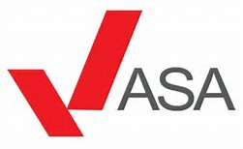
The clearance for advertisement is also ran by ASA as they are the regular for the advertising across the whole media. They are important as they will look at the clearance as they get about 30,000 complaints a year this is about 20,000 ads and they don’t want this to happen so they will prevent this by having the clearance test before they are released. A clearance can cover misleading meaning, harmful or offensive adverts, the sale promotions and the direct marketing.

