Brainstorming ideas
Advertisement for a new radio/Tv program, e.g. Heart
If I were to do an advert for a radio/ Tv program, there would be the logo of the new channel. I will also need to have a voice over and this may introduce the new presenters and other special guests. The Ad would need to include what times the stations will be on. If I was going to do the Tv program ad there would be some of the new shows that will be playing and then I would need to figure out what age range, I would do. Where-as if I did the radio show it would have an age group of just everyone.
- Most of the filming would involve interviews with ‘D’J’s and footage of them doing their jobs (actors would play the role).
- Video mainly consists of wide shots and close ups of the room and the controls/people (camera angle).
- Drama studio control room has been noted as a potential filming site.
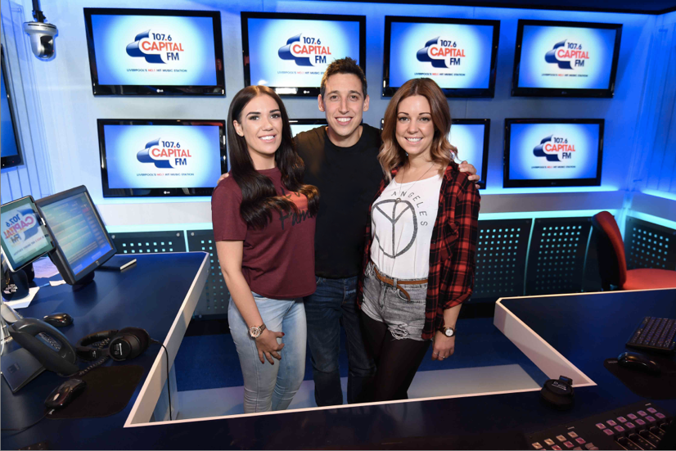
- We would need two to three actors representing the D’J’s. (weather/music/chatter person)
- For the audio of the film we would have music playing throughout the video in the background, other sound effects and narrations would be played on top but with the volume adjusted so it is louder than the music.
- This film would only need to be filmed in one room, resulting in little to no changes in scenery other than a panoramic of the studio.

Advertisement for a new brand of trainers
The trainers will need to have a new and unique name, there will also need to be a logo that is eye-catching. The advert will need to influence and engage with the new customers, I will need to have a set age rating. The trainers will probably need some type of catchphrase. The advert will have more things involved and the footage will be better. The ad will need to have a model or old shoes with a new logo to have a new thing.
- There is a wide range of filming opportunities, but mainly filming outside due to the sporty purpose of the shoe type.
- For audio we would have music playing in the background, energetic music and potentially a voice over.
- Close up on the legs and trainers. (camera angle)
- We would need to design our own props. (Purchasing plain white canvas shoes and painting/applying the design).
- We would only need 1 to 2 actors.
- High tops with a thick spongy soul would present opportunity to insert LED lights in the bottom which could be flaunted as a USP.
- Stop motion or film focused on the legs and feet (small changes such as different trousers/skirts but with different backgrounds). – possible video idea

Advertisement for a new “cereal” bar
The advert for the new trainers will be the easiest to create this is because you can stick any type of cereal bar that already exists into the new one. The bar would need some new ideas and I think one of the best ways to do it would be to create it as a healthy product so people will by it. The bar may need some type of logo, catchphrase and wrapper for the product.
- The genre can be fun and friendly
- There will need to be close ups with the cereal bar
- There will be a friendly mum chatting in the background.
- There will also need to be a few props such as a cereal bar and a person to eat it.
Advertisement for CAMSFC – for the Creative Media course suitable for next year’s new intake
The Creative Media course at Marple college is a good course as you have lots of things to show off. You can show the work of the students already on the course. The advert will be jammed packed full of the fun things that we do such as, website design, animation, graphic design, an advert. The advert can be full of work and make it look great. If I were to do this, I would cover the things that we have done in the class. I wouldn’t do the course work were the wording is and the documents with thousands of words on it as this can come across as being boring.
- Genre could be serious but light and friendly.
- Wide shot angles would be used to pan the college and close ups would be used during interviews. (Camera angles)
- Interviews of students and teachers would be required in small amounts broken up throughout the video.
- Props would not necessarily be required however during the interview it could be wise to add some items arou nd for a “set” e.g. books on the desk.
- Voices would be needed during the interviews; soft music could play throughout to fill in the silence. (making sure the audio is louder than the music)
- Multiple actors would be required.
- Permission would be required from actors in order to use faces and voices on our product.

A general advertisement about life at college
The general advert will be about the college and not too much about the courses, it may show the different unique courses but it wouldn’t show what they are about, there may be a detailed map to show where about’s you are in the college on the vid. This would show the new facilities and the new sports centre and the new and awesome classes with what they have to offer. The advert will show how much fun everybody is having and this will be great to have some interviews with the higher up roles in the college .
Conclusion
My overall conclusion taking in the consideration with the amount of time I have to create it, it would be down between the cereal bar or the shoes. I wouldn’t do the advert for the tv/ radio show as it would require a lot of talking about and the advert will be too vast as I will need a new office to show off and that would take a lot of time to set up. The other advert that I don’t want to do is the CAMSFC as it would be too easy and it would just be about my previous work and that is just something that I don’t want to do. The life at college is a very big job and I would need a time that no-one is in to show it off, I would need to set up some interviews with the older people and this will take a lot of time to do.
So the one I have chosen to do is the shoe advert as it can be as simple or as bad as I want it to be. The advert can be for any age and the whole idea in my head is great. I didn’t chose the snack one as it can be a good idea, but at the end of the day they aren’t as good as a pair of shoes. The advert will be a bit of a struggle as I need to make it aimed at parents to buy the product and the child to get them to eat it.

