Unit 5 – Assignment 4
Relationship with client
Liaison with client
For both of the unit 33 and unit 4 I did not have any client liaison meetings however, I did have one in another assignment and unit which Is below. This is just a brief chat that I have had with the client just to see whether I have done the work and where and what I am going to be doing next. This liaison is below.

Dealing with difficulties or complaints
If I have had any difficulties throughout the assignments I would have talked about this in the diary and then changed them around, I did solve this usually by figuring it out myself or by watching a YouTube video. Below are a small section of where I changed something.

Revisions to brief
The revisions to the brief are when you are keeping to the brief and that you have everything strictly to the brief and that you have not gone away from them and talked about different things. The brief is something that you have to stick to and below a couple of the briefs that I used.

Revision to plan
I did plan both the advert and the animation and then throughout I would have just tweaked and changed the design as they could have been wrong and I just went to change things around. This would have been in the diary or the evaluation.

Format
Evidence needed for a written report/ podcast/ PPT/ pitch
The format for an animation or a advert would have been on a document of the above, and I found this.

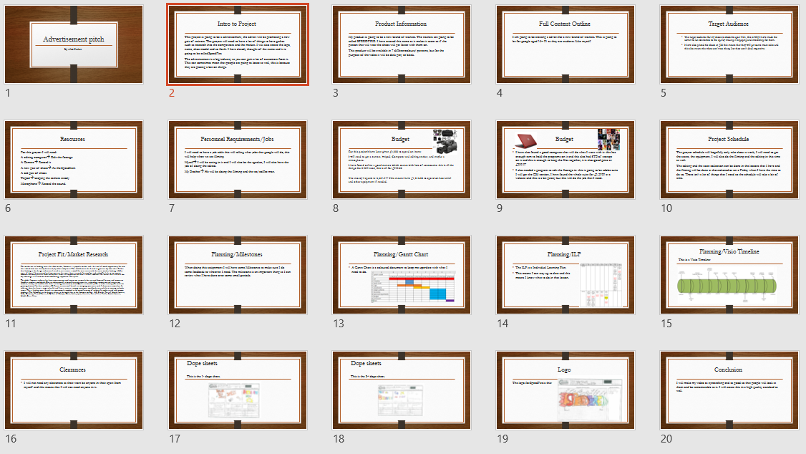
Constraints experienced
Legal and Regulatory
Here is the box standard legal and ethical documents, which would have talked about in the two different units and I might have changed a couple of things around so that it would go into some of the more specialist information in.

Management
Time management and working to agreed timescales
For this task I needed to know the deadline and for when the documentations were supposed to be handed in. I used an ILP for this job. An ILP is an acronym for an Individual Learning Plan and this was the source of how I was able to get the work done on time and so see how much work I needed to do in between lessons. As you can see from my ILP I wasn’t in some of the lessons due to being ill or being at a hospital appointment. However, this is the case I did still meet the deadline. This is because I did work at home and at the weekend so that on the Monday I could have time to hand it in without too much stress.

Communication skills
I would have needed to have communication skills to talk to the client or to talk about my PowerPoint and the subject. This presentation below was talked to with the client and then the client knew what I was going to be doing.

Meeting requirements
I needed to make sure that I had reached the requirements and to do this I would look on the Gannt charts and the ILP’s to see what work that I would need to do in order to make sure that I have got everything. Here are the bullet points of what work I would have needed to do. I have also included the ILP to show when I did the work.
Unit 4 -
The scenario of this unit was the following;
As a result of completing this assignment you will be given the opportunity to enhance your skills through the planning and management of a media product where the outcome is a video advertisement. The subject will be chosen by you from the selection below. You will demonstrate production management skills. You will need to consider one of the following:
- Advertisement for a new Radio/TV program e.g. Heart
- Advertisement for a new brand of trainers
- Advertisement for a new “cereal” bar
- Advertisement for CAMSFC for the Creative Media course suitable for next year’s new intake OR a general Advertisement about life at the College.

I selected to make an advertisement for a new brand of trainers. These trainers where called SpeedFire and they were to be shoes that when you run, you go twice as fast.
The things that I did and need to do for this unit were:
- Proposal: full content outline; target audience; resources; personnel requirements team, specialists; budget; project schedule

- Pitch: style; format, e.g. PowerPoint, product information (content outline, target audience, resources, of your design ideas

- Planning: Basic planning details to show planning ability – ILP, Timeline, Gantt Chart
- Develop an idea: eg mood boards, mock-ups, storyboards and dope sheets
Unit 33 –
As you can see from the image above my Unit 33 brief. I had a practical piece of work, but this had many different documentations that I also had to work on as well.
The things that I needed to cover in this assignment where to:
- Read the scenario to enable so that I could understand the assignment
- Create a “Sources Document” and keep up-to-date throughout this assignment (this sources document is also now on this one too).
- Have a Research Report - Research the web, television, DVDs etc for inspiration. In particular you should be looking at Audiences and Generation of production ideas
- Create a Format Report - You should also research the use of possible formats that will be used for your animation production.

- I then needed two Initial Ideas Report - You will now need to consider different ideas for your own animation. For each idea you need to consider the use of possible formats, generation of production ideas and consider your audience.
- Chose a Animation and to create a Proposal - You need to decide on the idea you will take forward to actually make into an animation. You need to fully explain why you chose this idea and go into great detail on the generation of concepts and audience considerations.
- Plan a detailed Storyboard and Dope Sheet(s) - A detailed Dope Sheet outlining the Scenes/Shots you assist your creation is also required. Ensure you have enough footage/scenes for a 30 second animation plus additional time for any opening and closing credits. Needs to be detailed.
- Design and create the props and characters for the animation - In preparation for your animation to begin, you need to design storyboards/detailed drawings of supporting characters, props, background, base design etc. Collect any resources you may need – card, straws, wool etc.

In this assignment, I did not need to take notes but I did have many drawings that will follow.
Below is my first page in a readable form and then the rest of the porposal as screen shots, this is the proposal document

Achieving agreed outcomes
The outcomes of the lessons would be what I need to have done at the end of the day. So for instance, I could have set a goal to complete the asset collection for the end of the day, which would have given me 3 hours to do so. I then probably would have got the assets done in that lesson which gave me enough time to do something else and then to complete it by the end of the day. The outcome that where set would have been easily achieved by that end of the lesson. All of this information was found in the ILP.

Feedback
From peers
The peers would have given me some kind of feedback, this was given as a questionnaire and then this would have been done and this would have been in the lesson and this was the peers job to give some feedback.

Final/ overall conclusions/evaluations
The final overall conclusions and evaluations would have been done at the end and sometimes they would have been as a podcast but not in the ones that I have been talking about.
I have also created these reviews from units 33 and unit 4. These are the last things that I usually do for the units, as they are something that you can see a result and they are just something to look at.
For all of my work and for you to find some information: http://alexparkercm.weebly.com/

