Unit 54- Assignment 1

File Formats and Applications Theory

File formats:
Raster graphics –
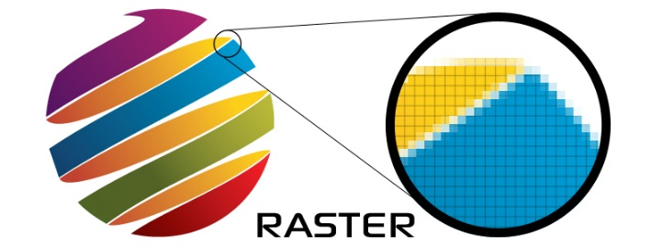
Raster images are more commonly known by Bitmap images, as they include information, which is planned out on a grid of pixels on the screen. You normally find raster images on the web and therefore websites. But raster images are also the ones, which you download from a camera, or a mobile device. Raster images are usually digital images that can be created or captured. Raster images are made on a grid with x and y coordinates, this is so you can select the exact pixel on the grid and this can be changed to a different colour. The common versions of free image editing software, which you can download, are only able to create and open raster images, which is another reason why they are more popular. Raster images aren’t the best when it comes to being resized as it disjoints all the pixels in that image.
In terms of file size raster images are normally larger than vector graphics, because it has to save all the individual colour. You can also convert a raster file into a vector image, you normally do this refined image. Raster graphics are mostly used in computer animation opposed to vector graphics because they allow for extra levels of colour detail, this also makes it look better. This is added when the animator can add to the characters or background. A good thing about making raster animations over vector ones is that you don’t require a specialised piece of software to create them. These kind of animations can be made easily within a program like Flash. Again when saving these kind of animations the file sizes are much larger then vector animations and if enlarged as a whole they will lose quality and become pixilated.

Vector graphics –
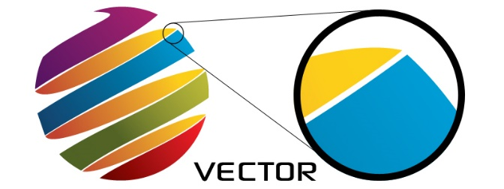
This is the use of lines, curves and shapes that make up an image on a computer graphic. The vectors in the image lead through places called control points. These points are found on the x and y coordinates and determine the path either for a stroke colour, shape, thickness and fill. In vector images polygons allow any path which is on the object to join from three or more adjoining line segments. The curves are worked out and drawn when you know the position of two end points and control points. A point that is shown when it’s at the start and end of the path included parts which the path changes at. Vector graphics are commonly used for logos, maps, cartoons and drawings as they all designed on the computer using lines and shape, and they can be enlarged without pixelating.
Vector graphics aren’t made up of dots so they can be scaled to a larger size without losing any image quality, whereas if you zoom in on a raster image it will appear blotchy and more pixelated. When making a vector image bigger the edges of each object stay smooth. When you change the shape and size it won’t affect the way the image will look. If your image is a vector graphic allows you to change the properties of the image meaning you can have more control over the overall image.
Vector images can be decreased and increased, whereas if you did that with a raster image it would pixelate. If you move a vector image it will stay the same and they don’t have any automatic background like you get on a raster image. This makes cropping and changing the shape on a vector image much easier than with a raster image.
Metafiles –
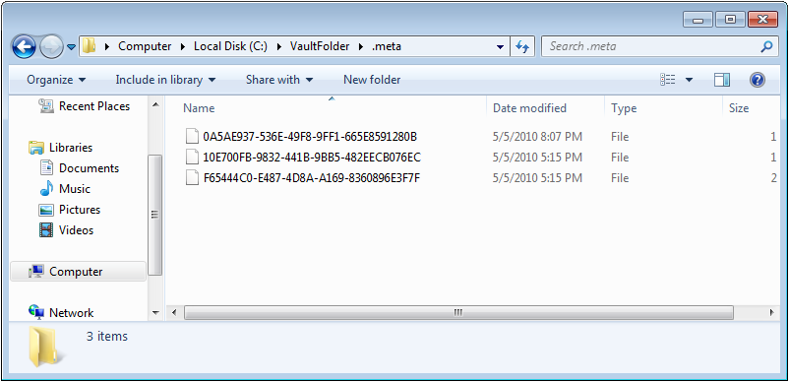
A metafile is a type of file format that stores and specifies different kinds of data. A metafile usually stores graphical file formats, which can either be raster, vector, and type data. These files are mostly used in order to provide support for an operating system's computer graphics. If you have a Microsoft Windows computer then it uses Windows Metafile, and if you own a Mac OS X, it uses PDF. A file that describes the contents of another file may contain metadata, which defines a group other files and gives a summary of what data they contain. By using WMF files rather than already-built bitmaps, it saves space on your computer when many bitmaps are used repeatedly by different components of the operating system or of an application. The WMF file assumes that the operating system it is being run on is only 16 bit, but since there are now very few operating systems that are 16 bit Microsoft has an enhanced metafile format for its 32-bit operating systems. They had to do this so that they can keep up with the latest and improving technology. As you can see from the image to the right the metafile doesn’t contain as much colour and is generally less bold.
There are many advantages and disadvantages to using metafiles. An advantages is that metafiles can contain both a containing mixtures of vector and bitmap data, and can be smaller than rendered bitmap versions of the same image. Metafiles generally compress well for file transfer which is another great advantage. A disadvantage is that most metafiles are very complex, because they are usually written by one application for another application.

File extensions –
File extensions are a useful way of naming you file so your computer can keep track of what they contain. They let the user and the computer know what type of program has been created by any given file. .BMP file extension is a raster image, which is made on a rectangular grid of bitmap pixels, each with a different colour. Some programs which open .BMP files are Adobe Photoshop,
Adobe Illustrator and Microsoft windows photo viewer. The format was first developed by Microsoft for storing bitmap files in a device-independent bitmap format. This meant and allowed for Windows to display the bitmap on any type of display device, whether it is a big computer screen or a tiny tablet. It is a raster graphics image file format used to store bitmap digital images, however these days you don’t really hear of this format being used as it is only compatible with windows. BMP files always contain RGB data which can range from 1 bit to 24 bit. 1-bit: 2 colours (monochrome), 4-bit: 16 colours, 8-bit: 256 colours etc. .GIF stands for Graphical Interchange Format File and it can contain up to 256 colours.
CompuServe first created this file format in 1987 with the purpose of transferring images quickly across slow connections. GIF formats also allow for movement for short animations in the final saved image, and these can be made in software like Photoshop. Small animations like GIFs are becoming more and more popular and can be used on mostmedia computer forms. The best uses for GIF images include web graphics where few colours are going to be used. This file can’t be made as small as a JPEG because it can be compressed but no detail from the image is lost. These type of images can be great for banners, text headings and diagrams because they are fast loading graphics. GIF formats are also a good format to use for single-bit transparency which means one colour can be chosen to be transparent. .PNG stands for Portable Network Graphics, these allow for a full range of colour and are very small files. This file format was designed in the mid 1990s as a way around patent issues with the GIF format and to include benefits from both Gifs and JPEGs making it an excellent all-round file format.
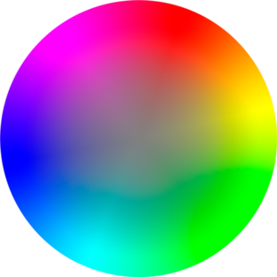
They support a maximum of 16.8 million colours and are resolution dependant. The compression method is lossless which means no information is lost. Colour quality is 2 -256 colours grey scale and true colour. PNG-8 files are very similar GIFs in that they can only display 256 colours and only allow for 1-bit transparency. On the other hand PNG-24 files allow 24-bit colour which is similar to a JPEG, this means they can include over 16 million colours which makes them great for vibrant images. PNG files use alpha-channels, this means they allow transparency to be set on a scale between opaque and completely transparent, this means they are excellent when creating a faded or translucent look. PNG files can be used for all kinds of things however are best used for web images such as logos as they allow for transparency.
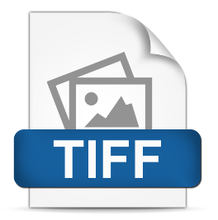
TIFF is the shorten abbreviation for Tagged Image File Format; they can be saved in an uncompressed format and is only used to store bitmap data. It is used for storing images with many colours such as digital photos. The TIFF format is still quite popular today even though it was one of the first image formats to be created. The graphics are normally high- quality but consequently they have a big file size. You rarely see TIFF files that contain any text or vector data like other formats such as PNGs, even though the file format would allow for it. One of the benefits of the TIFF format is that it can work with most computer operating systems and is recognized be the majority of image editing software meaning they can be opened and saved easily.
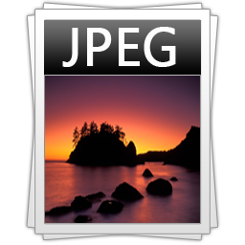
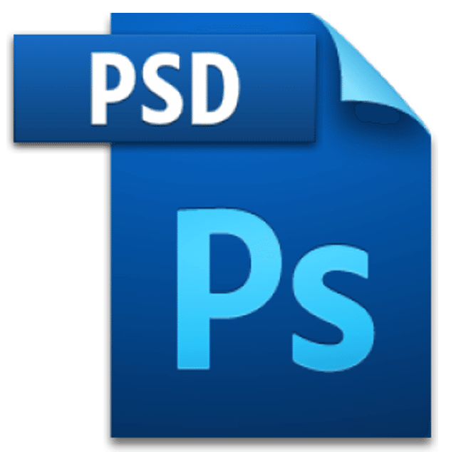
A JPEG file stands for Join Photographic Experts Group, this file format was first designed in 1986. JPEGs are most commonly known as they are the standard file format for most digital cameras. .JPEG can store many colours but usually this will result in a loss of quality. These types of image file formats are good for use on the web. It mostly supports 16.8 million colours and it is also resolution dependant. It uses a lossy compression so the image may lose information when resaved or created. Colour quality is 1-100%. This format of file works across many platforms such as PCs and Macs and its also compatible on other programs such as web browsers and images editors. The best uses for jpegs are for still images, real-world images such as photos, complex colouring and the shading of light and dark.
.PSD is a Photoshop image file mostly used on the graphic editing program itself and it is a layered image file, which means that the file is made up of layers which are joined together. Photoshop allows you to flatten the layers so that the flat image can be converted into a JPEG, GIF or TIFF. Once a PSD image has been flatten by conversion however, it cannot be converted back to PSD meaning the individual layers are lost. A PSD is a exclusive file that allows the user to work with the images’ individual layers even after the file has been saved and re-opened again.
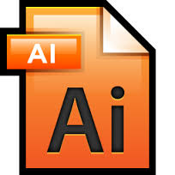
AI files is the common file format for editable files in the Adobe Illustrator drawing software and it is used for vector graphics. This software is a popular vector graphics-based drawing program and you can only open with specific software. If you’re working on a piece of work on Illustrator and have to save it half way through but want to save all of the layer information you will have to save it as an AI file as that remembers all of the layer information. If you were to save it as another file format then the layers would get compressed and it would be very difficult to continue working.

Applications:
Vector-based applications –
A good vector based application is one such as Illustrator because it is purely a vector based editing software developed by Adobe systems and designed to deal with shapes and line when creating images. Vector images that are created in Illustrator are used for company logos, promotional uses or even personal work, both in print and digital form.
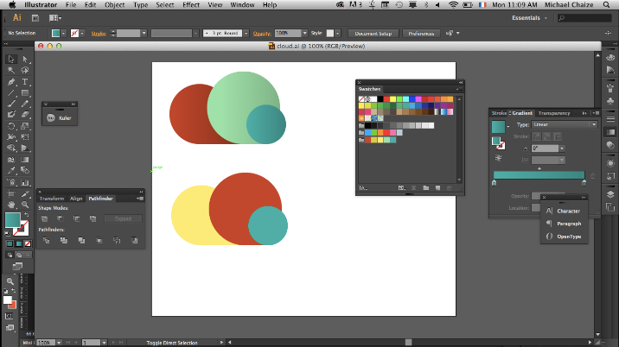
llustrator is very much the same as Photoshop in terms of it containing the same tools and features. In illustrator you mostly draw illustrations, cartoons, diagrams, charts and logos. Whereas a program like Photoshop is where you use different layers to add and edit raster images. Unlike bitmap images that stores information in a grid of dots, that are used in Photoshop, Illustrator uses mathematical equations to draw out the shapes. This makes vector graphics scalable without the loss of resolution.
The main advantage to Adobe Illustrator is the fact that even if you cant draw very well you don’t actually require any prior knowledge of drawing or painting or skill for that matter. Illustrator allows you to create freehand drawings, but also import a photograph and use that photograph as a guide to trace and re-colour a particular subject. This can be classed as cheating but it allows you to get a good guideline/outline to follow. Another advantage to making graphics in illustrator is the fact that you can then save it and edit in Photoshop is necessary, as it is compatible. When saving graphics in Illustrator you tend to save them like you would in Photoshop however you can also save them as a PDF. Illustrators file format for editing the images is AI.
A good vector based program, which is available online and can be downloaded, is Vectr. This piece of software isn’t as advanced as Illustrator nor is it as well known. You can only perform very simple edits on it and add the simple shapes whereas Illustrator is slightly more advanced.
It can also be used to create and edit vector graphics such as illustrations, diagrams, charts, logos and complex paintings. The good thing about this software is that you can use it all online and you can have many other formats that can be imported and exported. With vectr you can have many different lines and shape, which are also known to be objects that can be filled with solid colours, patterns, radial or linear colour gradients. It has a similar feature to Illustrator where you can manipulate it by dragging it, resizing it and rotating it. A disadvantage to using a program like this is that you need to internet to use it as well as a computer. Alongside this the tools aren’t very complex to use which makes it easier but different to achieve exactly what you want.
Raster-based applications –
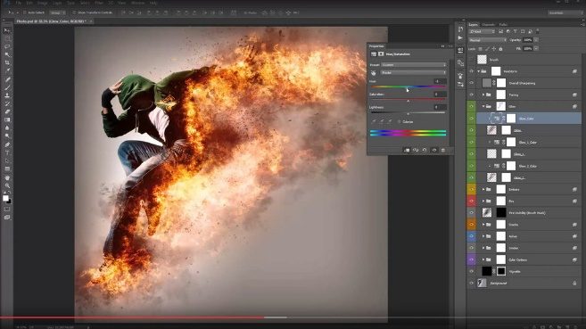
A raster-based application is a piece of software where you can edit and add to pictures that are made up of pixels. An advantage of using this kind of application over a vector based one is that your image will be more complex and therefore the quality will be better. However with raster images if you change the size of an image it changes the quality.
In 1987 the American brothers developed Photoshop, who sold the distribution license to Adobe Systems Incorporated in 1988. Thomas Knoll began writing a program on his Macintosh to display grayscale images on a monochrome display. He named this program Display, which then caught the attention of his brother John Knoll. He recommended that Thomas turn it into a full-fledged image editing program, to do this Thomas took a six-month break from his studies in 1988 to team up with his brother on the program. Thomas renamed the program ImagePro, but the name was already taken so he renamed his program Photoshop. Photoshop also has an animation feature where you can put movements and put a series of images together.
In Photoshop you can edit and put together raster images, which are all on different layers and supports masks, alpha compositing. Several colour models such as RGB, CMYK, spot colour and duotone are also supported which means you can use any colour you want. There are many other things you can do in Photoshop for example you can add gradients and add a transparent background. Gradients allow you to put a texture or colour effect over an image to give a different effect.
When you save a Photoshop file there is many supported file formats you can save it as such as its own PSD and PSB, which support all the aforesaid features. In addition to raster graphics, it has limited abilities to edit or render text, vector graphics, 3D graphics and video. In Photoshop there is many tools, which you can make, use of like the magic wand tool, paint bucket tool, paintbrush, eraser, selection tool and eyedropper.
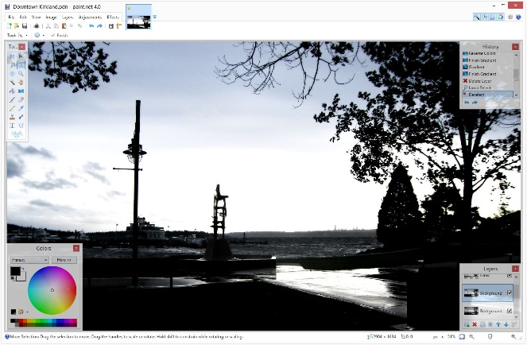
The second raster based program, which i know about is called Paint.NET, it is free to download. It is well known to be an easy image and photo-editing software made especially for windows PC rather than a Apple Mac. It features an in-built and advanced user interface with support for layers, unlimited undo, and special effects. Along with all these, it offers variety of useful tools that you’d find on programme such as Photoshop.
Unlike most free downloadable piece of photo editing software’s, Paint.NET gets a lot of updates regularly to help improve its performance and to add new features.
One of the good things about Paint.NET is that you don’t need previous experience with working on imilar software and I you do it just means you can add more complex techniques to your photos. Another advantage is that once you get used to the basic tools on the programme you can simply download one of the extension packages, which contain hundreds of new tools, effects and fonts. Paint.net is simply a good programme however the only downside is that it isn’t as professional as Photoshop but you can get more free add ons to make your graphics better in Paint.net. There are a few other raster-based applications, which I have not heard of or had any experience with. A couple of these include ones such as Image magick and designer pro.
Use in different media forms (print, moving image, interactive) –
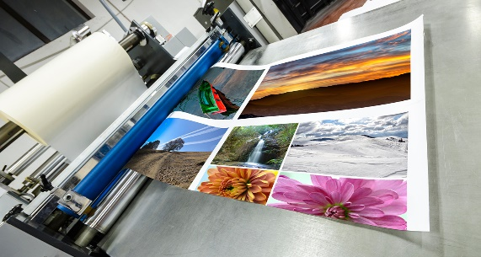
Printing – Both raster and vector graphics can be used for printing but it depends on what they are being used for and the quality you want. For example if you are creating a normal graphic that will need to be printed out, it will be best to use the vector based format so that when you change the resolution of an image it doesn’t change the quality.
Another reason the vector format would be a good idea is that it doesn’t add an automatic background colour to your images so that they stay transparent, however sometimes this doesn’t matter during printing. Sometimes you use printing to make a business card or for personal use, but before that you will need to create logos on an application such as Illustrator or Photoshop. On the other hand printing can also be used for things like newspapers where you will mostly use raster images where it doesn’t matter about the quality of the image.
This is because newspapers aren’t expensive to sell and the paper they are printed on makes the images look slightly worse in quality. If for example you were printing a magazine instead then raster graphics would still be used but the quality will need to be considered more. Printing is used in other contexts such as schools or businesses where they have to incorporate a logo into their letterhead to make it look more professional and give the reader contact details. Printing is also used on clothing items to add a logo of a brand to a jumper or a t-shirt for example. This however is more expensive and takes longer. On the plus side somepeople think that having a branded logo on their jumper is fashionable and trendy. The printing process for t- shirts uses a big machine and this makes it very expensive. In general printing is used for all kinds of purposes which makes it a very versatile thing especially for the media.

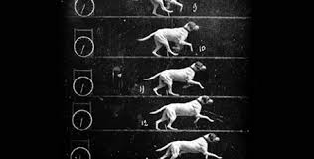
Moving images – These tend to be more well known as being animations that can either be computer generated or in the style of clay motion. If you are creating a moving image on computer software you will more than likely use vector images unless the animation is made to look realistic. Again vector graphics would be a good one to use as they have a low file size which makes it easier to store than a lot of raster images making up an animation. A low file size will also mean that the animation will be smoother because there isn’t as much data to go through. Another good thing is that if your image is a vector graphic, it allows you to change the properties of the image meaning you can have more control over the overall image.
As there are different forms of animations like flick books, Claymation and computer animation. Flick books tend to use simple designs and a lot of them use stick men when drawing characters, which means that vector graphics would be the best choose. As you have to take photographs to make a Claymation animation, you would always use raster images which means that they have a big file size but a good quality.
Graphics can be used in moving images for media products such as web banners too where a logo can be incorporated and then affects can be added to make the logo graphic move around. Animated gifs are also moving images, which can be anything from children related, or more geared towards adults. They use several sequential graphics to move second by second to create a movement illusion.

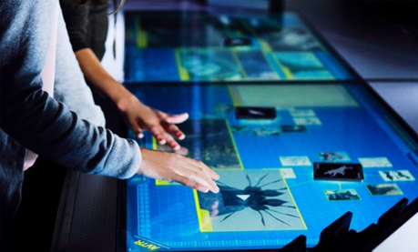
Interactive – When it comes to making and saving graphics for interactive media forms like games or videos you will be more likely to use raster images as you want the quality to be as high as possible and you don’t need to worry about what happens to the pixels when a images is enlarged. An advantage of using a raster image for these kinds of interactive media forms is that the images can be layered so that text is over the top of a graphic to show a character talking in a game.
Another media form which is interactive is a DVD menu where there is more than one type of menu including an ‘Overlay menu’ and the other is a ‘Layered menu’. The advantage that an overlay has is that it has a faster playback time and the authoring files don’t normally take up as much space on the DVD disc. Whereas a layered menu allows you to add more creativity in the menu design. It does take up more space on the DVD though. The only problem with this type of menu is that you have to make sure that all the background and button graphics are saved onto different layers when using a piece of software such as Photoshop. DVD menus use raster images because they are more realistic but also because films and animations use raster images/video footage to shoot their films. Some interactive elements that are used on websites and games are buttons that are actually graphics.

