Unit 5 – Assignment 1 Working to a professional brief
In this document, I am going to be comparing two different assignment 2’s from Unit 33 and Unit 4. I will talk about Unit 4 first as this was the unit that I worked on in September when I started in the year. After this I will talk about unit 33 as I worked on this about half way through the year. I can then compare in the improvement over time as well.

Unit 33 – Assignment 2

As you can see from the image above my Unit 33 brief. I had a practical piece of work, but this had many different documentations that I also had to work on as well.
The things that I needed to cover in this assignment where to:
- Read the scenario to enable so that I could understand the assignment
- Create a “Sources Document” and keep up-to-date throughout this assignment (this sources document is also now on this one too).
- Have a Research Report - Research the web, television, DVDs etc for inspiration. In particular you should be looking at Audiences and Generation of production ideas
- Create a Format Report - You should also research the use of possible formats that will be used for your animation production.

- I then needed two Initial Ideas Report - You will now need to consider different ideas for your own animation. For each idea you need to consider the use of possible formats, generation of production ideas and consider your audience.
- Chose a Animation and to create a Proposal - You need to decide on the idea you will take forward to actually make into an animation. You need to fully explain why you chose this idea and go into great detail on the generation of concepts and audience considerations.
- Plan a detailed Storyboard and Dope Sheet(s) - A detailed Dope Sheet outlining the Scenes/Shots you assist your creation is also required. Ensure you have enough footage/scenes for a 30 second animation plus additional time for any opening and closing credits. Needs to be detailed.
- Design and create the props and characters for the animation - In preparation for your animation to begin, you need to design storyboards/detailed drawings of supporting characters, props, background, base design etc. Collect any resources you may need – card, straws, wool etc.

In this assignment, I did not need to take notes but I did have many drawings that will follow.
Below is my first page in a readable form and then the rest of the porposal as screen shots, this is the proposal document.
Proposal for the animation
Storyline
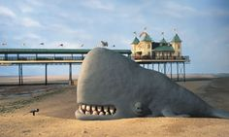
The story will be about the fact that you should not litter near the beach as it can harm the animals at sea and that we need to protect them. Therefore, I will have the child struggling to move and breathe and then the dad comes and helps his son out, then the dad says that you should never litter especially near the seaside as it can affect the wildlife as it has done with my son. Then towards the end, the whales will come together and they will say what is going to happen next time. This is a simple concept but I do feel as if the story will be good, the concept of this Is that people are just starting to learn about the sea and what can harm the animals and they will go out on day trips to the sea. Depending on how long this takes, to create I might add some different scenes onto it by having a child placing the litter in the bin, this makes it longer and then it adds people into the story to show that it is a real problem now. The subject that I will do is good as this is an important threat to the people of the world and this is going to be a big thing, we want our sea life to stay alive. So therefore, I feel like this idea can be a good idea, the whales that are going to be a good character as you would not expect it, the storyline is definitely unique, and the children will be able to see a new animal that they just might not have come across before today.
Characters
I will have two characters for this show, one will be an older and bigger whale called Wilber, the other smaller character is the son, and he will be called Swish. They need to be learning about the world, this concept will be ok to do, I could have had them in the water and then using string to keep them there. I have decided that I will have them on top of the water as if they are sticking their heads out of the water. As I will be making them out of plasticine as it is to do with Claymation, I will need a character that will take the shortest amount of time to create as I will have everything set out and ready to do the filming. The whale will be a child friendly kind of character, one of the whales will be small so that’s why I need to make them look good. As I said before I might be adding a child into the story so I will have to create that one as well. The character is going to be good as they are going to be in a Claymation style and it will be good. The characters are called Wilber as this is a name that I feel like explains the whale, the other character is called swish as it is like the waves and this is what I could think of, the other girl character doesn’t have a name as she doesn’t really speak. The girl wears a pink top and blue top. These characters make the story good as they are creative and they look like they could have been created by the children that make it.
Visualisation
I want the animation to run smooth without any hiccups; I will try to make the best out of the items that I have to offer. The visualisation that I want it to be is to be able to make the film longer but if I do this then I will be running out of time and that is not a good Idea. The visual style is Claymation, so I will have to make the characters look like they are that type. The other things I will be using is going to be about the frames will need to be thought about as they will be going at a rapid speed and the images will be weird and misplaced if they were mixed up. So I will make sure that I have a separate camera storage device so other peoples work will not be a problem. The target audience is 2-5 year olds, so I to show that it is a real problem at the moment. The storyline will be good and effective as it will get the job done correctly and this will work out good. The story is one of a kind and it is going to get the point across correctly.

This document is big and this document is on my weebly web page (link bellow) and this site means that you can see this better. This is bullet point 6.

You can see this is bullet point 3. This is the research document, and you can see the whole document in bigger font on my on my weebly web page; this will liked bellow

I then had a task of getting two concepts and you can see these here. You can see the whole document in bigger font on my on my weebly web page; this will be linked below. There aren’t any images on these documents as these were my own plans.
No. 1

No. 2

The only other documents that I had for this unit were the model creation and the storyboard creation. Bullet point seven and eight.

The evidence above proves that I have understood the requirement of the brief and was able to complete all the correct documents for the client. All of the work in red is all the information that I have added in to get a better grade. I feel as if I have met all of the client’s requirements in this proposal. You can see all my evidence on weebly. The link is below.

Weebly Link to Unit 33- Assignment 2: http://alexparkercm.weebly.com/unit-33.html

Time Management for Unit 33
For this task I needed to know the deadline and for when the documentations were supposed to be handed in. I used an ILP for this job. An ILP is an acronym for an Individual Learning Plan and this was the source of how I was able to get the work done on time and so see how much work I needed to do in between lessons. As you can see from my ILP I wasn’t in some of the lessons due to being ill or being at a hospital appointment. However, this is the case I did still meet the deadline. This is because I did work at home and at the weekend so that on the Monday I could have time to hand it in without too much stress.
I could have used Milestone reviews to do this job as well as a ILP, but the milestone review is more of a long term keep track document. I also could have used a diary but a diray is a document that is used more in a practical part of a assignment. This unit does use a diary in assignment three, which you can check out on weebly.

I am now going to talk about the other unit 4 assignment 2. This is so you can see a different side of my creative media work.

Unit 4- Assignment 2

As you can see from the image above my Unit 4 brief. I had a practical piece of work, but this had many different documentations that I also had to work on as well. This assignment was to create a promotional video for a selection of choices.
The scenario of this unit was the following;
As a result of completing this assignment you will be given the opportunity to enhance your skills through the planning and management of a media product where the outcome is a video advertisement. The subject will be chosen by you from the selection below. You will demonstrate production management skills. You will need to consider one of the following:
- Advertisement for a new Radio/TV program eg Heart
- Advertisement for a new brand of trainers
- Advertisement for a new “cereal” bar
- Advertisement for CAMSFC for the Creative Media course suitable for next year’s new intake OR a general Advertisement about life at the College.

I selected to make an advertisement for a new brand of trainers. These trainers where called SpeedFire and they were to be shoes that when you run, you go twice as fast.
The things that I did and need to do for this unit were:
- Proposal: full content outline; target audience; resources; personnel requirements team, specialists; budget; project schedule

- Pitch: style; format, e.g. PowerPoint, product information (content outline, target audience, resources, of your design ideas

- Planning: Basic planning details to show planning ability – ILP, Timeline, Gantt Chart
- Develop an idea: eg mood boards, mock-ups, storyboards and dope sheets

In this assignment, I did not need to take too many notes but I did have many drawings that will follow. Below is my first page in a readable form and then the rest of the powerpoint that I created in this unit they are going to be as screen shots.
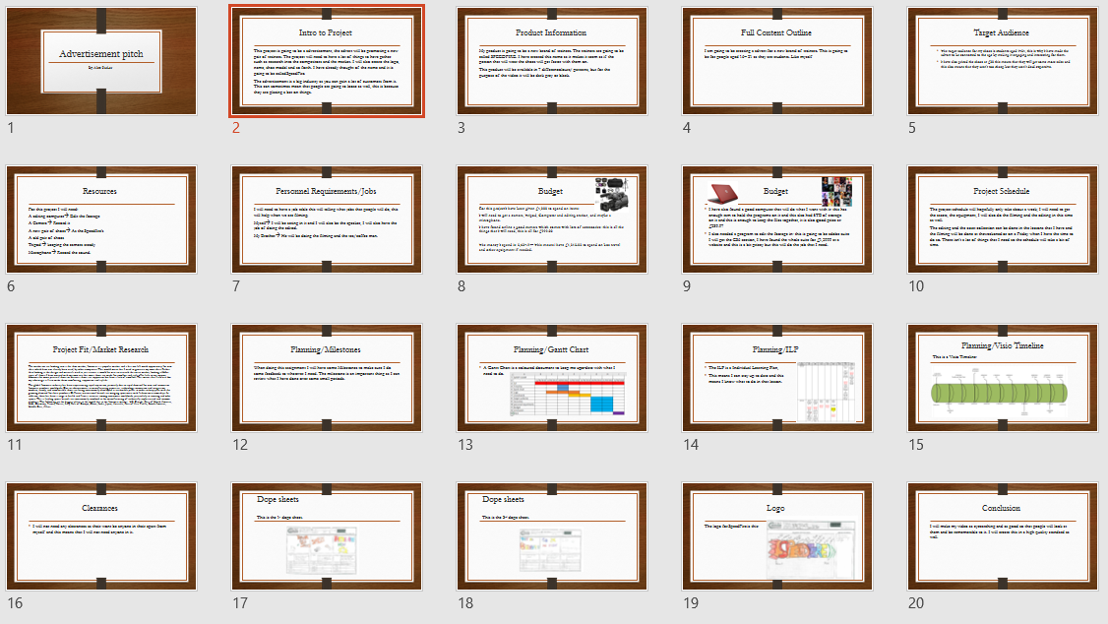
The following 20 pages are these screenshots below. As you can see, I talked about a lot of different information. In weebly, you can see this document better, like the one I have above.

This was the only document that I used for this assignment as this assignment was to be a one which just needs you to create the dope sheets for the advert, so how it goes through. I also needed a logo for the product I was creating.

As you can see from the documents on the left, the scanner that I used did not pick up all of the data. Although in this case I do have the documents in a file, but you can understand what I am talking about.

The logo did survive the scanner and as you can see this is what I wanted to create. This didn’t really have too much information about the effects and transitions section, but this is just a visual representation that I have made with little arrows and pieces of text on it.

These where all of the documents that I made in this assignment, the other things that I made where some time management documents but this is for later on.

Time management for unit 4 – assignment 2
For this task I needed to know the deadline and for when the documentations were supposed to be handed in. I used an ILP for this job. An ILP is an acronym for an Individual Learning Plan and this was the source of how I was able to get the work done on time and so see how much work I needed to do in between lessons. As you can see from my ILP I wasn’t in some of the lessons due to being ill or being at a hospital appointment. However, this is the case I did still meet the deadline. This is because I did work at home and at the weekend so that on the Monday I could have time to hand it in without too much stress.
I also used a Gantt chart in this assignment opposed to unit 33. This is a little excel worksheet that has a lot of colour on which section of the work I will be doing in the different lessons. This also gives me a good break down of the items I need to make in the assignment. I think that this is a good thing to use, but I just did not use it as much as I was going to. As you can see, there are also dates on the top of the table as well.
I also made a timeline, which is a visual way of showing the same kind of information like the Gantt chart, this was created in a software called Microsoft Visio and this was hard to understand the first time when using it, but I made in the end.

Weebly for Unit 4 – Assignment 2: http://alexparkercm.weebly.com/assignment-24.html

