Asset Name | Description | Where Taken from / How it was created | Web page(s) it will be used on | Copyright Yes / No | Image
NAVIGATION BAR | It helps you get from one place to another on the web site. | I made it myself in Microsoft Word for an example. I will make it on the software later on. | Every page, in the top right corner. | NO | 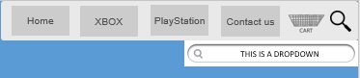
Skin logo | This is the websites logo. This is a bit of text will a Xbox controller hanging off to the left. | It was made in Adobe Photoshop in the last unit, (unit 19) It was made by myself. | Every page, In the top left corner. | NO
Facebook icon | This is a screen icon, when you click on it, you will see that it goes to the facebook page. | It was made in Adobe Photoshop in the last unit, (unit 19) It was made by myself. | In the footer in the bottom section. | NO
Twitter icon | This is a screen icon, when you click on it, you will see that it goes to the twitter page. | It was made in Adobe Photoshop in the last unit, (unit 19) It was made by myself. | In the footer in the bottom section. | NO
Cart | This is the basket for the website, this is where you can buy things from. | It was made in Adobe Photoshop in the last unit, (unit 19) It was made by myself. | This is part of the navigation bar. | no
Magnifying glass and search bar. | This is a section where you click on it and it will then have a drop down to a search bar, to search things from. | I got these on the internet. | This is part of the navigation bar | Yes
Xbox one controller skin | This is the product image that will show the user what they want. | I got it off the internet. | This will be in the main body. | Yes | 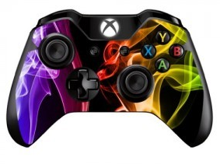
Xbox one controller skin | This is the product image that will show the user what they want. | I got it off the internet. | This will be in the main body. | Yes | 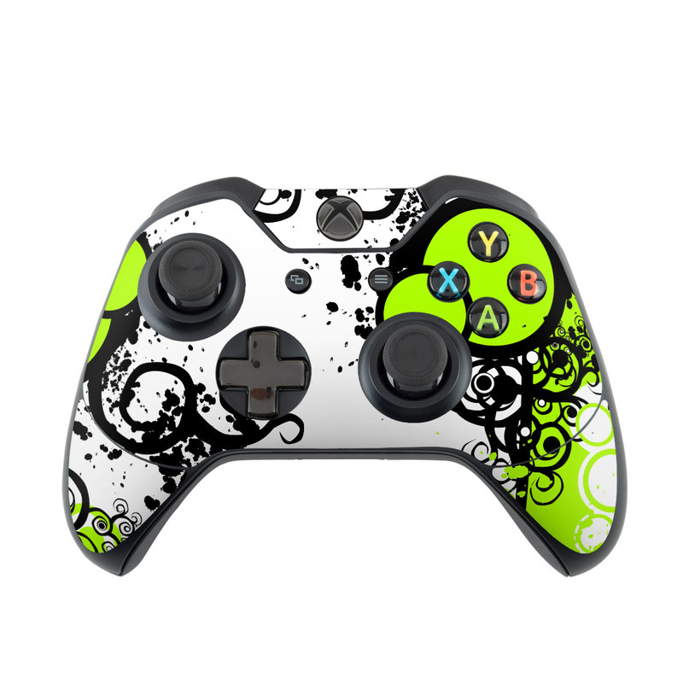
Xbox one controller skin | This is the product image that will show the user what they want. | I got it off the internet | This will be in the main body | Yes | 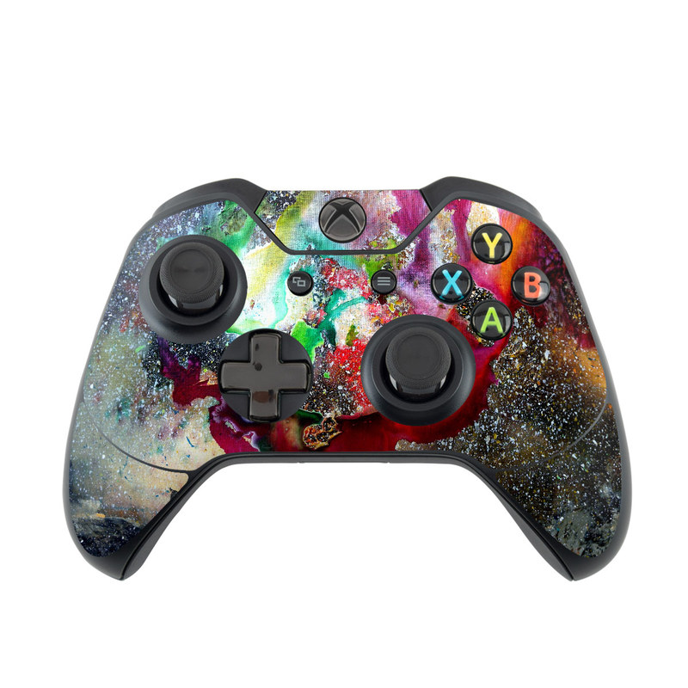
Xbox 360 controller skin | This is the product image that will show the user what they want. | I got it off the internet | This will be in the main body | Yes | 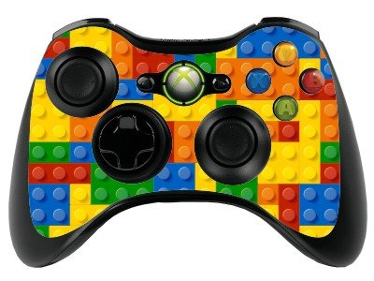
Xbox 360 controller skin | This is the product image that will show the user what they want. | I got it off the internet | This will be in the main body | Yes | 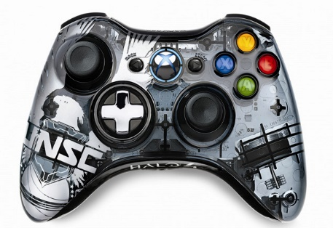
Xbox 360 controller skin | This is the product image that will show the user what they want. | I got it off the internet | This will be in the main body | Yes | 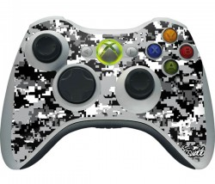
PlayStation 4 controller skin | This is the product image that will show the user what they want. | I got it off the internet | This will be in the main body | Yes | 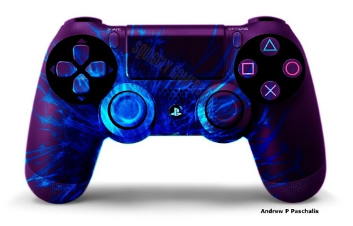
PlayStation 4 controller skin | This is the product image that will show the user what they want. | I got it off the internet | This will be in the main body | Yes | 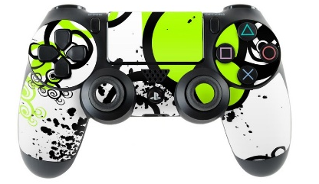
PlayStation 4 controller skin | This is the product image that will show the user what they want. | I got it off the internet | This will be in the main body | Yes | 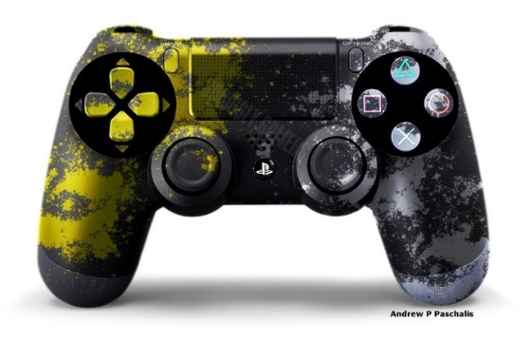
PlayStation 3 controller skin | This is the product image that will show the user what they want. | I got it off the internet | This will be in the main body | Yes | 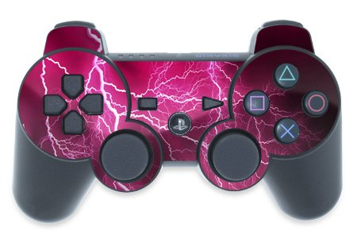
PlayStation 3 controller skin | This is the product image that will show the user what they want. | I got it off the internet | This will be in the main body | Yes | 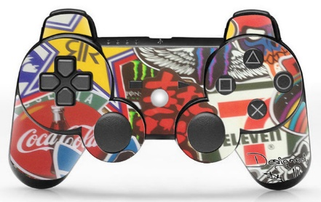
PlayStation 3 controller skin | This is the product image that will show the user what they want. | I got it off the internet | This will be in the main body | Yes | 