Assignment 1 – Defining audiences report
I will be looking at the new Star Wars Episode 8 The Last Jedi, I will be looking at the audiences and the social sides to the way that this film and the trailer makes the film real in the customers before people go and see the film.
LINK TO THE TRAILER: https://www.youtube.com/watch?v=zB4I68XVPzQ

Quantitative audience research
BARB
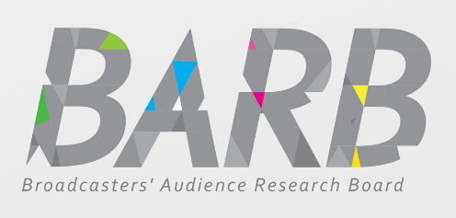
Since 1981, Broadcasters’ Audience Research Board (BARB) have been delivering the official viewing figures for UK television audiences. We commission research companies Ipsos MORI, Kantar Media and RSMB to collect data that represent the viewing behaviour of the UK’s 26 million TV households. To estimate viewing patterns across all TV households, a carefully selected panel of private homes is recruited, to help do their task. As BARB are the audience research group, when needed to I can look at their figures and then see what people would like and then what those peoples favourite kind of TV or what they like to watch and to get readings on what it will be like. But with BARB I can use this reading to get the figures and from the box office on how well the trailer was and then also how good this could be. As the Star Wars Episode 8 The Last Jedi is played through the website YouTube, you can get some information and this is getting a lot of many different views and this then means that people are going to spread the word through the different social media sites.
RAJAR
RAJAR (Radio Joint Audience Research) and is the official body in charge of measuring radio audiences in the UK. It is jointly owned by the BBC and the Radio-centre on behalf of the commercial sector. RAJAR is also responsible for setting the research specification, the awarding of the research contracts to third party suppliers and the overall quality control, management and delivery of the service. As my film trailer hasn’t got anything to do with radio, RAJAR would not be used as RAJAR only specializes in radio statistics. Due to this being the case RAJAR wouldn’t be able to do anything with the data from a TV film trailer advertisement. The only way RAJAR could collect data for the trailer is if the trailer was being talked about or advertised via a radio station. This would only be a one off. The trailer can be talked about with the various actors/ actresses on their radio as a special guest and then people can then have some sneak previews or a sneak peek into what the show would be like.
ABC
ABC (Audit Bureau of Circulations), the industry body for media measurement. They inspire market confidence by delivering a valued stamp of trust across the media world. Their data is used by a wide range of decision makers: Media owners, Media agencies, Advertisers, Rights owners, Investors and Management. The Board will include representatives from advertisers, media agencies, media owners and trade bodies. They represent the interests of the media industry and meet regularly to agree new standards for industry data and processes and to agree the strategy for ABC as an organisation. As they’re a membership body, any funds generated are invested back into the business to keep it going and they have great services for their members. ABC mostly deals with newspapers and which companies advertises in each one.
They also deal with the circulation figures, as a film trailer these figures aren’t necessary. In a newspaper, there may be a little box on the bottom of a page, which is advertising the new trailered film coming out. To advertise in the paper however the film company will have to buy the space off the newspapers or ABC first. The newspapers could have some images of the trailer as this can give a good view to the public as in the elder adults who grew up with Star Wars can read it and see some of the information about when it is coming out, this is because they might not know or can’t use the internet.

In conclusion only a couple of these advertising boards are associated with film trailers. This means that because the film trailer is a product which you must watch it can’t be easily advertised within a newspaper or on a radio station. The only way to really see the advert is to see it on YouTube or some social media sites. This means that if you don’t have access to these then there will be a problem.

Qualitative audience research
Focus groups
A focus group is a form of research where a group of people is asked about their opinions and belief towards a product, service, advertisement or idea. Questions are asked by anyone in a setting where participants are free to talk with other group members. Focus groups are very similar to interviews in the sense that you ask questions; in fact, they were first called focused interviews. Focus groups were first developed to evaluate the responses to radio programs; these days’ social scientists have found them useful for understanding how/why people hold beliefs about a topic.

Questionnaires
Questionnaires are normally a sheet of paper that has around 8-10 questions on it, this is then given to the relevant people so that they can answer them with their own opinions. It is a way of collecting and recording information about a particular interest/topic. It is mainly made up of a list of questions, but they can also include clear instructions and space for answers. There are many types of questions that could be used these include open and closed questions, graded questions and comment type questions.

This is a questionnaire that I asked 10 people to fill in and give back to me:

Questionnaire for Films
1. What age group do you think would watch a film like ‘Star wars Episode 8 The Last Jedi’ the most?
4 – 9 10 – 15 16 – 22 23+
2. What genre of film do you watch?
Action Romantic Comedy Horror Other
3. How often do you watch films?
Never Sometimes
4. Where do you watch films?
Online TV Cinema
6. What would you rate the ‘Star Wars Episode 8 The Last Jedi’ trailer on a scale of 1-10 in terms of the storyline and entertainment value?
1 2 3 4 5 6 7 8 9 10
7. Do you pirate films or watch them legally?
Pirate Legally
Statistical review
As part of this assignment I need to gather some feedback from my questionnaire to find
out peoples opinions on films and the one I have chosen (beauty and the beast). I have
given out 10 questionnaires and now I am going to analyse the results below.

1. What age group do you think would watch a film like ‘Star wars episode 8 the last jedi’ the most?

When looking at my results from this question I have found that 4/10 people (40%) said that 4-9 year olds would be likely to watch a film like star wars, with 30% suggesting 10-15 year olds, 20% said 12-22 year olds and 10% thought that 23+ would watch it. This suggests to me that this film would be suitable for most age groups and it isn’t suited to a particular age.

2. What genre of film do you watch?

For this question I gave various answers to circle. 20% watch romantic, 30% watch action, another 20% like comedy. The other two people circled more than one answer, which shows that they tend to watch a variety of films and don’t like a set genre. The first person circled action, romantic and comedy and the second person circled both romantic and comedy. Only one person circled other which suggests that they watch a genre that wasn’t an option such as sy-fy or thriller.

3. How often do you watch films?

From this question I found out that most people do watch films but not all the time. The statistics from this question are that 6/10 people only watch films sometimes, 3 people watch them all the time and only one person said that they never watch films. I think this is a generally good response as it shows that films are still quite popular.

4. Where do you watch films?

From the gathered information I have found that most people (60%) tend to watch films
online, which is probably due to the improvement of internet facilities. Only 20% watch
films on TV as this is an older way of viewing films. 1 person selected both TV and
cinema whilst the last 10% watch films on all three media platforms.

5. What would you rate the ‘star wars’ film trailer on a scale of 1- 10 in terms of the storyline and entertainment value?

I got a mixed result from this question as 10% rated it 1, 10% rated it 5, 10% rated it 6, 20% rated it 7, 20% rated 8, 10% rated it 9 and 20% rated it 10. This shows that some people thought it was good and some thought it wasn’t.

6. Do you pirate films or watch them legally?

Half of the people asked all pirate the films they watch, which means they watch them
illegally, 2 people watch films legally and 3 people watch them legally and illegally. The
other 50% of people asked pirate their films. This isn’t too good because it means that
they don’t actually have permission to watch the films, however websites still make it
possible to pirate them.

Face-face interviews
These are conversations where there is normally an interviewer and interviewee and then questions are asked and answers are given in return. The word "interview" refers to a one-on-one conversation with one person deciding if the other person is right, for example this may be the case when applying for a new job. The participants take it in turns talking so that each person can be heard clearly. Sometimes at the end of an interview it turns into a general chat relating to the situation. The whole idea of an interview is to transfer information from interviewee to interviewer although information transfers can happen in both directions simultaneously. Interviews are normally organized in advance so that there is more certainty that both people can make it, this is because most interviews take place face to face in person. A face to face interview is what can be done in a trailer as it could say that their is a upcoming film today.

Audience profiling
Audience profiling is where you find out the profile of your audience beforehand so that you can find the most effective way to produce the best result in the long term for your potential customers. It might include details like age, gender, educational qualification, work experience, financial background, field of work, interests, mood, food habits, religious background, physique and health condition. The reason audience profiling is done is so that products can be made more suited to the right audience in the sense that it helps choose where to spend time and money in a company. This means a better return profits for the company in the future.
Socio- economic status
Socio-economic status is a way of separating people up based on their income, education, and occupation. It is an economic and sociological combined total measure of an individual's or family's economic and social position in relation to others. The socioeconomic status it is broken down into three levels high, middle, and low to describe the three areas a family or an individual. If a person comes from a high family socio-economic family they would not really struggle to find a way to watch the film or the trailer/ teaser trailer. But if the person comes from a low/ working class family they will be limited and they might have to find out about it from other people, in the work place or at schools. As students don’t have a lot of money they can get some discounts and offers to get cheaper tickets or they could go to a public computer and find it to watch the trailer.
Psychographics
Psychographics is a way of dividing the market into groups based on social class, lifestyle, personality characteristics and opinions. It works by using the assumption of what kind of products and brands an individual purchase as these will reflect that person’s characteristics and living lifestyle.
Psychographic studies of individuals are valuable in the fields of marketing, demographics, opinion research, prediction, and social research. This is a way of audience profiling as it allows you to target towards a specific class with people of the same wealth etc. A person’s social class is to do with people being put into a group depending on their income, wealth, power, occupation, race and education. They are used to organize society and have put them in either the lower, middle or the upper group.
Psychographics is a good thing for film trailer producers because it allows them to see the opinions of people depending on their personality and class. They can look at what products people buy and decide what they like and dislike based on that.
The Star Wars film trailer it contains scenes of Sci-fi and fighting so people will only watch it if they have an interest in these types of genre, but a lot of different people that might not share that interest can always watch the film anyway as people will still watch the film as it is a part of a billion-dollar franchise.

Geo- demographics
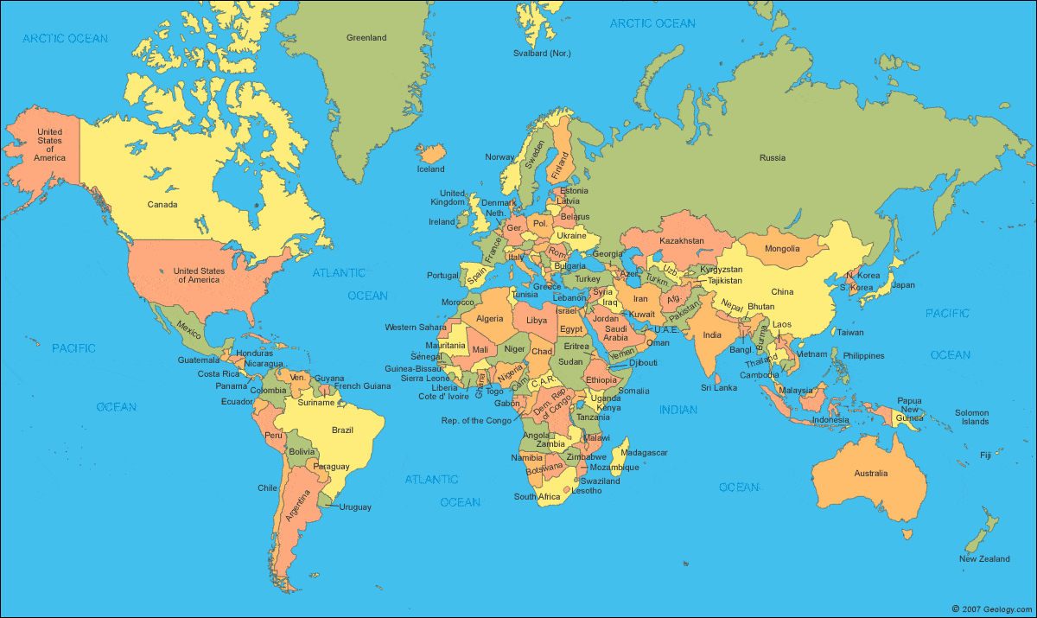
This is all about grouping people together within the same area and is a way of analyzing survey data of a specific geographical area to profile economic and demographic characteristics of the current population living there. Several things such as their town, city or country can group Geo-demographics. Most films these days are released in most countries so they geo-demographics doesn’t really matter however for a film like ‘Moana’ which has only come to screens recently, was only available to watch in the country it was made. Then a couple of months later is was released in the UK which then meant more people could watch it, i think that this means that the different countries had a head-start so they could have some sort of advantage, although this could mean that people could ruin it for the UK. Film companies don’t consider geo-demographics as a priority because you can watch a film anywhere these days.

Age
Age is all about how old someone is and before making and producing a game trailer or film
Trailer, the companies will need to decide what age they want to target towards, a lot of different films have lots of different age restrictions. For a film trailer such as the star wars 8 film there isn’t really a specific age group that it’s targeted towards because it doesn’t contain any sexual content and not too much violence, which makes it suitable for younger children to watch. The Film companies will need to consider the age carefully to make sure all the films content is entertaining but still appeals to the age group they have given the film.
If the film trailer was put onto a website like YouTube, you can also analyses the data about what age groups have watched the trailers. This is one of the ways in which you audience profile the targeted age. As this is a trailer their might be a date and the age group for the film itself. So if won’t have a actually have a age restriction on the trailer.
Star wars Episode 8 will probably be given the PG rating, that stands for ‘Parental Guidance’, as some material may not be suitable for children. This hasn't been fully confirmed yet.

Gender
Gender is a way of determining the range of characteristics to differentiate a person
between, masculinity and femininity. Depending on the context, these characteristics may include biological sex, sex-based social structures or gender identity. Again, gender is another thing that film companies will need to research beforehand by gathering the
statistics of how many males and how many females watch films that will be similar to theirs. They will also need to see how they make a film aim towards that specific gender more than the other. With gender it can be a hard thing to get right as you don't want to confuse or to get the wrong end of the stick from something that someone may think its wrong.
The star wars film doesn’t really lean towards one gender, more to the nerdy or the science fiction genre people that like that kind of thing. As it contains something that will appeal to all genders such as Fighting for boys and the characters for girls. The film includes things that suit different people’s interests to entertain everyone. In general, I think that both girls and boys will watch this film due to the content being suitable for everyone.

Sexual orientation:
Sexual orientation is an continuing pattern of romantic or sexual attraction to persons of the opposite sex or gender, the same sex or gender, or to both sexes or more than one gender.
These attractions are usually categorised and named either heterosexuality, homosexuality, and bisexuality, while asexuality (the lack of sexual attraction to others) is sometimes identified as the fourth category there are many more kind of different sexual orientations but these are the main ones.
The film company will only really consider the sexual orientation of the their
audience if they are making a Science-Fiction film such as ‘Star Wars Episode 8’ as it means that couples will be likely to watch it whatever their sexual orientation may be. This is a good thing for the film companies making the trailers as it means they will be capturing a bigger audience category. The Star Wars films aren't going to be too much about sexual orientation as it is one of those films where it wont come into it too much.

Regional identity
Regional Identity is all about referring to people depending on their different regional groups and their rarity. This part of the audience research is largely gathered based on the regional competitiveness between the groups. You can collect this type of data using the citizens in one area. The information will be useful to audience research as you will be able to find out whether the people feel the place they came from/grew up in is a part of who they are today. people that have a regional place of origin that live in the countryside and they don't have internet access that they live on farms will struggle to see the trailer will probably not see anyone else. Surveys that are based on regional identity may look into people’s backgrounds, to decide whether it effects how they are in modern day. When it comes to the film trailer company using audience research methods, Although if the film is American, then English people may not like the accent so might not be as interested in the film trailer than if it is an English made film. Also it is assumed that a person who grew-up around action films, would continue to have that type of film preference with them as they grow older, as that’s what they’ve been used to.

Mainstream
Mainstream is all based upon a trending product, and mainstreaming was the online term that was used however now it’s used on other media platforms. Mainstream products can be both virtual as well as physical. Physical products can also become a mainstream item, like those on the internet. If a physical item is mainstream it means that, everyone will know about it, want it, or own it. This is especially the case amongst the younger audience, who are more used to getting what they want. Unusually it tends to be the cheaper items that trend the most as people can afford them even if they are not played with for long. This also allows kids to keep up with the latest trends. On the other hand more expensive products such as the latest phones, tablets and computers became a mainstream product. I think that if ‘Star Wars’ film company advertises its new coming film well and over several media platforms such as the internet and billboards, then it has a good chance of becoming mainstream. A new film trailer such as the Star wars one will not have a problem bringing in steady profit as the old version of the film is already a popular hit, especially with kids. As the Star Wars universe is massive, this means that the new oncoming films will be a mainstream set of films.

Alternative
Alternative advertising is a method which sets your message apart from the rest. It is a way in which ensure that it to stands out and can be noticed against all the other advertisements on the internet and television. This is accomplished by being positive, strategic, and by adjusting techniques in order to appeal greater.
Star Wars’s company will audience profile using this by researching into current trending and successful films so that there film can contain some of the unique selling points of other films. Then after analysing it, create a new sales pitch which will contrast their method, which will then result in a new selling tactic which is an alternative to the original method being used time and time again. If the film is released from a alternative perspective i do believe that their will be more people watching a alternative film as it is more unique and then this means that not everyone will know too much about what will be like.

Niche
A niche audience is a small, select group of people that have a very unique interest of a certain product or service. On the other hand, niche marketing means that you target customer group for marketing on a specific product. The niche market aims at satisfying specific market needs, as well as considering other things such as the price range, production quality and the demographics. The niche market is highly specialised, and aims to survive among the competition from numerous super companies. As you can figure out, each and every product can be defined by its own market niche, which means there all a lot of different niche audiences and markets. The Star Wars films are not niche as there are many if not billions of people that love and like to watch the films.

