Aardman Animation

What is Aardmans?
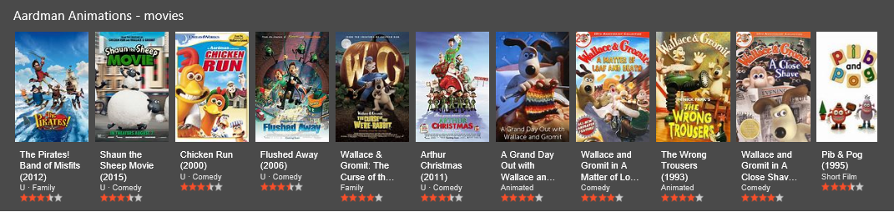
Aardmans is a company and Television animation company, that specifically looks at creating animations in Claymation. This is a type of animation that uses clay to create characters and this is then filmed in stop motion so when they play it back they can get an animation. Aardman have made $971.8 million worldwide and average $162 million per film, they have made a lot of films.

As you can see from their films above they have made a lot they have also got a 3 to 4-star average with their films. The company have made about 15 films all together. The most iconic film they have created is Wallace and Gromit, which is a man called Wallace and he has friend which is a dog and he is called Gromit and they have a lot of adventures. This was a film but was a television series. The other most popular series is a television series called Shawn the Sheep and this is about a sheep. They have also made one for younger ones called Timmy Time about a sheep.

Films and TV series
Shaun the Sheep the Movie (2015) – Shaun the sheep is a film that is based on a TV series on CBBC. This is when their farm owner gets lost they go on an adventure to get him back; they also struggle to get him as they are being chased by animal containment
Chicken Run (2000)– Chicken run is about chickens who will attempted to fly over the fence of the farm, they are trying to escape from as in fear of turning into a chicken pie.
The Pirates! The Adventure with scientists (2012)– This is about pirates who will try to get a big award which is to become a pirate of the year. They have an assistance with scientists, from Charles Darwin.
Wallace and Gromit, the curse of the were-rabbit (2005) – Wallace and Gromit is when Wallace turns into a rabbit and Gromit who doesn’t speak has to save him. From going absolutely berserk.
Flushed Away (2006) – This is about a rat that accidentally gets flushed down the toilet and is then found to have problems getting back from the sewer village. Once he gets back home he finds that he enjoyed it so much he went back to have some fun.
Arthur Christmas (2011) – This is about the child of father Christmas (Arthur). He has to save Christmas and make sure that every child gets a toy.
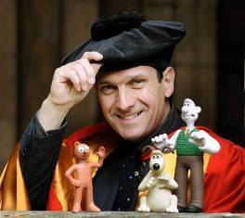
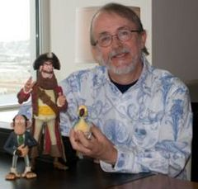
The founders
The first founders where Peter lord and David Sproxton, they started their animation partner at their school. Once they graduated they went to Bristol to create their first program called Morph. They have doe lots of things such as, a video for a music video.
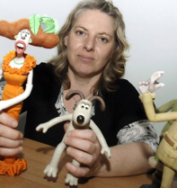
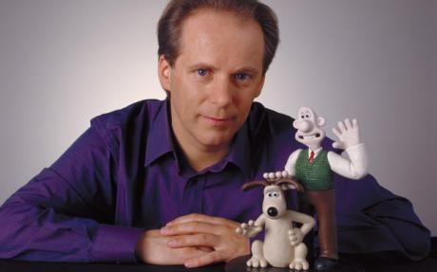
People’s roles
Dave Sproxton: Director and Founder
Peter Lord: Director and Founder
Nick park: Director and Animator
Jan Sanger: Model Maker
Louise Holmes: Producer
Chris Barrow: Lightning Technician
Charlotte Worsaae: Animator
Will Byles: Computer Animation
Jacky Chrisp: Production Co-ordinator
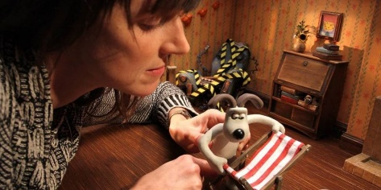
Luis Cook: Commercials Director
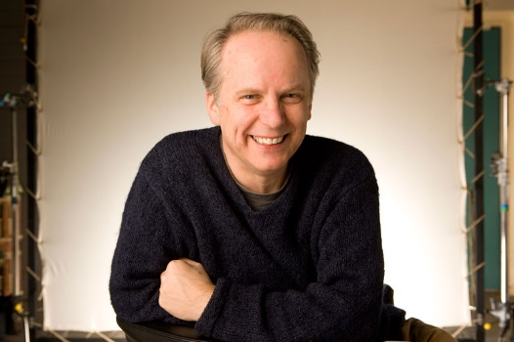
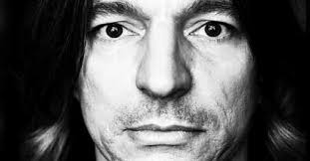

As you can see above these are the people and their roles within the Aardman company, but they still have a lot of job vacancies. Such as a Animatior, Assistant Animator, Storyboards, Storyboard artists, layout artists, CGI animators, If people want to find out a bit more about them go to: http://www.telepathy.co.uk/aardman/culture/jobs.html

Here is a link to a Aardmans studio tour: https://www.youtube.com/watch?v=wRgTB9VS4HA. This video shows the watcher about how they create the film, this is a good video even though it is quite old.
Sledgehammer
Aardman created the animations for Peter Gabriel’s Sledgehammer song, this looks very good as they used clips from Claymation and they also used real life video, if you haven’t checked it out yet please watch it as it has over 5 million views as it is amazing animation for the time of publication.
https://www.youtube.com/watch?v=OJWJE0x7T4Q

Finance
Aardman’s films had to be funded by DreamWorks but they then changed to Sony productions later on as they used a lot of their money, and when the film was produced they lost their money when It can out so they did change, so they will have money to do it. The company can’t fund the movie by themselves, this is why they need a sponsor. Each film has had a certain budget.
One of the first filmed created by Aardman, was called Chicken Run, this was made in 2000, the budget for this film was $45 million but they and they received a gross profit of $224.8 million. This was produced with help in a partnership with DreamWorks Animations.
Wallace and Gromit the curse of the were-rabbit, was produced in 2005 and they had the same budget from DreamWorks Animations and this time they had a smaller budget of $30 million, when it hit the big screens they gained a gross profit of $192.6 million.
Flushed away was the next film they created, but this turned into a big argument with DreamWorks as they had a big budget of $149 million, and they only had a small profit and making $178.1 million. This had quite a bit of bad publicity this then sprung a new dealership with another company.
As they had lost a lot of money for DreamWorks Animations, they needed a new partnership with a company this turned out to be Sony Pictures. This film turned out to be Arthur Christmas, they had a smaller budget of $110 million. They reached a gross profit of $147.2 million.
As the previous film had some reasonable reviews so they went on to create The pirates! In an adventure with scientists! This had a budget of $55 million and this smashed this and gained a gross profit of $147.2 million. Then they had to get another partnership, this time it was with Studio Canal.
The first film that has been created by this company was Shaun the Sheep the Movie, this was recently produced in 2015. They had a small budget of $50 million. This gained a gross profit that was $106 million. This is one of the best films they have created as a lot of people and critics loved it.
Aardman are currently in the process of making two more films, the first one is called early man, this is estimated to come out in 2018, but they have a budget of $50 million. The other film is going to be a Shaun the sheep sequel, this hasn’t got a release date or a budget yet. They will create the other one first and then work on that.

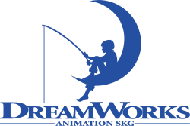
These are the partnership people’s logo. (DreamWorks, Sony Pictures, Studio-Canal)

