Aardman Research

Market Trends
Products and services
The Aardman Company was small at the start, this meant that they had a small budget, over time this budget got bigger as the company was getting bigger. They have done lots of films but they have also done lots of different advertising. They have done some advertising for change 4 life, they have created the family with their computer software, they have also done things for the mother’s day funky Pidgeon advert. They did the whole advert for Sudafed, this looks great. they have done an advert for underdog, this is an insurance company. To look at some more Aardman adverts go to: http://www.aardman.com/work/?#filter=.advertising they have done lots, it all has the same Claymation feel to them. They have also helped by creating websites for some companies, this is mainly for the fan pages like; morph, Shaun the sheep in the city, the grand appeal. To see these websites you can visit: http://www.aardman.com/work/?#filter=.interactive. The Aardman company have the rights for the following: Timmy time, Shaun the sheep, championsheeps, tilly and friends, angry kid, pythagasaurus, Wallace and Gromit cracking contraptions, purple and brown, Timmy’s seaside rescue, creature comforts, Wallace and Gromit, the pirates! In an adventure with scientists, rex the runt, morph. They can use these programmes with brand development as they have all the rights to them.
This would mean that Aardman Animations will provide services in creating animations such as films, specials, shorts for adults and children, as well as mixture of both audiences this is so they don’t get seen as discriminating people. Creating commercials to advertise their products, to create entertainment for their audiences they also develop applications for smartphones, games and interactive, as you can see they do a lot of different things for lots of different well- known companies.
Aardman Animations have also been trying to make their services to be seen across the globe and by experimenting with different audiences and pushing out as they want their company to be as well-known as Disney, Pixar and DreamWorks, they did try to be as good as DreamWorks with a contract but they failed with a film and are now trying to recreate their fame.
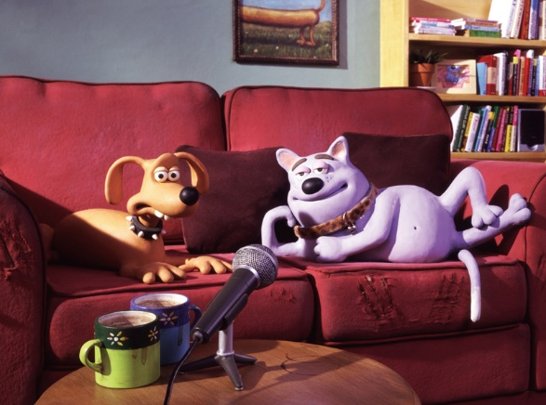
A series that Aardman did was Creature Comforts which was a massive success around the globe and which won them an Oscar and is now currently being developed for the USA region, as this was their main global region. This basically means that Aardman Animations are unique in what they do by using plasticine and wax figures to create stop-motion animation. This makes the Aardman Animation an iconic figure for this new industry.

Research and development
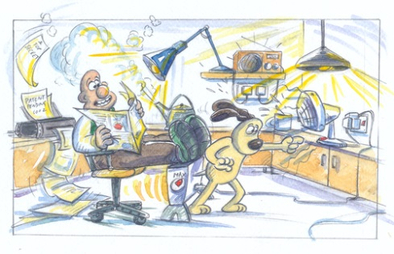
In order for Aardman Animations to become popular they needed to have a good storyline, but in this case they struggled with a film in particular (Flushed Away). Even when they were creating the film, they didn’t know what to do. The main people that created the ideas were David Sproxton (founder) and Peter Lord (founder) and Nick park. Nick Park was the person who made the characters famous and this brought in lots of success. At some point along the way, the crew had to think of some new people to come in that can help to get the ideas flow a lot better as they were needing to get some profit for the films. The main success of the majority of the films were the change of the animation that Nick Park did in some of the shots, this wasn’t in the main script. He wanted the characters to come alive and to do this he got permission to change this to his own accord. The big success of the company wasn’t the computer animated films, but the Claymation films as no one had seen this done before. They created the films in such a good high quality of production that it made the films famous along with the characters.
Once the films started to become famous they could employ more people to the company, this means that there is a development team that are there to help generate the ideas for the films, they needed something that would be fun, a bit like the Pirates! In an adventure with scientists. They would have a group of designers and researchers working together to create all the scripts, characters and extras. They needed the voices as well, so they would look for people who might fit the role of the characters. The development part of the film or short takes a long time, they will start by creating the outline of the story and then work off that, the film will usually take about 3 months just for the ideas, then they need to make sure to copyright any of their material so that no one can come and take it. The ideas for the advertisements that they create will usually come from the other company but they may get to input some of their own ideas.
Product development cycle
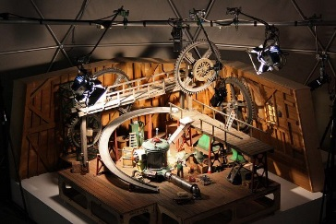
The production of the films is the most important bit about any film. They need the cycle of production before anything else. Once they have the budget of the film from either Sony, DreamWorks or any other company. They will start by creating the script, they will also have pre ideas of the work. As they have this the production team can use this to create the characters, sets, backdrops. Then once they have done this they will create the film, they will add in sounds and the actor’s voices, they will have animated the film as well. This then means after about 18 months they will have the film, they will then need to publish it and the will have different film critics to see it. They eventually will show it on the big screens for people to watch.
Part of the production is to create the characters in real life, they have to find the correct materials in order to create their animations which they will primarily use; plasticine, foam, latex, wood, metal, silicone, resin and putty. For their Wallace & Gromit episode, they mostly used plasticine which is a softer version of plasticine, but nowadays they will primarily use clay as it is much softer and easier to mould into different shapes which is what ideally they need to happen. They also require creating skeletons which are uses to help it moved. They are placed under the clay for the characters using stainless steel or mild steel plate to make the armature pieces from which Aardman designs and use a local model making company to hand cut the plates and drill the ball bearings to create the ball and socket joints as required. They never used to use the skeletons and this was harder to move the clay around especially when the clay gets hard.
Visions of organisation competitors
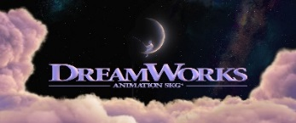
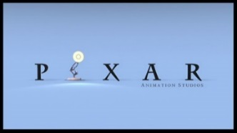
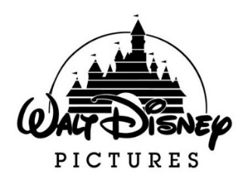
Aardman have a vision of having their films seem more appealing to adults, they have mainly been targeting the children audience. The main rivals are PIXAR, Disney, DreamWorks (since they split). They want to be as good as these, they do have quite some famous voices but this just needs to be better.
Pixar are popular as they have made films like, Toy Story, Cars, Monsters INC. This company mainly bases their company on computer generated films. There visions are to create an original film each year, with a sequel.
Disney films are also computer generated, they originally created the films using cell animation, this was done with drawing them first. The company also use acting as well, one of these that is quite famous is Pirates of the Caribbean, they have a lot of films as they started with a film in 1928, with Steamboat Willie, this was hand drawn cell animation. They want to keep creating films for more in the future.
DreamWorks have been using the same type of computer generated animation as Pixar, there famous films will include films from Shrek, Kung Fu Panda, Madagascar. They want to make their films stream able from Chromecast, this will be a great new feature for this.
The big thing that Aardman want to become is like this, but they want to create films for lots of time in the future. They want to use computer generated animation to do this, but they want that feel of Claymation in there. This is a hard task but they almost pulled it off in flushed away, it just didn’t have a storyline. But they did well with this in the Pirates film, this is one of their latest films to day.
They have still won many Oscar awards for these films as well as nominated for having their first CG features in there, they later stepped down in creating large films and funded themselves to create a lower budget film with the budget only £100,000 for Wallace & Gromit: A Matter of Loaf and Death which Aardman described how they much preferred the success for this short film rather than working with DreamWorks and SONY which they also won awards - BAFTA Award for best short animation and an Annie Award for best animated short subject the film was also nominated for an Oscar as well as Academy Award. As you can see they have won some awards, but unfortunately they are no longer with them, there was a fire in the Aardman studios which meant that they have lost them but they have gotten many more since then.
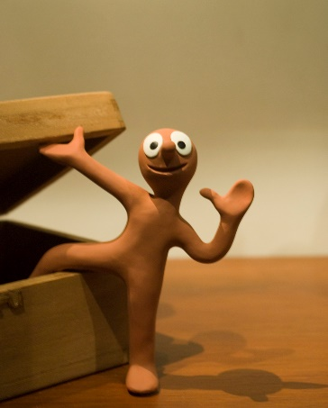
Customers
Aardman want to get the most amount of viewers (customers). When they are creating the films they will think of the audience, this is the age and gender of the people. They originally created the films for children, but after trying in the adult industry they even won an Oscar award. But they suddenly went back the children’s market, as they had more viewers. They targeted the Morph series at deaf people, using sign language. The Aardman Company had to stop the series as they didn’t have enough funding. The people in the public decided to create a Kickstarter called “Bring Back Morph”. They managed to raise enough money (£75,000) to fund another 15 episodes. Nowadays they still make the series and put it on a children’s channel. This is still popular to many children as it teaches them about sign language and other bits about people’s problems.
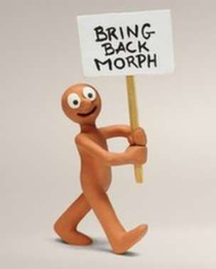
Aardman want to reach out to as many of their customers as possible, so they need to select what type of demographic (the age, gender and ethicality) and what they are aiming at specifically in order to produce a strong product that can correctly aim at the gender and age. Aardman Animations wanted to produce their animations for adults which won them many awards such as Oscars but they suddenly reverted back to producing animations for children as their demographic is mainly popular with children with the average age of 5 since they watch Aardman’s animation and the fact that the series. They thought it would be better to keep the children demographic as their customers as they are the main people that where children so they kept it at that.

Current international and national market trends
International market trends- I have found an international newspaper (telegraph) article that tells the reader how Shaun the sheep became a global phenomenon, this tells us that he became famous from the Wallace and Gromit a close shave, this sheep was a crucial bit in the plot, this has since then been a lovable character. The Wallace and Gromit film had a BBC broadcast in Christmas 1995, this short film became an Oscar wining. Then he had a big role in advertising the company for about 12 years. Then finally he got his own TV show on the CBBC network this has given him 140 episodes, with his own film called “Shaun the sheep the movie”. This will have a sequel as well. This has also created a series called “Timmy time” this is about a smaller sheep in the herd that goes to school, this is on the Cbeebies channel as well.
http://www.telegraph.co.uk/culture/film/11365274/shaun-the-sheep-movie-aardman-behind-the-scenes.html

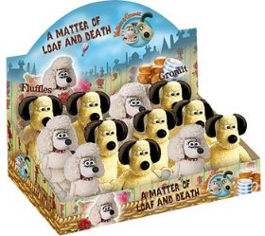
National market trends- In the UK the Aardman Company set out to do something called Shaun in the city, this is to raise money for the Wallace and Gromit’s Children’s foundation, and they had the task of creating 70 colourful and eye-catching statutes. They created them and then auctioned them to the Bristol’s and Brittan’s cultural history, they wanted the statues to be placed in adored iconic locations with green spaces. The foundation received a grand total of £1,087,900. This money was used to support the sick children and their families across the UK. These statues where placed so that they lead to Bristol’s hospital, the Aardman company is based in Bristol in the UK. This picture to the right is all of the 70.

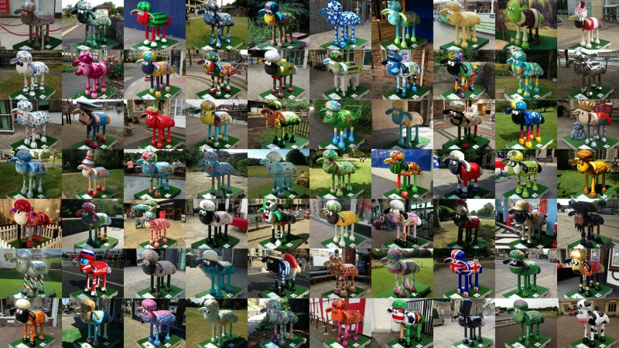

Aardman are still well known for their featured film, Wallace & Gromit. Since their Wallace & Gromit the franchise has been so popular globally both with children and adults, they have begun making official merchandise for Wallace & Gromit fans this is for them to collect as well as stationary equipment which Aardman would have already noticed how much attention Wallace & Gromit has gained, they will carry on creating more and more to do with their films. This means that Aardman are capable of opening their own official shop which sells hand-crafted creations which many fans are able to purchase and see the magic of Aardman’s models up-close as well as for Aardman to gain profit from merchandising to the public so that they are able to expand their funds and resources for new upcoming films, shows and series, they can gain a lot of money for this as it is a new bit of an experience for the people to do. This also gives a new and a big chance for Aardman to advertise their company as well as their studio which can get potential new customers and fans of their series.

Industry trends
Property rights
Aardman have lots of different rights that they are liable for, one of these is the intellectual property rights. This states that the Aardman company has the license of the rights on their site, it means that all the rights are reserved by us.
The property rights say that you can print off 1 copy and download pages of the sites, but you need to use this as your own personal use. With these copies you CAN’T modify them at ALL. This means that if you are in breach of this then the right of your server will be ceased immediately and you must with their option return or destroy the copies that you have made with the Aardman company.
ALL the characters that have been created by Aardman Animation limited are protected. The trade marked shows or anything to do with Aardman is, Wallace and Gromit, Shaun the Sheep, Timmy time. The following words are associated with Aardman and are registered as a Aardman animation limited in the trade marks, Chop socky chooks and creature comforts. Also the visual depictions of the registered trademarks of Aardman Animations Limited are Aardman and Underdog. If you need to contact them go to: privacy@aardman.com.
Like all other organisations they have property rights under their terms and conditions which meaning they own that property exclusively and nobody can use that product unless they acquire or gain some type of permission from the director which in Aardman’s case, they would need to contact either Nick Park, David Sproxton or Peter Lord as they are the three founders since they are the owners of their unique creations and work they have acquisitions with, if you can’t get in touch with them then you can speak to a member of their team, this might be that they are in a meeting and are not able to talk at the moment. Consequences will follow if another organisation decided to jump in to use their characters freely for whatever their project would be, this is because they not have permission. It would be considered for that organisation breaching the property law as that organisation does not own the characters and creations made by Aardman as well as not asking permission before using. They don’t want anything to happen that they don’t want.

Sequels
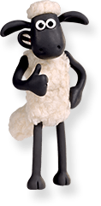
A sequel means that once the first film comes out the next film which will continue the story. The Aardman have created a lot of sequels for Wallace and Gromit, this also made two other series and a film called Shaun the sheep on CBBC and Timmy time on Cbeebies. The first few sequels from the Wallace and Gromit, these where: a grand day out, the wrong trousers, a close shave, the curse of the were-rabbit and a matter of loaf and death. The film called the curse of the were-rabbit is currently gained profits from the release in 2005.
Aardman have currently confirmed in development there is a Shaun the Sheep sequel, from the Shaun the sheep the movie. They haven’t told us yet about this, but from some rumours this will be good. They have got a fair gross profit for the Shaun the sheep the movie was £82 million. So this means they have gained some money for Studio Canal.
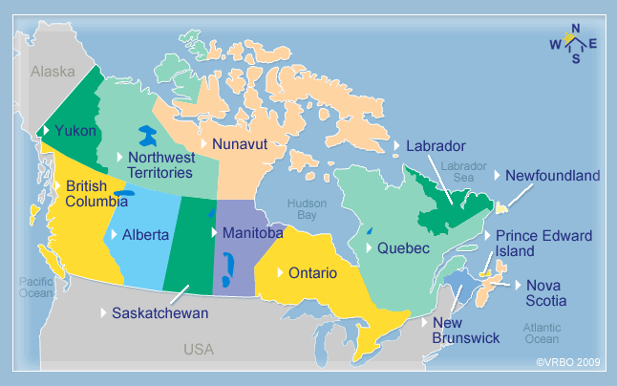
Aardman have created another plot for the pirate’s sequel, this is going to be called “Pirates! Risks choppy waters”. This means we will get more pirates, this will take them a long time to create the sequel as it is a stop motion and Claymation animated.
Aardman have also been making spin-off series from Wallace & Gromit featuring characters from Shaun the Sheep and Timmy Time as Shaun the Sheep has been popular lately among the viewers. Not only is this a brave idea for Aardman, but the fact that Wallace is known to be an inventor which gives them infinite ideas for the story plotline such as where Wallace travels to the moon in ‘A Grand Day Out’.

Outsourcing
Outsourcing is when organisations usually produce their products cheaper than they should do, this involves the sending portions of their work overseas to get them produced for less than they are. This can be down to taxes.
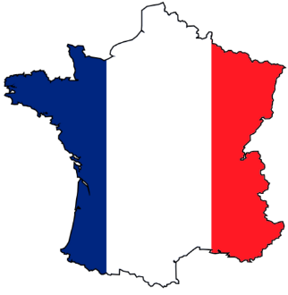
Aardman are going to be moving their company in the near future as they can’t afford the taxes in the UK as they can be quite expensive and pressurising. They will be moving to Canada or France as they are going to be cheaper. It will be cheaper to produce the films internationally.
Another reason why Aardman took on creating CG films with DreamWorks and SONY is the fact that they would be able to cut the cost of producing Claymation as it involves many stages of work which involves in creating the character models and animating them step-by-step which requires many workers to work in each sector whereas if Aardman chooses to work with CG, they would have less employees developing the film as it is digital based and rather much easier which in the end saving money on the production without spending a lot. But if the Aardman company did move to another country they can get more labour, if they moved to China they can get the props and models made quicker and they don’t have to wait for 6 months for the creation, they can get things done cheaper and quicker making it at about 3 months.

