Aardman Report
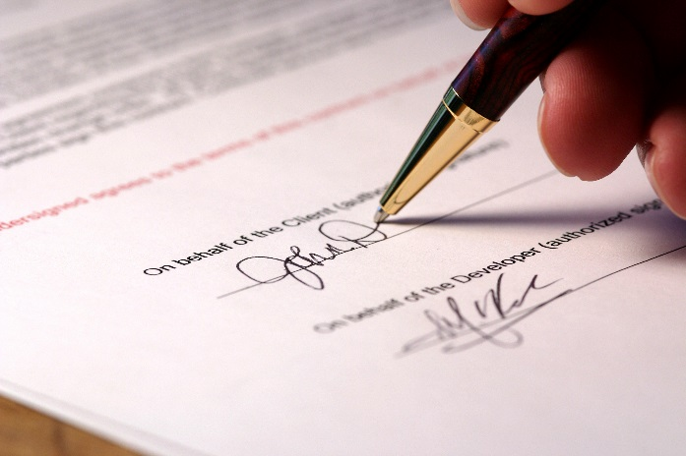
Contractual

Types of contract
A contract is a legal binding of an agreements between two people, this has created an enforceable obligation to do, or to refrain from doing a particular thing. There are lots of different types of these and I will name them and explain what they do below;
Contracts under Seal- This is a traditional contract that became an enforceable legal document only if it became valid with a stamped seal. The seal was represented by the parties intended for the agreement. All of the contracts were required to be under the seal in order to be valid, but the seal has lost some or all of its effects by statue in many jurisdictions.
Express contracts- A express contract is a contract that parties or people will state the terms either orally or in writing at the time of its formation or creation. This needs to state the explicitly and demonstrates the terms.
Implied contracts- this contract is implied in fact and contracts implied in law are both called implied contracts, a true implied contract consists of obligations arising from a mutual agreement and intent to promise, which have not been said in words. It is misleading to label as an implied contract one that is implied in law because a contract implied in law lacks the requisites of a true contract.
There are many other contracts such as; Executed and executory contracts, bilateral and unilateral contracts, unconscionable contracts, adhesion contracts, aleatory contracts, void and voidable contracts.
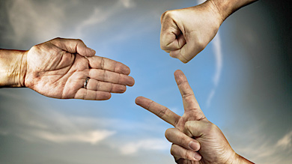
Aardman will have different contracts with different companies. One company which Aardman have a contract with is Data Return UK. This company is hosting the Aardman's website www.aardman.com.
Negotiating contracts
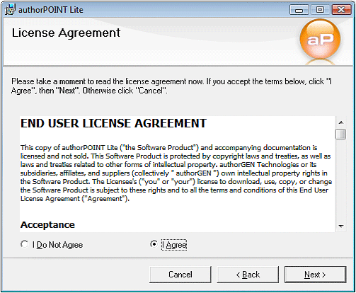
Contract negotiations involve discussing and compromising on contract terms to reach a final, approved draft of a contract that is acceptable to all parties, this can take some time to get what they want to do. Some contracts are non-negotiable, as is usually the case with leases and manufacturer warranties. However, other contracts, such as business, real estate and financial contracts, may be negotiated to reach terms satisfactory to all parties involved. If you want to change your contract then firstly you have to look at your contract already and see what you want to change, this could mean that you look at contracts in your area to look at what different people are entitled to, then you need to make sure that you can change it because people have some End User Licence Agreement (EULA). Then you need to get the base of the changes that you want to happen and you can then have some information to back you up. Once you have done this they will get back to you and you can have the problems solved by the end of the day.
Aardman animation employees will negotiate with their supervisor or their boss, this means that people can be happy with their contracts after some negotiations. The negotiations could be a way to get your concerns to the company, this does mean that you will get some type of solution. The main things that people will want to change in the company is, their money income or their work hours, people want to change these so they can get paid more money for less hours. People will change this once every few years, this means that people can seem like they aren’t too pushy for it, people can also get fewer hours with their contract if they are getting old and need time to do other things.
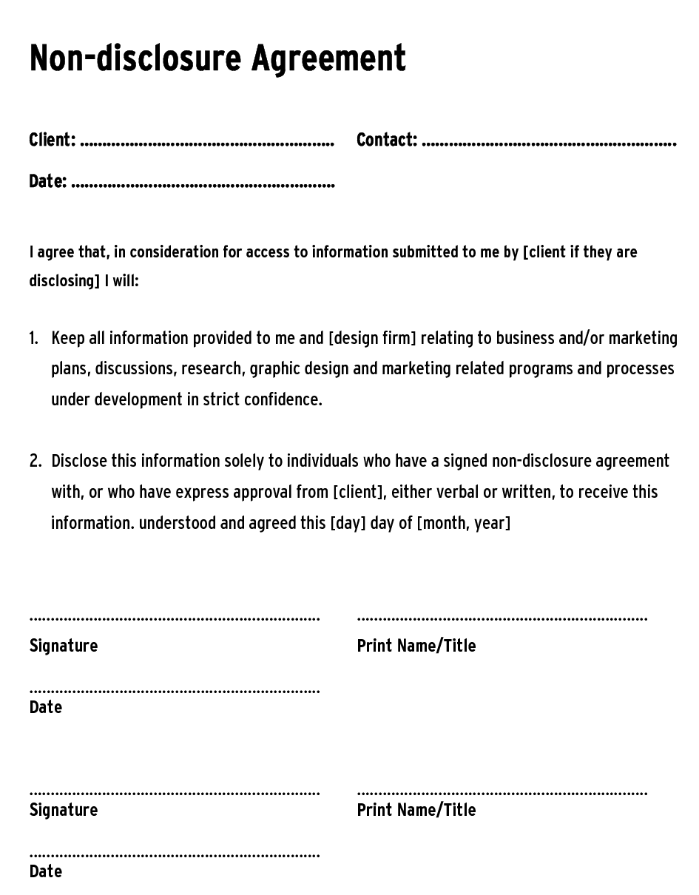
Non-disclosure agreement
A non-disclosure agreement is also known as a confidentiality agreement (CA), confidential disclosure agreement (CDA), proprietary information agreement (PIA), or secrecy agreement (SA), but this is a legal contract between at least two parties that outlines confidential material, knowledge, or information that the parties wish to share with one another for certain purposes, but wish to restrict access to or by third parties. It is a contract through which the parties agree not to disclose information covered by the agreement.
The people in the Aardman animations will have all signed this agreement, this means that people can’t tell other companies what films or Tv shows that they are creating. Not a lot of people have access to the whole workshop so they can’t get in. There will be restrictions about taking photos as this is can be seen as breaking the agreement. This could mean that at the highest sentence by the court that you can be imprisoned.
You will have to fill out a form like the one to the right, but this is just a basic one, the others can be bigger with lots of things that you need to do.
Risk management
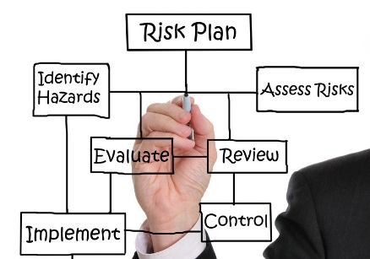
In lots of different companies there will be health and safety guidelines that will be put into place to help prevent a risk, or a risky situation. There can be a lot of risks involved in something like a film being made. Before any work or any film there will be certain risk assessments that are needed in order to get the place safe for people to do things.
The Aardman company will have to risk all the different bases, this is because they don’t want anything to happen, they will check to make sure that there are no cables that can trip people up, they will make sure that people can get out of the building if there have been any fires, they will do lots of major and minor tests to get the place safe.
There will be a health and safety inspector that will come to make sure that the place is safe and that it can stay open, if the inspector finds any risks or something that could potentially go wrong. Then the company or business if they have anything to look at they will have a limited time to get things solved.
One of the main things that can be wrong is the equipment that they use, this is things like the camera equipment, people will have to wear special safety harnesses to move things around, this means that the operator won’t get hurt and the equipment won’t get broken, there are also things like the spraying room for some of the bigger props, the people will wear a safety gas mask, so the fumes don’t hurt, there will be helmets worn for the big set building.

Regulatory issues

Freedom of information
The Freedom of Information Act 2000, will provide the public with access to information held by public authorities, this can be a lot of different things that they have. The Freedom of Information Act 2000 is an Act of Parliament in the United Kingdom, this creates a public "right of access" to information held by public authorities. It is the implementation of freedom of information legislation in the United Kingdom on a national level. The final version of the Act is believed to have been diluted from that proposed while Labour was in opposition. The full provisions of the act came into force on 1 January 2005. What this act does is that it will allow you to gain any relevant information from the government, but you will have some restrictions on what you can access. This Act will record any information that is held by a public authority in England, Wales and Northern Ireland, and by UK-wide public authorities based in Scotland. Information held by Scottish public authorities is covered by Scotland’s own Freedom of Information (Scotland) Act 2002. But you can still get this information.
Aardman will have access to this information like all the other people, they may have a bit more access to this, to use this information in a film or a Tv series they may have to ask the government about whether they can use it. The information can be a lot of different things.
Censorship
From the dictionary- “Censorship is the suppression of speech or other public communication which may be considered objectionable, harmful, sensitive, politically incorrect or inconvenient as determined by a government, media outlet or other controlling body.”
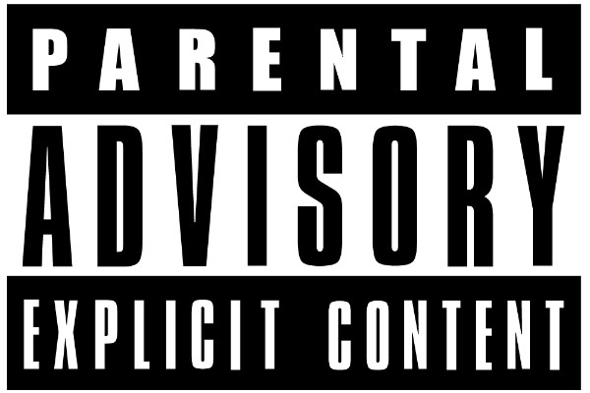
Censorship in the media industry will take many different forms to get in your news. While news stories are often edited for length, there are many choices that are made that are designed to keep some information from becoming public, this means that people will use this info to make it into a bigger but better story. Sometimes these decisions are made to safeguard a person's privacy, others to protect media outlets from a fallout.
Aardman animations will need to make sure that they don’t use anything that could be harmful, sensitive or politically incorrect or inconvenient, they will have a team that will come in a few days a week to see what they have done and created, they will then have a big critic and they will say what they think could be seen as harmful, sensitive, politically incorrect or inconvenient. This may mean that they have to do the whole thing from the beginning.
Aardman will go through so many different things before they can show the film or the Tv program, this means that you might have to change things earlier. Aardman may have an age group that want to watch the program, they can then see what will offend them. So they can then change this later on.

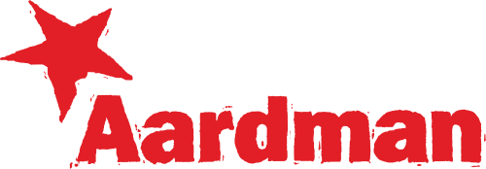
Trademarks
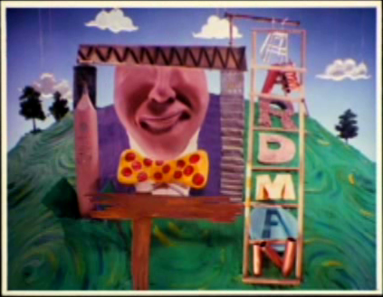
A trademark is a recognizable sign, design or expression which identifies products or services of a particular source from those of others, this means that it stands out. The trademark owner can be an individual, business organization, or any legal entity. A trademark may be located on a package, a label, a voucher or on the product itself. For the sake of corporate identity trademarks are also being displayed on company buildings.
The trademark for the Aardman company is to the right and as you can see it is the name of the company and it has a star near the first ‘A’. The bright red that it has makes it stand out, this also in a grainy effect, this makes it look like it has been drawn in a crayon and just been stamped around the place.
Trademarks are acceptable if they are: Distinctive for the goods and services you provide. In other words, they can be recognised as signs that differentiates your goods or service as different from someone else's.
No other company or person can copy the trademark and if you are found to do so then you could be taken to court. The Aardman trademark symbol was different for a long time, this was like the one that is the bottom right. This is a man looking through something but with some scaffolding with the words Aardman. You can see this trademark on the old films.
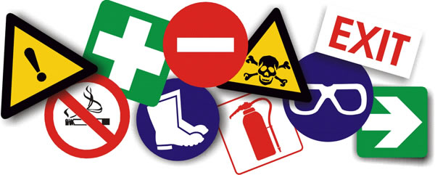
Health and safety policy
Health & Safety at Work Act (1974) – Under this Act of Parliament, employers are legally required to do all that is possible to ensure the health and safety of their workers and the Heath & Safety of non-employees such as visitors and students. The following regulations are procedures to safeguard the risk of injury to people. This is so there aren’t any problems, the health and safety of everyone is in your own hands, sometimes on different activities you sign something that is going to be in your own hands, so they don’t have to worry about you too much.
Health & Safety is obviously very important. Employers are legally required to minimise the risks for employees, whereas employers have a duty of care when carrying out their jobs. Acting in an irresponsible way could lead to injury or illness and is a criminal offence that could lead to prosecution. This is the worst situation that you could end up in.
Aardman will have a Health & Safety Policy covering working hours, conditions of employment, working conditions, access to health care, lighting, heating, Hazardous Materials etc/etc. The Aardman company will have to risk all the different bases, this is because they don’t want anything to happen, they will check to make sure that there are no cables that can trip people up, they will make sure that people can get out of the building if there have been any fires, they will do lots of major and minor tests to get the place safe. This is just as a prevention if there is something.
Trading standards
Trading Standards is the name given to any local authority departments in the UK formerly known as Weights and Measures. This has a lot of different standards that will need to be covered at some point in the company.
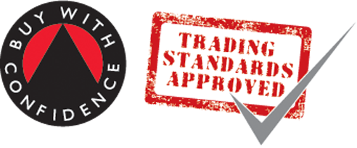
Trading Standards enforcement functions are part of your local authority but they are performed by a small part of a larger department which enforces a wide range of other legislation: environmental health, health and safety, licensing and so on, there are lots and lots of trading standards that will need to be covered.
If they find any attempt to break breaches by advice or by formal enforcement action. The Aardman company will have trading standards like every other companies.
Advertising Standards Authority
The Advertising Standards Authority (ASA), this is the UKs independent regulator for advertising across all the different types of media. The ASA works on the complaints that they receive and will take action if the advertisement is misleading, harmful or offensive to anyone. There are different ways that they work as a team, the authority will make sure that you don’t do anything illegal, if they find that you have then they will prosecute you and some other.
ASA also work with others and the two major regulator companies. One is Ofcom. They also work with others such as;
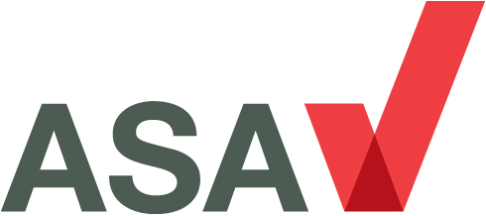
Gambling Commission, 1Financial Conduct Authority, Food Standards Agency, Medicines and Healthcare Products Regulatory Agency, Phone-Pay-Plus, The Portman Group, Trading Standards,
The ASA would have visited Aardman or the other way around, they will need to make sure that if they have any sponsorship adverts or any advert of theirs that they have had permission to use it on the platform they will stream it on.

Professional bodies

British Interactive Multimedia Association (BIMA)
The British Interactive Multimedia Association (BIMA), do a lot of different things but the main things which the BIMA do is support and promote the British digital industry, share knowledge and best practice, reward great work and they also encourage the next generation to take part to continue the great work of others and make the work even better. They want the work that is produced to become better.
As there are many different sectors this means that BIMA need to provide a valuable way to keep up with the developments of other sectors, they will do this lots of different ways, BIMA work with the government departments, professional bodies to provide access to the markets and the latest trends. They will hold regular talks to talk about the key issues and anything that doesn’t work or needs approving.
Aardman will have to comply with this organisation, in order for them to get some benefits and they might even get their own products mentioned in the meetings that they have.
Professional body codes of practices
A professional association (also called a professional body, professional organization, or professional society) is usually a non-profit organization seeking to further a particular profession, the interests of individuals engaged in that profession, and the public interest. Workers at Aardman could join this type of organisation, this is in order to get more public interest to their company as they could implement from this in their own work to make it better.
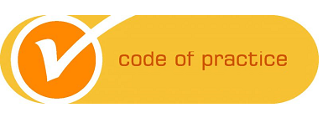
All leading professional bodies, such as the IIA, have a code of conduct to guide the member and raise the level of trust and confidence of the public in the profession, the people at Aardman will need some of this to keep the film looking professional. All members must express their commitment to the code when they join the IIA and to subsequent changes to the code which may be agreed from time to time, in other words they need to keep to it and if they want to change the rules or codes then they can from time to time. The rules for dealing with any allegation of infringement (copying) against the code are described in the Professional Complaints Procedures. This code and the procedures are available to the public, so this means anyone can have a look at them or they can use it in their work.
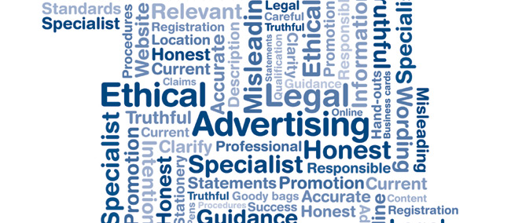
Ethnical

Ethnical requirements
There are always restrictions when creating any part of media production or anything to do with something that is digitalized. The restrictions are there to help people so that they know what they can do and what they cannot do. The restrictions are there to help make sure that people are protected against any racist comments that may offend people or cause any problems, this is done so that people aren’t going to be offended with the content. Many people do this as they know that they can do it anonymously, this means that they can’t be traced, but they still can be. Different restrictions apply for different uses e.g. media job roles, TV channels, radio presenters etc. Many people that find something unacceptable on a website can sue the company for a lot of money so companies have to be very careful about what they put on, they will check a lot of them but they can be prevented by the following:
- Not taking any pictures, videos or sound clips without permission of the owner which sometimes may be needed in writing.
- Not making any verbal statements about any individual which is seen as abusive or harmful towards them as this is known as slander.
- Not making any written statements about any individual which is seen as abusive or harmful towards them as this is known as libel.
- Do not take any part of somebody's work without getting permission of that person as this would be copyright.
- Be careful when you represent and describe the content and characters in work as you must make sure that you are unbiased and accurate.
This applies to all the people below;
- Race (black, white, Asian)
- Sexuality (homosexual, heterosexual, gay)
- Disability (able bodied and otherwise)
- Nationality (British or otherwise)
- Class (working, middle or upper)
- Regionalism (north and south)
- Age (old and young)
With all this it means that you cannot say or suggest in any way that one of these groups is inferior to the other, this is to protect people from things that they might not want to see. If this was to happen then that person would be in breach of this rule and the production that has been created may not be allowed to be seen, they can choose to have a blank dot on their faces and their voices changed. There are different laws which help to make sure that stuff like this doesn’t happen. An act that supports this is called The Race Relations Act, there are many more.
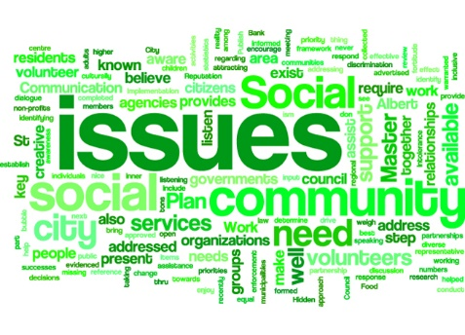
This means that Aardman animations will have to comply with these and cannot break any other wise they will be in breach and can be prosecuted.
Social issues and sensitivities
Whenever people are working with multimedia world, them MUST still obey all laws that you do in day to day life, so you need to think about anything that you do before you change anything. The internet is not a place where people can write what they want to anybody; if they are breaking the law in doing so such as making racist words they will face the same legal action as they would if they had said the same in person, there isn’t any special rights that they can earn. Internet comments can be made anonymously and easily to anybody, wherever and whenever, the internet can be tracked any illegal comments are not allowed to be published on the internet. In most cases such as work in the television industry, more laws apply that do normally. In fact, you can be sued a lot of money for making racist remarks on television.
Aardman will have to apply to these rules and can’t break them, they need to think about what they put in their program, this means that they aren’t going to be sued and don’t have to pay money as they don’t have that much of their own.
Representation of gender and Representation of religious beliefs
To make sure that any promotional material for Aardman doesn’t seem prejudice towards any race, gender or Religious, they need to make sure that any images on humans modelling the clothing/equipment represent the bigger picture.
Aardman have to make sure that all the models are varying in race and ethnic origin. They also have to think about how promotional material will affect any religious groups.
To ensure that none of them get offended by promotional material, particularly when Aardman products are World-Wide, and being delivered to every major country in the world, Aardman will need to work on not offending anyone's beliefs or are gender specific.
Not just Aardman but all other companies even if they have actors, they have to mix things up this then means that they can’t have just all white people and they are all boys. That isn’t how it works, you will need to have different races and different religious people and they need to be women and men.
Cultural issues and language
Within the media industry it is important to understand different cultural issues and language before anything is done. When creating a product for the industry it needs to be checked so that there is nothing that will discriminate anyone. There will be lots and lots of different tests to do this, the cultural issues are that people thing that if you make a black guy homeless, then you could offend the African culture and they would sue. You need to make sure that you get the language correct for the target audience, you need to make sure that the children’s shows don’t have effing and jeffing in it, but it needs to be smaller words with educational words in.
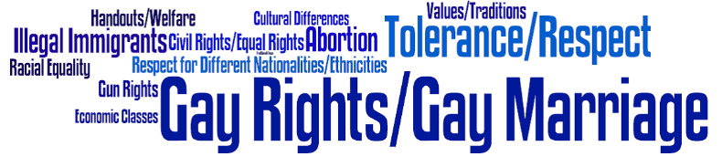
Aardman would of need to make sure that all of their productions were suitable and also most importantly all of the characters that they were creating would offend anyone.

